Chapter 1

Introduction

This report marks a change to the format in which the National Housing Supply Council will publish its work.
The Council will now look at specific issues and themes in this Housing Supply and Affordability Issues publication each year. It will also publish its annual assessment of the balance between housing supply and underlying demand, as well as what is happening to housing affordability, in a shortened State of Supply Report around the middle of the year. The latter will be similar to the Housing Supply and Affordability — Key Indicators, 2012 report published in June 2012.
There have been recent changes to the Council’s terms of reference, and the updated version is included in Appendix 1. These changes will allow the Council to look at the broader implications for housing supply of the closely linked area of urban planning and infrastructure development. As the changes have been made recently, this report has been compiled in line with the previous terms of reference.

Market backdrop
The housing market backdrop remained soft over 2012 and continues to provide a difficult operating environment for the industry. House prices held broadly stable at a national level from the start of the year, while transaction volumes remained low by historic standards and building activity sluggish. Meanwhile the Reserve Bank of Australia (RBA) cut its official cash rate by 1.75 percentage points between November 2011 and December 2012. Mortgage rates fell by around 1.35 percentage points in response. This is likely to support the housing market, although events in the broader domestic economy — and overseas, for that matter — are obviously important. But any improvement, from what was a low base, should be kept in perspective. The market remains fragile, in the Council’s view, and modest improvements have only occurred following substantial weakness.
Figure 1.1 shows that, at a national level, transacted house prices fell modestly over the latter part of 2011 and into early 2012. They then recovered a little over the middle part of the 2012 and essentially stabilised thereafter. For the year to December 2012, median prices for all dwellings across Australia were down 0.4 per cent compared to a year earlier. There was significant regional variation within this. Between December 2011 and December 2012, prices declined most significantly in Melbourne (2.9 per cent). Adelaide and Brisbane saw more modest falls (0.8 per cent in both cities), and there was little change in Canberra (down 0.3 per cent) and Hobart (0.1 per cent lower). Prices rose by 8.9 per cent in Darwin and more modestly in Sydney (1.5 per cent) and Perth (0.8 per cent). Prices outside of the capital cities were almost unchanged (a 0.1 per cent increase) over the year for the country as a whole. Non capital city prices increased in New South Wales (2.1 per cent) and Queensland (0.9 per cent) and declined in Victoria (3.4 per cent), South Australia (4.2 per cent) and Western Australia (1.8 per cent).
Figure 1.1 National annual house price growth and mortgage rates
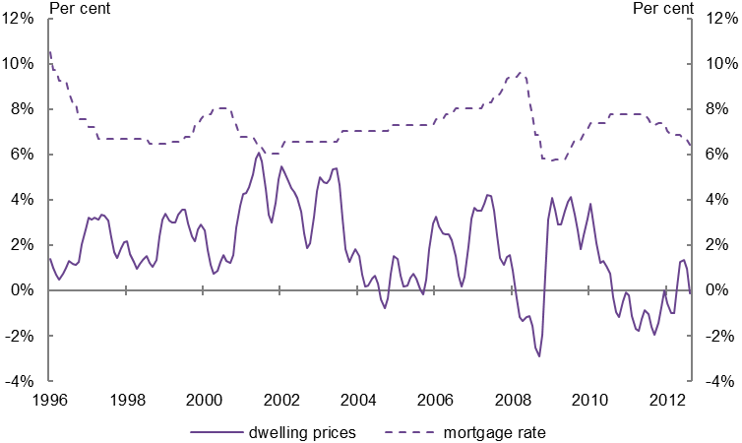
Source: RBA November 2012 Indicator Lending Rates, RP Data – Rismark.
Note: House price annual change is a three-month average of monthly data. The mortgage rate is the standard variable rate quoted for banks by the RBA. Many mortgage borrowers do not pay this rate, being either on a fixed rate or some type of discounted rate. While the actual rate is not necessarily representative of the rates paid by most borrowers, changes in it are a reasonable indicator of what is happening in the mortgage market as a whole.

The data behind the stratified split of house price growth (Figure 1.2) shows that falls over the last year have been a little larger in both lower priced suburbs and more expensive areas than in the middle-market suburbs — although more recent tentative rises have been larger in the more expensive areas.
Figure 1.2 House price indices (suburbs ranked by price) (indexed)
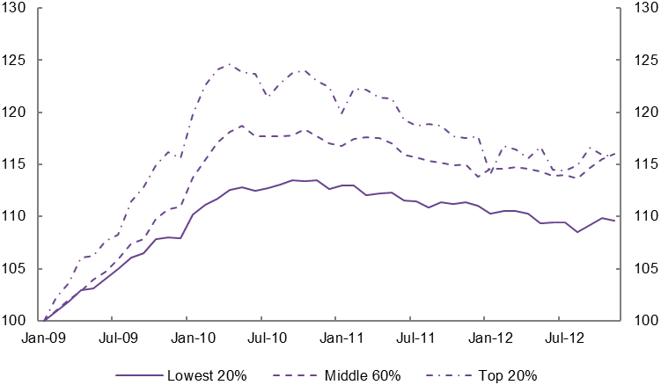
Source: RP Data–Rismark, stratified hedonic indices.
Note: Stratified data are for the average price in suburbs in each price sector. Data are based on the capital cities and indexed to January 2009.

Mortgage commitments are the most timely proxy measure of housing transactions available, albeit an incomplete one as they do not include cash purchases, which typically account for around one-quarter of all sales. Figure 1.3 shows that the total value of loan commitments to owner occupiers on a monthly basis has changed little since mid-2010, with activity materially below that seen in the preceding years — with the exception of the sharp drop in the wake of the global financial crisis (GFC) in 2008 and into 2009. The mini-cycle around the turn of 2011/2012 is likely to have been at least partly due to the phasing out of some first home buyer incentives in New South Wales over that period. This likely led to some activity being brought forward and a subsequent fall after the turn of the year. Once this had worked through, activity returned to broadly the level of the two preceding years. The number of mortgage commitments to owner occupiers over the first half of 2012 tells a broadly similar story: it edged up slightly from a year earlier but was down almost 20 per cent from the average volume of the last decade.
Figure 1.3 Mortgage commitments for house purchase, value and volume, Australia, trend
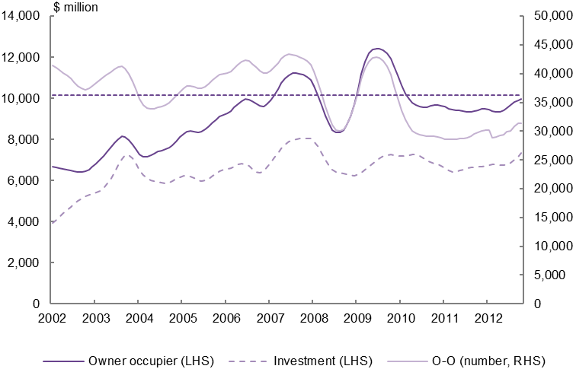
Source: ABS 2012, Housing Finance, cat no. 5609.0.
Note: LHS = left-hand scale; RHS = right-hand scale. All data are the ABS’ monthly trend series. The value of loans to owner occupiers and investors relate to the left hand scale. The number of loans to owner occupiers (O-O) relates to the right hand scale, with the dotted line indicating the average level of monthly activity over the last decade. Refinancing activity is excluded from owner occupier commitments.

The number of loans to investors is not available, but the value data suggests a similar pattern to that seen in the owner occupier market — that is, activity in 2012 ran above the lows of the GFC and its immediate aftermath but at a low level on a historical comparison. By value, investors’ share of housing finance has been broadly stable since 2004, apart from a relatively short-lived decline in the immediate aftermath of the GFC in 2008 and 2009.
Despite the soft home purchase market, rents have increased faster than house prices. This points to a possible pressure point where a lack of available housing is biting. Data from the Real Estate Institute of Australia (REIA) show that rents on houses in capital cities in the second quarter of 2012 were up by 3.2 per cent on a year earlier). Rents on ‘other dwellings’ (mostly flats/apartments) were up just over 2 per cent over the year.
Figure 1.4 Rents and earnings, Australia (indexed)
Source: ABS 2012, Average Weekly Earnings, cat no. 6302.0. REIA October 2012, quarterly median rents on three-bedroom houses. NHSC calculations.
Note: All data are indexed to the first quarter of 1995. Other dwelling rents are calculated from the index for each city, weighted by factors used by the ABS in its Established House Price Index.

Compared to a decade ago, the average nominal rent paid is up by 75.8 per cent for houses and 91.8 per cent for other dwellings (mostly flats/apartments) (see Figure 1.4). By comparison, average earnings rose by 57 per cent over the same period and house prices rose by 69 per cent. A further factor suggesting that the market remains tight is that vacancy rates remain low, at around 2 per cent.
House building activity also remains sluggish, although there are signs that it may have edged up a little from recent lows. As the Council’s previous report explained, building of public sector housing played a significant role in maintaining overall completion volumes during and immediately after the financial crisis when private sector activity was weak. This softness, coinciding with the phasing out of the rise in public sector activity at the time, means that residential building completions are likely to have been lower in 2012 than in previous years.
Recently there have been some slightly more encouraging signs of an increase in private sector approvals (see Figure 1.5), but it remains to be seen whether these will be sustained. Monthly building approval data can be volatile, particularly the impact of large apartment block projects. The number of approvals relates to the number of dwellings, so approval for a large project can mean a (relatively) large number of dwellings being approved at once. The total number of approvals (both private and public) remains low by historical standards.
Figure 1.5 Residential building approvals, Australia, trend
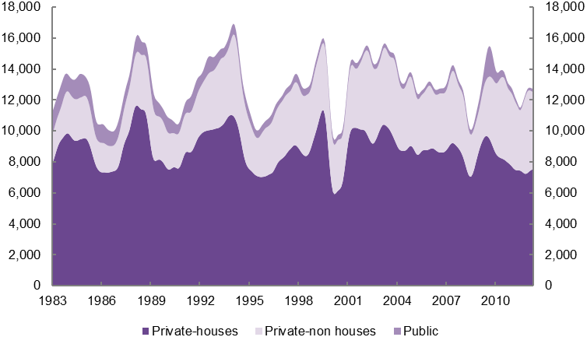
Source: ABS 2012, Building Approvals, Australia, cat no. 8731.0.
Note: Private sector approvals are split into house and non-house (predominantly flats/apartments); public sector approvals are grouped together.

As the Council has outlined in previous reports, a slow housing market, reflecting sluggish effective demand, is not necessarily inconsistent with an underlying housing shortage. In fact, a slow house purchase market and subsequent low volume of new supply coming onto the market potentially exacerbates the problem of inadequate supply. The shortage is likely to continue to be felt by the more vulnerable in society, such as those at the lower end of the rental market and those in need of government support.

Census results
The release of data from the 2011 Census is a key source of information for the Council’s work. It provides an opportunity to recalibrate and investigate key data on population, household formation and housing consumption patterns. Initial investigations are presented in Chapter 2.
The Census data provides evidence of the changing ways in which Australians occupy the housing stock. The analysis points to a decrease in household formation rates among younger age groups over the last decade, and the population at large forming fewer new households than would have been expected from demographic trends and past household formation patterns. Those in their late teens and early twenties are less likely to form households than a decade ago, and there has been a noticeable increase in the share of Australian-born younger people living with their parents for longer.
There have also been significant changes in the housing tenure of various age groups, particularly a sizeable increase in those nearing retirement age with a mortgage. A range of issues arise from this. In some cases retiring households may need to use lump sum superannuation payments to clear mortgages and in other cases they may need to sell their homes. Financial institutions may, in an environment of limited funding and less appetite for risk, choose to focus on lending to older groups with more established track records and more assets as collateral, possibly at the expense of younger potential first home buyers. A larger share of retirees who do not own their homes outright could also have implications for aged care and how people will fund their retirement.
The current structure and use of the housing stock also throws up challenges. The share of the stock that is flats, apartments and attached houses has increased over the last decade as the industry has adapted to the challenges of the modern economic, planning and social environment. As a consequence the share of dwellings that are detached homes has fallen a little, although it still accounts for three-quarters of all dwellings. Lone-person households occupied a larger share of detached houses in 2011 than in 2001, and a larger share of families lived in flats and attached dwellings. There are many one-, two- and three-person households in relatively large dwellings. This is unsurprising given the ageing population and the fact that many older households will opt to stay in their family homes after their children move out. However, it does point to a potential inefficient distribution of the current housing stock whereby small households often occupy relatively large homes and younger family households end up in smaller homes.
The Census data have provided evidence of the changing ways in which Australians occupy the housing stock. Disentangling how much change is driven by social change and conscious decisions and how much is ‘forced’ by a lack of available and affordable housing is a difficult task. However, there does appear to be some evidence that rising house prices relative to income and the oft-contested housing shortfall estimated by the Council (relative to the supply required to maintain historical housing consumption patterns) are affecting the population’s housing choices.
The initial release of the 2011 Census data in June 2012 led a number of commentators to question whether there actually is a housing shortfall. The Council considers that much of this analysis missed the key point that what the Census actually shows is how potential mismatches in housing demand and supply are reconciled. The aggregate Census data shows how many dwellings and people there are in the country. It cannot be expected to reveal a shortage in its own right.
While it does not provide as detailed evidence as is available from survey data, the Census does provide evidence of more households facing higher housing costs. Table 1.1 shows the share of households that face mortgage costs of 30 per cent or more of income. This is a broader, and less significant, analysis of households across the entire income spectrum than previous Council work, which focused on lower income within tenure groups, specifically those in the lowest 40 per cent of earners who had a mortgage (and, separately, those who rent). Unlike that analysis it includes those higher up the income spectrum, who are less likely to face the same pressure as those on lower incomes even if they do spend a relatively high proportion of their income on housing, and does not exclude households in other tenures. It may also include a number of older, established households that have refinanced their dwelling for both consumption and investment purposes.
Furthermore the analysis in Table 1.1 does not take account of the fact that, due to challenges around housing affordability and more recent issues with accessing finance, recent home buyers may have typically been further up the income distribution than earlier buyers. These buyers are more likely to face higher mortgage costs relative to income. But if this group is nearer the higher end of the income distribution than previously, then their mortgage costs may not be as great an issue as the aggregate analysis suggests, as higher income households have a greater capacity than lower-income households to bear mortgage costs above 30 per cent of income.
This is an illustration of why the income-segmented work previously done by the Council is of greater value. It is not currently possible to analyse available Census data using the same segmentation.
In aggregate, the share of all households that face mortgage costs of more than 30 per cent of income increased noticeably between the 2006 Census and the 2011 Census (Table 1.1). The share of households with mortgage costs of more than 30 per cent of household income remained highest in New South Wales, Western Australia and Victoria. The States with the sharpest increase between 2006 and 2011 were Western Australia and Tasmania. In the case of Tasmania, this was from a relatively low base in 2006.
Table 1.1 Households with mortgage costs of more than 30 per cent of gross household income
 | 2006 | 2011 | Percentage point change | Proportionate increase
NSW | 9.6% | 10.5% | 0.9% | 9.4%
VIC | 8.7% | 10.1% | 1.4% | 16.1%
QLD | 7.7% | 9.7% | 2.0% | 26.0%
WA | 7.8% | 10.2% | 2.4% | 30.8%
SA | 6.9% | 8.8% | 1.9% | 27.5%
TAS | 5.6% | 7.5% | 1.9% | 33.9%
NT | 6.0% | 7.7% | 1.7% | 28.3%
ACT | 6.5% | 7.8% | 1.3% | 20.0%
Australia | 8.4% | 9.9% | 1.5% | 17.9%
Source: ABS Censuses of Population and Housing, 2006 and 2011.
Note: Data includes households that do not have a mortgage on their dwelling.

Table 1.2 provides the equivalent analysis for the rental sector. Queensland and New South Wales have the highest shares of households facing rents of more than 30 per cent of household income. The sharpest increase between 2006 and 2011 was in the Northern Territory, followed by Tasmania. The higher share facing rental costs of more than 30 per cent of income, compared to those equivalent mortgage costs, is despite the fact that more households have a mortgage on their home than rent. It adds weight to the contention that the greater affordability pressures are found in the rental market.
Table 1.2 Households with rents of more than 30 per cent of gross household income
 | 2006 | 2011 | Percentage point change | Proportionate increase
NSW | 10.7% | 11.6% | 0.9% | 8.4%
VIC | 8.1% | 9.1% | 1.0% | 12.3%
QLD | 10.3% | 11.9% | 1.6% | 15.5%
WA | 7.4% | 8.9% | 1.5% | 20.3%
SA | 8.4% | 9.3% | 0.9% | 10.7%
TAS | 7.4% | 9.5% | 2.1% | 28.4%
NT | 6.8% | 9.0% | 2.2% | 32.4%
ACT | 7.1% | 8.0% | 0.9% | 12.7%
Australia | 9.3% | 10.4% | 1.1% | 11.8%
Source: ABS Censuses of Population and Housing, 2006 and 2011.
Note: Income includes receipt of Commonwealth rent assistance. Data includes households that do not rent their dwelling.
The Council believes that the various factors outlined support the view of a shortfall — or at least that there are groups who are unable to access housing as readily as earlier cohorts did at the same age. At the most extreme end of the spectrum of housing situations, the ABS reported an increase in homelessness between 2006 and 2011. Within this the largest increase was in those living in ‘severely crowded dwellings’ — usual residents of dwellings that need four or more extra bedrooms to accommodate them adequately. There will clearly be those who fall into homelessness categories for social rather than housing-specific reasons, so an increase in these numbers is not in itself indicative of a housing shortage. However, it could at least partly reflect pressures faced by some at the lower end of the housing system (specifically social renting and the low end of private renting) and an increase in demand that cannot be met by the conventional market.
There is clear evidence of a change in household formation patterns since the 2001 Census. Since 2001, fewer households have formed than would have been expected on the basis of past patterns given age and population changes. In other words, people of the same age were less likely to form households in 2011 than in 2001. Meanwhile, the number of group households has risen more rapidly than household growth as a whole — as the ageing population means a larger share of people are older, and older people are more likely to live in smaller households. On a related note, average household size has not declined as much as would have been expected from demographic drivers.
However, the Census has raised a number of points that the Council will explore further. Revised ABS estimates of the number of people resident in Australia at end-June 2011, which arise from new and improved collection and adjustment techniques, present the Council with particular challenges. Historical population estimates are due to be revised by the ABS in mid-2013. There will likely be a considerable delay until official numbers of households for 2011 are produced. However, past household estimates and projections — projections based on earlier trends form a crucial part of the Council’s estimate of underlying demand — are unlikely to be updated, and the impact of revised population estimates on household estimates is not clear. These and other matters, such as concerns about the unoccupied housing estimates in the Census, have contributed to the Council reflecting on how it presents the implications of its approach to estimating underlying housing demand and supply. These issues, which are explored in more detail in Chapter 5, may lead the Council to reassess how it judges the balance between housing demand and supply in future.

Scoping studies
The Council has initiated scoping research that has helped develop its understanding in a number of areas and will enable it to fine-tune further research on important aspects of demand and supply. This report outlines findings from four separate scoping exercises.
The first focused on those from the Baby Boom generation who reached the age of 65 in 2011. The present and future housing consumption pattern of Baby Boomers will be highly significant for the entire housing system. They will continue to shape mainstream housing outcomes rather than simply represent an interesting demographic group or ‘other’ in housing, planning and other policy considerations. The study looked at a number of possible housing paths for this group. The possibilities are diverse. They include remaining in the family home long into retirement years, staying in the same area, and moving away (sea changers and tree changers) either from choice or from financial necessity. There is also a potentially more vulnerable group who do not own their own homes and will need to retain or find affordable rental accommodation.
Second, a study of migrants’ settlement patterns and their impact on demand for housing found that, unsurprisingly, migrants are a diverse group with a wide variety of experiences. Their situations change the longer they are resident in Australia. There are significant differences between temporary and permanent arrivals and within these groups as well. Given that net overseas migration represents around half of Australia’s population growth, a developed understanding of migrants’ housing consumption patterns is important for understanding the adequacy of additions to Australia’s housing stock.
The Council has long noted the impact of supply and affordability constraints on the formation of households and on housing consumption choices. It has also questioned what choices and trade-offs households make to deal with higher housing costs. The third study considered the feasibility of measuring these trade-offs. It also studied the non-private dwelling sector and estimated that there were between 135,000 and 167,000 people living in non-private dwellings (or other informal arrangements) at the 2006 Census because of the inability of these individuals to access the private dwelling market.
The fourth study commissioned by the Council looked at supply-side responses to affordability challenges and how the industry is changing the type of product it produces. The main conclusion of this report is that the biggest change in recent years has been a reduction in dwelling and lot sizes for new homes. There has also been some innovation in production methods and in materials usage. But the report also noted some challenges faced by the industry in adopting new techniques and processes at a time when it already faces a range of challenges from a softer market. There is a potential role for governments to act as catalysts when partnering with the private sector to deliver new homes.
The results of these studies are discussed in detail in Chapter 3, and the full reports can be found on the Council’s website.

Changes in housing and planning policy
Housing policy, urban planning and infrastructure provision have been subject to extensive critique and change over the past couple of years. The Council broadly supports the direction of reform but notes that enactment and implementation are some distance away in many cases. A range of matters still need to be addressed substantially, many of which are interrelated and politically challenging.
The recently released Council of Australian Government (COAG) Housing Supply and Affordability Reform report made a number of recommendations as to how the States and Territories could enhance housing supply and affordability. These include making the development assessment process more efficient; making greater use of code-based frameworks for assessing development applications; adopting more consistent and transparent principles for infrastructure charges; and ensuring that planning policy regarding the diversity of lot size and dwelling mix does not constrain the operation of the market. The report also recommended trialling underutilised land principles for land held by the Commonwealth and considering whether housing programs could be made more efficient and effective.
The Australian Government remains a significant player in the housing field and continues to administer a variety of programs aimed at increasing housing supply. These include the National Rental Affordability Scheme, the Housing Affordability Fund, Building Better Regional Cities, the Social Housing Initiative and the National Partnership Agreement on Social Housing. The Council will look into these programs in more detail in future reports. The COAG Reform Council’s review of capital city strategic planning systems identified a key point relevant to housing: that no single level of government holds all policy responsibility for or expertise on city strategic planning and so it is important that they work together.
There have been changes to State and Territory regimes both in terms of grants and taxes for housing and in terms of planning regimes. Some of the most high-profile developments have been in New South Wales, where first home owner grants have been targeted solely for new homes rather than for the existing market (as has also happened in Queensland and South Australia) and substantial changes to the planning system have been proposed. Meanwhile the Council of Mayors in South East Queensland has been driving planning reform initiatives to deliver effective and efficient planning systems and spread good practice.
These issues and changes are examined in more detail in Chapter 4.

RP Data – Rismark, hedonic house price indices.
Data for prices outside of the capital cities are only available for these States.
Recent changes in State policy settings are outlined in more detail in Chapter 4.
Rents on other dwellings for Australia as a whole have been estimated by the Council from REIA data for each capital city, weighted by the factors used by the ABS in its Established House Price Index.
ABS May 2012, Average Weekly Earnings, Australia, average full-time adult earnings, cat no. 6302.0.
RP Data – Rismark, eight capital city hedonic house prices.
Both SQM Research and the REIA report rental vacancy rates near 2 per cent as at mid-2012.
NHSC 2012, Housing Supply and Affordability — Key Indicators, 2012, pp 16 and 17.
NHSC 2012, Housing Supply and Affordability — Key Indicators, 2012, pp 39–46.
The RBA in its March 2012 Financial Stability Review (pp 53–56) observed that it is older households that are most likely to have taken out additional owner occupier mortgage debt (as well as being the cohort most likely to pay down mortgages) over the last decade.
ABS 2012, 2011 Census of Population and Housing: Estimating Homelessness, cat no. 2049.0.

