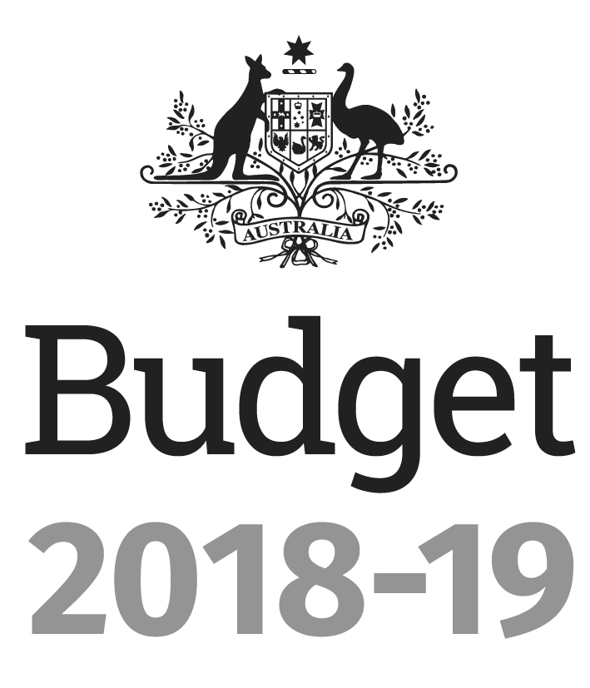
Portfolio Budget Statements 2018-19
Budget Related Paper No. 1.16
TREASURY Portfolio
Budget Initiatives and Explanations of
Appropriations Specified by Outcomes
and Programs by Entity
© Commonwealth of Australia 2018
ISSN 0728 7194 (print); 1326 4133 (online)
This publication is available for your use under a Creative Commons BY Attribution 3.0 Australia licence, with the exception of the Commonwealth Coat of Arms, the Treasury logo, photographs, images, signatures and where otherwise stated. The full licence terms are available from http://creativecommons.org/licenses/by/3.0/
au/legalcode.

Use of Treasury material under a Creative Commons BY Attribution 3.0 Australia licence requires you to attribute the work (but not in any way that suggests that the Treasury endorses you or your use of the work).
Treasury material used 'as supplied'
Provided you have not modified or transformed Treasury material in any way including, for example, by changing the Treasury text; calculating percentage changes; graphing or charting data; or deriving new statistics from published Treasury statistics – then Treasury prefers the following attribution:
Source: The Australian Government Department of the Treasury
Derivative material
If you have modified or transformed Treasury material, or derived new material from those of the Treasury in any way, then Treasury prefers the following attribution:
Based on The Australian Government Department of the Treasury data
Use of the Coat of Arms
The terms under which the Coat of Arms can be used are set out on the Department of the Prime Minister and Cabinet website (see www.pmc.gov.au/government/
commonwealth-coat-arms).
Other uses
Enquiries regarding this licence and any other use of this document are welcome at:
Manager
Media Unit
The Treasury
Langton Crescent
Parkes ACT 2600
Email: medialiaison@treasury.gov.au

Treasurer
parliament House
canberra 2600
President of the Senate
Australian Senate
Parliament House
CANBERRA ACT 2600

Speaker
House of Representatives
Parliament House
CANBERRA ACT 2600

Dear Mr President
Dear Mr Speaker
I hereby submit Portfolio Budget Statements in support of the 2018-19 Budget for the Treasury portfolio.
These statements have been developed, and are submitted to the Parliament, as a statement on the outcomes for the portfolio.
I present these statements to provide accountability to the Parliament and, through it, the public.
Yours sincerely
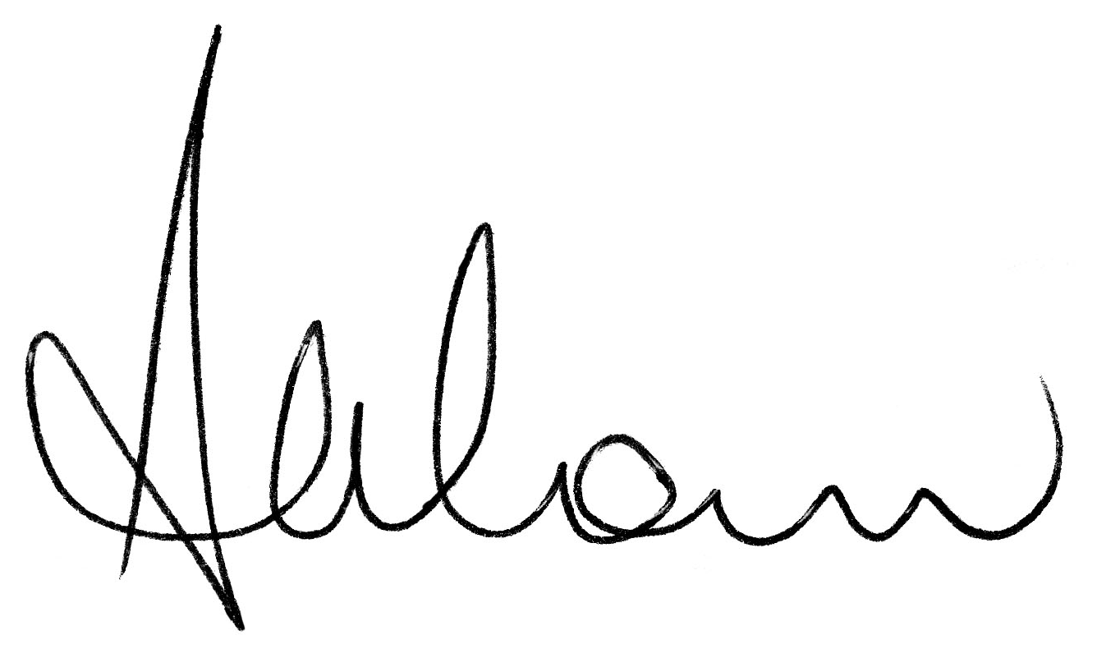
The Hon Scott Morrison MP
Abbreviations and conventions
The following notation may be used:
NEC/nec not elsewhere classified
- nil
.. not zero, but rounded to zero
na not applicable (unless otherwise specified)
nfp not for publication
$m $ million
$b $ billion
Figures in tables and in the text may be rounded. Figures in text are generally rounded to one decimal place, whereas figures in tables are generally rounded to the nearest thousand. Discrepancies in tables between totals and sums of components are due to rounding.
Enquiries
Should you have any enquiries regarding this publication please contact Mr Robert Twomey, Chief Financial Officer, Department of the Treasury on 02 6263 2111.
Links to Portfolio Budget Statements (including Portfolio Additional Estimates Statements and Portfolio Supplementary Additional Statements) can be located on the Australian Government Budget website at: www.budget.gov.au.

User Guide
To The
Portfolio Budget Statements

User guide
The purpose of the 2018-19 Portfolio Budget Statements (PB Statements) is to inform Senators and Members of Parliament of the proposed allocation of resources to government outcomes by entities within the portfolio. Entities receive resources from the annual appropriations acts, special appropriations (including standing appropriations and special accounts), and revenue from other sources.
A key role of the PB Statements is to facilitate the understanding of proposed annual appropriations in Appropriation Bills (No. 1 and No. 2) 2018-19 (or Appropriation (Parliamentary Departments) Bill (No. 1) 2018-19 for the parliamentary departments). In this sense, the PB Statements are Budget related papers and are declared by the Appropriation Acts to be ‘relevant documents’ to the interpretation of the Acts according to section 15AB of the Acts Interpretation Act 1901.
The PB Statements provide information, explanation and justification to enable Parliament to understand the purpose of each outcome proposed in the Bills.
As required under section 12 of the Charter of Budget Honesty Act 1998, only entities within the general government sector are included as part of the Commonwealth general government sector fiscal estimates and produce PB Statements where they receive funding (either directly or via portfolio departments) through the annual appropriation acts.
The Enhanced Commonwealth Performance Framework
The following diagram outlines the key components of the enhanced Commonwealth performance framework. The diagram identifies the content of each of the publications and the relationship between them. Links to the publications for each entity within the portfolio can be found in the introduction to Section 2: Outcomes and planned performance.

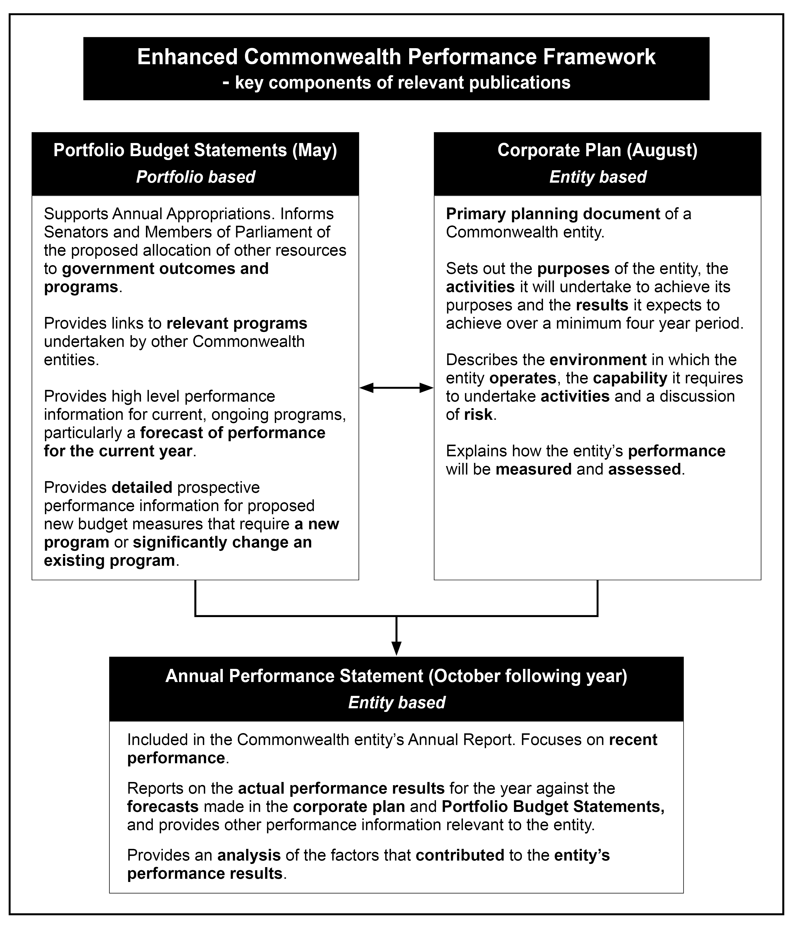

Contents
Portfolio overview 1
Entity resources and planned performance 7
Department of the Treasury 9
Australian Bureau of Statistics 53
Australian Competition and Consumer Commission 71
Australian Office of Financial Management 99
Australian Prudential Regulation Authority 121
Australian Securities and Investments Commission 141
Australian Taxation Office 167
Commonwealth Grants Commission 223
Inspector-General of Taxation 239
National Competition Council 255
Office of the Auditing and Assurance Standards Board 269
Office of the Australian Accounting Standards Board 285
Productivity Commission 301
Royal Australian Mint 317

Portfolio Overview

Treasury portfolio overview
Ministers and portfolio responsibilities
The Treasury portfolio undertakes a range of activities aimed at achieving strong sustainable economic growth for the good of Australians. This entails the advice to portfolio Ministers as well as the effective implementation and administration of policies that fall within the portfolio Ministers’ responsibilities.
The Treasury portfolio comprises 15 entities in the general government sector.
The Department of the Treasury assists the Australian Government as the pre-eminent economic adviser. The Treasury serves the Australian people through the development, delivery and implementation of sound economic policy and advice. The result is better informed policies designed to create economic prosperity for the Australian people.
The Australian Bureau of Statistics is Australia’s official statistical entity. It provides statistics on a wide range of economic, environmental, population and social matters, covering government, business and the community in general.
The Australian Competition and Consumer Commission is an independent statutory authority which administers the Competition and Consumer Act 2010 and performs functions under other Commonwealth legislation and State and Territory Competition Policy Reform Acts.
The Australian Office of Financial Management is responsible for the management of Australian Government debt and financial assets.
The Australian Prudential Regulation Authority is the financial supervisor responsible for the prudential regulation of the banking, other deposit taking, insurance and superannuation industries.
The Australian Securities and Investments Commission (ASIC) is Australia’s corporate, markets, financial services and credit regulator. It is responsible for consumer protection and market integrity. As part of its remit, ASIC also regulates investment management and superannuation, insurance, deposit taking, financial reporting, auditors and insolvency practitioners. ASIC promotes investor and consumer trust and confidence and fair and efficient markets and provides efficient registration services.
The Australian Taxation Office is the Australian Government’s principal revenue collection agency and administers Australia’s tax system and significant aspects of Australia’s superannuation system. It administers legislation governing tax, superannuation and the Australian Business Register and supports the delivery of government benefits to the community.
The Commonwealth Grants Commission provides advice to the Australian Government on the equitable distribution of GST revenue to State and Territory governments.
The Inspector-General of Taxation seeks to improve the administration of the tax laws for the benefit of all taxpayers.
The National Competition Council is an independent advisory body for all Australian governments that advises and makes recommendations under the National Access Regime and recommendations and decisions in relation to natural gas pipelines.
The National Housing Finance and Investment Corporation’s objective is to improve housing outcomes by operating an affordable housing bond aggregator to provide loans to registered community housing providers financed by the issue of bonds on the commercial market; and a National Housing Infrastructure Facility to provide loans, grants and investments to overcome impediments to the provision of housing that is due to the lack of necessary infrastructure.
The Office of the Auditing and Assurance Standards Board’s objective is to develop, issue and maintain in the public interest, principle-based, independent auditing and assurance standards for all sectors of the Australian economy that meet user needs, contribute to the development of international auditing and assurance standards and assist in maintaining confidence in the Australian economy, including its capital markets.
The Office of the Australian Accounting Standards Board’s role is to develop, issue and maintain principle-based independent financial reporting standards for all sectors of the Australian economy that meet user needs, contribute to the development of international accounting standards and assist in maintaining confidence in the Australian economy, including its capital markets.
The Productivity Commission is the Australian Government’s independent research and advisory body on a range of economic, social and environmental issues affecting the welfare of Australians.
The Royal Australian Mint manufactures and sells circulating coins to meet the coinage needs of the Australian economy, and collector coins and other minted products for Australia and foreign countries.
The Financial Advisers Standards and Ethics Authority Ltd and the National Housing Finance and Investment Corporation do not appear in the Portfolio Budget Statements as they are not directly appropriated by government. The Australian Reinsurance Pool Corporation and the Reserve Bank of Australia do not appear in the Portfolio Budget Statements as they are not part of the general government sector.
For information on resourcing across the portfolio, refer to Part 1: Agency Financial Resourcing in Budget Paper No. 4: Agency Resourcing.
Figure 1: Treasury portfolio structure and outcomes
Portfolio Minister — Treasurer
The Hon Scott Morrison MP
Minister for Revenue and Financial Services
The Hon Kelly O'Dwyer MP
Assistant Minister to the Treasurer
The Hon Michael Sukkar MP
Department of the Treasury
Portfolio Secretary: Mr John A. Fraser
Outcome: Supporting and implementing informed decisions on policies for the good of the Australian people, including for achieving strong, sustainable economic growth, through the provision of advice to Treasury Ministers and the efficient administration of their functions
Australian Bureau of Statistics
Australian Statistician: Mr David Kalisch
Outcome: Decisions on important matters made by Governments, business and the broader community are informed by objective, relevant and trusted official statistics produced through the collection and integration of data, its analysis, and the provision of statistical information
Australian Competition and Consumer Commission
Chair: Mr Rod Sims
Outcome: Lawful competition, consumer protection, and regulated national infrastructure markets and services through regulation, including enforcement, education, price monitoring and determining the terms of access to infrastructure services
Australian Office of Financial Management
Chief Executive Officer: Mr Rob Nicholl
Outcome: The advancement of macroeconomic growth and stability, and the effective operation of financial markets, through issuing debt, investing in financial assets and managing debt, investments and cash for the Australian Government
Australian Prudential Regulation Authority
Chair: Mr Wayne Byres
Outcome: Enhanced public confidence in Australia's financial institutions through a framework of prudential regulation which balances financial safety and efficiency, competition, contestability and competitive neutrality and, in balancing these objectives, promotes financial system stability in Australia
Australian Reinsurance Pool Corporation
Chief Executive Officer: Dr Christopher Wallace
Purpose: To protect Australia from economic losses cause by terrorism catastrophe
Australian Securities and Investments Commission
Chair: Mr James Shipton
Outcome: Improved confidence in Australia's financial markets through promoting informed investors and financial consumers, facilitating fair and efficient markets and delivering efficient registry systems
Australian Taxation Office
Commissioner: Mr Chris Jordan AO
Outcome: Confidence in the administration of aspects of Australia's taxation and superannuation systems through helping people understand their rights and obligations, improving ease of compliance and access to benefits, and managing non-compliance with the law

Figure 1: Treasury portfolio structure and outcomes (continued)
Commonwealth Grants Commission
Secretary: Mr Michael Willcock
Outcome: Informed Government decisions on fiscal equalisation between the States and Territories through advice and recommendations on the distribution of GST revenue
Financial Adviser Standards and Ethics Authority Limited
Chief Executive Officer: Dr Deen Sanders OAM
Outcome: Strengthen the professional and ethical standards of financial advisers through enhancing educational and training requirements and ethical standards to improve consumer outcomes
Inspector-General of Taxation
Inspector-General: Mr Ali Noroozi
Outcome: Improved tax administration through investigation of complaints, conducting reviews, public reporting and independent advice to Government and its relevant entities
National Competition Council
President: Ms Julie-Anne Schafer
Outcome: Competition in markets that are dependent on access to nationally significant monopoly infrastructure, through recommendations and decisions promoting the efficient operation of, use of and investment in infrastructure
National Housing Finance and Investment Corporation
Chair: Appointment to be made following establishment of the entity
Outcome: Improved housing outcomes for Australians, including through financial and other assistance to improve the efficiency and scale of the community housing sector, as well as for critical infrastructure that increases housing supply
Office of the Auditing and Assurance Standards Board
Chair: Dr Roger Simnett
Outcome: The formulation and making of auditing and assurance standards that are used by auditors of Australian entity financial reports or for other auditing and assurance engagements
Office of the Australian Accounting Standards Board
Chair: Ms Kris Peach
Outcome: The formulation and making of accounting standards that are used by Australian entities to prepare financial reports and enable users of these reports to make informed decisions
Productivity Commission
Chairman: Mr Peter Harris
Outcome: Well-informed policy decision-making and public understanding on matters relating to Australia’s productivity and living standards, based on independent and transparent analysis from a community-wide perspective
Reserve Bank of Australia
Governor: Mr Philip Lowe
Purpose: In its role as Australia’s central bank, the Reserve Bank of Australia determines and implements monetary policy, fosters financial stability, undertakes a range of activities in financial markets, acts as a banker to the Australian Government, issues Australia’s banknotes and has policy, supervisory and operational roles in the payments system
Royal Australian Mint
Chief Executive Officer: Mr Ross MacDiarmid
Outcome: The coinage needs of the Australian economy, collectors and foreign countries are met through the manufacture and sale of circulating coins, collector coins and other minted like products

