Portfolio Additional
Estimates Statements 2014-15

Treasury Portfolio

Explanations of Additional Estimates 2014-15

© Commonwealth of Australia 2015
ISBN 978-1-925220-34-6
This publication is available for your use under a Creative Commons BY Attribution 3.0 Australia licence, with the exception of the Commonwealth Coat of Arms, photographs, images, signatures and where otherwise stated. The full licence terms are available from http://creativecommons.org/licenses/by/3.0/au/legalcode.
Use of Treasury material under a Creative Commons BY Attribution 3.0 Australia licence requires you to attribute the work (but not in any way that suggests that the Treasury endorses you or your use of the work).
Treasury material used 'as supplied'
Provided you have not modified or transformed Treasury material in any way including, for example, by changing the Treasury text; calculating percentage changes; graphing or charting data; or deriving new statistics from published Treasury statistics – then Treasury prefers the following attribution:
Source: The Treasury
Derivative material
If you have modified or transformed Treasury material, or derived new material from those of the Treasury in any way, then Treasury prefers the following attribution:
Based on Treasury data
Use of the Coat of Arms
The terms under which the Coat of Arms can be used are set out on the It’s an Honour website (see www.itsanhonour.gov.au)
Other uses
Enquiries regarding this licence and any other use of this document are welcome at: Manager
Communications
The Treasury
Langton Crescent
PARKES ACT 2600
Email: medialiaison@treasury.gov.au
President of the Senate
Australian Senate
Parliament House
CANBERRA ACT 2600

Speaker
House of Representatives
Parliament House
CANBERRA ACT 2600

Dear Mr President
Dear Mr Speaker

I hereby submit Portfolio Additional Estimates Statements in support of the 2014-15 Additional Estimates for the Treasury portfolio.
These statements have been developed, and are submitted to the Parliament, as a statement on the funding requirements being sought for the portfolio.
I present these statements by virtue of my ministerial responsibility for accountability to the Parliament and, through it, the public.
Yours sincerely
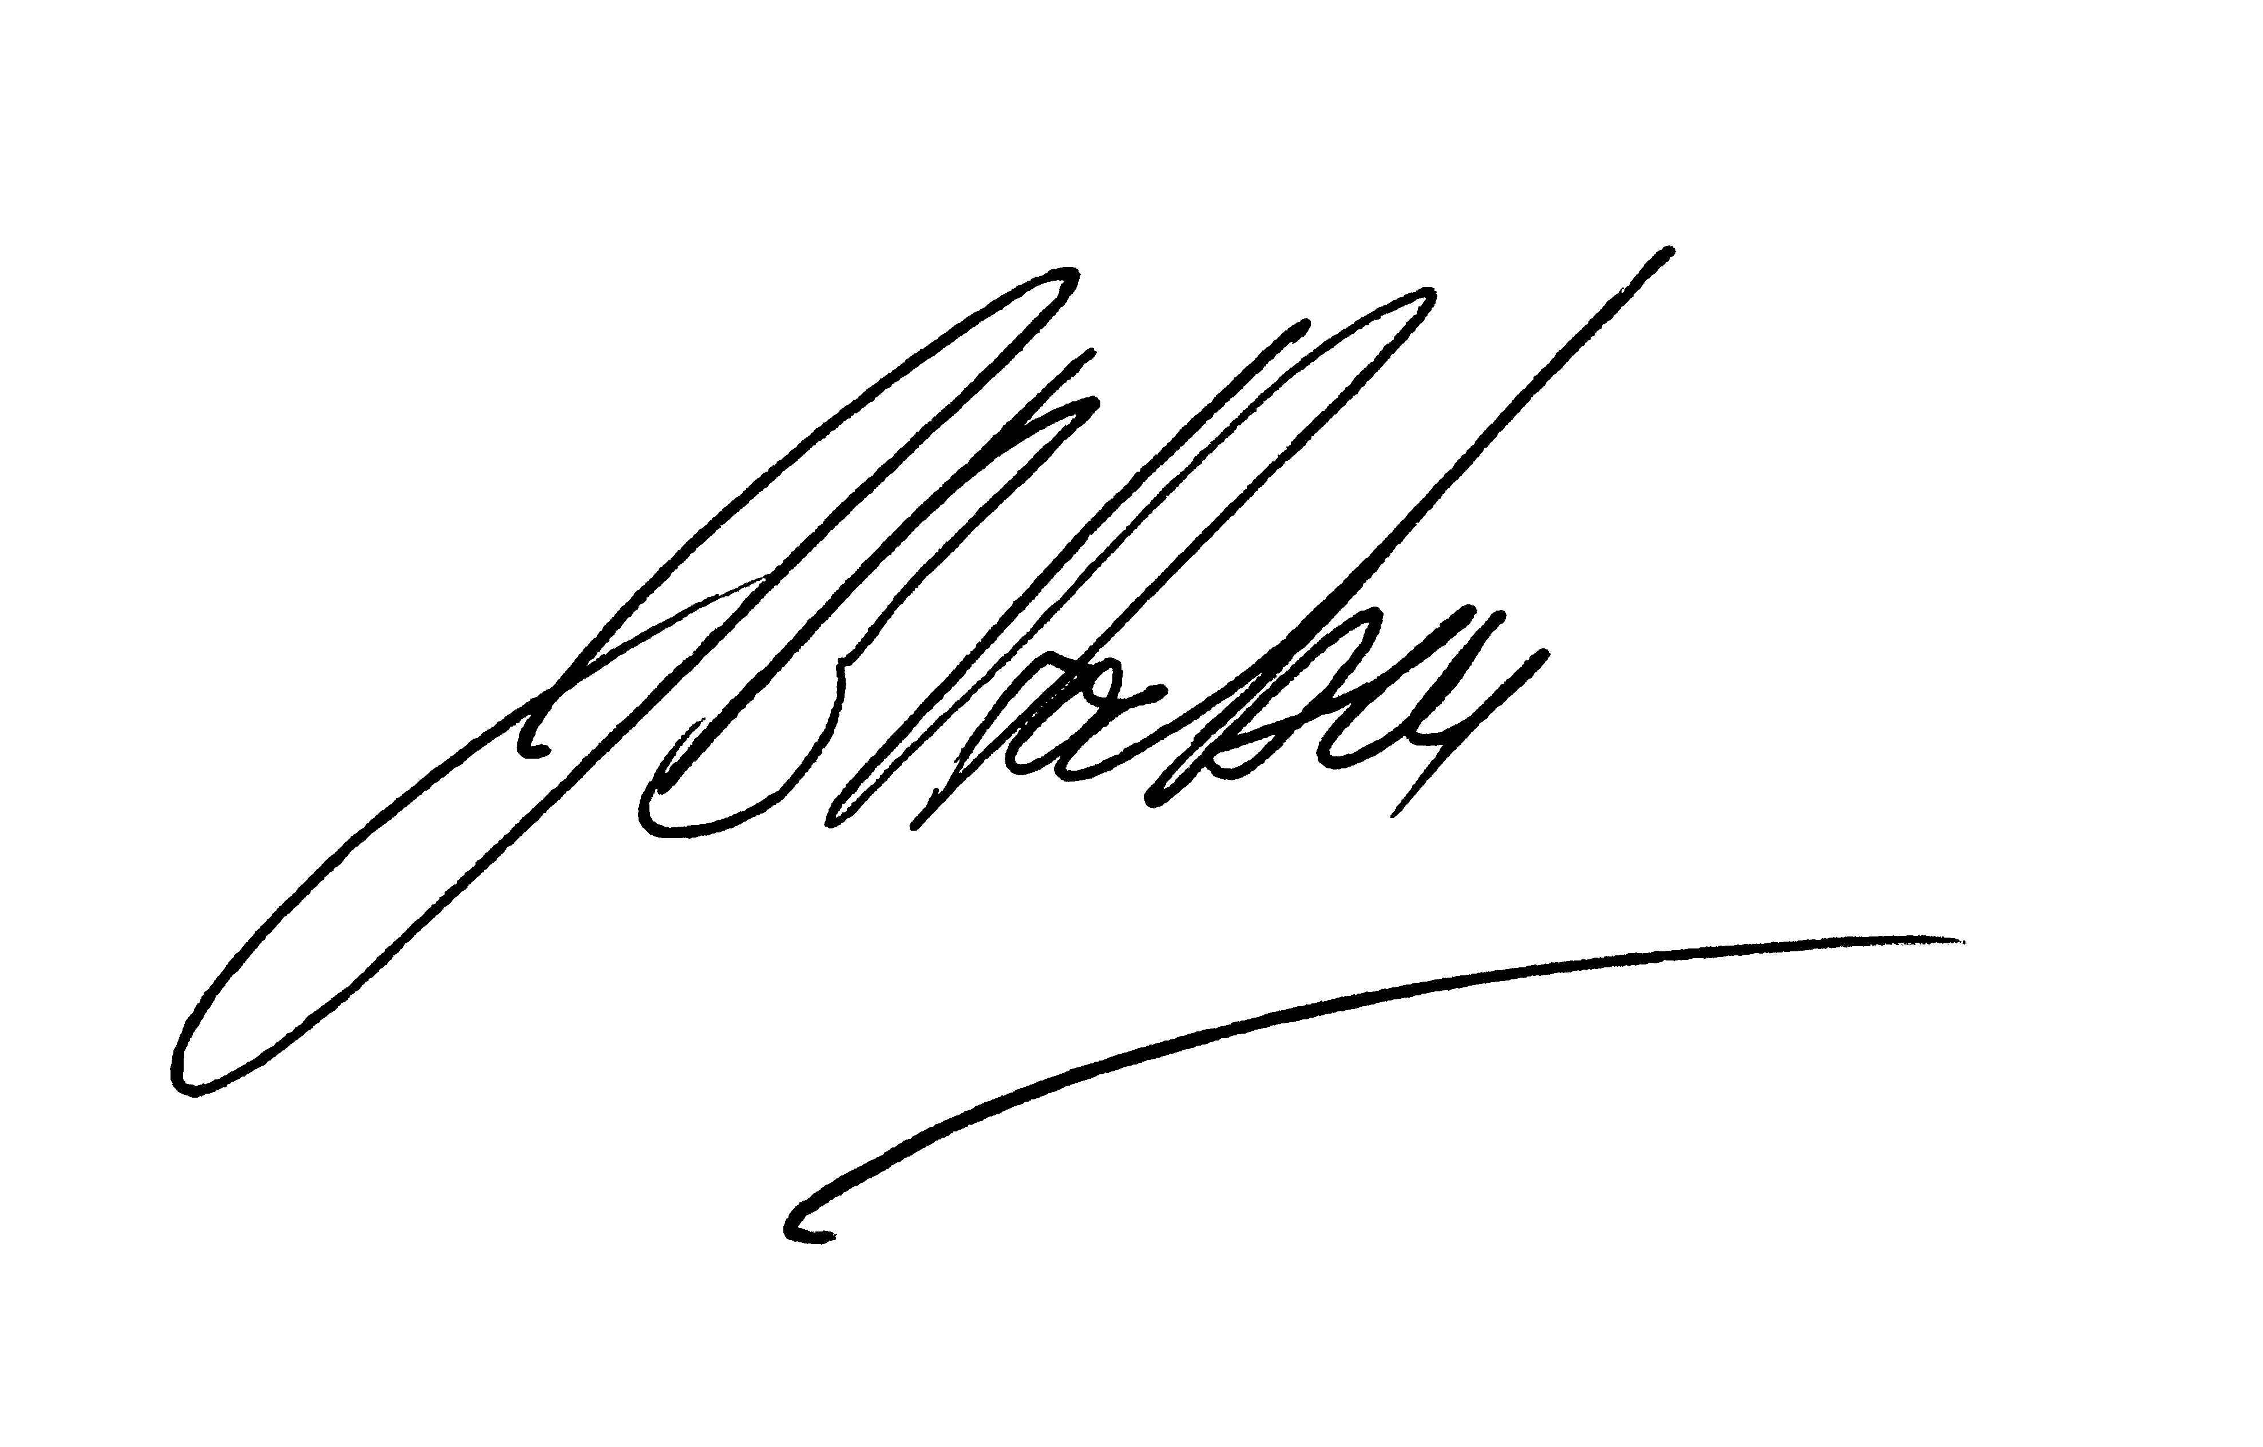
HON J. B. HOCKEY MP

Abbreviations and conventions
The following notations may be used:
NEC/nec not elsewhere classified
- nil
.. not zero, but rounded to zero
na not applicable (unless otherwise specified)
nfp not for publication
$m $ million
Figures in tables and in the text may be rounded. Figures in text are generally rounded to one decimal place, whereas figures in tables are generally rounded to the nearest thousand. Discrepancies in tables between totals and sums of components are due to rounding.
Enquiries
Should you have any enquiries regarding this publication please contact Matthew King, Chief Finance Officer in the Department of the Treasury on (02) 6263 2111.
A copy of this document can be located on the Australian Government Budget website at: www.budget.gov.au.

User Guide
to the
Portfolio Additional
Estimate Statements

User Guide
The purpose of the Portfolio Additional Estimates Statements (PAES), like that of the Portfolio Budget Statements (PB Statements), is to inform Senators and Members of Parliament of the proposed allocation of resources to Government outcomes by entities within the portfolio. The focus of the PAES differs from the PB Statements in one important aspect. While the PAES include an Entity Resource Statement to inform Parliament of the revised estimate of the total resources available to an entity, the focus of the PAES is on explaining the changes in resourcing by outcome(s) since the Budget. As such, the PAES provides information on new measures and their impact on the financial and/or non-financial planned performance of programmes supporting those outcomes.
The PAES facilitate understanding of the proposed appropriations in Appropriation Bills (Nos. 3 and 4) 2014-15. In this sense the PAES is declared by the Additional Estimates Appropriation Bills to be a ‘relevant document’ to the interpretation of the Bills according to section 15AB of the Acts Interpretation Act 1901.
Whereas the Mid-Year Economic and Fiscal Outlook (MYEFO) 2014-15 is a mid-year budget report which provides updated information to allow the assessment of the Government’s fiscal performance against its fiscal strategy, the PAES update the most recent budget appropriations for entities within the portfolio.

Structure of the Portfolio Additional Estimates Statements
The PAES are presented in three parts with subsections.
User Guide
Provides a brief introduction explaining the purpose of the PAES.
Portfolio Overview
Provides an overview of the portfolio, including a chart that outlines the outcomes for entities in the portfolio.
Entity Additional Estimates Statements
A statement (under the name of the entity) for each entity affected by Additional Estimates.
Section 1: Entity Overview and Resources | This section details the total resources available to an entity, the impact of any measures since Budget, and impact on Appropriation Bills Nos. 3 and 4.
Section 2: Revisions to Outcomes and Planned Performance | This section details changes to Government outcomes and/or changes to the planned performance of entity programmes.
Section 3: Explanatory Tables and Budgeted Financial Statements | This section contains updated explanatory tables on special account flows and staffing levels and revisions to the budgeted financial statements.
Contents
Portfolio Overview 3
Agency Additional Estimates Statements 7
Department of the Treasury 9
Australian Securities and Investments Commission 33
Australian Taxation Office 61
Corporations and Markets Advisory Committee 87
Productivity Commission 101

Portfolio Overview

Portfolio Overview
There has been no significant change to the portfolio overview, portfolio responsibilities or agency outcomes from that included in the Portfolio Budget Statements 2014-15 (pages 3-5).
Additional estimates are being sought for the Department of the Treasury, the Australian Securities and Investments Commission, the Australian Taxation Office, the Corporations and Markets Advisory Committee and the Productivity Commission. Explanations of additional estimates for these agencies are detailed in their respective section in the Portfolio Additional Estimates Statements.
There are no additional estimates for the Australian Bureau of Statistics, the Australian Competition and Consumer Commission, the Australian Office of Financial Management, the Australian Prudential Regulation Authority, the Clean Energy Finance Corporation, the Commonwealth Grants Commission, the Inspector-General of Taxation, the National Competition Council, the Office of the Auditing and Assurance Standards Board, the Office of the Australian Accounting Standards Board or the Royal Australian Mint.
Figure 1: Treasury Portfolio Structure and Outcomes
Figure 1: Treasury Portfolio Structure and Outcomes (continued)

Portfolio resources
Table 1 shows for those entities reporting in the PAES the additional resources provided to the portfolio in the 2014-15 budget year, by entity.
Table 1: Portfolio resources 2014-15

Entity Additional Estimates Statements

