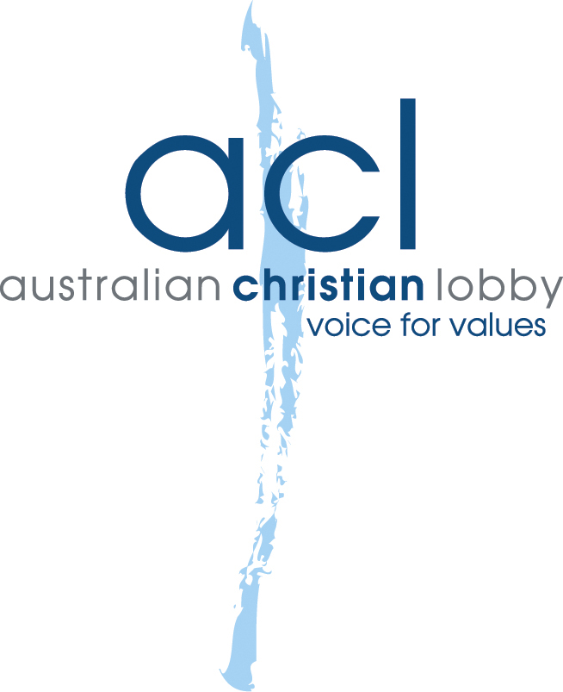
National Office
4 Campion Street
Deakin ACT 2600

T 02 6259 0431
F 02 6259 0462

E natoffice@acl.org.au
W acl.org.au

ABN 40 075 120 517

10 August, 2011
Manager
Philanthropy and Exemptions Unit
Personal and Retirement Income Division
The Treasury
Langton Crescent
PARKES ACT 2600

To the Manager:
On behalf of the Australian Christian Lobby I am pleased to present our submission to the Treasury in response to the Treasury’s Exposure Draft - 'In Australia' Special Conditions for Tax Concession Entities.

Yours sincerely,

Lyle Shelton
Chief of Staff

RE: Exposure Draft – “In Australia” Special Conditions for Tax Concession Entities
To the Manager:
The Australian Christian Lobby (ACL) appreciates the opportunity to comment on the Treasury’s Exposure Draft - 'In Australia' Special Conditions for Tax Concession Entities.
The ACL has strong relationships with churches, charities, and other not-for-profit entities (NFPs) understands and the public benefit they have. These organisations also focus on countries outside Australia, performing charitable and mission work in disadvantaged areas. NFPs in turn rely on donations in order to carry on their work.
NFPs have a long history of income tax exemption due to the role they play in serving society’s most needy. Their activities relieve a heavy burden of governments. NFPs, by definition, operate without the aim of making a profit; rather they use funds raised to meet the expenses of caring for others. Given their charitable purposes, NFPs have long been allowed to operate without the added burden of income taxes.
In addition to the positive domestic role NFPs play, many NFPs also promote Australia’s involvement in foreign aid, again relieving some of the burden from the Australian Government by attending to the needs of overseas communities through direct philanthropic aid.
The ACL is concerned that the proposed amendments may have the effect of adding financial burdens on NFPs which will make it very difficult for them to continue to operate and place further pressure on their donors.
In such a wealthy country as Australia, with many neighbouring countries experiencing a much lower standard of living than our own, organisations should be encouraged in their pursuit of advancing the basic living standards of our foreign neighbours.
Many churches have a strong interest in working overseas, with part of their income dedicated to supporting charitable activity in foreign countries.
Similarly, many overseas groups depend solely on the financial support of churches and other organisations in Australia.
There is a concern that churches and mission organisation which conduct charitable work or support charitable groups or individuals overseas may be in danger of losing their tax exempt status.
In their Charity & Not for Profit Tax Bulletin, legal firm Blake Dawson made the following observations:
The Exposure Draft has also proposed an additional requirement that limits entities to donating to other "exempt entities". While "exempt entities" are not limited to charities (for instance, the term also includes certain State or Territory bodies as well as public authorities), this would prevent distributions for charitable purposes to some entities.
If the tax exempt status of an organisation is in danger if they continue to make financial contributions to people overseas, they may have to cease giving this financial support.
ACL urges the Government to acknowledge the valuable contribution Australian institutions make overseas and encourages the Government to consider the impact these amendments may have on:
- the ability of NFPs to pursue charitable purposes overseas;
- the willingness of Australian citizens to donate to NFPs which work overseas.
ACL also urges the Government not to make any amendments to the tax system which could have a negative impact on how NFPs are able to operate overseas. The great wealth of Australia is in stark contrast to a majority of the rest of the world, much of it on our very doorstep.

In light of these considerations, the ACL recommends that:
- The Government retain the current tax concessions for organisations operating overseas and for Australian organisations which donate to overseas organisations.

Jadie Teoh, Ian Murray, and Teresa Dyson, ‘The 'in Australia' special conditions for tax concession entities’, Blake Dawson, http://www.blakedawson.com/Templates/Publications/x_article_content_page.aspx?id=62917

