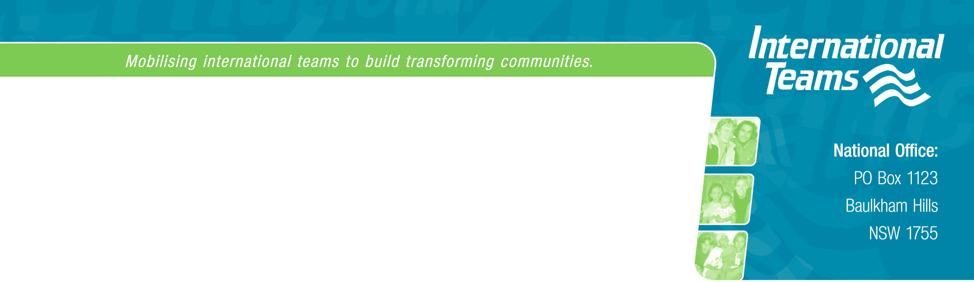

12 August 2011

Manager
Philanthropy and Exemptions Unit
Personal and Retirement Income Division
The Treasury
Langton Crescent
PARKES ACT 2600
Email: NFPReform@treasury.gov.au

International Teams Ministries Australia
Submission regarding: Exposure Draft –
‘In Australia’ Special Conditions for Tax Concession Entities

Since 1 July 2000 International Teams Ministries Australia Incorporated has been endorsed as an income tax exempt charitable institution under Item 1.1 in section 50-5 of the Income Tax Assessment Act 1997

In addition International Teams Ministries Australia Inc received endorsement as a deductible gift recipient for the Sydney Refugee Team on 1 July 2007.

International Teams Ministries Australia is helping churches help the poor and oppressed both in Australia and overseas. We provide opportunities , training, equipping and support for many projects that seek to give support to marginalized people in Australia and overseas.

In Sydney our Refugee Team visits refugees offering them physical and emotional support. Activities including teaching English, driving refugees to medical and counseling appointments, and running events such as camps and sporting events and picnics, are all part of the means of helping families and individuals in their needs.

This help is multiplied as the Sydney Refugee Team trains volunteers from the community and local churches to be relating well to refugees. These volunteers and community groups in particular supply much material aid which is passed on to the refugees.

International Teams Australia is engaged in similar projects overseas to refugees, street children and also victims of human trafficking. Currently 14 Australians are volunteering in such programs in six countries. International Teams offers material and emotional support to these people and receives and remits funds as needed

Concerns

I have received Professional advice suggesting that the Exposure Draft will have the following impact on International Teams .

- Loss of income tax exempt status under 50-50(d) of the Income Tax Assessment Act as a member of Australian Evangelical Alliance Inc (Missions Interlink) which is prescribed by law under regulation 50.50.02. This would put at risk all the community and individual support programs in which International Teams is currently involved both in Australia and overseas.

- International Teams presently receives donations from local churches and community groups. These Donor organisations would lose their income tax exempt status.. If International Teams loses its income tax exempt status, then under the Exposure Draft any other tax-exempt organisation that makes a donation to us will lose their own tax exemption. This will have a huge impact on the organisation concerned, have low compliance (because of lack of information and understanding), and reduce donations to International Teams. Overall there would be less funds available for our projects

Recommendation

The new law retains exemptions for all prescribed institutions listed in the current regulations.

A minimum threshold for donations to entities without income tax exempt status should be introduced into the legislation.

Janice Collins
National Director

