 | DEVELOPMENT ASSOCIATES INTERNATIONAL INC. ABN 6997 8338 277

22/632 St Kilda Road  Melbourne VIC 3004  AUSTRALIA | 61 (0)3 9533 6600  icathie@daintl.org  www.daintl.org

12th August 2011

Manager
Philanthropy and Exemptions Unit
Personal and Retirement Income Division
The Treasury
Langton Crescent
PARKES ACT 2600

Dear Manager,

I write in response to an invitation for submissions regarding the Exposure Draft - 'In Australia' Special Conditions for Tax Concession Entities.

Development Associates International Inc. is an organisation focused on leadership development education in third world countries. We work in Papua New Guinea, Mongolia, India, China and Uganda. We conduct workshops, seminars and formal education through a Masters of Arts in Organisational Leadership – the latter in partnership with tertiary institutions in those countries. The emphasis of our training is on leadership integrity and practical skills in nations where corruption and ineffective leadership hinder development and perpetuate the need for overseas aid – including aid from Australia.

We are concerned that our ability to engage in this work will be restricted by the loss of our tax exempt status under 50-50(d) of the Income Tax Assessment Act as a member of Australian Evangelical Alliance Inc. (Missions Interlink) which is prescribed by law under regulation 50.50.02. The small amount of tax payable will have to be administered, adding to the cost of operating and reducing the time available to actually engage in the work of education and training.

Of far greater concern is the impact of the proposal on our ongoing income. If Development Associates International loses our income tax exemption, any institution supporting us will also lose its tax exemption. The potential loss of income to Development Associates International would cripple our ability to conduct the very work needed in the counties in which we are

2

active. Funds will be sent directly to overseas organisations where there is far less control over how they are used.

In terms of revenue raised, cost of compliance and role of Australia in overseas aid the ‘catch-all’ structure of the proposal is deeply flawed.

Development Associates International strongly recommends that any new tax law retains the exemptions for all prescribed institutions listed in the existing regulations.

Yours sincerely,

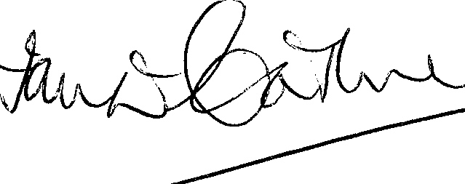

Ian D Cathie
Director

