Submission regarding:

Exposure Draft –
‘In Australia’ Special Conditions for Tax Concession Entities

4th August 2011

Middle East Christian Outreach (MECO Australia)

MECO Australia works in a number of countries in the Middle East region. We are currently involved in helping refugees from countries that are experiencing unrest at the present time. We provide services primarily to people who are poor, disadvantaged and disabled.

These services include the provision of help in areas of medical, literacy, communications, community support/development, education etc. Currently we have twelve (12) people belonging to our organization helping in a variety of these ways in the region.

Concerns

Recent communication and professional advice to us suggests that the Exposure Draft will have the following impact on Middle East Christian Outreach (MECO Australia):

Firstly, loss of income tax exempt status under 50-50(d) of the Income Tax Assessment Act as a member of Australian Evangelical Alliance Inc (Missions Interlink) which is prescribed by law under regulation 50.50.02. This would put at risk all the good things that Middle East Christian Outreach (MECO Australia) is doing as noted above. If these changes were to be adopted and legislated in the current form then our ability to provide resources and support for our personnel would be greatly harmed.

The impact of losing tax exemption is not just because of the tax that would become payable but we would be under pressure to employ additional staff because of the additional administration to fulfill ATO requirements.

Secondly, donor organisations would lose their income tax exempt status. The workers we send overseas receive all their support (living allowances, rents, education, medical costs, etc) from donations from family and friends (who have already paid tax) and churches who are interested in their work. If Middle East Christian Outreach (MECO Australia) loses its income tax exempt status, then under the Exposure Draft any other tax-exempt organisation that makes a donation to us will lose their own tax exemption.

This will have a huge impact on Middle East Christian Outreach (MECO Australia) and very likely reduce donations to Middle East Christian Outreach (MECO Australia). This would mean we would not be in a position to be able to continue our work and probably have to close our operations.

Recommendation

I believe that this ‘exposure draft’ should retain the current exemptions for all prescribed institutions listed in the current regulations.

Yours Faithfully,

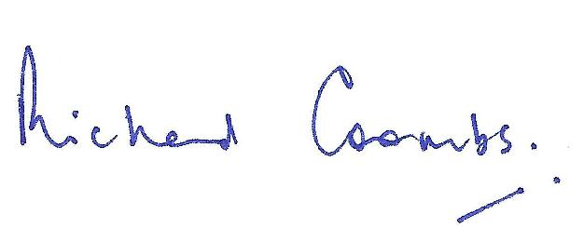

Richard Coombs
MECO Australia - Director

