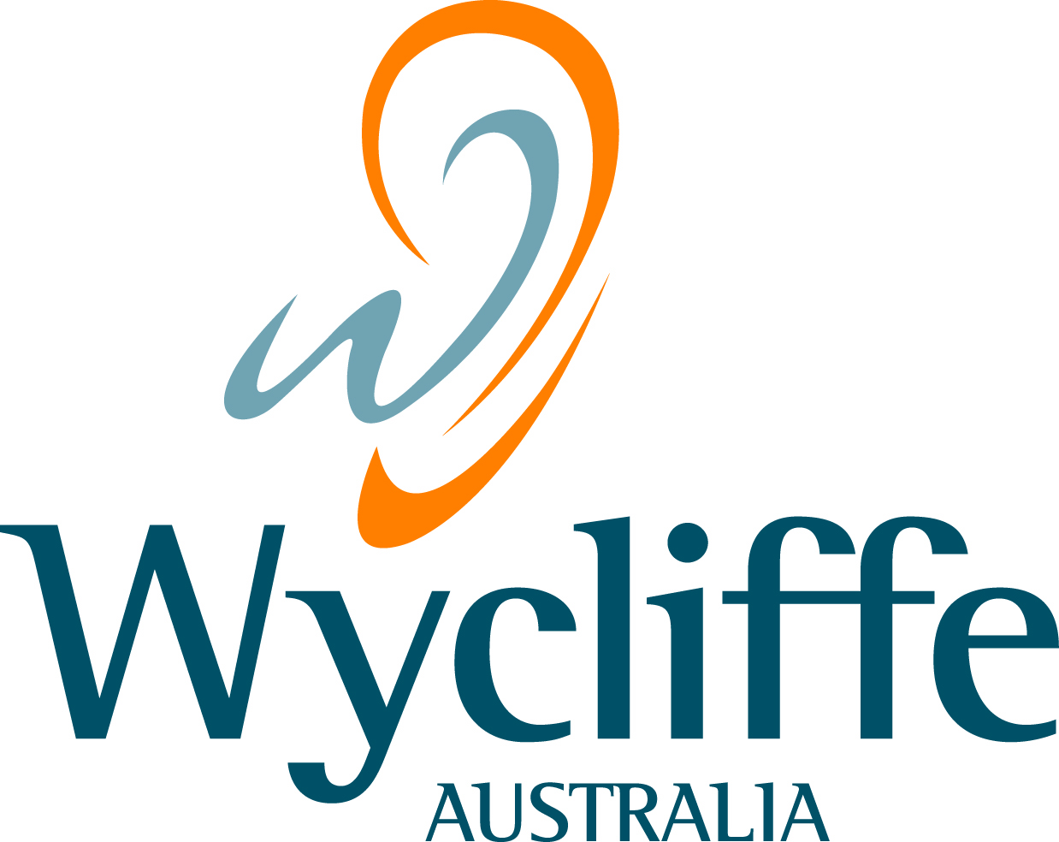
Wycliffe Bible Translators Australia
70 Graham Road
Kangaroo Ground VIC 3097
ABN 22 004 705 953
PHONE 03 9712 2777
FAX 03 9712 2799
EMAIL CEO_australia@wycliffe.org
WEB www.wycliffe.org.au

Submission regarding:

Exposure Draft –
‘In Australia’ Special Conditions for Tax Concession Entities

11 August 2011

Wycliffe Australia is made up of Australians who have the deepest commitment to people of all cultures, serving people’s needs holistically, building capacity through translation, literacy and associated services, and providing medical and other literature in many indigenous and vernacular languages.
Approximately 250 Australians are serving as volunteers with Wycliffe in Australia and overseas, with about 25% of total legacy, interest, rental, gift and other income being spent overseas.

Within Australia, Wycliffe volunteers seconded to AuSIL (Australian Society for Indigenous Languages) have been actively involved in indigenous development. This year we celebrate 50 years of such service which has included supporting bilingual education through the training of teacher linguists in the 1970’s and 80’s, undertaking linguistic research in cooperation with communities and universities, publishing or being major contributors to dictionaries in indigenous languages, as well as developing and delivering extensive training to indigenous translators. The reason we mention these activities amongst indigenous communities which will not be affected by the ‘in Australia’ clause is because they are similar to the activities and services that we provide to some of the most disadvantaged countries and communities around the world that will be affected.

Allow me to give you a couple of examples. In Papua New Guinea (PNG) our partner organisations provide extensive training to local translators, and also to teachers wanting to establish village schools. They also have a memorandum of understanding with a university to develop their linguistics and translation courses, and they translate community health materials such as Government and NGO HIV educational pamphlets into local languages. A new training centre in the Eastern Highlands, supported by the PNG Government and funds within PNG, was recently opened to build capacity in PNG. Wycliffe volunteers provide much of the curriculum development and delivery. Our Aussie volunteers in PNG make an outstanding contribution to this country.

Similarly a new training centre was opened in Honiara, Solomon Islands this year. It was opened by their Governor General and was also attended by the Minster for Education as 15 Solomon Islanders received their Certificate IV in Translating, a course delivered by our Wycliffe Australian trainers in Honiara. The Solomon Islands Government has expressed great appreciation for our commitment to the minority languages of the Solomon Islands.

These two countries are also nations with which the Australian Government has a long historical relationship, contributing significant amounts of foreign aid. They are also countries where our organisation and the Australian Government have shared objectives when it comes to training and capacity building. These are however, just examples of similar ventures in which we are involved in Indonesia, Asia and some of the poorest countries of Africa.

Our concern with the ‘in Australia’ clause is that our own capacity to serve the poorest countries and communities in a very cost effective way will be hindered by the Australian Government’s desire to tax the funds we send to such projects. From a humanitarian perspective the clause appears unjust because it will limit our capacity to serve the poorer nations, though from a tax collection perspective it may merely be seen as widening the net. I would ask that you put your humanitarian hat on and continue to support the Australian value of giving a helping hand to those less well off.
Concerns

Professional advice suggests that the Exposure Draft will have the following impact on Wycliffe Australia:

- Loss of income tax exempt status under 50-50(d) of the Income Tax Assessment Act as a member of Australian Evangelical Alliance Inc (Missions Interlink) which is prescribed by law under regulation 50.50.02. This would severely limit some of the things our organisation is doing as noted above.
- Donor organisations would lose their income tax-exempt status. If Wycliffe loses its income tax-exempt status, then under the Exposure Draft any other tax-exempt organisation that makes a donation to Wycliffe will lose its own tax exemption. This will have a huge impact on Wycliffe, given that Christian churches, which currently have exemption, are our main supporters.
- Word Investments Ltd, a key supporter of Wycliffe volunteers who are based in Australia, may lose its tax-exempt status, and this would greatly reduce the funds available for Wycliffe’s work.

Recommendation

That the new law retains exemptions for all prescribed institutions listed in the current regulations.

Respectfully submitted

Barry Borneman
CEO

