8 August, 2011

Mr Chris Leggett
Manager
Philanthropy and Exemptions Unit
Personal and Retirement Income Division
The Treasury
Langton Crescent
PARKES ACT 2600

Dear Chris,

Re: 'In Australia' Special Conditions for Tax Concession Entities

Thank you very much the opportunity to comment on the above draft legislation. Philanthropy Australia has two general comments to make on the Exposure Draft, and in particular on section 50-50.

Section 50-50 states that an entity “must not donate money to any other entity, unless the other entity
is an *exempt entity.”

Philanthropy Australia has two comments on this point.

Firstly, the use of the word “donate” is confusing. It is unclear whether this section applies to charitable trusts, which make grants rather that donate.

Secondly, if this section does apply to charitable trusts, will it apply to charitable purpose trusts, which under current law can grant to individuals and non-charitable entities such as Aboriginal corporations providing the gift is for a charitable purpose? If this section is intended to apply to charitable purpose trusts, it may prevent those trusts from legally pursuing the purposes for which they were established.

Philanthropy Australia urges that careful consideration should be given to the above issues in order to avoid unintended negative consequences from this legislation.

Yours sincerely
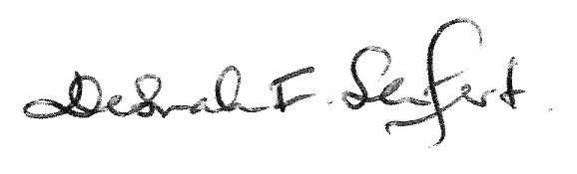

Dr Deborah Seifert
Chief Executive Officer

