Tax Institute Australia 48th South Australian Convention
Speech by Roger Brake

Chart 1. Sources of growth in real national income per person
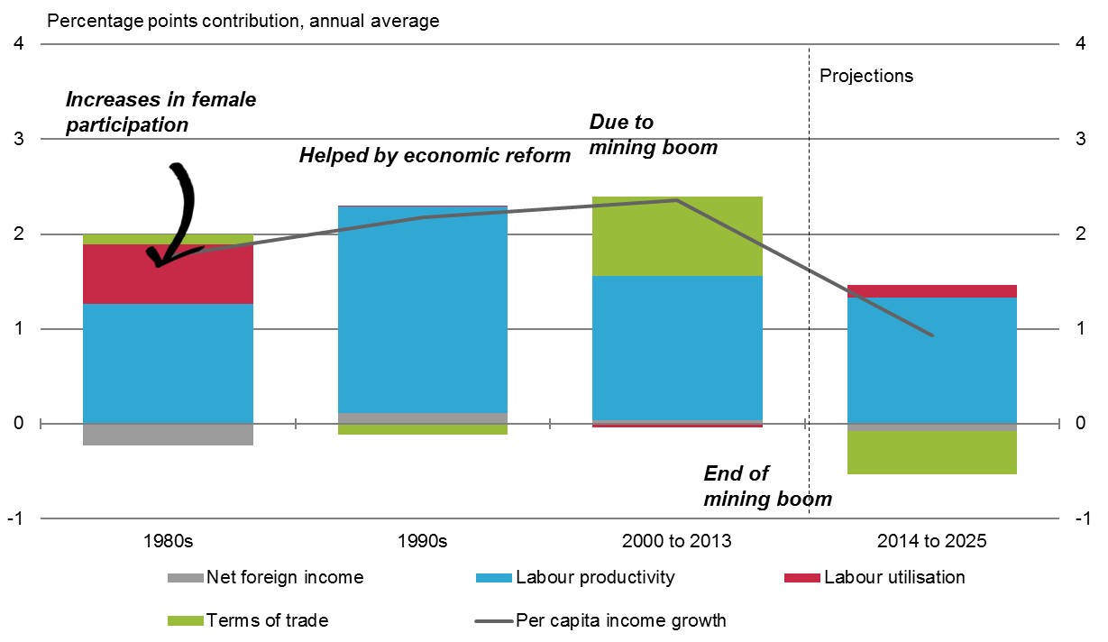
Source: ABS 2015, Australian National Accounts, cat. no. 5206.0, ABS, Canberra and Treasury
This chart shows the contributions to real gross national income per capita annual average growth of net foreign income, labour utilisation, labour productivity and the terms of trade.
Sources of growth in real national income per person
 | Per capita income growth | Labour utilisation | Net foreign income | Terms of trade | Labour productivity | Terms of trade
1960s | 3.0 | 0.6 | 0.0 | 0.0 | 2.2 | 0.0
1970s | 1.4 | -0.3 | 0.0 | -0.1 | 1.9 | -0.1
1980s | 1.7 | 0.6 | -0.2 | 0.1 | 1.2 | 0.1
1990s | 2.1 | 0.0 | 0.1 | -0.1 | 2.1 | -0.1
2000 to 2013 | 2.3 | 0.0 | 0.0 | 0.8 | 1.5 | 0.8
2014 to 2025 | 0.9 | 0.1 | 0.0 | -0.4 | 1.3 | -0.4
2025 to 2055 | 1.4 | 0.0 | 0.0 | 0.0 | 1.5 | 0.0

Chart 2. Component of S&P 500 market value, 1975-2015
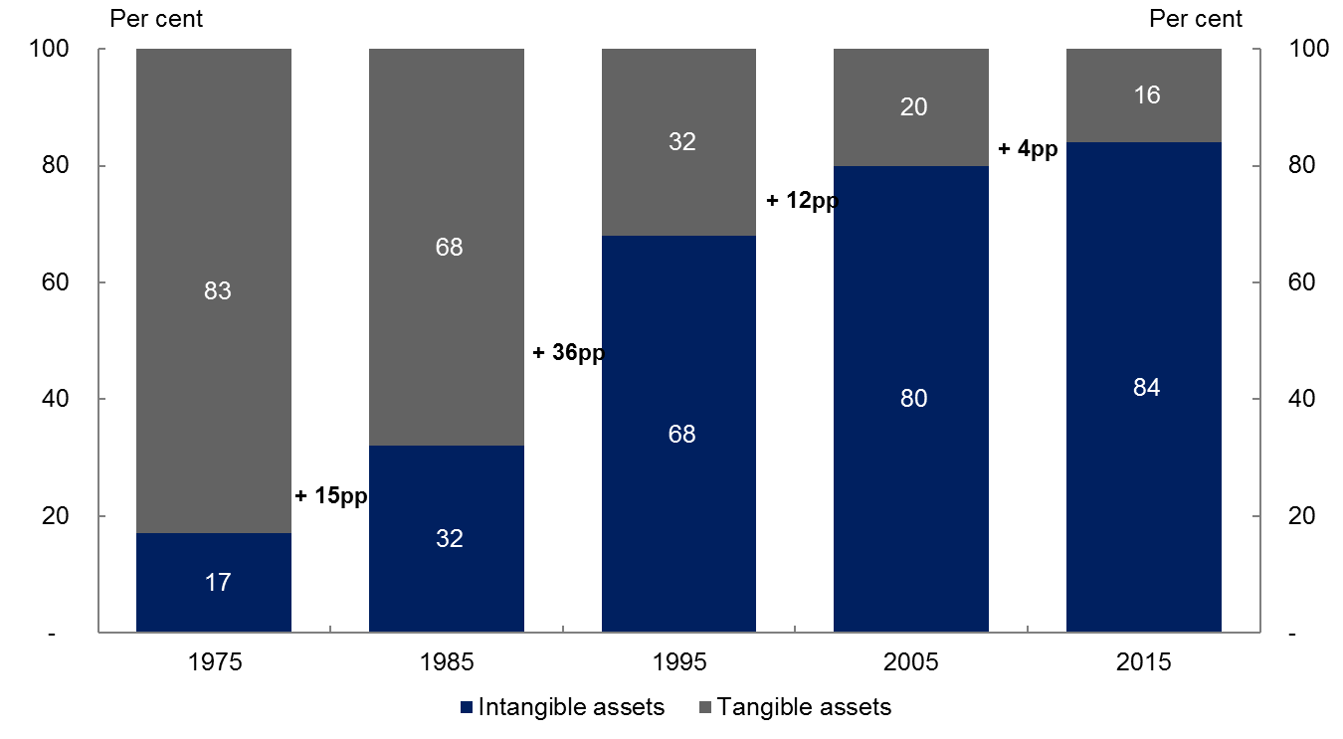
Source: Ocean Tomo 2015.
This chart illustrates that intangible assets have grown from less than a fifth of the market value of the S&P 500 to more than four-fifths.
Components of S&P 500 market value

 | Intangible assets | Tangible assets
1975 | 17 | 83
1985 | 32 | 68
1995 | 68 | 32
2005 | 80 | 20
2015 | 84 | 16

Chart 3. The number of people (aged 15 to 64) per person aged 65+ is decreasing
Source: Intergenerational Report 2015.
This diagram illustrates the decrease in number of people (aged 15 to 64) per person aged 65 or older is decreasing.
The number of people (aged 15 to 64) per person aged 65+ is decreasing
Year | Number of people aged 15 to 64
1975 | 7.3
2015 | 4.5
2055 | 2.7

Chart 4. Bracket creep
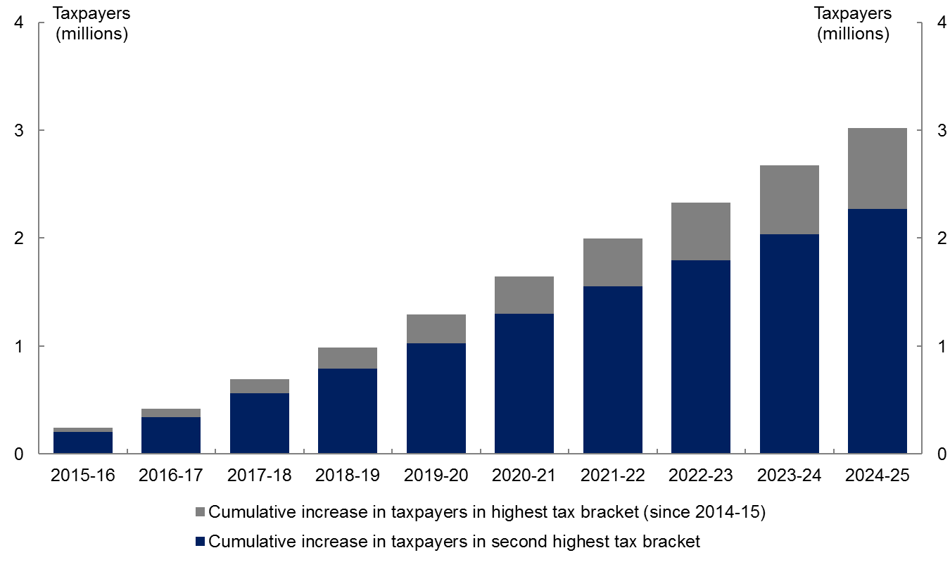
Note: Tax rates exclude Medicare Levy and Temporary Budget Repair Levy.
Source: Treasury estimates
This chart shows the cumulative increase in the number of taxpayers in the highest and second highest tax brackets over the next 10 years, relative to 2014-15.
Estimated cumulative increase in taxpayers in third and fourth tax brackets, relative to 2014-15
 | 2015-16 | 2016-17 | 2017-18 | 2018-19 | 2019-20 | 2020-21 | 2021-22 | 2022-23 | 2023-24 | 2024-25
Cumulative increase in taxpayers in highest tax bracket (45% tax rate) | 43,000 | 79,000 | 133,000 | 195,000 | 263,000 | 348,000 | 441,000 | 535,000 | 639,000 | 751,000
Cumulative increase in taxpayers in second highest tax bracket (37% tax rate) | 202,000 | 338,000 | 562,000 | 792,000 | 1,028,000 | 1,296,000 | 1,553,000 | 1,793,000 | 2,034,000 | 2,268,000

Chart 5. Long-run modelling estimates of the marginal excess burden of some of Australia’s taxes
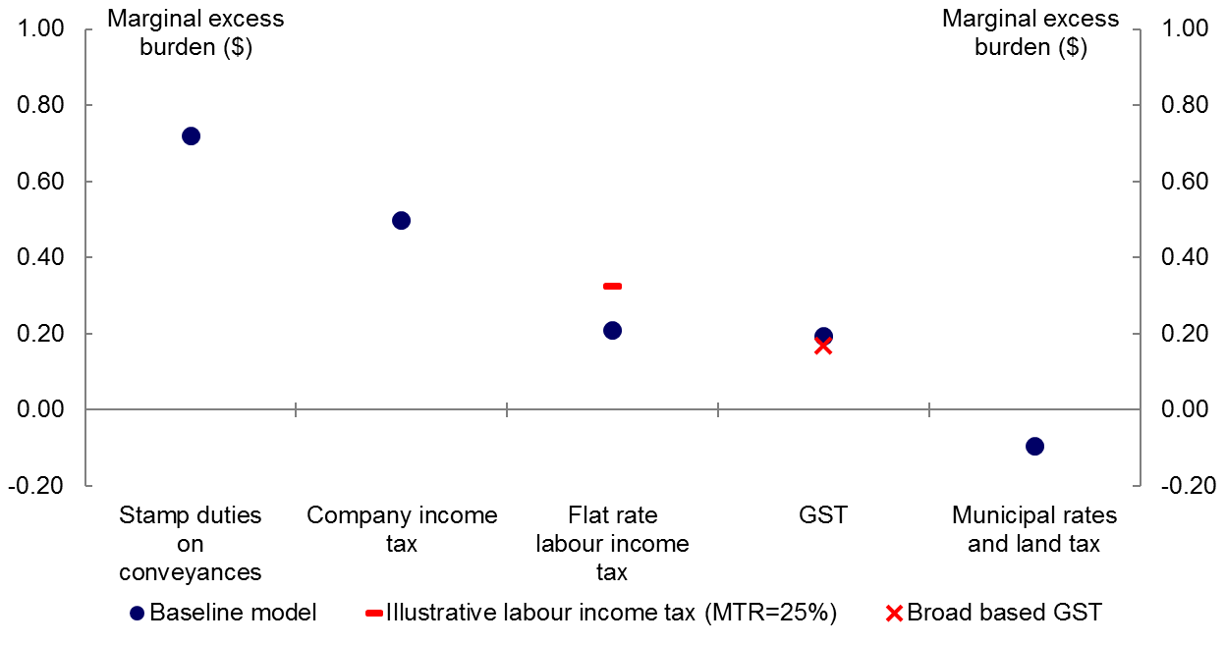
Note: Marginal excess burdens were estimated using a long-run CGE model of the Australian economy and tax system. Australian households are captured as a single economic unit in this model. The labour income tax is modelled as a stylised flat tax on labour income only. An out-of-model calculation for a marginal tax rate (MTR) of 25 per cent is presented as an illustration of an average taxpayer in 2011-12. Transfer payments are not captured in this model.
Source: Treasury estimates.
This chart plots the marginal excess burdens of stamp duties on conveyances, company income tax, flat rate labour income tax, goods and services tax, broad based goods and services tax and municipal rates and land tax, as well as an illustrative marginal excess burden for the progressive labour income tax.
Long-run modelling estimates of the marginal excess burden of some of Australia’s taxes
 | Baseline model | Broad based GST | Illustrative labour income tax (MTR=25%)
Stamp duties on  conveyances | 0.72
Company income tax | 0.50
Flat rate labour income tax | 0.21 |  | 0.32
GST | 0.19 | 0.17
Municipal rates and land tax | -0.10

Chart 6. Major taxes as a share of total taxation, Australia compared to OECD average, 2012
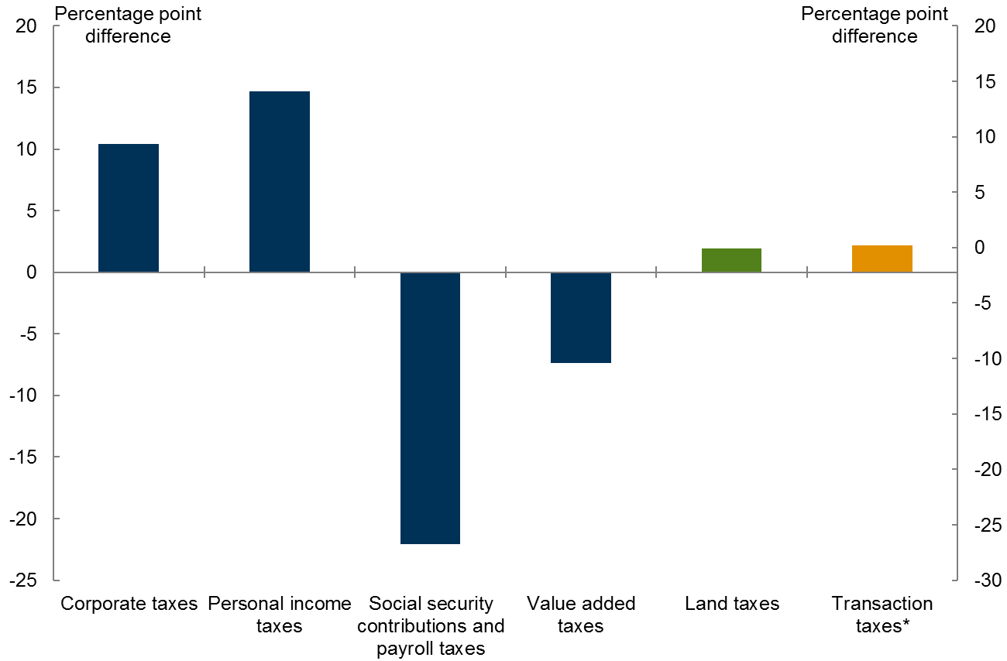
Source: OECD, Revenue Statistics
* Transaction taxes includes both financial and property transaction taxes.
This chart illustrates the difference between the OECD average and Australia of major taxes as a share of total taxation.
Major taxes as a share of total taxation, Australia compared to OECD average, 2012
2012 | Difference between OECD average and Australia (percentage points)
Corporate taxes | 10.4
Personal income taxes | 14.7
Social security contributions and payroll taxes | -22.1
Value added taxes | -7.4
Land taxes | 1.9
Transaction taxes* | 2.2
Payroll  taxes | 4.1
Social security contributions | -26.2

Chart 7. Cash transfer payments and taxes as a percentage of gross income, 2009-10.
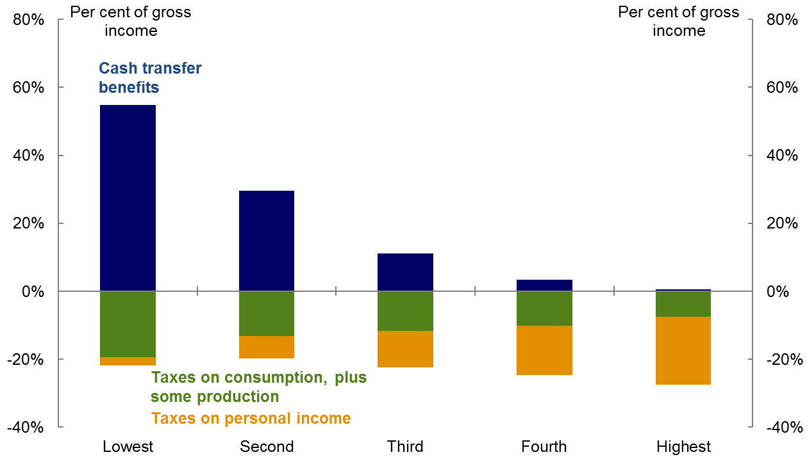
Taxes on income include individuals income tax plus the Medicare levy and Medicare levy surcharge. Taxes on production include taxes payable on goods and services; taxes and duties on imports; and taxes on the ownership or use of land, buildings or other assets used in production or on labour (but not taxes on corporate profits or other business income). Transfer payments and taxes are expressed as a percentage of household gross income, which is before income tax and includes social assistance benefits received in cash. Household quintiles are defined according to equivalised disposable household income.
Source: ABS, Government benefits, taxes and household income, Australia, 2009-10
This chart shows the progressivity of Australia’s tax system.
Cash transfer payments and taxes as a percentage of gross income, 2009-10.
 | Lowest | Second | Third | Fourth | Highest
Social assistance in cash benefits as per cent gross income | 54.8 | 29.5 | 11.2 | 3.3 | 0.6
Taxes on production as percent of gross income | -19.4 | -13.3 | -11.6 | -10.2 | -7.5
Taxes on income as percent of gross income | -2.5 | -6.4 | -10.8 | -14.5 | -20

