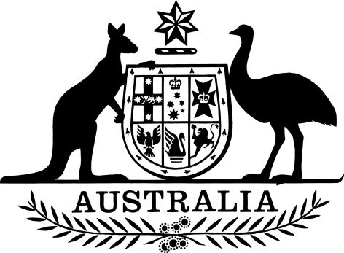
EXPOSURE DRAFT (21/02/2014)

A New Tax System (Australian Business Number) Amendment (Display of Trading Names) Regulation 2014

Select Legislative Instrument No. , 2014
I, Quentin Bryce AC CVO, Governor-General of the Commonwealth of Australia, acting with the advice of the Federal Executive Council, make the following regulation under the A New Tax System (Australian Business Number) Act 1999.
Dated 2014
Quentin Bryce
Governor-General
By Her Excellency’s Command
[DRAFT ONLY—NOT FOR SIGNATURE]
Arthur Sinodinos AO
Assistant Treasurer

Contents
1 Name of regulation 1
2 Commencement 1
3 Authority 1
4 Schedule(s) 1
Schedule 1—Amendments 2
A New Tax System (Australian Business Number) Regulations 1999 2

1 Name of regulation
This regulation is the A New Tax System (Australian Business Number) Amendment (Display of Trading Names) Regulation 2014.

2 Commencement
This regulation commences on the day after it is registered.

3 Authority
This regulation is made under the A New Tax System (Australian Business Number) Act 1999.

4 Schedule(s)
Each instrument that is specified in a Schedule to this instrument is amended or repealed as set out in the applicable items in the Schedule concerned, and any other item in a Schedule to this instrument has effect according to its terms.

Schedule 1—Amendments

A New Tax System (Australian Business Number) Regulations 1999
1 Subregulation 8(2)
Omit “July 2014”, substitute “November 2018”.

