Consumers and the ticket market

Ticket onselling in the Australian market

November 2010

© Commonwealth of Australia 2010
ISBN 978-0-642-74659-7
This work is copyright. Apart from any use as permitted under the Copyright Act 1968, no part may be reproduced by any process without prior written permission from the Commonwealth. Requests and enquiries concerning reproduction and rights should be addressed to the:
Commonwealth Copyright Administration
Attorney-General’s Department
3-5 National Circuit
BARTON ACT 2600

Or posted at:
http://www.ag.gov.au/cca

Mr Colin Neave AM
Chair of CCAAC
 | Telephone: | 03 9613 7300
 | Facsimile: | 03 9613 7345
30 November 2010
Dear Parliamentary Secretary
On 4 December 2009, the former Minister for Competition Policy and Consumer Affairs, the Hon Dr Craig Emerson MP, invited the Commonwealth Consumer Affairs Advisory Council (CCAAC) to examine issues related to the practice of ticket onselling. CCAAC also agreed to conduct the review with assistance from NSW Fair Trading.
The findings of this report have drawn on research and extensive consultation following the release of an Issues Paper. CCAAC invited written submissions from interested stakeholders on the practice of ticket onselling. In addition, NSW Fair Trading developed and launched an online consumer survey to gather consumer views and experiences on ticket scalping, as well as commissioning a NSW Newspoll study with participants selected at random.
Sports, the performing arts and other live entertainment events play an important role in the lives of many Australians. CCAAC found there is a tendency for issues to arise when consumers are unable to access tickets to popular events which often leads to consumer dissatisfaction. This report examines the current ticket market and considers the impact of ticket onselling on consumers.
I offer my thanks to and acknowledge the expertise and commitment of the CCAAC Subgroup in compiling this report. The Subgroup was led by Ms Deborah Healey, together with contributions from other colleagues, as well as assistance from NSW Fair Trading. I also thank those who provided submissions to CCAAC.
I am pleased to enclose a copy of CCAAC’s final report.
Yours sincerely
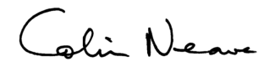
Colin Neave
Chairman, Commonwealth Consumer Affairs Advisory Council.

CCAAC Secretariat
Consumer Policy Framework Unit
The Treasury  PARKES ACT 2600 | Telephone: | 02 6263 2927
The Treasury  PARKES ACT 2600 | Facsimile: | 02 6263 3964

Executive summary
Ticket onselling practices, and particularly ticket scalping, can cause consumers concern, particularly when they miss out on a ticket to an event they want to attend. While this is so, the actions of consumers and developments in technology play a vital role in driving markets, particularly competition and innovation. Effective participation relies on consumers being well informed about markets in which they participate. CCAAC found that it is important to examine the characteristics of the ticket market to understand concerns raised by consumers.
Whilst the broad issue of ticket onselling does not cause significant consumer detriment, CCAAC found that some consumer dissatisfaction can arise from the operation of the ticket market. Consumer concerns about specific issues related to ticket onselling include issues about the transferability of tickets, transparency in ticket allocation and fair access to tickets.
CCAAC recognises that consumer dissatisfaction can be widespread. However, this is often a result of market forces when high demand exceeds limited supply, particularly for popular events, rather than as a direct result of ticket onselling. CCAAC found that technology is a major contributor to tickets being sold out quickly. The internet allows many consumers to purchase tickets concurrently, with an average of three tickets being bought at any one time by each consumer. Resale websites are also used by consumers to onsell unwanted tickets.
Ticket onselling can have positive impacts for both consumers and suppliers. For consumers, the benefits include providing an alternative avenue to access tickets, particularly for popular events, offering convenience and allowing tickets to be transferred. For suppliers, ticket onselling can assist increases in ticket sales, improve crowd attendance and promote publicity for events.
CCAAC considers that the existing consumer protection regulatory framework in Australia, which will be further enhanced by the Australian Consumer Law, is adequate to protect consumers from unfair trading practices. As such, CCAAC believes that industry can respond to the specific consumer concerns.

Findings
Chapter 2
- The level of unauthorised onselling in Australia is low, due to:
  - few sold out events in Australia each year, where sell out events and sell out ticket category or seating type are a precondition for a strong secondary market;
  - the number of onsold tickets for popular events being low compared to the total number of tickets sold; and
  - ticket onselling being less common in Australia than in some other markets, such as the United States and the United Kingdom.
- Technology and in particular the internet is allowing consumers to engage in the practice of ticket onselling.
- Widespread use of the online environment has heightened the visibility of ticket onselling.
- Technology has enabled many tickets to be purchased concurrently, with an average of one to three tickets being bought at any one time by each consumer. This contributes to events being sold out quickly.
- The broad issue of ticket onselling does not cause significant consumer detriment, however, there are concerns about specific issues related to onselling. These include issues such as the transferability of tickets, transparency in ticket allocation and fair access to tickets.

Findings (continued)
Chapter 3
- Onselling can have positive and negative impacts for both consumers and suppliers.
  - For consumers, where onselling is allowed, it provides greater access to tickets, convenience and the ability to transfer tickets. From an economic perspective, onselling allocates tickets to those with the greatest willingness to pay and provides efficiency gains.
  - The negative impacts of ticket onselling for consumers predominately relate to dissatisfaction, particularly about fair access to tickets and a perception that ticket onselling is a problem. This perception has been enhanced by the increased visibility of the secondary market as a result of the internet.
  - Onselling has benefits for suppliers including increased publicity, revenue and attendance at events. Onselling can also reduce the risks for suppliers associated with staging an event.
  - Onselling may impact on suppliers’ reputation and goodwill, lower their returns and undermine certain objectives, such as providing fans with access to affordable tickets.
Chapter 4
- The existing consumer protection regulatory framework in Australia, which will be enhanced by the Australian Consumer Law, is adequate to protect consumers from unfair trading practices in the ticket market.
  - There are issues associated with the enforcement of industry-specific regulation due to the disorganised nature of the secondary market.
Chapter 5
- Industry can respond to specific consumer concerns in relation to ticket transferability, fair access to tickets and transparency of ticket allocations, in a number of ways.
  - These concerns could be addressed through industry action such as primary ticket distribution methods and the transfer of tickets in some situations.
  - A mechanism to address consumer concerns is a voluntary industry led code of practice which encourages participation of all stakeholders to promote industry wide standards to better inform consumers.

Table of contents
Executive summary iv
Findings v
Glossary ix
1 Introduction 1
Context of the review 1
Consumers and the ticket market 2
Structure of the report 5
2 The market 7
The primary market 7
The secondary market 8
The impact of technology 11
The nature of consumer concerns 12
Findings 13
3 Functions of the secondary market 15
Exploring the secondary market 15
The economics of ticket onselling 16
The positive impacts of onselling on consumers 18
The negative impacts of onselling for consumers 20
The positive impacts of onselling for suppliers 25
The negative impacts of onselling for suppliers 27
Findings 28
4 Regulation 29
Australian legislation 29
Overseas legislation 31
Adequacy of current regulation in Australia 33
Findings 35
5 Non-regulatory approaches 37
Transferability, refunds and exchanges 37
Primary distribution methods 40
Pricing strategies 42
Industry code of practice 43
Findings 45
6 Conclusion 47
References 49
Appendices
Appendix A: Terms of reference 53
Appendix B: Consultation process 55
Appendix C: List of submissions 57
Appendix D: Summary of submissions 59
Appendix E: Consumer survey 69
Appendix F: Complaints data 79
Appendix G: The economics of ticket onselling 81
Appendix H: Australian legislation 97
Appendix I: International legislation 105
Appendix J: Non- regulatory approaches 109
Appendix K: CCAAC members and the Review Secretariat 117

Glossary
ACL | Australian Consumer Law
CCAAC | Commonwealth Consumer Affairs Advisory Council
MCCA | Ministerial Council of Consumer Affairs, made up of Ministers responsible for consumer affairs from the Australian, New Zealand and state and territory governments.
TPA | Trade Practices Act 1974

1 Introduction

Context of the review
The NSW Minister for Fair Trading, the Hon Virginia Judge MP, raised consumer concerns about ticket onselling practices at the Ministerial Council on Consumer Affairs (MCCA) meeting on 4 December 2009. MCCA asked the then Minister for Competition Policy and Consumer Affairs, the Hon Dr Craig Emerson MP, to invite the Commonwealth Consumer Affairs Advisory Council (CCAAC) to examine the practice of ticket onselling. CCAAC agreed to conduct the review with the assistance of NSW Fair Trading. CCAAC, under its terms of reference and in consideration of MCCA’s interest in this issue, examined the practice of ticket onselling. This examination explored possible responses including regulatory and non-regulatory options.

Purpose
CCAAC examined ticket onselling practices in the context of consumer protection to determine the impact of these practices on consumers. On 26 May 2010, CCAAC released an Issues Paper, Ticket scalping: Ticket onselling and consumers, which explored the current market for ticket selling and onselling and possible responses which might address any apparent consumer concerns.
Interested parties were invited to comment on the paper and written submissions closed on 23 July 2010. CCAAC received 25 written submissions. CCAAC also conducted a series of targeted consultations and NSW Fair Trading conducted a Roundtable with interested stakeholders. A range of stakeholders contributed to the process, including individual consumers, businesses, academics and consumer agencies.
In addition to the Issues Paper, an online Ticket Scalping Consumer Survey (the online survey) was conducted by NSW Fair Trading to examine consumers’ experiences in relation to ticket onselling. The survey was available to consumers from 30 June 2010 to 31 August 2010. During this period 294 respondents participated in the online survey.
NSW Fair Trading also commissioned a Newspoll Ticket Scalping Study (the study) from
12-14 November 2010. The study interviewed 332 respondents using a random sample selection process in NSW.

Consumers and the ticket market
The ticket selling market has undergone significant change over the past 20 years. As with most goods and services, regulatory reform, more open global markets, the development of new technologies and the growth of consumer services have been agents of change. These changes have increased the need for consumers to have information about product availability and how products are marketed and sold.
New technologies have revolutionized ticket onselling, with online sales often replacing ‘scalpers’ or ‘touts’ outside event venues. Technology provides new and flexible approaches to manage event promotion and ticketing selling. These approaches challenge traditional thinking about ticket onselling as well as providing opportunities to change the usual methods of ticket distribution.
During the last ten years the ticket market has been examined by State and Territory governments and industry bodies. In May 2010, for example, Live Performance Australia (LPA) released a benchmark study on the economic size and scope of the Australian live performance industry. This study reported the industry’s contribution to the economy is in excess of $1 billion. It highlighted the diversity within the industry ranging from ballet and dance to classical music and rock festivals

Defining the problem
CCAAC acknowledges there are challenges for policy makers in detecting and evaluating consumer problems and determining whether consumer detriment requires government action. The Organisation for Economic Co-operation and Development (OECD) Consumer Policy Toolkit, and specifically its Process of consumer policy making has guided CCAAC in considering this issue (see Figure 1). CCAAC has used a number of methods to determine consumer detriment including assessment of complaints data, consumer surveys, independent research and consultation with stakeholders
The Consumer Policy Toolkit defines consumer detriment as a loss in economic welfare if consumers are misled into making purchases of goods and services which they would not otherwise have made or if they pay more for purchases than they would if they had been better informed.
Figure 1: Process of consumer policy making
Source: OECD Consumer Policy Toolkit.

The online survey conducted by NSW Fair Trading highlighted a distinction between consumer detriment and dissatisfaction in the ticket market. Consumer detriment arises when consumers buy onsold tickets which are invalid, for example, when organisers cancel tickets which have been sold in breach of their terms and conditions. While complaints data indicates issues relating to ticketing are limited, consumer detriment, experienced as dissatisfaction with the operation of the ticket market, exists. CCAAC acknowledges that whilst consumer detriment may not be significant in the ticket market, consumer dissatisfaction can arise from the operation of the ticket market. Ticket onselling can be concern for consumers when they are unable to access tickets to a highly sought after event.
The online survey found that consumers who purchase onsold tickets are generally satisfied. However, some survey participants disagree with the practice of ticket onselling. This is consistent with recent studies that note there is a degree of consumer hostility towards ticket onselling.
According to the OECD’s Process of consumer policy making, the nature of the consumer problem needs to be identified as a first step in the consumer policy making process. CCAAC found problems related to ticket onselling are centred on consumer dissatisfaction demonstrated by consumer’s perception of unfairness rather than on significant levels of consumer detriment. Whilst levels of consumer detriment are low, CCAAC is of the view that consumers may experience dissatisfaction and are often frustrated by various issues related to unfairness. These issues include access to tickets and online sales causing tickets to sell out quickly.

Defining ticket onselling
CCAAC found there are a number of terms used to describe and explain ticket selling and onselling. For the purpose of consistency and clarity, the following definitions are used in this report:
- ‘Ticket onselling’ is the practice of selling a previously purchased ticket. Tickets can be on sold with or without the authorisation of the performer or event promoter;
- ‘Authorised onselling’ is the practice of onselling tickets with the authorisation of the performer or promoter. This includes authorised agents, individuals and vendors who onsell tickets in accordance with the terms and conditions outlined on the ticket;
- ‘Unauthorised onselling’ is the practice of onselling tickets without the authorisation of the performer or promoter;
- ‘Opportunistic onselling’ is the unauthorised onselling of a ticket that was originally obtained for personal use; and
- ‘Ticket scalping’ is the unauthorised onselling of tickets, usually at a price higher than the ticket’s original face value, purchased with the intention of making a profit.
Figure 2 summarises the various terms used to describe the ticket onselling market.
Figure 2: Defining ticket onselling
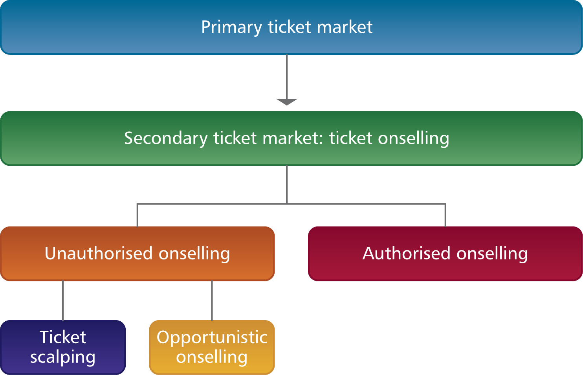

Consumer protection
In Australia, generic consumer protection laws, which include the Trade Practices Act 1974 (TPA) and State and Territory fair trading laws, provide the overarching regulatory framework to protect consumers when they purchase goods and services. Some States and Territories also have specific laws to regulate ticket onselling in certain circumstances. Significant reforms have occurred recently to the TPA. The Australian Consumer Law (ACL) represents the largest reform to Australia’s consumer laws and will take effect on 1 January 2011. It will introduce a single, national law for fair trading and consumer protection, which applies in all jurisdictions, to all sectors of the economy and to all consumers and businesses.

Structure of the report
This report explores a variety of issues relating to ticket onselling. Chapter 2 examines the current ticket market which includes the primary and secondary market. Chapter 3 examines the functions of the secondary ticket market, providing an economic perspective of ticket onselling and its social impacts. Chapter 4 outlines the current regulatory framework in Australia and the regulatory environment in some overseas countries. Chapter 5 details a number of industry led approaches to ticket onselling and the final chapter discusses CCAAC’s findings.

2 The market
The entertainment and sporting events industries form a substantial market in Australia and make up an important part of the economy. In 2007, Australians spent $1.23 billion on close to 19 million tickets for live performances (excluding sporting events). The market for the sale and purchase of tickets to performances, sporting and live entertainment events can be divided into two main categories — the primary ticket market and the secondary ticket market.

The primary market
The primary ticket market is where tickets are originally released for sale. There are various participants in the primary market, including performers (such as actors, musicians and sportspeople), event organisers and producers (such as sporting bodies), event promoters (such as tour companies), venue operators and ticket agencies (such as Ticketmaster, Ticketek and Moshtix).
Ticketek and Ticketmaster are the two largest ticket agencies in Australia, selling tickets to major sporting and live entertainment events, and control a large share of the ticket sales market through exclusive ticketing arrangements with major venues. These exclusive ticketing arrangements are not unique to Australia. For instance, in the United States, Ticketmaster manages a large number of well-known performers (such as Madonna, U2 and Jay-Z), owns most of the amphitheatres and controls many clubs and theatres.
CCAAC found that industry participants have adopted measures in the primary market to prevent unauthorised ticket onselling, such as to maintain goodwill and for financial reasons. These include improving ways tickets are originally marketed and distributed to the public, cancelling onsold tickets and delaying the dispatch of tickets until closer to the event. Ticket selling websites are also monitored to check that purchases are within maximum ticket limits and online auction sites monitored to check for tickets that are being onsold without permission. Despite the use of these methods unauthorised onselling in the secondary ticket market exists in Australia.

The secondary market
Some consumers choose to bypass the primary market to buy tickets in the secondary market. In the secondary market, tickets purchased in the primary market are onsold at a higher price, lower price or at their original face value. To this end, ticket onsellers assume a risk if tickets cannot be onsold or are onsold below the original price.

The characteristics of the secondary market
CCAAC found that ticket onselling is not a major issue for most parts of the industry in Australia. Unlike the UK and US where ticket scalping is prevalent and organised, ticket onselling is less prevalent in Australia. This is due to differences in the size of the market, audience and venues. For instance, ticket resales account for around 20 per cent of all ticket sales in the US, whilst the estimated market share of Australia’s main authorised ticket onseller, Showbiz, is between 5 and 7 per cent of all ticket sales.
High demand for tickets, sell out shows and sell out ticket category or seating type are necessary preconditions for a strong secondary market. Situations such as popular concerts and grand final sporting events attract scalpers. While opera, theatre and ballet tickets are sometimes offered for resale at a premium, this is believed to be relatively rare. In Australia, the number of sold out events each year is low and, given the total number of tickets sold, the proportion of tickets that are successfully scalped is said to be very few. For example, eBay submitted that the 2005 Australia v Uruguay Soccer World Cup qualifier game was a sell out and attended by more than 82,000 people, with the number of tickets resold on eBay estimated to be less than 0.9 per cent of the total number of tickets sold. CCAAC found that ticket onselling is low in Australia given the size of the secondary market and the necessary precondition of having a sell out event.
CCAAC notes that while ticket prices in the secondary market are typically set higher than in the primary market (for example, tickets to the 2010 Australian Football League (AFL) Grand Final were being offered for $1,299 where their face value was $270), there is a difference between the advertised resale price and the actual resale price for a ticket. That is, despite a ticket being advertised for resale at a mark-up of its face value, this may not necessarily represent the final ticket price. There are also instances where the final ticket price is below the face value of the ticket. For example, events at which the average listed price on eBay was below the original ticket price included the November 2008 Britney Spears concert in Sydney, the April 2006 Rolling Stones concert at Sydney’s Telstra Stadium and the third State of Origin Game in Sydney in July 2010.

Participants in the secondary market

Authorised onsellers
CCAAC acknowledges the allocation of tickets, limits on the number of tickets that can be purchased, resale prices for tickets, terms of resale and marketing arrangements are a business decision for promoters and sporting clubs. For example, sporting bodies such as Tennis Australia license a number of authorised onsellers, such as travel companies, to buy and onsell tickets to its tournaments as part of package deals with tickets, travel and accommodation. Ticket packages offer supporters a different experience and an enhanced level of service at events, and can provide a significant revenue stream for promoters and sporting clubs.

Unauthorised onsellers
Technology has given consumers the opportunity to engage in onselling to sell unwanted tickets. CCAAC found that there has been a reduction in the distinction between ‘ticket scalping’ (reselling with the intention to profit) and ‘opportunistic onselling’ (reselling a ticket originally purchased for personal use). People who may appear to be scalpers are often consumers who for one reason or another cannot use a ticket. Statistics provided by eBay found that 78 per cent of ticket sales are consumer-to-consumer sales, involving individuals selling an average of only one to two tickets a year.

Causes of the secondary market
The characteristics of the primary market and the activities of promoters are part of the reasons for the existence of the secondary market. CCAAC considers it is important to explore these reasons in order to better understand the secondary market. Characteristics and activities which contribute to onselling include:
- setting the original price of the ticket below its market value (underpricing), thereby creating profit opportunities for tickets to be resold at a higher price;
- demand for tickets exceeding supply, so that the shortage creates incentives for tickets to be resold at a premium to those who are willing to pay higher prices;
- onsellers having early or priority access to in-demand tickets through pre-sales or priority allocations programs;
- a lack of variation of prices between tickets based on quality, which provides opportunities for tickets to be resold at different prices based on the differences in quality;
- when tickets are released in advance to members or subscribers through pre-sales, thereby encouraging onselling when personal circumstances change and individuals want to offload unwanted tickets; and
- when popular events sell out quickly, which can direct some disappointed fans to the secondary market.

Reasons for underpricing
Event promoters are usually responsible for determining the face value of their tickets. Most authorised ticket agents have no control over ticket prices, although some venues offer tickets at discounted prices closer to the time of the event. Pricing tickets below what the market is willing to support (underpricing) is said to encourage scalping. However, underpricing is not always a result of an inefficient market or a market failure; rather the original price could indicate that promoters are taking into account factors other than demand when setting ticket prices. Consultations with industry revealed that pricing decisions are influenced by a variety of factors and considerations, including the level of demand, the promoter’s revenue model and social objectives. CCAAC found that the common reasons for underpricing include to:
- generate reliable revenue by attracting demand and maximising attendance, with additional revenue from television ratings and sponsorship deals;
- provide fans with access to affordable tickets and value for money;
- remain competitive in price with earlier shows and other similar events;
- guarantee the success of future events by retaining the loyalty of existing fans and creating goodwill amongst consumers;
- encourage fans to spend more inside the venue on merchandise sales, food and drinks and membership sales; and
- minimise risk by ensuring the sale of more tickets.

Sporting events
Evidence from submissions and consultations revealed that some professional sporting clubs choose to underprice to meet a social objective of ensuring their events are accessible to as many people as possible, including grass-roots supporters, families and those who cannot afford to pay market prices for tickets. Not-for-profit sporting associations, such as Tennis Australia and Cricket Australia, undertake extensive analysis to determine what are fair, reasonable and appropriate ticket prices for buyers, and which can generate sufficient revenue to continue staging major sporting events. The National Rugby League (NRL) reported that in setting prices for its grand final tickets, consideration is given to pricing the lowest category tickets at a level that is affordable to supporters, noting that some supporters may wish to attend all four weeks of the Finals Series.
Example: Tennis Australia
For a not-for-profit organisation like Tennis Australia, it is particularly important to generate sufficient revenue to continue staging major sporting events, to continue investing in grass-root activities and to develop current and future elite sport stars. As such it invests a significant amount of time and resources in ensuring that ticket prices are set within ranges that balance out the need to provide access to as many people as possible, whilst also ensuring an appropriate commercial return on investment.

In this respect a number of sporting clubs have implemented measures to reduce unauthorised onselling, for example, by restricting early access to tickets to ‘genuine’ supporters through strict pre-registration requirements or by limiting the maximum number of tickets that can be purchased by any single person.

The impact of technology
During consultations CCAAC found that technology has had a significant impact on the ticket market and provides alternative methods for buying and selling tickets. This is evident in both the primary and secondary ticket markets.
Technology is used by promoters to access a wide customer base. Web-based ticket services have proliferated and online purchases are becoming an increasingly popular form of ticket sale in Australia. The growing popularity of online social networks is also being used directly by performers to sell tickets to fans. For instance, the website ‘Posse.com’, launched in Australia in May 2009, has been used by music artists to enable fans to promote and sell tickets to concerts through social networks. This method of selling has helped artists to keep their promotion costs low and at the same time reward fans with a nominal fee for each ticket they sell.
Technology, and in particular the internet, offers convenience to consumers to purchase tickets from the security of their own home or office. CCAAC found the most compelling evidence to demonstrate the impact of technology on the ticket market is the large number of users who are able to purchase tickets concurrently online, contributing to events being sold out at a much faster rate. For example, between 15,000 and 20,000 concurrent users can be online using the Ticketek website at the same time buying an average of three tickets at any one time.
CCAAC considers the greater transparency associated with the online marketplace also provides consumers with the opportunity to make more informed choices by allowing them to compare prices, types of tickets and sellers. In addition, resale and auction websites provide consumers with the opportunity to buy tickets at lower prices and to enable sellers to offload unsold tickets at the last minute.
As well as offering benefits to consumers, CCAAC found that technology can be used by promoters and sporting clubs to prevent unauthorised onselling if they so choose. Technology enables the primary market to have greater control over the onselling process, including who onsells and for what price. For example, technology has been used to reduce the transferability of tickets (and thereby the incidence of unauthorised onselling) through ‘virtual tickets’.

The nature of consumer concerns
In Australia, onselling practices lack sophistication, with most onsellers using the same technology as consumers and competing with consumers to secure popular tickets. Resale and auction websites have provided a platform for unauthorised onselling to operate and provides a simple mechanism to resell unwanted tickets for consumers. In addition, only a few multiple purchases can be made by a person before the most in demand shows sell out, due to the limited time buyers have to make a purchase and limited number of tickets available.
The internet has not only made it easier for consumers to obtain tickets, but has also made the ticket market visible to consumers. It is CCAAC’s view that this has caused some consumers to experience frustration and contributes to their perception that scalping is a significant concern. This leads to concerns about having ‘fair access’ to tickets. The internet also allows tickets to be offered for resale soon after their general release.
The internet has allowed consumers to know when tickets are available for sale or pre-sale, if events have been sold-out and when tickets are available for resale. In addition, technology has allowed thousands of consumers to log on concurrently to buy tickets which can result in popular events being sold out within a few minutes. For example, tickets to Queensland State of Origin NRL matches can sell out within 40 minutes of going on sale. As technology improves it is likely that transactions will occur at faster speeds.
CCAAC found that the broad issue of ticket onselling does not lead to significant consumer detriment. However, it does lead to consumer dissatisfaction which arises from specific concerns relating to the transferability of tickets, transparency in ticket allocation and fair access to tickets.

Findings
- The level of unauthorised onselling in Australia is low, due to:
  - few sold out events in Australia each year, where sell out events and sell out ticket categories are a precondition for a strong secondary market;
  - the number of onsold tickets for popular events being low compared to the total number of tickets sold; and
  - ticket onselling being less common in Australia than in some other markets, such as the United States and the United Kingdom.
- Technology and in particular the internet is allowing consumers to engage in the practice of ticket onselling.
- Widespread use of the online environment has heightened the visibility of ticket onselling.
- Technology has enabled many tickets to be purchased concurrently, with an average of one to three tickets being bought at any one time by each consumer. This contributes to events being sold out quickly.
- The broad issue of ticket onselling does not cause significant consumer detriment, however, there are concerns about specific issues related to onselling. These include issues such as the transferability of tickets, transparency in ticket allocation and fair access to tickets.

3 Functions of the secondary market
It is CCAAC’s view that the secondary ticket market performs a variety of functions for participants. The ticket market has both positive and negative impacts for participants. An analysis of the market from an economic and social perspective illustrates that actions of participants in the secondary ticket market have an impact both within the ticket market and the wider economy.

Exploring the secondary market
Economic analysis of the secondary market provides insights about the market structure, the effects of underpricing and the economic impact of onsellers participating in the market. From an economic perspective, the functioning of the secondary ticket market can lead to efficiency gains and increase consumer welfare. Appendix G provides a detailed economic analysis of the secondary ticket market.
From a social perspective, the secondary market has both positive and negative impact on consumers and suppliers. Consumers may benefit by being able to participate in the secondary market. However, as evidenced by the online survey undertaken by NSW Fair Trading, some consumer dissatisfaction exists in relation to unauthorised onselling. CCAAC acknowledges that some consumers perceive onselling to be a problem. This perception has been enhanced by the increasing visibility of onselling due to the widespread use of online selling platforms.
Complaints data is one of the indicators of the level of consumer detriment. Complaint levels need to be interpreted in conjunction with other indicators to fully determine the level of detriment in a market. Complaints data about ticket onselling from State and Territory consumer agencies and the Australian Competition and Consumer Commission (ACCC) indicate that the level of reported complaints about ticket onselling is low. The OECD’s Process of consumer policy making states that identifying and measuring the nature and magnitude of consumer detriment is a crucial component of evidence based policy making. It also states that a low level of consumer complaint can be associated with little consumer detriment. For this reason it is important to highlight the distinction between consumer dissatisfaction and consumer detriment and note that most consumer concerns about ticket onselling relate to dissatisfaction rather than detriment.

The economics of ticket onselling
Economic analysis leads to three main observations about the secondary ticket market:
- onselling does not lead to a loss of net economic welfare;
- there may be efficiency gains with allowing onselling to occur; and
- the promotion of competition between onsellers may increase consumer surplus and welfare.
Broadly, these observations show that, from an economic perspective, the secondary ticket market provides benefits to consumers and the wider economy and are discussed below.

Onselling does not lead to a loss of net economic welfare
As discussed in Chapter 2, underpricing can encourage the unauthorised onselling of tickets in the secondary market. When underpricing occurs, the same quantity of tickets will be sold in total, however, some tickets will most likely be sold to different people. The excess demand that is generated by underpricing means that more people are willing to purchase a ticket than there are tickets available. This raises the question: who will receive tickets?
It is likely that some consumers — who without underpricing did not receive tickets — will now do so, displacing some consumers who would have received tickets if underpricing did not occur. In this situation, some consumers are better off, as they now receive tickets, whilst some consumers are worse off, as they will not receive the ticket they would otherwise have received without underpricing.
Underpricing may mean the allocation of tickets is different to the allocation of tickets without underpricing. When this occurs, society is not worse off with onselling (that is, onselling does not lead to a net loss of economic welfare), as onselling reflects a redistribution of welfare among participants in the secondary market and not a loss of welfare. Onselling within the ticket market does not reduce total welfare.
In some circumstances, consumers are better off when onsellers operate, as those who place a greater value on a ticket (reflected by a higher price) will have access to onsold tickets, whilst those who value their tickets at a lower price (and are therefore willing to sell them) may be able to sell their tickets at a profit. These gains are known as ‘gains from trade’. There can be net economic gains for the economy when these ‘gains from trade’ are realised, and these lead to benefits for consumers. Additionally, ticket onselling ensures that tickets go to the consumer who values the ticket the most, which is an added benefit for consumers who have a strong desire to attend an event.

There may be efficiency gains associated with allowing onselling to occur
Generally, underpricing within the market will not initially lead to an economically efficient allocation of resources. This occurs as the arbitrary assignment of ticket holders will generally involve someone holding a ticket who values a ticket less (and economically is willing to pay less for that ticket) than someone who does not hold a ticket.
Where the onselling of tickets is illegal, the ‘gains from trade’ discussed above are prohibited and the allocation of tickets will not be economically efficient. In an efficient market, any consumer who holds a ticket must have a higher willingness and ability to attend an event (and in an economic sense, therefore, have a higher willingness to pay) than any consumer who does not hold a ticket.
If onselling is allowed, the market will generally move towards an efficient outcome, since there will be gains from trade that can be realised after the initial public offering, acting as an incentive to move consumers to an efficient outcome. These gains provide benefits to consumers, known as increasing consumer welfare. CHOICE supports this view, noting that the benefit to consumers of ticket onselling is essentially a proportion of the welfare from trade. Hence, efficiency gains associated with onselling provide benefits to consumers by allocating tickets to those who value them most.
Example: Efficiency gains
Suppose a ticket is purchased by John from an event promoter for $50, when the market equilibrium price is $75 (that is, tickets are underpriced). There is another consumer, Wendy, who does not receive a ticket but is willing to pay $100. If Wendy purchases the ticket from John for any price between $50 and $100; both Wendy and John are better off and gains from trade have been realised — Wendy gets a ticket and John makes a profit.

The promotion of competition between onsellers may increase consumer surplus and welfare
Dead weight loss
When onsellers enter the market they can choose the prices they wish to charge consumers. If onsellers charge every individual their exact willingness to pay they are said to be engaging in perfect price discrimination. If onsellers price discriminate, they can charge different prices to different consumers and thereby extract the greatest amount of profit from them.
If consumers are not aware of the price of other tickets available in the market, then information asymmetry exists and ticket onsellers may be able to charge each consumer exactly the maximum price that they are willing to pay for a ticket, that is, ticket onsellers may be able to perfectly price discriminate. Cricket Australia suggests that onsellers prey on fans who lack knowledge of how many tickets are available and who are authorised sellers.
Example: Price discrimination
If we return to the case of Wendy and John, we know that Wendy will pay any amount up to $100 dollars to obtain a ticket. We also know the equilibrium price in the market is $75. If John knows that Wendy is willing to pay up to $100, then he will charge her exactly $100, maximising his profits and reducing her consumer surplus to zero. This is known as price discrimination.

The occurrence of price discrimination, reflected in some consumers paying a significantly higher price for tickets than their original face value, is often a cause of dissatisfaction. However, ticket onselling can have benefits for consumers, including increasing competition within the secondary ticket market.
If there is increased competition in the secondary market, consumers may become better informed about the true market price as onsellers compete for buyers and may choose to reduce prices. This may reduce the price of tickets until all tickets are being sold at the market clearing price (the equilibrium price). Increasing transparency in the ticket market from online sales platforms is already allowing this to occur. For example, eBay suggests that in 2009, 25 per cent of tickets advertised on its website resulted in no sale at all. By having visible alternatives, consumers looking to purchase tickets in the secondary market can compare tickets available, which may reduce the mark-up on tickets in the secondary market, and so benefit consumers.

The positive impacts of onselling on consumers

Greater access to tickets
Onsellers provide a service by selling tickets to consumers. This transaction is between a willing buyer and a willing seller. Onsellers may be able to obtain highly sought after tickets for events and onsell them to a portion of the public that cannot secure a ticket by other means. For some consumers the option to purchase onsold tickets is better than to miss out on tickets altogether.
The key benefit ticket onselling offers is that consumers who miss out or choose not to purchase tickets in the primary market have the opportunity to obtain tickets later. Where tickets are hard to obtain or have been released to specific groups, such as club members or sponsors, onsellers may access tickets from these groups and offer them to a wider group of consumers. For some consumers, paying a higher price for an onsold ticket is justified because of the convenience, opportunity cost saved and the ability to secure tickets for sold out events or obtain tickets at the last minute.
In addition, if onsellers identify the exact seat that is for sale consumers can secure a preferred seat. When consumers purchase tickets directly from suppliers or promoters, they may have to settle for a preferred class of seat. Hence, where consumers are willing to pay a premium to secure specified seats, onsellers provide a service.
The prices charged by onsellers are often greater than the face value of a ticket to reflect the demand for that ticket. For example, tickets for the second day of the Ashes Test in January 2011 are being offered for $350, where the original sale price is $130. However, in some cases onsellers sell tickets at below their face value, allowing consumers to secure tickets at a cheaper price. In this case, the risk that onsellers assume in purchasing tickets is evident. For example, one eBay ticket reseller stated that he had sold 46 tickets below face value in 2006, 87 in 2007, and 39 in the first 6 months of 2008.

Convenience
Onsold tickets allow consumers to attend events without having to plan in advance. Some consumers wish to purchase onsold tickets to avoid having to wait in line for tickets. This allows consumers to choose between spending time and effort queuing for a ticket (physically, online or over the phone) or purchasing it from an onseller saving them the time and inconvenience of securing tickets themselves. These consumers are willing to pay a premium for this. In this way, ticket onsellers provide a service as time and convenience brokers for those consumers who have a high opportunity cost of time.

Ticket transferability
Whilst some promoters and ticket providers have refund or exchange policies, the inability to obtain a refund or to exchange tickets encourages some consumers to enter into the secondary market to sell unwanted tickets. The secondary market enables ticket holders to sell tickets to events which they can no longer attend, for example, due to illness or unavoidable circumstances. The effect of not being able to onsell a ticket if an individual cannot attend an event is believed to be restrictive. Many submissions believe that property rights attached to ticket ownership should mean that tickets can be transferred or onsold in the same manner as other goods. For example, the Publishers’ Advertising Advisory Bureau submitted that consumers who are unable to attend an event for genuine reasons should have the ability to resell their tickets either where they first purchased the tickets or by other means. CCAAC considers limitations to ticket transfer causes consumers to seek alternate ways to resell unwanted tickets. The internet provides an easy avenue for consumers to participate in the secondary market.

The negative impacts of onselling for consumers
It is important to distinguish between consumer dissatisfaction and detriment in the ticket market. Consumer detriment may take many forms, the effects of which often vary, affecting some consumers more than others. Consumers will incur a loss in economic welfare if they are misled into making purchases of goods and services which they would not otherwise have made or if they pay more for purchases than they would if they had been better informed. These losses are commonly referred to as consumer detriment. Consumer dissatisfaction on the other hand can be described as a situation where a consumer feels displeased or discontent about a transaction, but is not necessarily damaged or harmed. Evidence reviewed by CCAAC found that consumer detriment in the secondary ticket market is low, although there remains some consumer dissatisfaction, and a perception that the secondary ticket market is unfair.

Dissatisfaction

Fair access to tickets
Some consumers perceive that the inflated prices demanded by onsellers, or the shortage of tickets caused by onsellers buying tickets, cause fans to miss out on tickets in the primary market. There is some community expectation of fair access to an event, based on the notion of maintaining accessibility, and that fans, irrespective of their wealth, should equally have the opportunity to attend an event. Onselling means some fans may be unable to attend an event simply because there are no tickets left or because they have been ‘priced out’ of the market. This in turn creates frustration for some consumers, leading to dissatisfaction. Tennis Australia, supports this view, submitting that when onselling occurs, consumers ultimately lose out as prices for events are artificially increased above the prices deliberately set by the event owner or operator.
Some fans believe that tickets should be allocated to those who are prepared to line up (physically, over the phone or online), rather than to those who can afford to pay the most or are well-connected. This would ensure that all spectators, irrespective of wealth, have the opportunity to attend events. This view is supported by Cricket Australia, which believes it is important that all members of the community, particularly grass roots fans, have fair access to cricket. Fans willing to wait in line to see their favourite artist or team perform may become disenchanted, believing that to allocate tickets on a basis other than waiting in line is inherently biased and unfair.
Despite the perception that onselling makes the operation of the ticket market unfair, the onselling of tickets arises because some consumers are willing to pay a higher price for tickets than the price at which they are initially offered for sale. The higher prices paid for tickets reflect the operation of a market economy, which brings demand into line with supply, in a similar way as other high demand goods or services in the economy. It has been suggested that if resale could effectively be shut down there would still be complaints that tickets are hard to obtain in the primary market, as underpricing means there will still be excess demand and there will still be people who are willing to buy tickets at higher prices but are unable to do so. Additionally, during consultation CCAAC found that grass roots fans are able to obtain tickets for many major sporting events by becoming members to a club or association.
Example: Access to tickets
The NRL holds 14000 tickets to the Grand Finals back for sale on the Monday before the game. These are offered to the ticketed members of the two participating clubs first, with any remaining seats sold to the general public.

The limited capacity of event venues means that for popular events there will often be people who would like to attend the event that miss out on tickets. During consultation, CCAAC found that in some circumstances demand for tickets to an event can exceed capacity by up to seven times. The limited nature of such events makes ticket shortage and missing out on tickets an inevitable consequence for consumers. The combination of a limited number of tickets on offer and ticketing distribution methods raises issues of unfair access to events and can result in consumer dissatisfaction. However, CCAAC found that the number of events which fill to capacity in Australia is low, so that demand does not exceed supply for most events.

The perception of onselling
CCAAC found no evidence to support the view that onselling is significant within the ticket market. CCAAC found that the notion of ticket scalpers purchasing large numbers of tickets appears to be a perception in the market, rather than a characteristic. This perception has been fostered by online auction sites, which make the operation of the secondary market much more visible. Developments in website capacity have also allowed consumers to purchase tickets at a much faster rate. When consumers see tickets available for onselling, they assume that it is scalpers who have caused the initial offering to be quickly sold out. CCAAC found that this is due to a high level of demand with many consumers purchasing concurrently, and that the offering of tickets for resale is generally a very small percentage of tickets sold to any given event in Australia.
There is also a perception among some consumers that they should have equal access to tickets. Consumers often feel dissatisfied if they do not believe that tickets are being distributed or obtained in a fair manner. Some consumers lack confidence in the ticket distribution process, wanting to know how onsellers secure their tickets and how they manage to obtain supposedly large numbers of tickets. In instances where it is perceived onsellers are offering large amounts of tickets to sold out events, the level of dissatisfaction can be high. In these circumstances, consumers appear to assume that there must be some form of collusion or corruption amongst sellers, and this reduces confidence in the market.

Transparency in the market
The allocation of tickets to corporate sponsors, officials and clubs may also be a source of consumer dissatisfaction. CHOICE suggests that often the ‘best available’ seats you choose or have been assigned may exclude seats — usually with the best view — that have already been privately allocated by the event promoter as complimentary tickets to corporate sponsors. To this end, consumer satisfaction may be improved if ticketing distribution methods in the primary and secondary markets are more transparent. If consumers are aware of the total number of tickets available for the general public and the number released to corporate and hospitality bodies they may feel more satisfied with the outcome, whether or not they receive tickets themselves.
Greater transparency of the ticket allocation process can improve consumer confidence in the ticket market and avoid situations when dissatisfaction, frustration and disappointment result when fans miss out on tickets to popular events. CHOICE believes the number, proportion and timing of the release of seats should be far more transparent and that consumer confidence can be best promoted by the operation of transparent markets and by correcting any information asymmetries which exist between the consumer and the ticket seller about the ticket. LPA disagrees, stating that the number of tickets released to sponsors, fan clubs and corporate and hospitality bodies is commercially sensitive, and it would not be appropriate for these figures to be revealed.

Profiteering by onsellers
Some consumers feel dissatisfied that unauthorised onsellers are unfairly making profits by buying and selling tickets. They believe that unauthorised onsellers are not adding any value to tickets and are unfairly profiteering.
For example, not-for-profit sporting associations oppose scalping suggesting that onsellers who purchase tickets for the sole purpose of reselling them at a profit prey on genuine fans of the sport. These organisations suggest scalping involves profiteering by individuals who take advantage of their policy of setting affordable ticket prices. However, it has also been submitted that the profit earned on the transaction is compensation for time spent sourcing the ticket, and compensation for bank interest forgone when spending money on tickets, as well as taking the risk of not being able to sell all their tickets. Additionally, promoters and performers have the ability to control the onselling of tickets, to address concerns related to profiteering.

Consumer complaints and the consumer survey
The OECD Consumer Policy Toolkit states that the number of consumer complaints recorded by public bodies or consumer organisations can be used as a sign of a market problem. Data provided to CCAAC by the Australian Competition and Consumer Commission (ACCC) and State and Territory consumer agencies indicates that the level of complaints about ticket onselling is low. The ACCC reports that the number of complaints and enquiries that it receives in relation to ticket onselling are low (both in real and relative terms) and based on anecdotal awareness, not nearly as high as in other countries and in particular within Europe. Ticket sellers also report that they receive few complaints about ticket scalping.
Consumer agencies have received a greater number of enquires about ticket onselling than complaints. These enquires have been focused on the legality of scalping, highlighting that the consumers who complain are more likely to express their dissatisfaction with the practice of scalping rather than reporting specific detriment. This finding is further supported by data gathered as part of the online survey. The online survey asked about consumers’ experiences in relation to ticket onselling, with 294 respondents participating in the online survey. Although the survey is limited by the number of participants and the fact that they selected themselves, it does highlight consumer views in relation to onselling. Forty-five per cent of those surveyed had purchased a ticket from a scalper or onseller. Of these consumers, the survey found that 92 per cent of respondents who had purchased a ticket from a scalper or onseller had not faced any problems with their tickets. This suggests that consumers who purchase onsold tickets are generally satisfied with their purchase, providing further evidence that detriment in the market is low.
The survey results also found that 55 per cent of respondents had not purchased a ticket from a scalper or onseller. Of these consumers, 65 per cent said that they would never buy a ticket from a scalper or onseller, with the main reason given that the respondent does not agree with scalping. This result suggests that it is more likely that some consumers are dissatisfied with the market due to their beliefs and values.

Detriment

Authenticity
Purchasing tickets from an unauthorised onseller can expose the purchaser to the risk of fraud. Consumer detriment arises if a consumer purchases a ticket that is invalid or counterfeit. The authenticity of a ticket can be hard to establish as it can be difficult to identify if the ticket is real and whether a consumer is purchasing from an authorised onseller, such as a licensed ticket broker, or an unauthorised onseller. Creative Festival Entertainment suggests that when someone purchases a ticket in the secondary market, they have no way of recognising if the ticket is legitimate until they have paid for the ticket and it is presented at the gate. Further Cricket Australia reports that a number of consumers who have come to Cricket Australia to check the legitimacy of websites run by resellers, or complained to Cricket Australia about the prices charged for tickets, not understanding that there is no connection between the operator of the site and Cricket Australia. However, as seen by the level of consumer complaints it does not appear that counterfeiting is prevalent within the Australian secondary market. According to eBay, the actual incidence of counterfeit tickets being listed for sale on ‘eBay.com.au’ is practically non-existent.
Example: Internet scam
Police in Sydney are investigating what appears to be an internet scam that targeted fans who wanted to attend the 2010 NRL Grand Final. Fans and supporters were left without tickets outside the ANZ Stadium after purchasing them online and receiving emails promising them seats to watch the final, which were never received. Allegedly the tickets were purchased online at TicketFinders.com.au. The police say around 100 people may have been victims of the scam.

Cancellation
Some promoters cancel tickets that have been on sold without their consent, or in contravention of the conditions of sale. For example, where an onseller identifies the exact seat for sale when onselling online, promoters can use this information to cancel the ticket. In this situation, consumer detriment can arise, as the consumer may not be aware that the onselling of a ticket is prohibited by the terms and conditions of the ticket. Live Performance Australia (LPA) provides anecdotal evidence that consumers have limited understanding of the risks and rights in purchasing tickets from unauthorised sources. Additionally, LPA notes that the industry’s most effective weapon against scalping at the moment is the cancellation of tickets purchased from an unauthorised source. However, LPA submits that this punishes consumers who may or may not appreciate the difference between authorised and unauthorised sellers, and does little to punish the ‘scalper’.
Additionally, some online sites inform purchasers of the laws and regulations that may apply to their transaction when consumers are purchasing tickets. For example, when purchasing a ticket on eBay, interstitial (interim/pop-up) pages during the bidding/ buying and selling transactional flows inform members about safe trading, items that might be prohibited and transaction risks.
An issue raised by various submissions is event cancellation because original ticket purchasers are generally entitled to a refund of their purchase price. Since refunds are usually provided directly to the original purchaser, the consumer who purchases an onsold ticket may not receive the refund from an onseller. Creative Entertainment Australia notes that such a refund is often made directly to the original purchaser’s bank account or credit card. In this case, the unauthorised onseller not only receives a refund of the original purchase price for the ticket but also retains the profits from onselling that ticket.

The positive impacts of onselling for suppliers

Increased attendance, publicity and revenue
The practice of ticket onselling benefits promoters by increasing attendance when onsellers actively promote events and sell tickets that otherwise would have gone unused. Onsellers also help promoters connect with consumers who are hard to reach or attract. Authorised onsellers can provide a useful function by maximising a promoter or producer’s revenue and opening up distribution strategies and routes which would not otherwise be available. The existence of the secondary market at the least provides a mechanism for tickets that may have been unused to be resold.
A higher level of attendance at an event also increases the revenue derived from the sale of products, such as merchandise, food and beverages. Increased sponsorship associated with events that have greater levels of attendance may also increase total revenue. The collateral benefits of having a large and enthusiastic crowd flows through to areas such as sponsor satisfaction, merchandise sales, providing a great television spectacle and growing sustainable long-term supporters of the game.
Television rights to events with larger crowds are worth more. Higher attendance creates positive publicity and heightens the sense of demand and excitement leading up to the event. Additionally, consumers enjoy the experience of seeing a live performance or event if there is a larger crowd. Revenue may also be increased by authorised onsellers who sell tickets with the full approval of the event promoter. Authorised onsellers are significant investors in the entertainment industry, including sourcing and developing event sponsorship and negotiating marketing support with major events and tourism bodies.

Reduction of risk
Onsellers benefit event organisers and ticket vendors by providing an avenue for them to resell tickets. Promoters can trade off charging lower ticket prices (underpricing) to ensure a certain level of revenue against the increased risk of higher priced tickets. This transfers a degree of risk to onsellers, who take the risk of not being able to sell all their tickets, with a limited time when tickets are of any value and losses if a show does not sell well. Onsold tickets may be sold for higher or lower than their original face value or at the original face value, and the onseller may or may not have made a profit in the sale. The secondary market for ticket sales appears to penalise sellers who set prices well above predicted prices by reducing the probability that they will find buyers for their tickets.

Direct engagement with the secondary market
Performers and promoters benefit from onselling by capitalising on the secondary market. One way that promoters can deter ticket onsellers from competing for revenue is to compete against them in the secondary market. This includes encouraging authorised onselling by allowing nominated secondary agents to enter the secondary market. Promoters benefit by competing in the secondary market themselves, and recouping revenue from resales. For example, many US states have repealed their unauthorised selling of tickets laws as promoters and teams lobby to capture for themselves the ticket resale market. Although this is not a significant feature of the Australian market at this time, with increasing technology it may be in the future.
Example: Engagement in the secondary market
In the US, according to the Wall Street Journal, Neil Diamond himself sold large batches of tickets to his August 2009 concert at premium prices through Ticketmaster’s ‘resale’ site. Ticketmaster’s senior vice president for legal affairs said that selling premium priced tickets on TicketExchange, priced and similar to resales by fans, is a practice used by many other top performers.

Another example of artists taking advantage of the promotion of tickets and events by market participants is the website ‘Posse.com’. The site encourages fans to promote and sell tickets to live performances on social networking sites. Although this is not a form of onselling, the intention of the website is effectively to engage those who would usually be involved in the secondary market to help promote events.
Example
Posse.com encourages individuals to promote bands and gigs to their friends. Members sign up to Posse.com, which creates a unique link for promoting events. This link takes a member’s friends directly to the official ticket retailer (for example, Ticketmaster). When a friend purchases a ticket the member earns a commission which can later be redeemed for cash or exchanged for merchandise.

The negative impacts of onselling for suppliers

Reputation and goodwill
Performers and clubs recognise the need to protect their long-term image, and can suffer negative publicity when onselling inflates ticket prices. Creative Festival Entertainment believes onsellers effectively undermine the goodwill of artists and entrepreneurs. Performers have an interest in maximising the attendance of their fans and generating the kind of experience that is an important part of an event.
Tennis Australia suggests that it invests a significant amount of time and resources in ensuring that ticket prices are set within ranges that balance out the need to provide access to as many people as possible, whilst also ensuring an appropriate commercial return on investment. Where fans believe they are prevented from attending events as a result of being priced out of the market by onsellers the goodwill of the promoter is affected. Additionally, where tickets have been cancelled for being onsold in breach of terms and conditions, a consumer may feel illwill towards the promoter who cancels the ticket. Live Performance Australia states confidence in e-commerce may be eroded when tickets obtained from an unauthorised source are cancelled.

Lower returns
When onsellers purchase tickets which have been deliberately underpriced it can undermine the ticketing objectives of promoters. This can mean that the returns anticipated by deliberately choosing to underprice, such as providing fans with access to affordable tickets and remaining competitive in price with other events, are not received by suppliers.
Additionally, any returns from onselling flow beyond those who bear the risk with organising and participating in the event. To this end, some event promoters have sought to prevent the onselling and/or transfer of tickets to others by including conditions of sale on tickets and using distribution practices. Such conditions may include prohibiting ticket holders from onselling the ticket at a price higher than its original face value and refusing admission to bearers where this has occurred. The enforceability of such conditions, however, may be an issue in terms of the costs and practicality of tracing onsold tickets and enforcing conditions.

Findings
- Onselling can have positive and negative impacts for both consumers and suppliers.
  - For consumers, where onselling is allowed, it provides greater access to tickets, convenience and the ability to transfer tickets. From an economic perspective, onselling allocates tickets to those with the greatest willingness to pay and provides efficiency gains.
  - The negative impacts of ticket onselling for consumers predominately relate to dissatisfaction, particularly about fair access to tickets and a perception that ticket onselling is a problem. This perception has been enhanced by the increased visibility of the secondary market as a result of the internet.
  - Onselling has benefits for suppliers including increased publicity, revenue and attendance at events. Onselling can also reduce the risks for suppliers associated with staging an event.
  - Onselling may impact on suppliers’ reputation and goodwill, lower their returns and undermine certain objectives, such as providing fans with access to affordable tickets.

4 Regulation

Australian legislation
There is no national anti-scalping legislation that prohibits the unauthorised onselling of tickets in Australia. Generic consumer protection laws apply in all jurisdictions to the supply of all goods, including the sale of tickets. In addition to these generic protection laws, some States have specific legislation in place to manage the sale of tickets in certain circumstances.

Generic consumer protection laws
Nationally, the Trade Practices Act 1974 (TPA) contains generic consumer protection laws that create standards of business conduct and prohibit suppliers from engaging in unfair trade practices. This includes protecting consumers from misleading and deceptive conduct and false representations, and providing statutory warranties in consumer transactions. The Australian Competition and Consumer Commission (ACCC) is an independent statutory authority responsible for administering and enforcing the TPA.
Similar protections also exist in the fair trading and sale of goods laws in the States and Territories, which the State and Territory offices of fair trading are responsible for administering and enforcing in their respective jurisdictions.

The Australian Consumer Law
The Australian Consumer Law (ACL) is a single, national consumer law that harmonises the consumer protection provisions of the TPA and in the various State and Territory fair trading and sale of goods laws. The Productivity Commission (PC) in its 2008 Review of the Australian Consumer Policy Framework estimated that its consumer policy reforms package (which the ACL is a key part of) could provide benefits to the Australian community of between $1.5 billion and $4.5 billion a year.
The ACL will commence from 1 January 2011 and will apply nationally as a law of the Commonwealth and a law of each State and Territory. For the first time, under the ACL all consumers will enjoy the same protections against unfair trade practices wherever they are in Australia, and businesses will be subject to the same obligations regardless of where they operate.
The ACL contains the following protections for consumers:
- it prohibits sellers from engaging in false, misleading or deceptive conduct — for example, it will be unlawful for a seller to make a false, misleading or deceptive statement about the price, value or quality of a ticket they are selling;
- it provides statutory guarantees for purchases of goods and services — for example, a seller will be required to guarantee they will supply a ticket with reasonable care and skill, they have they have a right to sell the ticket and that the ticket will be fit for purpose, free from defects and match its description;
- it prevents the inclusion of unfair terms into standard form consumer contracts — many tickets are standard form consumer contracts. If a ticket contains a term which:
  - causes a significant imbalance in the parties’ rights and obligation under the contract;
  - is not necessary to protect the legitimate interests of the party who would be advantaged by the term; and
  - would cause detriment to a party if it were to be applied or relied on;
then the term may be considered ‘unfair’;
- it requires sellers to prominently display the total amount payable for a purchase as a single figure price, including any additional fees, charges or taxes (such as delivery fees, handling charges, postage costs, credit card surcharges);
- it requires a seller who supplies a good or service to a consumer of a total price of $75 or more to provide proof of transaction as soon a practical after the goods are supplied.
The ACL will be supported by industry-specific regulations (such as existing state-specific legislation on ticket onselling) where appropriate and will not automatically replace these regulations.

State-specific legislation
In addition to the generic consumer laws that exist in all jurisdictions, some States have specific laws to regulate activities at certain events or at certain venues which includes monitoring the sale of tickets to these events or at these venues. Some States believe under certain circumstances there is a need for state specific legislation to address onselling.
Presently, Victoria has event-specific legislation to regulate the staging of certain major sporting events in the state, such as AFL Grand Final games. Queensland, South Australia and NSW all have venue-specific legislation which covers the selling of tickets near or within certain venues, such as at select Stadiums Queensland venues and the Sydney Cricket Ground.
The Coalition of Major Professional and Participation Sports (COMPPS) submitted that a fragmented consumer protection legislative framework currently exists in Australia, particularly in relation to ticket selling. COMPPS noted that as events are often conducted in more than one jurisdiction, the lack of nationally consistent regulation can make enforcement difficult and complex when there are varying legislative requirements and different regulatory bodies involved. To this end, CCAAC considers the ACL will assist to relieve many of these concerns.

Overseas legislation
There have been a variety of overseas regulatory responses to ticket scalping. Some of these are outlined below.

The United States of America
Resale laws, policies and practices are generally decided at the state level in the US. There is no federal anti-scalping legislation in the US, although some states have adopted different approaches to address ticket onselling.
In the US, resale laws vary from state to state. Current state-based legislation ranges from prohibiting the practice of scalping or limiting the resale price, to licensing participation in the secondary market. However, currently the majority of US states do not have laws in place to limit the value placed on the resale amount of tickets or laws that limit where and how these tickets should be sold.

Trend towards deregulation
Over the last 20 years the legislative landscape for ticket onselling in the US has changed with a general trend to reduce or remove legislation which prevents ticket onselling. Many states have abolished or relaxed their anti-scalping regulations, and scalping is now legal in 45 states. For instance, many states have been repealing legislation that capped the price to resell tickets, including New York, Illinois, Florida, Louisiana and Minnesota.
With the growing trend towards deregulation, ticket onselling services and websites have increased in popularity in the US. A large secondary market for tickets now operates mainly through websites such as eBay, StubHub, Tickets.com, Craigslist and TicketsNow. Many individuals who would have waited outside the venue or on street corners to scalp tickets, now resell tickets online.
Evidence from the US does not suggest that legislation has been effective in eliminating the practice or improving consumer access to tickets. Rather the evidence suggests that the legislation had an inflationary effect on the face value of tickets in jurisdictions where reselling is restricted or prohibited.
Case-study: deregulation in New York
Until recently, New York had a cap on the resale price of tickets of 4 per cent above the face value for venues with more than 6,000 seats, and 25 per cent above the face value for smaller venues. In 2007, New York repealed its price cap legislation. Ticket conditions restricting the resale price and method of resale were also prohibited.
In its Report on Ticket Reselling and Article 25 of the Arts & Cultural Affairs Law (February 2010), the New York Department of State suggested that restricting or capping ticket prices in the secondary market has not proven to be effective at ensuring genuine fans can access tickets in the first place or to limit the existence of secondary ticket markets.
In July 2010, Article 25 of the New York Arts & Cultural Affairs Law was amended to specifically prohibit venue operators from restricting the resale of ticket in certain situations. For instance, Article 25.30.1 prohibits any operator of a place of entertainment (or their agent) to:
- restrict the resale of tickets included in a subscription season ticket package as a condition of purchase or as part of the package agreement;
- deny access to a ticketholder who possess a resold subscription or season ticket; or
- use a paperless ticket that does not allow the ticketholder to transfer the ticket at any price, at any time, without additional fees and without the operator’s permission.
The following reasons have been behind the progressive de-regulation in New York:
- in the internet era the price cap law was rarely obeyed, with internet sites setting up in other jurisdictions to evade anti-scalping laws;
- enforcing the price cap was not a high priority for police, whose focus was on more serious crime;
- an increase in the number of legal resellers would increase competition and prices for the consumer would fall; and
- realising that a multi-billion dollar market was being left untapped, a growing number of sporting teams, theatres and promoters had begun entering the secondary ticket market themselves.

New Zealand
New Zealand does not have generic legislation that prohibits or restricts the unauthorized onselling of tickets. However, it does have an industry-specific law, the Major Event Management Act 2007, which manages declared major events, including prohibiting the resale of tickets for a premium. The World Rowing Championships 2010 and the Rugby World Cup 2011 are two events that have been declared under this Act. The NZ Ministry of Consumer Affairs does not have evidence of many complaints from consumers about unauthorized onselling.

United Kingdom
In the UK, the resale of football tickets is illegal under the Criminal Justice and Public Order Act 1994, unless the resale has been authorized by the organizer of the match.
In February 2010, the UK Government decided not to regulate the secondary market following a three month consultation on whether the resale of tickets to certain major national sporting events should be banned. Instead, the UK Government decided to allow online resale sites, such as ‘Seatwave’ and ‘Viagogo’ to regulate themselves. This followed a report commissioned by the House of Commons in January 2008 which did not call for new regulations for the secondary ticket market and believed that the free market for tickets should remain without government interference, except as a last resort.

European Union
The European Commission has developed a directive on the protection of consumers in respect of distance contracts, setting out legislative obligations in European Union member states and in the European Economic Area. Some of these obligations apply to the sale of goods online, over the phone, via email or by mobile phone.

Adequacy of current regulation in Australia
CCAAC believes that the existing regulatory framework in Australia, made up of generic consumer protection laws and supported by enhanced protections under the ACL, is adequate to protect consumers from unfair trading practices in relation to ticket onselling. Based on the finding that ticket onselling does not cause significant consumer detriment in Australia, CCAAC considers that specific regulation of the ticket industry would not be justified. Regulation would impose administrative burdens on industry associated with monitoring purchase and sale activities and tracing and cancelling tickets, which industry submits, based on existing evidence, would be disproportionate to the size of the problem seeking to be addressed. The PC has noted that some overlaps between industry specific regulation and generic consumer laws can be overly prescriptive.
CCAAC found there is insufficient evidence that a market or regulatory failure exists to warrant further legislative intervention. The low level of registered complaints to consumer agencies is one indication that consumers are not experiencing significant detriment in Australia in relation to ticket onselling. Where a concern with buying an onsold ticket is the risk that it is invalid or a counterfeit, eBay has submitted that the actual incidence of counterfeit ticket being listed for sale on its Australian website is practically non-existent, and insufficient to warrant regulatory intervention. Additionally, there is a general trend internationally, to reduce or remove legislation which prevents ticket onselling.
The OECD’s Process of consumer policy making states that there needs to be evidence that consumer detriment is significant to warrant government action. With strong economic incentives, positive social impacts, new technologies and changing attitudes, the traditional thinking about ‘ticket scalping’ is becoming less relevant. Many stakeholders recognise that in some cases there are genuine reasons for individuals to onsell their ticket if they are unable to attend. There is little stakeholder support for monitoring through government regulation, believing that tickets should not be treated differently to other goods and should not be subject to specific regulation. CHOICE considered that there was currently no strong case for government intervention through regulation.

Enforcement issues
Research and consultations reveal a common view that regulation of the secondary market would be difficult to enforce, particularly where the transaction takes place away from the venue, such as online. For instance, difficulties in enforcement can arise due to the constantly changing nature of technology and the disorganised nature of ticket onselling (often engaged in by individuals). CCAAC agrees with the view that regulation should not be extended if it cannot be effectively enforced.
The ACCC noted that there would be a number of factors that would impact on effectiveness of legislation or self-regulation in this area. In both cases, there would be significant challenges in addressing conduct of short term or ad-hoc sellers in comparison with established industry participants.
In addition, technology, and in particular the internet, can make it easier for unauthorised onsellers to avoid local regulations by setting up websites or selling tickets in other jurisdictions to evade local anti-scalping laws. According to CHOICE, given the inventiveness of some scalpers, it is likely that they will manage to get around any legislation since at the heart of the problem is unfulfilled demand. It was also submitted that overseas experiences indicate that attempts to regulate the secondary ticket market have not been effective in reducing scalping and protecting consumers’ interests, which is why many US jurisdictions are moving towards deregulation.

Findings
- The existing consumer protection regulatory framework in Australia, which will be enhanced by the Australian Consumer Law, is adequate to protect consumers from unfair trading practices in the ticket market.
  - There are issues associated with the enforcement of industry specific regulation due to the disorganised nature of the secondary market.

5 Non-regulatory approaches
CCAAC notes that industry is best placed to address issues which arise in the secondary ticket market. Whilst CCAAC believes that the broad issue of ticket onselling has positive and negative impacts for consumers and suppliers, it currently does not cause a significant level of consumer detriment. However, if the broad issue of onselling does, in the future, lead to consumer detriment industry can use mechanisms to prevent onselling. CCAAC recognises that industry has the ability to respond to specific concerns raised by some consumers about unauthorised onselling, such as the transferability of tickets, transparency of ticket allocations and fair access to tickets. Industry can and does use a variety of mechanisms to address these concerns which are outlined below.

Transferability, refunds and exchanges
A ticket itself confers on the ticketholder a right of entry to a venue for a specific duration. The ticket may be subject to certain terms and conditions of sale. For instance, a ticket may contain the conditions of entry (such as late arrivals, the use of cameras and audio equipment and replacement fees), the promoter’s refund or exchange policy, and conditions in relation to resale. Most ticket providers have an arrangement in place for the distribution of tickets to events at certain venues, and most tickets sold to these events are subject to similar terms and conditions. For example, as part of the condition for sale for a Ticketek ticket, the ticketholder may be denied admission if the ticket has been resold at a premium and without prior written consent.
It is CCAAC’s view that the inability to transfer tickets or to obtain a refund provides incentives for consumers to participate in the secondary market to resell unwanted tickets. Consumer concerns have been raised about unfairness associated with this issue. Allowing refunds and exchanges, in certain cases, can help to reduce the incidence of unauthorised onselling. Different sectors of the primary market have adopted different approaches to this issue.
Examples: Ticket exchanges
- Moshtix provides a ticket exchange service that enables ticketholders to transfer tickets by providing the full name and date of birth of the person who will be attending the event in their place, before Moshtix will reissue the ticket.
- Some arts companies allow their tickets to be exchanged to another performance in the same season for free or for a small fee.

Submissions state that tickets should be freely tradeable commodities in the secondary market to allow consumers maximum flexibility when disposing of unwanted tickets and acquiring tickets. Submissions also believe that individuals should be entitled to do whatever they want with a purchased ticket including transferring it to another person. This argument is common where consumers take considerable risk in buying tickets ahead of time, but for unexpected reasons (such as illness or work commitments) are unable to use the ticket and wish to recover some costs. Preventing a ticketholder from getting a refund or transferring their ticket to someone else in all situations is considered to be unduly restrictive. Where refunds or transfers are not permitted, the purchaser who is unable to use the ticket suffers a loss.
CCAAC found most major sporting bodies recognise this view and have sought to address this concern about transferability. For example, during the second week of the finals, the NRL provides grand final ticketholders with a window in which they are able to obtain a full refund for their tickets (less the booking fee). Similarly, the AFL provides refunds subject to certain conditions. The Coalition of Major Professional and Participation Sports (COMPPS) accepts onselling in certain circumstances where the ticket is onsold at face value or through an authorised onseller or approved onselling facility.
CCAAC also notes that some major ticket providers have recently offered ticket insurance to ticketholders where they can obtain a refund, in certain circumstances, at an additional cost.
Example: Ticket insurance
Ticketek and Ticketmaster offer ticketholders the option of buying ticket insurance where individuals can get a refund of the costs of the ticket and transaction fees if they are unable to attend the event due to a range of circumstances which include illness, injury, accident, transport delay or adverse weather events. The cost of the insurance is on a sliding scale based on the face value of the ticket.

Incentives for promoters and ticket providers to offer refunds and exchanges include relieving consumer dissatisfaction, promoting good customer relations and encouraging greater consumer confidence in the ticketing process. Not including strict terms and conditions on ticket transferability would assist ticket providers to ensure they comply with existing legal obligations under the Trade Practices Act 1974 (TPA). These may include the unfair contract terms law (for instance, by ensuring that ticket terms are not unfair and that ticket conditions are set out in a clear, legible and comprehensible manner), the prohibition against engaging in anti-competitive conduct through exclusive dealing by restricting the resupply of goods or services, and the prohibition against false, misleading and deceptive conduct.
On the other hand, some submissions noted that a distinguishing factor between tickets and other consumer goods is that a ticket itself is evidence of a contract between the original seller and the original purchaser so that rights and obligations arising under it cannot be transferred.
It was also submitted that administering a refund process and ensuring compliance with the refund conditions can be timely, cumbersome and expensive. LPA submitted that a promoter’s position on ticket refunds, exchanges and transferability and their terms and conditions, should be left for each individual promoter to decide, as they are the bearer of the greatest risk.
CCAAC recognises that a risk for ticket sellers associated with offering a refund is the uncertainty with not being able to resell the returned ticket for its original value as the value of the ticket diminishes closer to the date of the event. There is considerable investment in organising an event and promoting the sale of tickets. The inability to resell returned tickets and the resulting loss in revenue could affect the business model of the promoter and ticket agent, which in turn could lead to higher ticket prices to offset the costs associated with providing refunds. However, CCAAC believes in cases of sold out events, the inability to transfer tickets can raise concerns of unfairness amongst some consumers since the risk to promoters and ticket providers holding unsold tickets would be minimal.
CCAAC considers that increasing consumer awareness about the terms and conditions on the transferability of tickets would assist ticketholders to understand any conditions that may exist in relation to onselling, such as cancellation and refusing entry. Greater consumer awareness was supported by stakeholders during the consultations. Where a condition of sale in relation to reselling has been breached, the ticketholder may be denied entry. Similarly, where a ticketholder is unable to use their ticket, the individual may just assume they are not entitled to a refund or exchange, whereas the ticket’s terms and conditions may provide otherwise. To this end, CCAAC believes that consumer detriment and dissatisfaction can be reduced by informing consumers about the terms and conditions, including any conditions on reselling and the promoter’s refund or exchange policy.

Primary distribution methods
Participants in the primary market choose the way tickets are originally distributed and sold. This choice involves consideration of various objectives, with the method chosen to take these into account. CCAAC found that some of the distribution strategies used in the primary market can indirectly encourage onselling in the secondary market. Modifying primary distribution strategies can help address issues associated with unauthorised onselling, subject to the various objectives and considerations of individual promoters. CCAAC found that there are a range of existing industry initiatives being used by some ticket providers to address specific concerns related to unauthorised onselling.
Examples
- Moshtix has implemented a number of measures to prevent ticket onselling, including:
  - limiting paper ticket delivery;
  - collecting the name and date of birth of attendees at time of purchase, printing these details on the tickets and verifying them at point of entry with scanning equipment;
  - limiting the number of tickets purchased per transaction
  - using the Moshtix resale facility to manage the transfer of tickets;
  - checking its booking database regularly for suspicious purchase behaviour that is commonly practiced by scalpers;
  - performing random checks and spot checks for ticketholders’ ID; and
  - cancelling tickets on discovery of a resale attempt not in accordance with a Moshtix supported process.
- Cricket Australia has taken measures to reduce the incidence of scalping, for instance, by providing fans exclusive access to early tickets, reducing ticket limits to prevent large volume of tickets being acquired and resold, and delaying the release of tickets to reduce the chances of reselling.

CCAAC acknowledges that while the promoter is usually responsible for setting ticket prices and limits on the number of tickets per buyer, in some cases the promoter is unable to choose the ticket distribution method due to contractual arrangements between its ticket agent and the venue. Public confidence in the ticketing system can be undermined when priority allocations are made. This can raise concerns amongst some consumers as they assume that there is an unequal and unfair allocation of tickets. According to CHOICE, the manner, proportion and timing of the tickets released should be far more transparent and the operation of transparent markets can promote consumer confidence.
Technology can be used by promoters and sporting clubs to prevent unauthorised onselling if they so choose. Live Performance Australia (LPA) supports the use of technology and other non-regulatory strategies to reduce ticket onselling. Similarly, major professional sporting bodies generally welcome advances in technology which provide different ways of issuing tickets to control admission to events. Consultations found that technology will continue to assist in reducing ticket onselling and that future advances in technology will eventually enable solutions to eliminate the practice completely. For example, a new entrant into the primary ticket market, ‘Foxtix’, believes it can improve customer service as well as minimise ticket scalping by using the benefits of innovative technology.
Appendix J outlines other distribution methods being used by industry participants to reduce unauthorised onselling and to address specific concerns raised by consumers.

Pricing strategies
The original ticket price is commonly said to encourage unauthorised onselling in the secondary market, with underpricing and the lack of dynamic pricing arguably creating profit opportunities for scalpers. Prices in the primary market are often set below market clearing levels (underpriced), do not vary over time and have few price levels.
CCAAC recognises that pricing decisions in the primary market are often subject to a variety of considerations which includes the promoter’s revenue model and social objectives, such as providing affordable tickets to the general public. One way to reduce resale activity is for the primary market to adopt price variations. Adopting more sophisticated pricing strategies in the primary market based on buyers’ willingness to pay, combined with improved distribution methods, could help address consumer concerns in relation to fair access.

Market clearing prices
CCAAC found some promoters acknowledge that tickets may be onsold due to pricing issues and that price adjustment might discourage this. Performers and promoters could adopt the same economic philosophy behind the secondary ticket market and set prices according to market forces, so that ticket prices match consumers’ willingness to pay. COMPPS acknowledges that if promoters charge the highest price which the market can bear, it not only helps to maximise revenue but could also deter scalpers from entering the secondary market by reducing their profit margins. However, CCAAC notes that embracing the higher market value could have the undesired effect of preventing some fans from buying affordable tickets. It could also undermine a social objective for some promoters of trying to keep events, such as major sporting events, affordable for as many Australians as possible.

Dynamic pricing
Promoters and ticket providers often sell tickets with different qualities and different experiences, for example, different seats, venues, cities and dates. Tickets to the same event can be sold at different prices where they have different product qualities. A dynamic pricing model, where prices are based on market forces and ticket quality, could reduce profit opportunities for unauthorised onselling. Dynamic pricing for tickets is said to be possible since each ticket offers a different experience, has a different level of demand and therefore has a different value attached to it, to enable tickets to be priced differently. For example, the NRL and the AFL engage in dynamic pricing to some degree by selling tickets at different prices for different seat categories (for example, ticket prices vary for general admission, member seating and corporate boxes).
However, dynamic pricing has the potential to undermine the social considerations of promoters by reducing the availability of affordable tickets to the general public and interfering with the ability to target certain audience demographics through ticket pricing. It is argued that dynamic pricing is untenable because of the demographic audience profile for some events (such as a younger audience to music festivals), the lack of adequate differentials between tickets (for instance, where only general admission or standing room tickets are available) and audience budget constraints (commonly found in youth and sporting events).

Industry code of practice
CCAAC believes a useful mechanism to address specific consumer concerns could be through a voluntary industry code of practice. This mechanism could encourage best practice ticket selling methods, respond to unauthorised onselling concerns, promote greater consumer awareness of the market and set industry wide standards for consumer protection. CCAAC found a number of stakeholders are in favour of a voluntary industry code covering all forms of ticket selling. CHOICE supports consideration of a code as part of a package of measures to improve the functioning of both the primary and secondary markets.
In the interest of national consistency, CCAAC believes there is merit in considering the development of an industry wide voluntary code of practice to apply to all platforms of ticket sales and to all event types, to provide consumers with clear and consistent information. Information can help empower consumers to make more informed purchasing decisions, promote greater consumer confidence in the ticket market and avoid situations of consumer dissatisfaction with the ticketing process. A voluntary code could be developed by peak industry bodies and key stakeholders. CCAAC acknowledges that any industry code would need to be flexible to take into account the variations existing between different sectors of the industry (for instance, between performing arts and sporting events). Matters worth exploring for inclusion within a voluntary code include guidance on possible terms and conditions on ticket transferability, procedures for dealing with identified incidents of unauthorised onselling, methods for distributing tickets, protocols for releasing tickets early, and encouraging greater transparency of the ticket allocation process.
In addition, there is support for developing an endorsement symbol for code signatories to indicate ticket authenticity to consumers. Publicly recognised industry accreditation to help consumers differentiate between authorised and unauthorised ticket sellers could also be considered.

Existing codes
The Codes of Practice developed by LPA and the UK Society of Ticket Agents and Retailers (STAR) provide useful examples for developing a voluntary industry code for ticket selling. In Australia, a number of industry participants believe the LPA Code provides a good starting point as a basis for industry wide code. There is evidence that many LPA members refer to the LPA Code as an industry standard and have a link to the Code on their websites.
The comprehensive nature of the UK STAR Code can be attributed to the particular structure of the secondary ticket market in the UK, which closely mirrors that of the US market. The UK market is comparably larger in size and value to the Australian market making the types of issues which the UK Code seeks to address different to those present in the Australian market.

Compliance issues
The very nature of a voluntary code is that it necessarily relies on industry self-regulation to encourage compliance. Given the usually informal and disorganised nature of unauthorised onsellers, CCAAC recognises it is debatable how effective compliance with a code can be in the secondary market.
Although the LPA Code is useful, its effectiveness to combat ticket scalping is said to be limited. LPA acknowledges that it has been difficult to enforce the Code and that monitoring compliance remains a challenge. Targeted consultations found that as the LPA Code only applies to members, it can be a source of frustration to members when competitors who are non-LPA members fail to observe the Code standards. In addition, major professional sporting events are not currently covered by the LPA Code since it applies only to the live entertainment and performing arts industry.

Findings
- Industry can respond to specific consumer concerns in relation to ticket transferability, fair access to tickets and transparency of ticket allocations, in a number of ways.
  - These concerns could be addressed through industry action such as primary ticket distribution methods and the transfer of tickets in some situations.
  - A mechanism to address consumer concerns is a voluntary industry led code of practice which encourages participation of all stakeholders to promote industry wide standards to better inform consumers.

6 Conclusion
Under its terms of reference, CCAAC was required to examine the practice of ticket onselling and explore possible responses. CCAAC was guided by the OECD Consumer Policy Toolkit, and specifically it’s Process of consumer policy making in assessing the level of consumer detriment. The Consumer Policy Toolkit defines consumer detriment as a loss in economic welfare if consumers are misled into making purchases of goods and services which they would not otherwise have made or if they pay more for purchases than they would if they had been better informed.
A number of methods have been used to determine consumer detriment including assessment of complaints data, consumer surveys, independent research and consultation with stakeholders. CCAAC acknowledges that whilst consumer detriment may not be significant in the ticket market, consumer dissatisfaction can arise from the ticket market’s operation.
CCAAC found that the level of unauthorised onselling in Australia is low. This is due to the fact that sell out events and sell out ticket categories are a precondition for a strong secondary market and there are few sold out events in Australian each year. Additionally, the number of onsold tickets for popular events is low compared to the total number of tickets sold. CCAAC is of the view that ticket onselling is less common in the Australian market than some other markets, such as the United States and the United Kingdom. CCAAC found there has been a reduction in the distinction between the practices of ticket scalping and opportunistic onselling as technology, and in particular the internet, enables consumers to onsell unwanted tickets.
CCAAC, having examined the evidence, found that ticket scalpers in Australia are not particularly sophisticated in their use of technology, often competing with consumers to obtain tickets. CCAAC found the widespread use of the online environment has heightened the visibility of ticket onselling leading to a perception amongst consumers that ticket onselling is a problem. Technology has made it easier for many tickets to be purchased concurrently with an average of three tickets being bought at any one time by each consumer. This contributes to events being sold out at a faster rate and the perception that onsellers obtain large amounts of tickets to onsell. Technology has also assisted promoters in addressing unauthorised onselling issues and will continue to do so in the future.
CCAAC found that the broad issue of ticket onselling does not cause significant consumer detriment, however, there are concerns about specific issues related to onselling. These include concerns in relation to the transferability of tickets, transparency in ticket allocation and fair access to tickets. These consumer concerns can contribute to a perception that ticket onselling is unfair. CCAAC recognises that consumers are dissatisfied when they do not receive tickets. CCAAC found that this is often not a result of ticket onselling but simply high demand and limited supply, especially for popular events.
Consultations revealed that the activities of the primary market, such as primary distribution methods and pricing strategies, can contribute to the occurrence of unauthorised onselling. However, CCAAC recognises that there are a number of considerations which industry takes into account when setting pricing and selling tickets.
Evidence suggests that the secondary market can have positive impacts for both consumers and industry. For consumers, the benefits of ticket onselling include providing an alternative avenue to access tickets (particularly for popular events), convenience and the ability to transfer tickets. While CCAAC recognises that unauthorised onselling may have some adverse impacts for ticket suppliers including lower returns and potential damage to reputation and goodwill, ticket onselling can also assist increases in ticket sales, improve crowd attendance and promote publicity for events.
In addition, ticket onsellers can minimise the risk for promoters when staging events and holding unused tickets. From an economic perspective, ticket onselling is a sign of a well functioning market where tickets are allocated to consumers with the greatest willingness to pay. Ticket onselling provides efficiency gains for both consumers and ticket suppliers.
CCAAC considers that the generic consumer protection laws are adequate in protecting consumers against unfair trading practices in the ticket market, including in the secondary market, and notes that the introduction of the Australian Consumer Law will enhance these protections. Additionally, CCAAAC notes that there are issues associated with enforcement of industry-specific regulation due to the disorganised nature of the secondary market.
Finally, CCAAC notes that industry is best placed to address issues which arise in the secondary ticket market. CCAAC considers that industry can respond to specific consumer concerns associated with unauthorised onselling, such as ticket transferability, fair access to tickets and transparency of ticket allocations. A mechanism to address these concerns is a voluntary industry led code of practice suitable to all stakeholders. This would assist them to adopt consistent standards across the ticket market in relation to consumer concerns. This approach would offer support to consumers through effective information leading to an increase in participation to the variety of events in this dynamic market.

References
ABC News, ‘Footy fans fleeced in online ticket scam’, 5 October 2010. Available at http://www.abc.net.au/news/stories/201010/05/3029942.htm (accessed 5 November 2010).
Associated Press, ‘Internet sales prompt move to ease scalping restrictions’, 31 May 2007, sports.espn.go.com/espn/news/story?id=2887957.
Australian Bureau of Statistics 2009, Arts & Culture in Australia: A Statistical overview, available at http://www.abs.gov.au/AUSSTATS/abs@.nsf/0/9B40CE66B0322300CA2576550013FA7D?opendocument.
BBC News, ‘Glastonbury tickets snapped up’, 1 April 200. Available at: http://news.bbc.co.uk/1/hi/entertainment/6511115.stm (accessed 25 May 2010).
Branch Jnr, A ‘Secondary ticket market in UK gets a boost’, Ticket News, 10 January 2010. Available at: http://www.ticketnews.com/news/Secondary-Ticket-Market-in-UK018100 (Accessed 12 November 2010).
CHOICE, ‘Ticketing – exposing hidden costs’, last updated 30 March 2009, Available at: http://www.choice.com.au/Reviews-and-Tests/Money/Shopping-and-Legal/Shopping/Ticketing-hidden-costs/Page/Introduction.aspx (accessed 1 October 2010).
Cianfrone, B ‘Legal issues associated with ticket scalping’, Smart Online Journal, Fall 2004, Vol.1 (1), pp.20-25.
Consumer Policy Toolkit, 2010, Organisation for Economic Co-operation and Development.
Courty, P 2003, ‘Some Economics of Ticket Resale’, Journal of Economic Perspectives Vol 17 No 2, pp 85-97.
Courty, P 2000, ‘An economic guide to ticket pricing in the entertainment industry’, Recherches Economiques – Louvian Economic Review 66(1).
Depken, CA 2006 ‘Another look at anti-scalping laws: Theory and evidence’, Public Choice Vol 130, pp 55-77.
Elfenbein, DW ‘Do anti-scalping laws make a difference online? Evidence from internet sales of NFL tickets’, June 2006, available at http://papers/ssrn.com/sol3/papers.cfm?abstract_id=595682 .
Gans, J, King, S, Stonecash, R and Mankiw, NG 2009, Principles of Economics (4th Edition), Cengage Learning Australia, pp 64, 71, 129, 135,146, 147, 330, 517.
Garner, B 2004, Black’s Law Dictionary Eighth Edition, United States of America.
Grech, J ‘Selling tickets to posse of online pals offers returns’, Daily Telegraph, 7 September 2010.
Griggs, L ‘Ticket scalping – its legal and economic effects on the illusion of perfect innocence’, (2006) Griffith Law Review, Vol 15 No 2, p 299.
Hamacher, A, ‘Secondary ticket market escapes UK crackdown’, EU Ticket News, 17 February 2010. Available at: http://www.euticketnews.com/20100217342/secondary-ticket-market-escapes-uk-crackdown.html (Accessed 12 November 2010)
Happel, SK, and Jennings, MM 1995, ‘The folly of anti-scalping laws’, the Cato Journal Vol 15 No 1.
Harrington, DE 2009, ‘Lessons from a Scalper’, Regulation Spring 2009, pp 16-29.
Isidore, C ‘In defence of $10,000 Super Bowl tickets’, CNNMoney.com, 31 January 2007.
Klein, N ‘Fuming fans left outside’, The Daily Telegraph, 4 October 2010.
Leslie, P and Sorensen, A, 2009 The welfare effects of ticket resale, Stanford University.
Leslie, P. personal communication, 2 September 2010.
Live Performance Australia, 2006, Ticket Scalping Discussion Paper, Victoria.
Live Performance Australia (LPA), May 2010, Size & Scope of the live entertainment industry.
Mehta, S ‘Ticket resellers: a butt in every seat’, CNNMoney.com, 4 February 2009.
Nelson, C ‘Ticketmaster Auction Will Let Highest Bidder Set Concert Prices’, The New York Times, 1 September 2003. Available at: http://www.nytimes.com/2003/09/01/technology/01TICK.html?ex=1377748800&en=6c7bd8e0e69ad367&ei=5007&partner=USERLAND (accessed 27 September 2010).
New York Department of State, Report on Ticket Reselling and Article 25 of the Arts & Cultural Affairs Law, 2010. Available at http://www.betterticketing.com/articles/Ticeket_Reseller_Report.pdf.
Office of Best Practice Regulation, available at: http://www.finance.gov.au/obpr/proposal/index.html.
Organisation for Economic Co-operation and Development, 2010, Consumer Policy Toolkit.
PerthNow, ‘Foxtix to take on major event ticketing duopoly’, 18 October 2010. Available at http://www.perthnow.com.au/business/foxtix-to-take-on-major-event-ticketing-duopoly/story-e6frg2qc-1225940033093 (accessed 5 November 2010).
Productivity Commission, Review of the Australian Consumer Policy Framework, Final Report, 2008, available at http://www.pc.gov.au/projects/inquiry/consumer/docs/finalreport.
Seabrook, J 2009, ‘The price of a ticket’, The New Yorker.
Simonson, R 2007, ‘Tickets Gone Wild: Broadway Braces Itself as NY Contemplates Deregulating Scalping’, available at: www.playbill.com/features/article/107425-Tickets-Gone-Wild-Broadway-Braces-Itself-as-NY-Contemplates-Deregulating-Scalping.
Smith, E 2009, ’Going “paperless” to thwart scalpers’ The Wall Street Journal viewed at http://online.wsj.com/article/SB124441789931592507.html.
Smith, E 2009, ’Concert Tickets Get Set Aside, Marked Up by Artists, Managers’ The Wall Street Journal p 1.
Sports and Recreation Victoria, Controlling ticket scalping and improving major event ticketing practices, Discussion Paper, July 2001, available at: http://fulltext.ausport.gov.au/fulltext/2001/vic/scalpingfinalpaper.pdf.
Sport and Recreation, Victoria 2001, Controlling Ticket Scalping and Improving Major Event Ticketing Practices, A Discussion Paper, Victoria.
Sydney Morning Herald, ‘Wiseguy four accused of $30m scalping op’, 21 September 2010. Available at http://www.smh.com.au/world/wiseguy-four-accused-of-30m-scalping-op-20100928-15uuv.html (accessed 5 November 2010).
Taylor, J and Frost, L 2009 Microecomonics (4th Edition), John Wiley & Sons Australia, p 106.
http://ec.europa.eu/consumers/cons_int/safe_shop/dist_sell/index_en.htm (accessed 28 October 2010).
‘EU cracks down on online sales of concert, sports tickets’, 17 September 2010. Available at http://www.euractiv.com/en/food/eu-cracks-down-online-sales-concert-sports-tickets-news-497873 (accessed 28 October 2010).
http://ec.europa.eu/consumers/enforcement/sweep/online_ticket_sales/index_en.htm (accessed 28 October 2010).
‘2012 Olympic Officials to Create Secondary Ticket Marketplace – face value resale only’, 24 October 2010. Available at http://www.euticketnews.com/ (accessed 28 October 2010).
http://www.telegraph.co.uk/sport/othersports/olympics/london2012/7496313/London-2012-Olympics-8m-tickets-available-to-public-says-Locog.html (accessed 28 October 2010).

Appendix A: Terms of reference
CCAAC agreed to conduct the review with the assistance of NSW Fair Trading. CCAAC, under its terms of reference and having regard to MCCA’s interest in this issue, will examine the practice of ticket scalping and possible responses including, if any, legislative options and their cost and effectiveness.
CCAAC will consider:
- whether there is consumer detriment and, if so, the level of detriment posed by ticket onselling practices;
- the views of stakeholders affected by ticket onselling practices, including consumer groups, ticketing organisations, auction/reselling websites, and peak sporting and live entertainment bodies;
- actions currently undertaken by industry that seek to limit ticket purchasing by scalpers for re-sale;
- the identification of any non-regulatory options that could address any harmful practices arising from ticket onselling practices;
- the effectiveness of consumer information to address any consumer detriment associated with ticket onselling practices;
- the effectiveness of current legislation related to ticket onselling practices;
- the impact of technology on ticket onselling practices; and
- the effectiveness of international approaches that address any consumer detriment related to ticket onselling and the appropriateness of these approaches for the Australian marketplace.

Appendix B: Consultation process
CCAAC, under its terms of reference, examined the issue of ticket onselling in the primary and secondary ticket markets. An Issues Paper, titled Ticket scalping: Ticket onselling and consumers, was released for public comment on 31 May 2010. Submissions closed on 23 July 2010. Submissions were received from a range of stakeholders. A total of 25 submissions were received; of these five were confidential.
Written non-confidential submissions are available on the Treasury website at www.treasury.gov.au. For a list of all stakeholder submissions refer to Appendix C.
In addition, a series of targeted consultations were undertaken based on the submissions, led by CCAAC member Ms Deborah Healey. A panel met stakeholders on 6 October 2010 in Sydney and 13 October 2010 in Melbourne, with additional discussions held via teleconference. NSW Fair Trading also conducted a roundtable consultation on 17 November 2010. A list of participants in the targeted consultations is set out below.
Participant | Date
Sydney (face-to-face)
Ticketek | 6 October 2010
Moshtix | 6 October 2010
National Rugby League (NRL) | 6 October 2010
eBay | 6 October 2010
CHOICE | 6 October 2010
Melbourne (face-to-face)
Australian Football league (AFL) | 13 October 2010
Showbiz International | 13 October 2010
Creative Festival Entertainment | 13 October 2010
Teleconferences
Live Performance Australia | 8 October 2010
Australian Competition and Consumer Commission (ACCC) | 18 October 2010
NSW Fair Trading Roundtable consultation
Ticketek | 17 November 2010
Ticketmaster | 17 November 2010
Foxtix | 17 November 2010
eBay | 17 November 2010
Cricket Australia | 17 November 2010
Showbiz International | 17 November 2010
Tennis Australia | 17 November 2010
Acer Arena | 17 November 2010
CHOICE | 17 November 2010
Live Performance Australia | 17 November 2010
Coalition of Major Professional and Participation Sports | 17 November 2010

Appendix C: List of submissions
Stakeholder submissions
Mr Andrew Kfoury
Mr Vince Dore
Mr Lynden Griggs, University of Tasmania
Ms Sally Freeman
Publishers’ Advertising Advisory Bureau
New Zealand Government — Ministry of Consumer Affairs
Showbiz International
Tennis Australia
Ticketek (Confidential)
Ebay Power Seller (Confidential)
Live Performance Australia (LPA)
eBay seller (Confidential)
Fairfax Media (Confidential)
ticketguy (eBay seller)
Cricket Australia
Grace
Moshtix
Mr Denis West
Creative Entertainment Pty Ltd
CHOICE
Ms Debbie Cox
Coalition of Major Professional and Participation Sports (COMPPS)
eBay
eBay (confidential)
Mr John Le Mare

Appendix D: Summary of submissions
Submission | Key Points
1. Mr Andrew Kfoury | Ticket onselling is a common practice, and has been so for many years. Once consumers have purchased their ticket from an authorised establishment they own that ticket and should have the right to do whatever they want with their ticket. The consumer has no right of refund once they have purchased the ticket, so why can’t they sell them? The affect of not being able to sell their ticket if for whatever reason they cannot attend that function is restrictive. Any harmful practice arising from onselling is due to the restrictions placed on onselling. Remove these restrictions and consumers will then openly buy and sell their tickets.
2. Mr Vince Dore | A simple solution to the large scalping of tickets at some popular events would be to regulate online auctions via legislation to only allow for the on sale at no more than the face value of the ticket. Those legitimate purchasers who can no longer attend would be happy to obtain a price close to that paid and this will ensure wholesale scalping is reduced.
3. Mr Lynden Griggs | Revised his previous position (in Ticket scalping — its legal and economic effects on the illusion of perfect innocence' (2006) that legislation was needed to respond to the public's perception of the unfairness of ticket scalping.  Provided the example of the AFL grand final where corporate hospitality packages have circumvented Vic legislation, where package prices are in excess of their market value.  Believes ticket distribution processes have been used to legalise organised corporate scalping, and although consumers suffer with sold out tickets, this is not a total welfare loss. Less concerned with opportunistic onselling by individuals with no deliberate intent to profit. The costs associated with regulation are often hidden and believes there is no strong evidence or clear justification that regulation would benefit the public or a section of it at the present time.  Allow conditions to be placed on tickets, refunds and reselling, provided they do not breach unfair contract terms law. Consumers should be given full details of the arrangements surrounding the purchase of tickets. Self-regulation in the primary market, like a voluntary code, should be the starting point. Code could require disclosure to the public and explore ticket allocation methods. Not convinced an industry ombudsman is needed. Difficult for a code to operate in the secondary market unless it is mandatory (akin to licensed bookmakers). Public education campaigns should also be explored.
4. Ms Sally Freeman | No issues with ticket reselling. Would rather have option to purchase tickets at a premium than miss out. Believes ticket resellers should have the ability to charge higher prices, due to effort, time, risk — some tickets sell for cheaper than face value. Believes that in house auctions held by promoters and bands are worse than ticket reselling.
5. Publishers’ Advertising Advisory Bureau | PAAB is an association of Australia's major newspaper and magazine publishers. It believes that individuals unable to attend events for genuine reasons should be able to resell their tickets. Conditions on tickets which prevent this leave consumers feeling dissatisfied and out of pocket. Sector specific legislation is welcomed, like in Qld (Major Sports Facilities Act 2001).
6. New Zealand Government | NZ does not have any general legislation that restricts or prevents unauthorised ticket onselling, or ticket scalping.  An exception is for major events of international significance that are deemed to be ‘major events’ under NZ’s Major Events Management Act 2007. For ‘major events’, the Act prohibits tickets being resold for more than the original price plus costs. It does not prevent the onselling of tickets. To date, these provisions have not been tested.  Ticket onselling does occur from time to time. To restrict onselling, NZ’s event management industry uses a number of the mechanisms mentioned in the Issues Paper, from limiting the number of tickets sold, to the addition of extra shows for sold-out events.  Also, Trade Me, the major on-line auction site in NZ, does not allow resale of tickets unless the trader physically has the tickets in their possession, to introduce separation between initial ticket sale and their resale. That way, consumers are less likely to get caught up in the frenzy that can occur immediately after tickets are released.  Overall, NZ does not support legislative intervention restricting tickets being onsold, except for major events, because:  - Original tickets may be underpriced, and onselling for an increased price will result where consumers are willing to pay the higher price;  - Event tickets are not necessities, so consumers have a choice whether to pay a higher price or not;  - NZ does not have evidence of many complaints from consumers or ticket agencies about ticket scalping.  The Ministry is not aware of a number of the issues raised in the Issues Paper occurring in NZ because consumers are afforded protection by Fair Trading and Consumer Guarantees Acts.
7. Showbiz International | Showbiz is Australia’s largest authorised ticket onseller. Believes that the existing legislative and non-legislative framework that currently exists in Australia is sufficient to protect consumers, like the TPA and the LPA’s voluntary Code of Practice.  Further, the ACL will provide enhanced consumer protection against unfair business conduct. Believes that the LPA’s Code should be the single national code covering all forms of ticketing. Believes that concerns about authenticity is only an issue with unauthorised onselling; Showbiz offers money-back guarantees on its tickets. Submits that greater transparency of ‘outside’ ticket fees (like handling charges, delivery fees, credit card fees) should be disclosed to consumers for greater transparency.  Notes that ticket shortages is rarely a real concern in Australia compared to the UK and USA, mainly due to the differences in the size of potential audiences and venues. Notes the benefits of the secondary market, for instance maximizing promoter’s revenue by opening upon distribution strategies. Also notes that the industry is developing sophisticated methods for restricting unauthorised onselling (that is, virtual tickets).
8. Tennis Australia | Advocates for uniform national regulation against ticket scalping. TA believes it has an obligation to ensure games are accessible to as many people as possible and that ticket prices allow for this, balanced with ensuring appropriate commercial return (as a not-for-profit organisation). TA supports opportunistic onselling by individuals unable to attend due to changes in circumstances, however, believes this should be through authorised/licence agents. TA does not support unauthorised onselling for profit — exposes consumers to counterfeited tickets and undermines the integrity of authorised sales. Internet has made it easier to scalp tickets and more difficult to stop.
9. Ticketek — confidential
10. Ebay Power Seller — confidential
11. Live Performance Australia | Overall, believes that scalping is not a major issue for most in the live performance industry, and is mainly a problem for poplar and high demand festivals. LPA favours the industry itself taking primary responsibility for developing and implementing responses to scalping issues; LPA has set industry standards for consumer protection via its voluntary Code of Practice. Not in favour of a regulatory response as it’s likely to place undue administrative burden on the industry that’s disproportionate to the size of the problem. Recognisees that in some instances it is legitimate for consumers to partake in opportunistic onselling but does not support onselling at above face value price. Notes industry initiatives that may reduce likely incidences of opportunistic onselling — offering ticket insurance to provide refunds for buyers unable to attend or due to unforeseen circumstances (that is, event cancellation), or providing a controlled resale marketplace for consumers to sell tickets unable to be used. Industry is committed to reduce scalping through technological advances and other non-regulatory strategies.  While LPA’s Code allows for refunds and exchanges in limited circumstances, different sectors take different approaches. Believes the issue should remain at the discretion of event promoters. Supports consumer education to battle scalping with evidence consumers have limited understanding of the risks involved with buying from unauthorised sources. Industry recourse of cancelling tickets punishes consumers. Does not support ticket distribution methods to be more transparent; information about tickets released to sponsors, fans, corporate and hospitality bodies is commercially sensitive.  Does not support regulatory response but if it is favoured then a nationally consistent approach should be adopted to overcome the confusion with having mixture of state legislation.
12. eBay seller confidential
13. Fairfax media confidential
14. ticketguy (eBay seller) | The writer is a sole trader selling tickets on eBay and includes all ticket-related income and expenses on tax returns, and is also registered for GST. Does not support regulation in the secondary market, mainly because it is a free market between willing buyers and willing sellers. Highlights some of the benefits of onselling, including convenience and obtaining sold out tickets. Also notes the risk scalpers bear when demand is low and tickets are sold below face value. Believes onsellers only buy a small proportion of available tickets (less than 1 per cent) and that consumers would be unlikely to get a ticket even in the absence of resellers.  Distribution methods of primary ticket sellers are responsible for some fans missing out on tickets (that is, releasing limited tickets, delayed release). Premiums charged by scalpers is to compensate for time spent sourcing tickets and foregone ban interest for tickets bought and held. Believes the main opponents to scalping are primary ticket sellers who miss out on profits. Argues primary sellers are also charging higher prices with dynamic pricing. Primary market should be responsible for reducing the incidence of scalping with no new laws introduced.  Buyers should be able to get a refund and do whatever they want with their ticket like resell them, just like any other good purchased. EBay monitors sales on its website and has guidelines in place. Not encountered counterfeit tickets. More information about number of tickets available to the public should be made available to buyers, but doesn't believe more information about tickets and sellers need to be disclosed.  Regulation, like the Qld Major Sports Facilities Act 2001, has hampered choice and convenience for consumers and has been rarely enforced. Does not support regulation of ticket distribution; enforcement would be difficult. Instead prefers a Code of Conduct for the primary market; a voluntary code for the secondary market would legitimise onselling and reduce the stigma associated with scalping. Licensing the secondary market would discourage smaller sellers from entering the market. Identity of onsellers are often hidden to prevent tickets from being cancelled by primary sellers.
15. Cricket Australia | While CA does not object to people reselling tickets at face value through changes in personal circumstances, CA is opposed to scalping or the resale of its tickets at a premium, particularly after their efforts to keep prices affordable. Scalpers who purchase tickets for the sole purpose of reselling them at a profit prey on genuine fans of the sport.  CA has a number of measures in our control to curb the on selling of tickets above face value and is continuously monitoring new methods to reduce scalping. However, the measures available to CA are limited due to; (i) the existing legal framework that operates, only indirectly, to address scalping and (ii) the cost and resources involved in taking formal action. This situation effectively results in wide-ranging protection of scalpers at the expense of National Sporting Organisations (NSOs), consumers and the public interest.  Firstly, while CA recognises the legislative protections currently in place in Victoria and Queensland, we are of the view that a national, consistent framework based primarily on the principles of the Queensland legislation is required to ensure all consumers are protected against those who sell tickets at highly-inflated prices simply for personal gain.  Secondly, a Code of Conduct should be introduced for ticket agencies and resale platforms that provides both (i) a publicly-recognisable industry accreditation to differentiate legitimate ticket sellers from scalpers and (ii) protocols and procedures for dealing with scalping incidents.  Increasingly, with the advent of new technologies, scalping websites are being set up to sell event tickets directly to consumers without resorting to online marketplaces such as eBay.  CA is against scalping or the resale of its tickets at a premium. The key reasons for CA’s position include:  (a) scalping involves profiteering by individuals who take advantage of our policy of setting affordable ticket prices and our strategy of providing an opportunity for all Australians and Australian families to attend cricket matches;  (b) scalping is a direct breach of contract that should not be aided or assisted in any circumstances; and  (c) scalping competes with and detracts from official commercial programs, thereby undermining CA’s and its State Association’s revenues and the ability of CA and those State Associations to fund grass roots cricket.  The submission outlines a number of initiatives that CA takes to minimise its tickets being resold at a premium.  CA’s view is that the principles of the Queensland Major Sports Facilities Act 2001 are most compelling and would provide an ideal basis for a national anti-scalping scheme. CA supports the creation of an offence for buying and selling tickets for specified events at greater than 10 per cent over face value.  A further element CA would support for inclusion in this proposed national scheme would be the prohibition on unauthorized ticket selling within the surrounds of specified venues, consistent with the principles in the Sydney Cricket Ground and Sydney Football Stadium By-law 2009.  Separate from the introduction of such legislation, CA also proposes the introduction of a voluntary industry Code of Conduct. CA’s view is that the Code of Conduct should replicate some of the intentions of the Code of the United Kingdom-based Society of Ticket Agents and Retailers.
16. Grace | Strongly opposes the practice of ticket scalping and supports the introduction of legislation to prohibit the practice. Has been affected by scalping by missing out on tickets that were sold on eBay for excessive mark-ups. Believes consumers suffer when they miss out on events or pay the inflated prices, and they also run the risk the event may be cancelled.  Acknowledges that ticket agencies, like Ticketek, have tried to control scalping with warnings and limits on the number of tickets that can be purchased, but scalpers have avoided these limitations and online scalping (via eBay) has made it difficult to stop the practice. Delays in sending out tickets until closer to the event does not prevent scalpers auctioning their tickets on eBay.  Has complained to a promoter but received negative response; only concerned with selling tickets no matter how. Technology has escalated incidence of scalping. Believes ticket agencies should allow for refunds to assist those who cannot genuinely attend the event and to free up tickets for fans.  Has concerns with profits going to scalpers and not performers. Believes regulation should extend to online websites.
17. Moshtix | Moshtix launched two surveys to gather promoter and consumer sentiment. An overwhelming majority of respondents think that industry players should be taking more responsibility of the issue. We believe the industry should take the lead on this issue as the technology tools that Moshtix uses has shown that scalping can be reduced significantly. The majority of comments received from the survey were in favour of a system that allows genuine fans unable to attend an event to pass the ticket onto their friends first before selling the ticket back to the ticketing provider or promoter for resale. They also called for a system that prevents scalpers buying in bulk with the clear intention of re-selling on auction websites.  When asked who should be responsible for monitoring ticket onselling, Two in five respondents (42 per cent) think ticketing providers should be responsible for monitoring/regulating ticket on-selling. One in five (20 per cent) said that websites on which ticket on-sellers sell their tickets should be responsible for monitoring/regulating ticket onselling. Only eight per cent respondents think monitoring and regulating ticket onselling should be the responsibility of the Governments (Federal and State).  Indicators which suggest a market failure exists include :  - Speed of tickets being placed on reselling sites (such as eBay)  - Premium (above face value) tickets available in secondary market  - Volume of tickets available in secondary market  - Number of sites starting up that purport the reselling of tickets  Submission includes a table on the sort of information they would like seen printed on the ticket. The current laws are difficult to enforce. It is only valid to regulate if the laws are capable of being enforced. Doing this at the ticket buyer level will not be effective, and would be better to focus on the ticketing providers and implementing conditions of operation for them to introduce across their business with the promoter that help minimise the detrimental effects of ticket onselling.  There should be a code of conduct. We believe it should be voluntary and more of a ‘best practice’ style of approach. Non regulatory approaches to control ticket scalping:  - Implementing best practice procedures for promoters and ticketing providers  - Consumer education campaign to inform them of the dangers of ticket reselling and what to look for when purchasing tickets  - Publishing a list of ticketing providers that do not have anti-scalping technology to inform ticket purchasers that they need to be aware of this when buying tickets through these providers.
18. Mr Denis West | Notes that those who may appear to be scalpers are consumers who are unable to attend events onselling their tickets to get their money back and not to profit.
19. Creative Entertainment Pty Ltd | It was found by the courts that a condition imposed by Creative Entertainment that “the ticket will be cancelled and the holder will be refused entry” where sold at a profit through online market sites was misleading as not all tickets where online selling occurred could be cancelled. Purchasing tickets through auction sites carries substantial risk to consumers as the promoter and ticketing agency will only refund the face value of the ticket to the original purchaser in the case of a show cancellation rather than the ticket holder.  The secondary ticket market and in particular online scalping, distorts the market, depriving audience members of buying tickets at the original price. The victims are the fans forced to pay exorbitant prices. Ticket scalping effectively undermines the goodwill of artists and entrepreneurs. All systems for reducing scalping are expensive, time consuming and mostly only moderately successful.  Promoters being forced to significantly tighten ticket distribution methods can result in difficulties in selling tickets. We have encountered incidences at the gate where a ticket holder has paid $300 for a $132 ticket that has been cancelled.  Low incidence of complaints to fair trade agencies.  - People do not know how/ who to complain to.  - Complaining is ineffective, complainer receives no satisfaction as there is limited legislation to effectively deal with scalping of tickets.  Underpricing  - Event promoters often underprice events due to carrying mostly 100 per cent of the risk for the events success in selling enough tickets.  - Alternatively, event promoters underprice events to create a great value ticket for fans  Risk transfer  - Unauthorised ticket onsellers do not assume risk associated with uncertainty of sales as common sense would preclude them from purchasing multiple batches of tickets for events which are slow to sell out. Most people go to the secondary market only once tickets in the primary market have been sold out.  Ticket distribution  - The event promoter is often unable to choose the ticket distribution method due to the venues often being contracted to sell tickets via one of the large global ticketing agencies  - Tickets held back for sponsors/management/family and friends are limited and only ever a small percentage of overall ticketing capacity, so add little to the process of limiting ticket sales.  Refunding tickets  - The process can be an administrative nightmare for promoters, costly and time consuming.  - A promoter should not be obliged to refund a ticket because the purchaser has changed their mind and no longer wishes to attend the event. This is the same as general retailing, where a retail outlet is not obliged to give a refund on a product just because the purchaser changed their mind.
20. CHOICE | CHOICE does not consider there is currently a strong case for interventionist regulation of ticket resale. Rather, CHOICE recommends the CCAAC should focus on the following issues:  - the market power of primary market ticket sellers and the actual or potential extension of this power into vertically related markets such as event promotion and any new secondary ticket sale markets;  - mechanisms to better identify and investigate breaches of existing laws, particularly relating to corruption, fraud and consumer protection; and  - mechanisms to ensure that revenue from ticket sales is more effectively captured by venues that receive public funding.  CHOICE recommends that the issue of underpricing is critical to dealing with issues in the secondary market.  CHOICE supports a right for consumers to return or refund tickets, subject to reasonable conditions on issues such as time before an event takes place. We believe tickets should be a freely tradable commodity on the secondary market to allow consumers maximum flexibility in both disposing of excess tickets and acquiring new ones. In the absence of further evidence of consumer detriment, CHOICE does not support monitoring by regulators of ticket onselling. The primary indicator that there is a market failure is the existing power of the two main agencies. CHOICE believes that authenticity is best promoted by the operation of a transparent, competitive secondary market.  The number, proportion and timing of the release of seats to popular events should be far more transparent. At this stage, CHOICE would support further consideration of codes of conduct as part of a package of measures to improve the functioning of both primary and secondary markets. The content of codes and whether they are voluntary or mandatory should be considered once issues on any other aspects of regulation are settled. CHOICE would support a system of licensing as an element of regulations to promote competition in the secondary market.
21. Ms Debbie Cox | Earlier this year I sat online for hours trying to purchase some concert tickets for my family. After the notice came up saying that it was sold out I had a look on EBay & there were about 5 tickets up already at three times the price.  I know people don’t have to buy these ‘scalped’ tickets but if someone really wants to see a particular band or show they might be prepared to pay the high price.  If there was no way people could on sell like this, or if they could only sell for the price paid, then they wouldn’t be doing this & others might have a chance to buy the tickets the right way.
22. Coalition of Major Professional and Participation Sports | There are five major aspects to the COMPPS’ submission:  1. They are opposed to scalping and profiteering — From the sports’ perspective, scalping has several negative impacts.  a) It is a breach of the contract between the original purchaser and the sport.  b) It takes advantage of and negates the impact of the strategic imperative of seeking to provide affordable tickets for major events for a broad range of Australians.  c) Where large blocks of tickets are acquired by scalpers, tickets become unaffordable for many potential supporters.  d) Where tickets are onsold in breach of the terms of the ticket and cancelled by the sport in order to enforce its rights, the purchaser is unhappy and the sport suffers reputational damage. Meanwhile, the scalper still achieves his or her objective of making a significant profit on the transaction.  e) It increases the risk of counterfeiting.  f) It impinges on event safety and security by reducing the ability of the sports to monitor and deter the attendance of undesirable individuals or groups.  2. They are not opposed to authorised onselling of tickets.  3. They are not opposed to onselling of tickets at face value where there is a valid reason for onselling.  4. They seek and support legislation that is consistent, effective, simple and national. The fragmented legislative framework dealing with this issue exacerbates the scalping problem as each COMPPS member organisation regularly conducts events in more than one state. The lack of nationally consistent regulations, makes the enforcement of the sporting organisations rights more complex as they have to deal with different regulatory bodies and varying legal and legislative requirements.  COMPPS seeks a nationally enforceable approach that provides specific provisions that make it an offence to offer for sale tickets for sporting events at a price above face value without the authority of the event owner/operator.  5. They are interested in being involved in discussions concerning an industry-wide solution to deal with scalping.
22. Coalition of Major Professional and Participation Sports (continued) | Other:  The collateral benefits of having a large and enthusiastic crowd flows through to areas such as sponsor satisfaction, merchandise sales, providing a great television spectacle and growing sustainable long-term supporters of the game. Affordable, highly discounted family tickets issued by several of the sports are the best example of this. Each of the sports sets its ticket prices so that it attracts a broad spectrum of supporters.  The emphasis on optimising attendance means that in many cases, the sports charge less than they would if they sought to maximise revenue.
23. eBay | eBay submits that the underlying objective of any review of ticketing practices in Australia should be to:  - improve consumer access to tickets;  - enable consumers to purchase tickets on fair and reasonable terms;  - protect consumers from unfair and exploitative practices;  - promote competition; and  - improve the transparency of the market.  eBay offers evidence to demonstrate that regulating ticket onselling — whether that be by restricting who may resell tickets; how tickets can be transferred or resold; the price at which they can be resold; or by banning the resale of tickets, would have the undesirable consequences of reducing competition, inflating ticket prices and encouraging consumers to engage in risky trading in anonymous, unprotected markets.  If regulation is implemented, there is a genuine risk that ticket purchases will be driven off transparent marketplaces such as eBay.com.au and underground to places with little to no consumer protection.  eBay believes that in many cases, the practices it has in place to create a safe and transparent market place for consumers exceed the level of transparency and consumer protection offered by Promoters in the primary ticket market.  In respect of ticket sales, eBay has in place clear trading policies, and displays prominent notices in the selling and purchasing flows on eBay.com.au, alerting potential sellers and purchasers to terms and conditions that might apply to tickets that they propose to sell or purchase.  Consumers can take their time to research prices offered on and off eBay.com.au, and to view prices that other buyers have agreed to pay for comparable ticket listings (both active listings and actual prices paid for completed listings). This information allows consumers to compare prices between sellers and to make an educated decision about how much they are willing to pay, and from whom they are willing to purchase tickets. By contrast, in the primary ticket market, tickets can sell out within minutes of going on sale, so buyers are compelled to complete transactions for popular events very quickly.  eBay, and the vast majority of the public, consider that tickets should be treated like any other consumer goods which can be transferred or on-sold at a price determined by what a buyer is willing to pay.  eBay therefore questions why tickets should be treated any differently to any other non-essential goods or services for the purposes of resale or transfer.  During 2009, approximately one in four ticket listings on eBay.com.au resulted in no sale at all. This means that, although the seller may have advertised the tickets for a price above face value, they may not have actually attained such prices from buyers, or in fact any sale at all. Those sellers who could not sell their unwanted tickets, or return them to the original ticketing agency for a refund, were actually out of pocket. eBay contends that this issue impacts far more consumers than the instances where tickets are resold at a price above face value.  In fact, the majority of ticket sales on eBay.com.au are consumer-to-consumer sales, with 78 per cent of all ticket sales involving individuals selling only 1-2 tickets per year.  Consumers value their time (and their jobs) and are often willing to pay an increased cost in return for the convenience of someone else taking the risk of buying the ticket in advance and doing the legwork to obtain the ticket for them.
23. eBay (continued) | Primary market ticket distribution practices are rarely directed at maximising a genuine fan‘s chances of buying a ticket; but, rather, at minimising the Promoter‘s risk and maximising the chances of securing profits for the Promoter well in advance of the event.  Ticket scalping arises as a result of the practices employed by Promoters in the primary market. Promoters fail to distribute tickets in a manner consistent with consumer interests in the first instance. They then impose restrictive and unfair policies on refunds and transfers which are inherently unfair to consumers and may be, in any event, unenforceable.  eBay discusses:  - the lack of competition and, arguably, anti-competitive practices, in the primary ticket market, with resulting detrimental impact on consumers;  - problems with ticket distribution practices utilised in the primary ticket market, and how these adversely impact consumers and unnecessarily exacerbate scalping; and  - the terms and conditions under which tickets are sold in the primary market and how these can be misleading, deceptive and unfair to consumers.  Where transfer is permitted, consumers are usually required to use the ticket exchange operated by the primary ticket agency itself, often at additional charge. Paperless ticketing, when combined with features which restrict or prevent transferability, enables primary ticket sellers to exclusively control both the primary and secondary ticket market, reducing competition and choice.  With paperless tickets, if consumers purchase tickets that they cannot use, they are stuck with them unless the ticketing agent also offers a paperless ticket exchange.  The organisers of the Splendour in the Grass festival implemented anti-scalping measures in 2006 in response to concerns that tickets were being procured and resold by scalpers for profit. All Splendour in the Grass tickets now have the attendee‘s name and date of birth printed on them and the ticketholder is required to bring matching ID that may be checked at the entry point to the festival.  While the Splendour in the Grass ticket sale process may be effective in addressing ticket scalping (although it is arguable that the organisers have merely supplanted the ‘scalper’ in the secondary market) it has still left many consumers dissatisfied with their ability to access tickets to the event for a number of reasons. This year, as in previous years, buyers of Splendour in the Grass tickets had to suffer through inadequate queuing and allocation processes.  Presumably Splendour in the Grass tickets were worthless to scalpers in light of the strict ID requirements; therefore it was not scalpers bogging down phone lines and bombarding online systems, triggering crashes; — it was genuine fans. Little has been done by primary market participants to address these access problems, even though the same issues have arisen in previous years.  The Government should consider the potential adverse impact that paperless tickets (which inherently restrict transferability) and paperless ticket exchanges can have on consumers. In so doing, the approach taken recently by legislators in New York provides excellent guidance on how to ensure that this technology can be used to reduce scalping without limiting consumers‘ choice and their ability to resell or transfer their unneeded tickets.  Problematic primary distribution practices include:  (1) Underpricing: tickets made available at a price deliberately below market value to achieve a sell out event and secure artist commitment to touring.  (2) Spreading risk: scalpers are welcomed by promoters because they are effectively a form of insurance (by self-assuming the risk of not selling tickets).  (3) Pre-sales and sponsorship allocations: tickets made available for priority purchase through presales are often based on arrangements with third party partners that fail to give real priority access to genuine fans.  (4) Corporate and hospitality package allocations: Promoters regularly hold back significant volumes of tickets for corporate interests, sponsors and hospitality packages, resulting in a significant reduction in tickets that the general public can access in the first place.  (5) Failing to identify purchasers and effectively limiting the number of tickets per purchase: Promoters regularly fail to pre-qualify/identify purchasers and/or impose limits on the number of tickets that any individual can purchase in the primary tickets market. Some Promoters also impose caps but fail to set-up systems to enforce the measures effectively.
23. eBay (continued) | (6) Poor timing of ticket sales: It is common practice that all publicly available tickets are dumped onto the market simultaneously, usually at 9am AEST on a Monday morning, causing phone lines and Internet sites to collapse under the pressure. Early sales of tickets to events — in particular, major finals (in some cases before the teams are even known) so far in advance of the event — also generate unwanted tickets.  An outcome of the review should be for the Government to review the terms and conditions used by Promoters  In light of its potential and real inflationary effects, regulation of the secondary ticket market, though well intentioned, is simply not in the best interests of consumers, as it will lead to increased ticket prices. While regulation may reduce the volume of ticket sales in highly transparent markets like eBay.com.au, it is also likely to increase ticket prices and drive such sales into less visible forums with little to no consumer protection.  eBay submits that Australia should now look to deregulation (just like the United States) and that far more effective measures can be implemented at the point of primary distribution without the need for secondary market regulation.  Section 5 of the submission suggests improvements which could be implemented by Promoters to curb ticket scalping and improve Consumer access to tickets on the primary market.
24. eBay — confidential
25. Mr John Le Mare | Has been selling online tickets for seven years and have not come across a single case of scalping.

Appendix E: Consumer survey
As part of the Review, NSW Fair Trading conducted an online Ticket Scalping Consumer Survey (the online survey). The online survey gathered information about consumers’ experiences in relation to ticket onselling. The survey was open for consumer participation from 30 June to 31 August 2010 on the NSW Fair Trading website. During this period 294 respondents participated in the online survey. The survey asked a range of questions relating to consumers’ experiences and dealings with the secondary ticket market. The questions asked and the answers provided are outlined below.
Additionally, NSW Fair Trading also commissioned a Newspoll Ticket Scalping Study (the study) from 12-14 November 2010. The study was conducted among 332 respondents in New South Wales aged 18 and over. The respondents were selected through a random sample selection process. The study asked four questions relating to the respondents experience of ticket scalping. The questions asked and the answers provided are outlined below.
Ticket scalping consumer survey
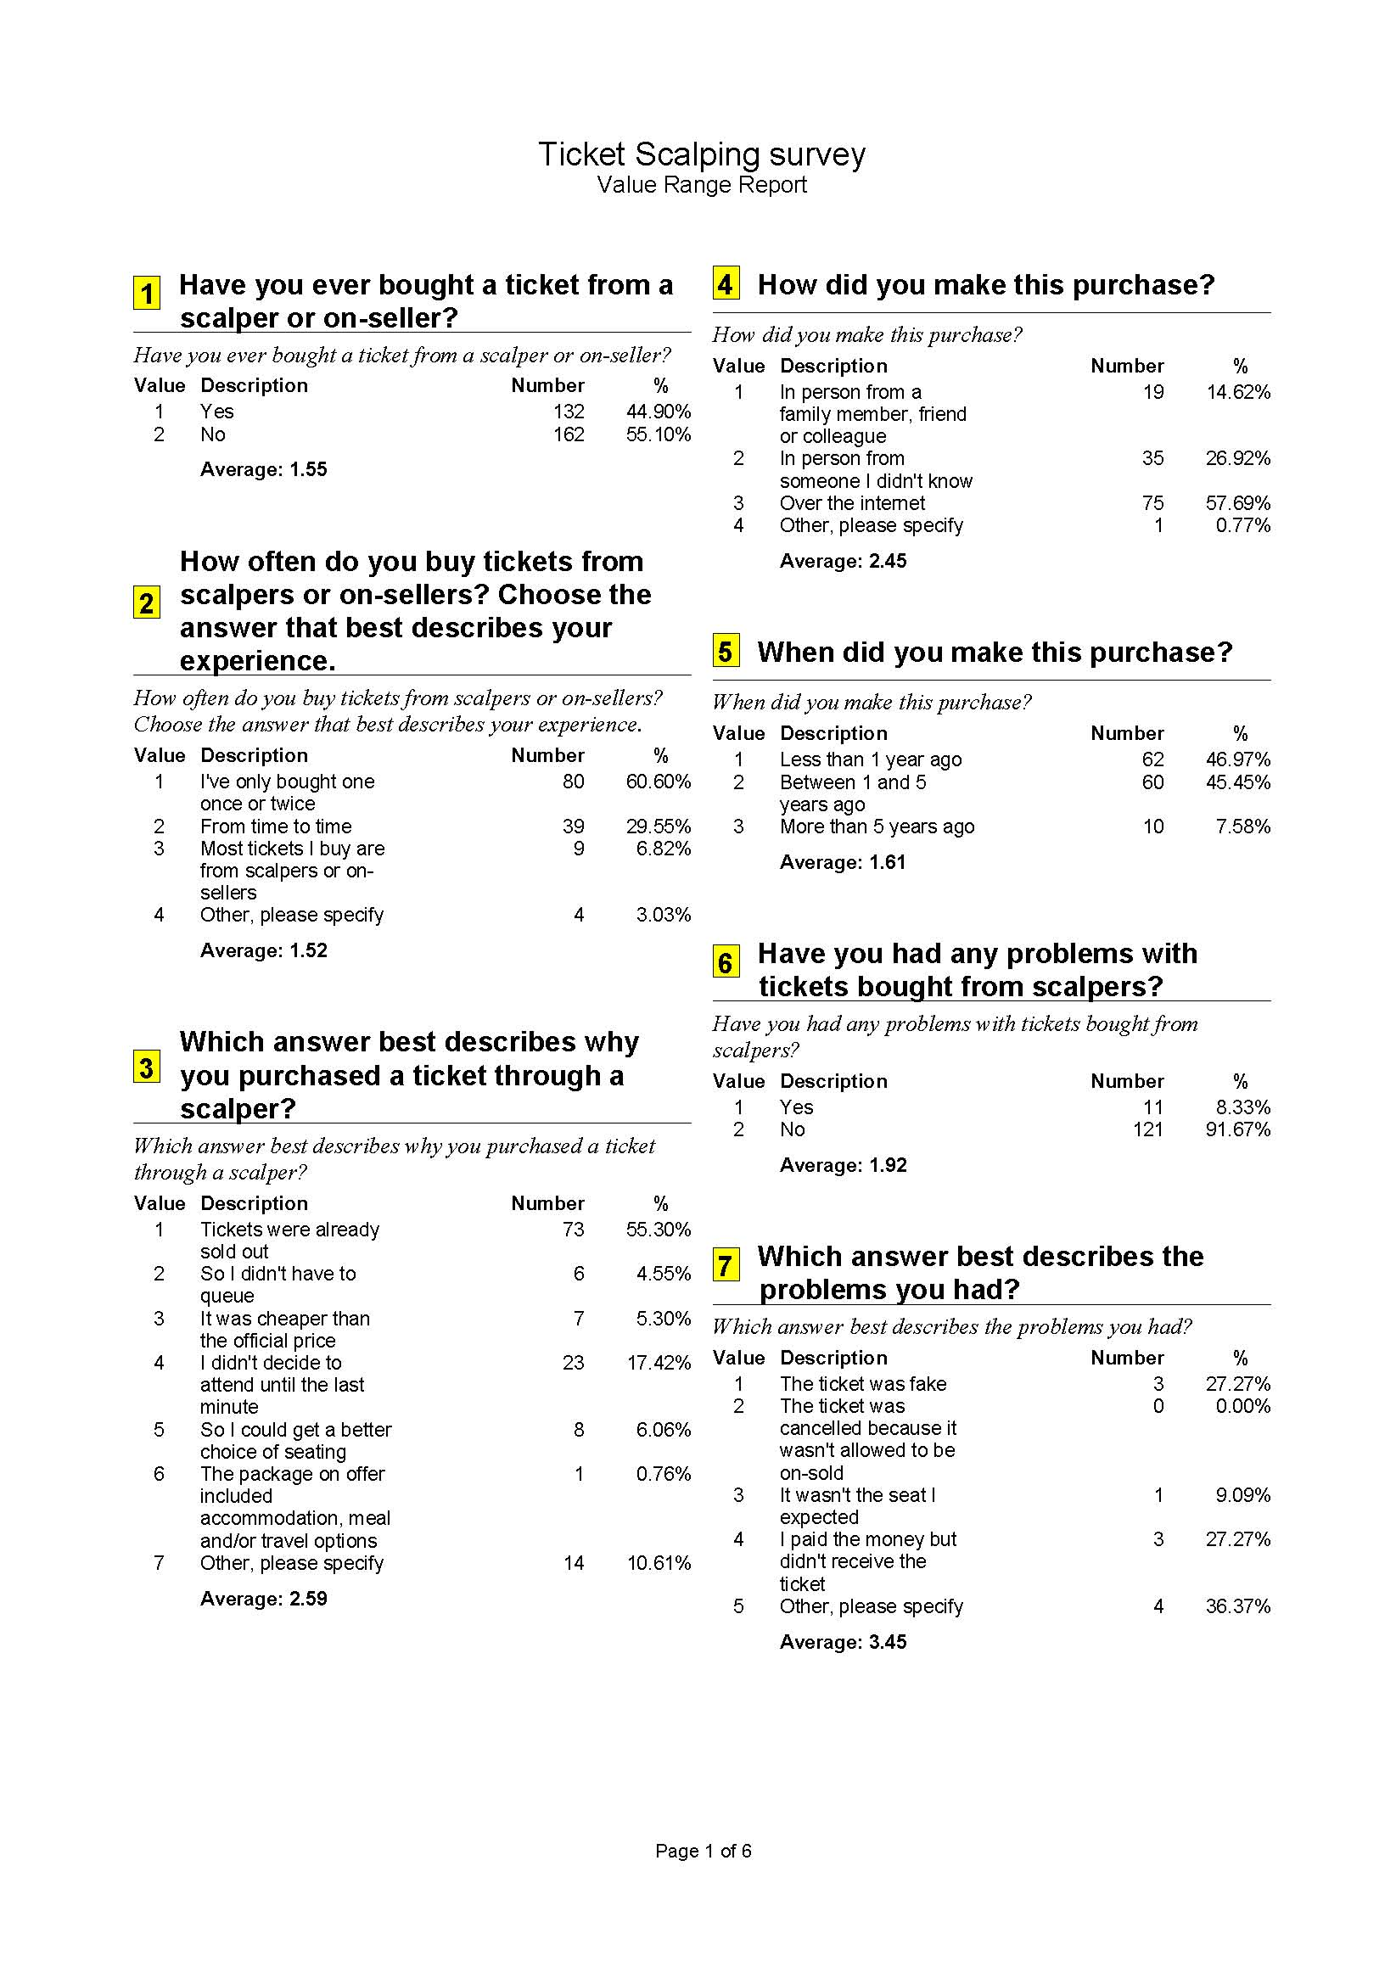
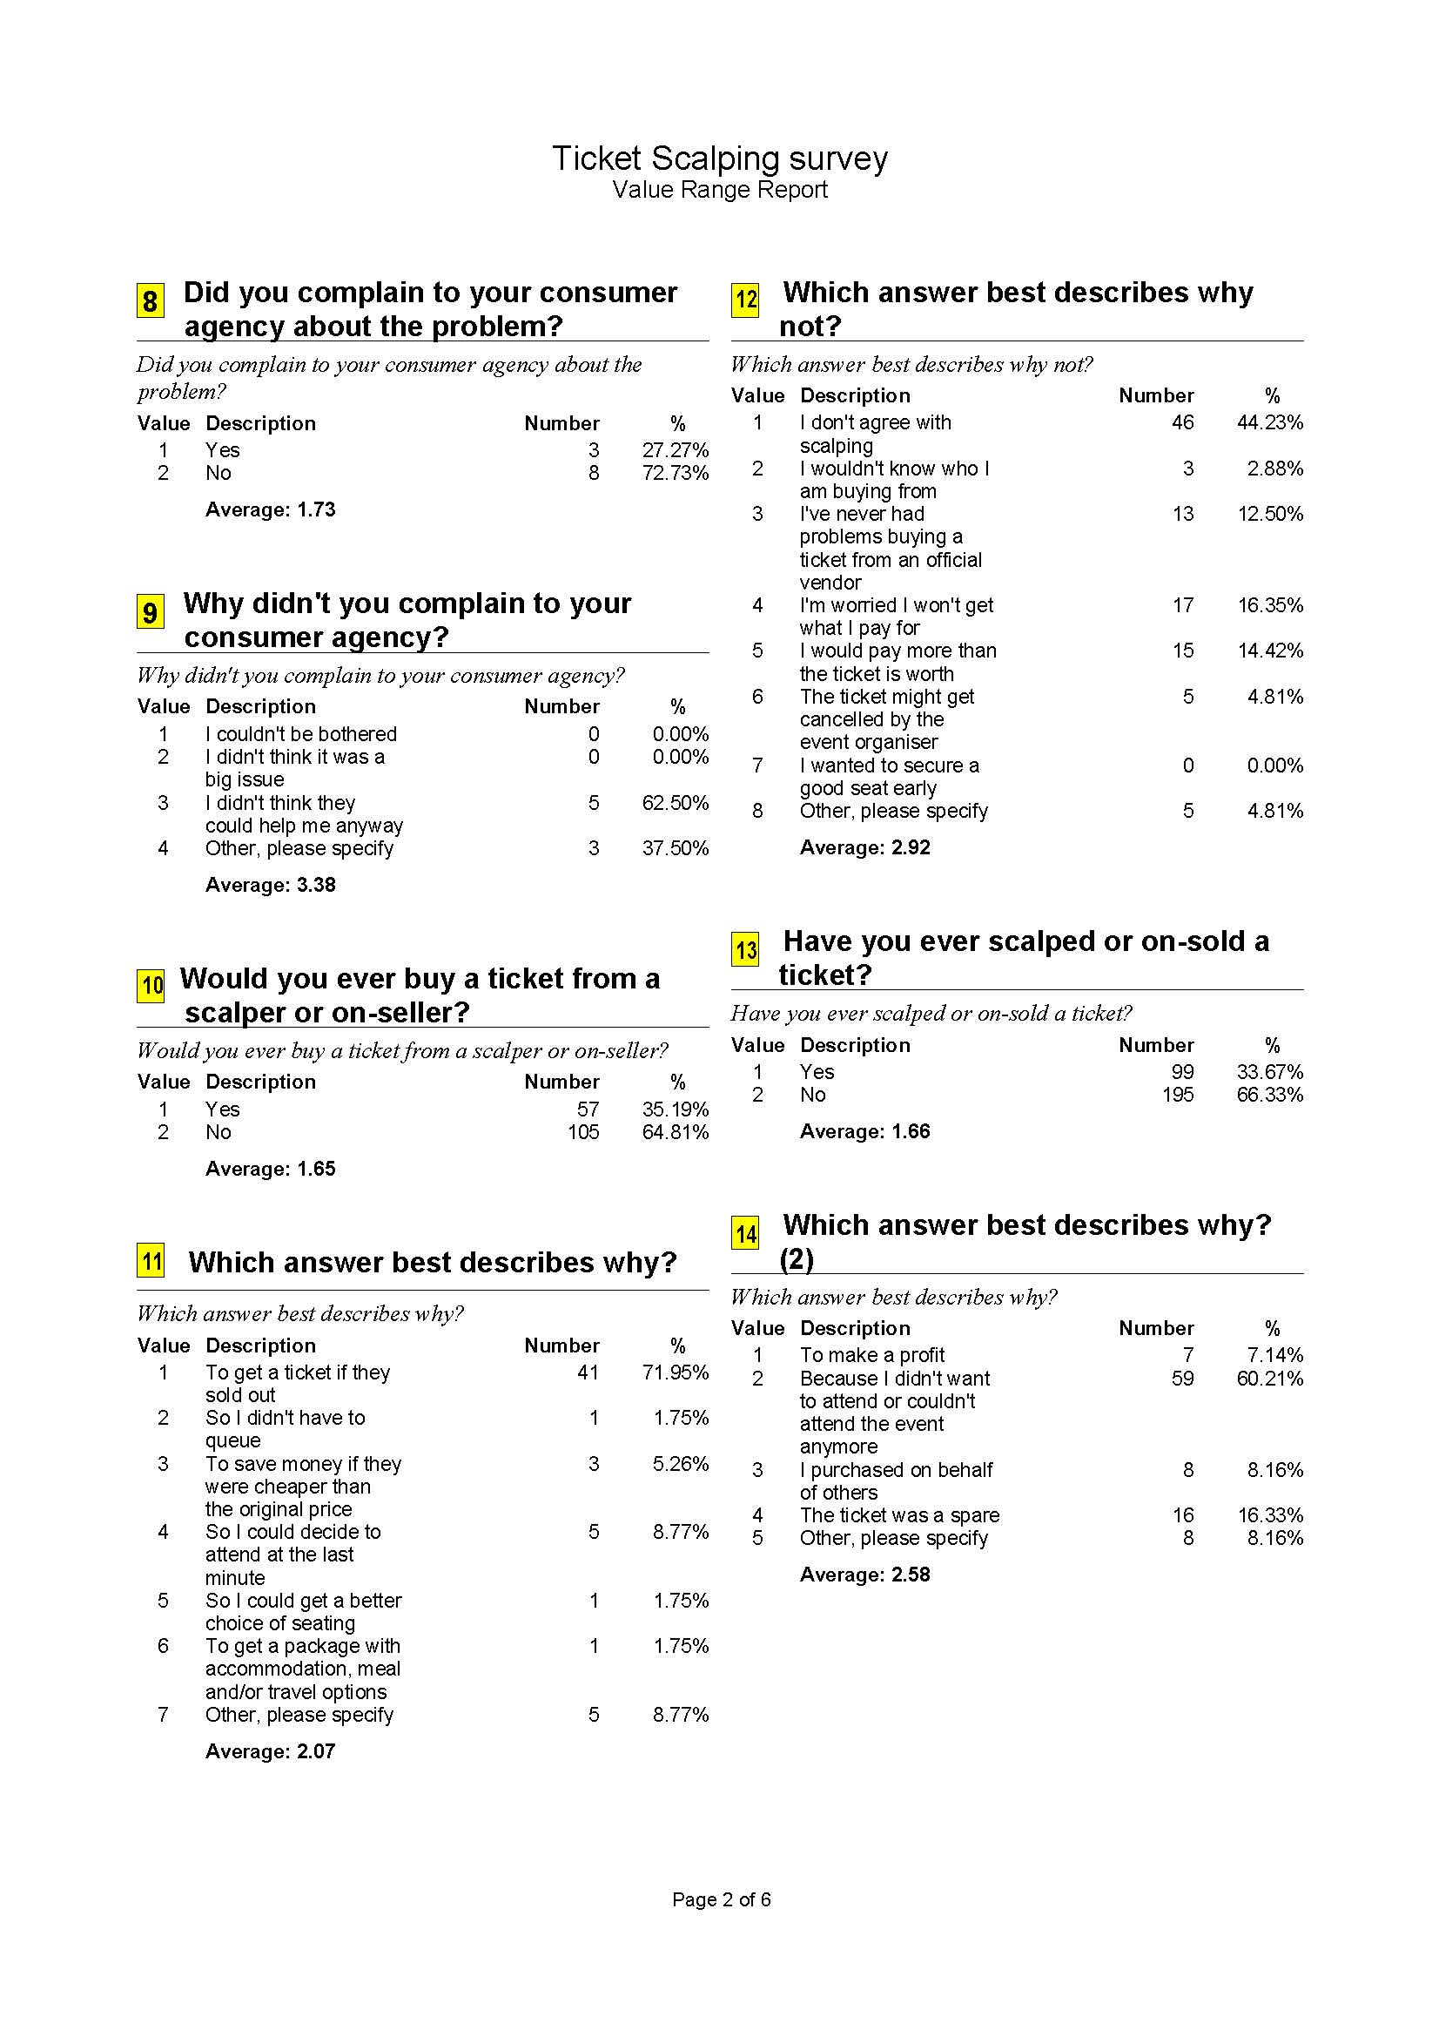
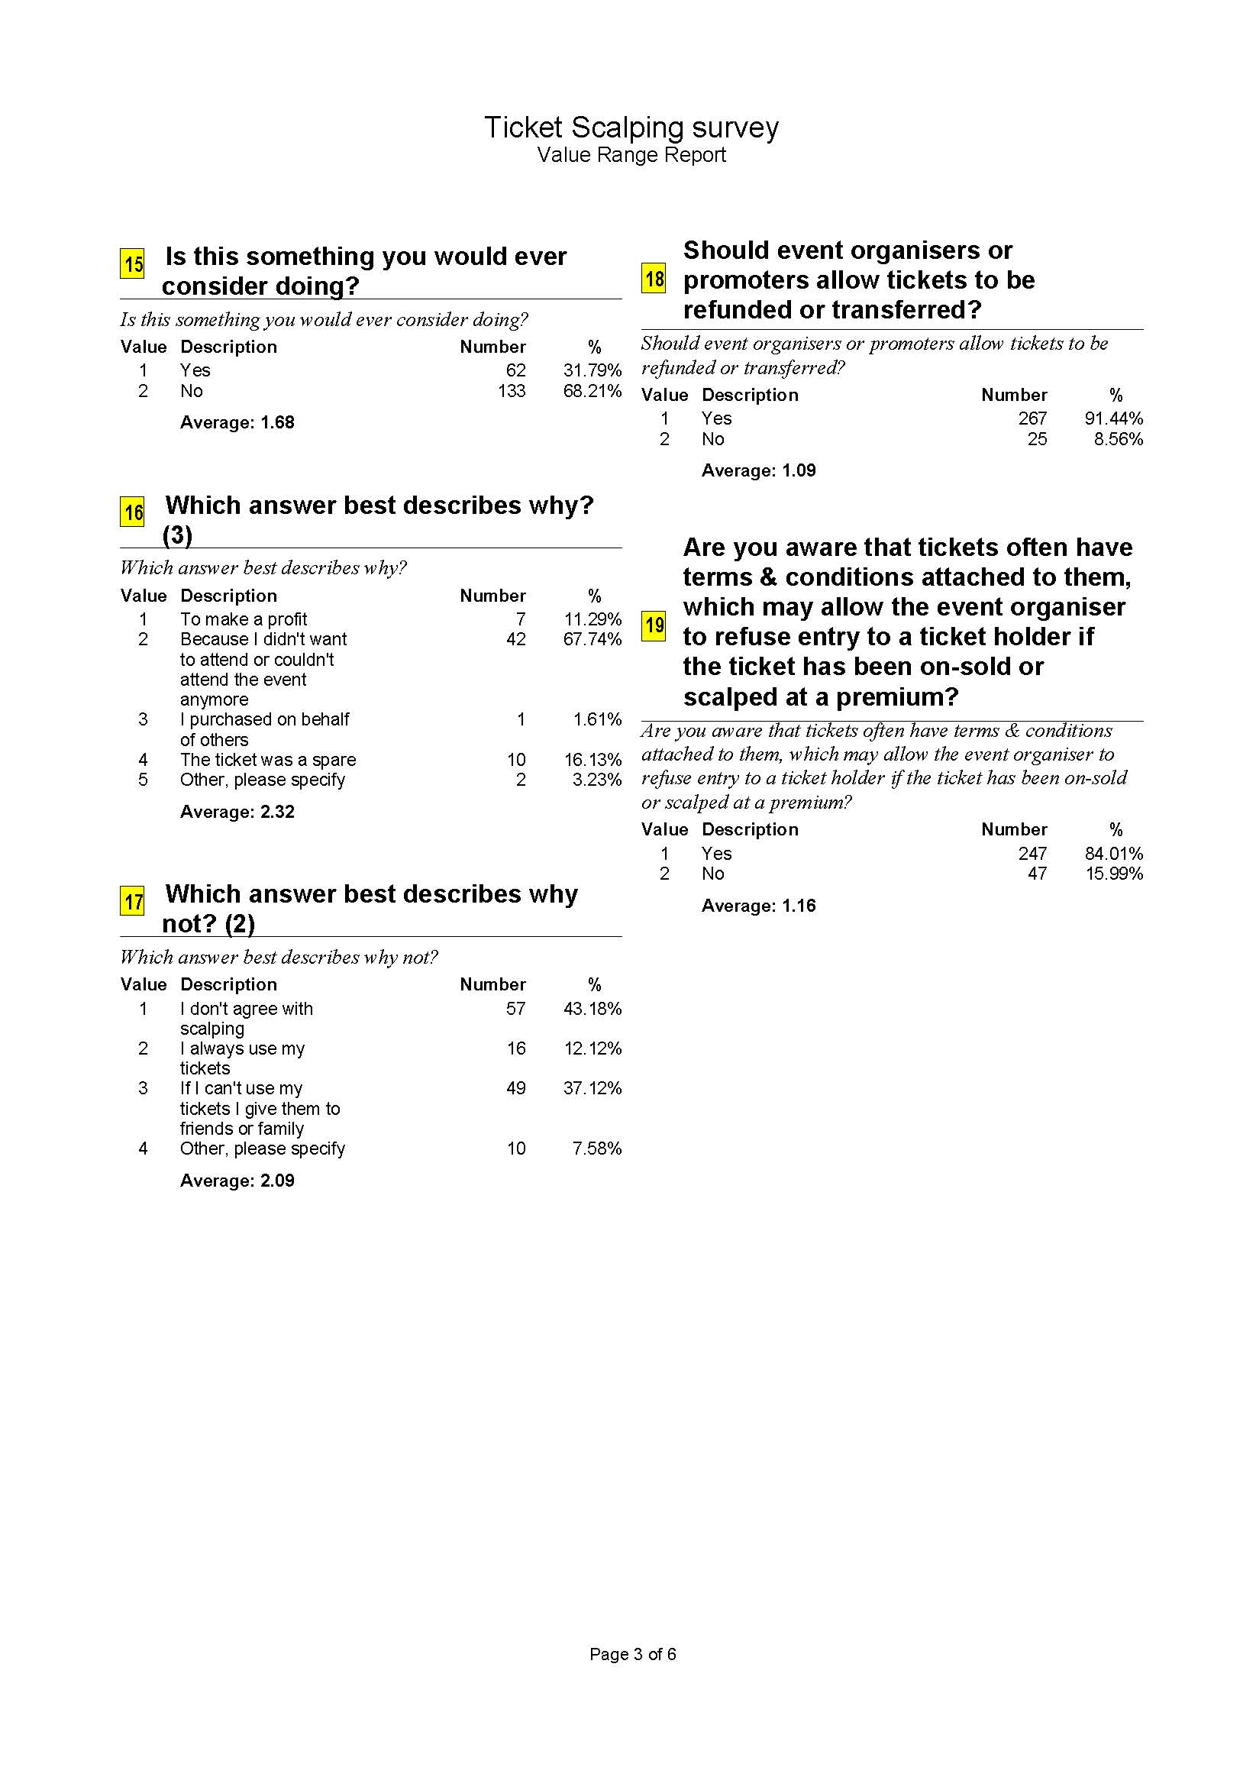
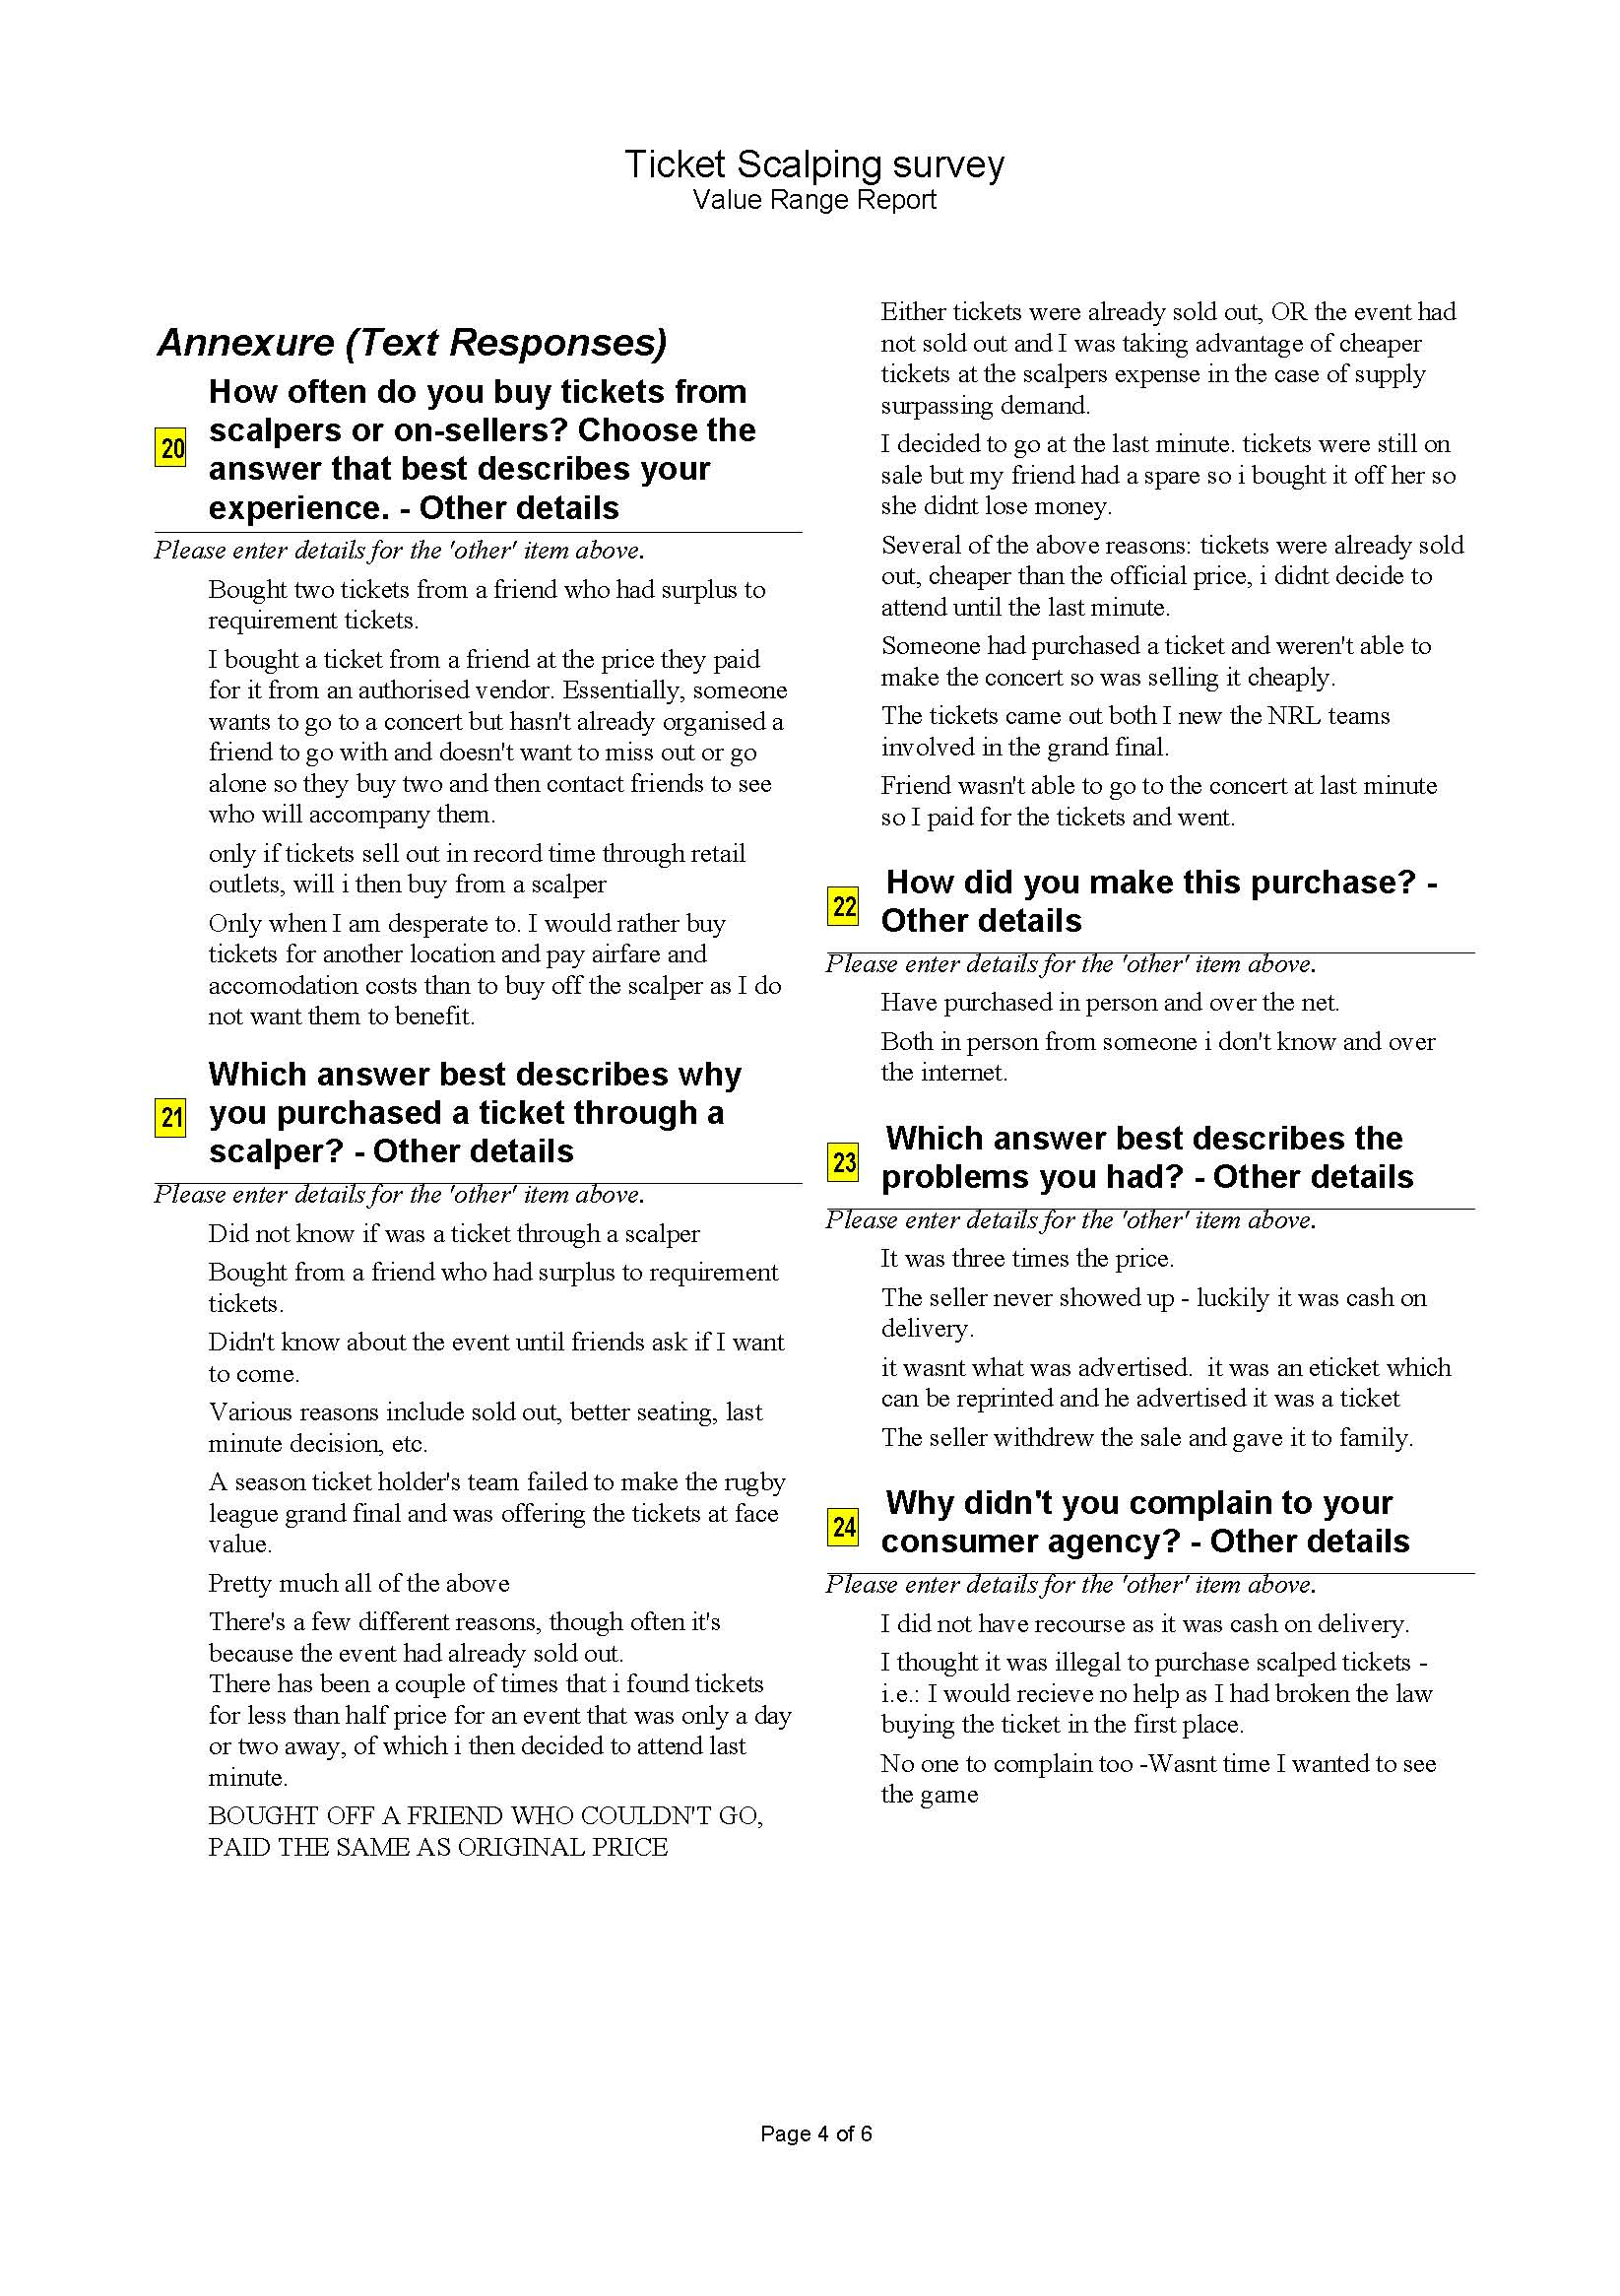
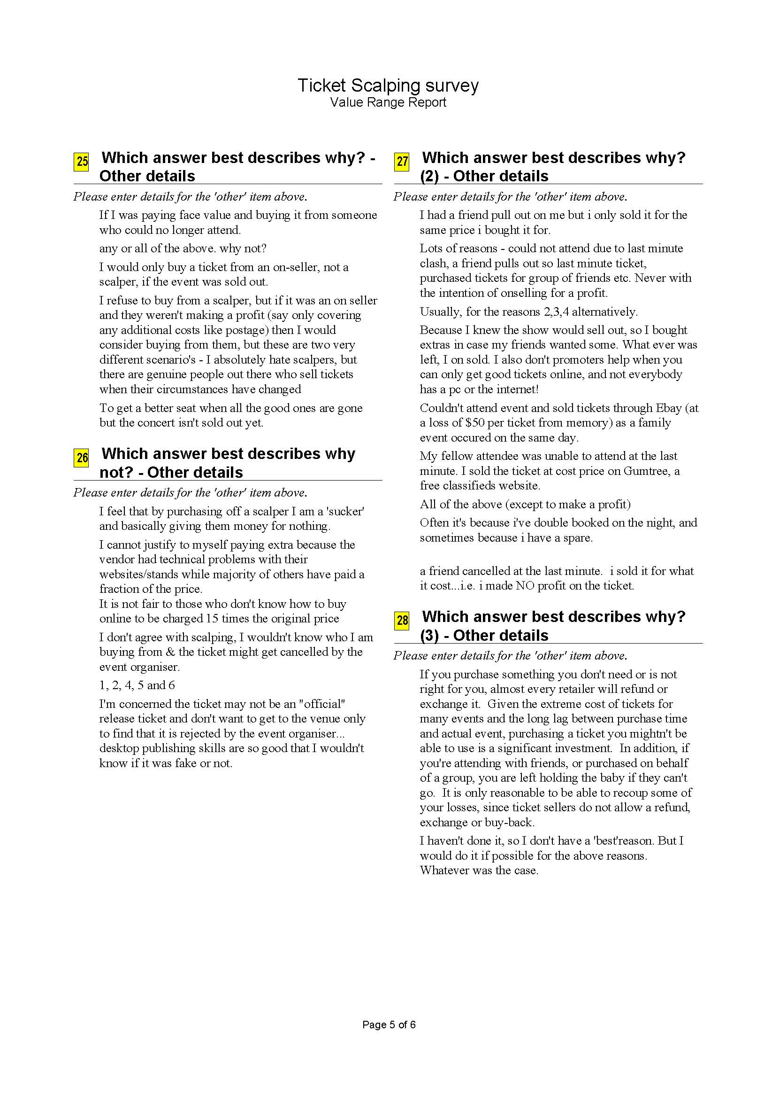

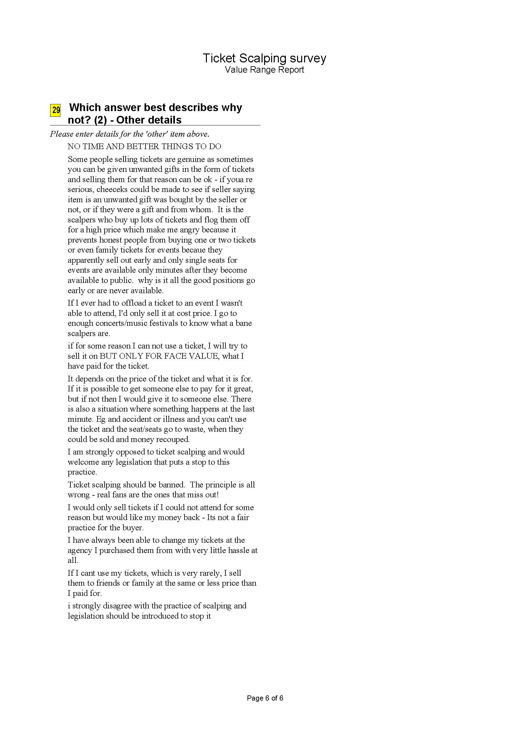
Newspoll ticket scalping study
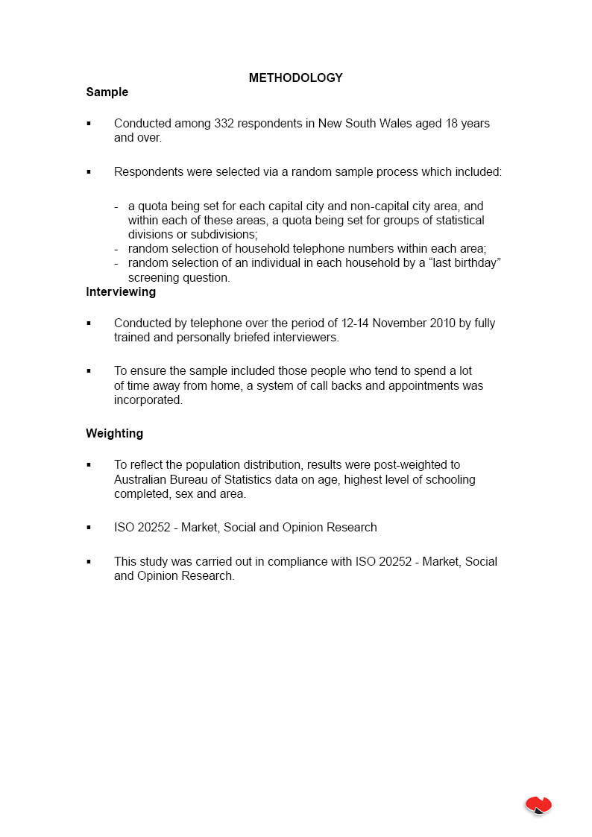
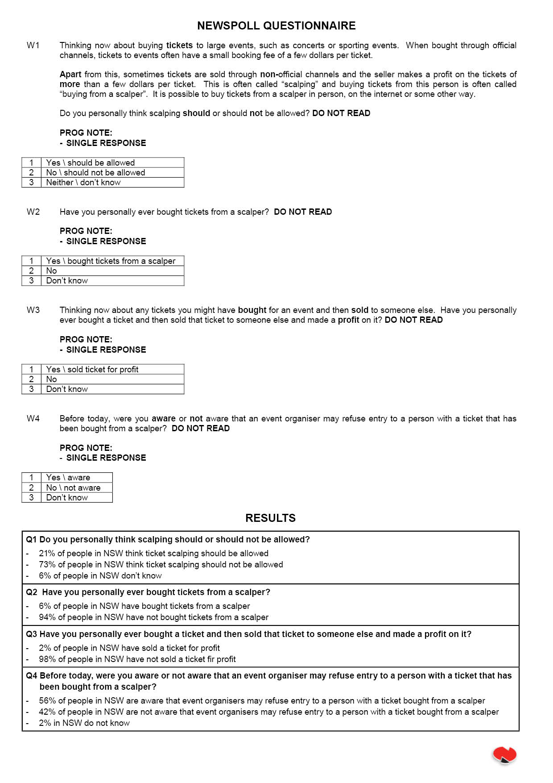

Appendix F: Complaints data
State / Territory | Period | Complaints | Issue | Enquiries | Issue
ACCC | 2007-2010 | 16 |  | 8 | Issues raised by consumers in inquiries and complaints concerned the following: The lack of enforcement of terms and conditions that restrict scalping by ticket sellers.  Ticket terms and conditions placing restrictions on refunds, returns and exchange of tickets.  Allegations that concerts and events had sold out due to scalping. Sellers on online auction sites reselling tickets. Inquiries about the legality of scalping.
ACT | 2009-2010 | 0 |  | 0
NSW | 2005-2010 | 16 |  | 2
NT | 2008-2010 | 0 |  | 0
QLD | 2009-2010 | 2 | eBay, of the trader's IT infrastructure and the popularity of the show
QLD | 2008-2009 | 1 | eBay
SA | 2008-2010 | 1 | Wanted to sell a ticket on eBay, prohibited as eBay had an agreement with Australian Golf Tournament organisers | 2 | seeking confirmation about whether ticket scalping is illegal
TAS | 2009- 2010 | 0 |  | 0
WA | 2009-2010 | 0 |  | 0
VIC | 2004 | 0 |  | 1 | Ticket Scalping — general enquiry
VIC | 2005 | 1 |  | 4 | Ticket scalping on eBay — falls festival tickets  Ticket scalping on eBay — The Wiggles concert
VIC | 2006 | 1 |  | 3 | Ticket scalping on eBay  Ticket Scalping of AFL tickets  Ticket scalping enquiry — selling on eBay
VIC | 2007 | 0 |  | 2 | Query — Anti-scalping legislation  Query — Offered free tickets to cricket, concerned about scalping
VIC | 2008 | 0 |  | 3 | AFL ticket scalping enquiry  Dual pricing and double ticketing  Legality around ticket scalping
VIC | 2009 | 1 |  | 4 | Ticket scalping on eBay  Query — Regulation of ticket scalping at events other than sporting events  Query — Why ticket scalping illegal for AFL Grand Final but not other events  Ticket scalping on eBay
VIC TOTAL |  | 3 |  | 17

Appendix G: The economics of ticket onselling
Appendix G is an economic analysis of the secondary ticket market to examine its effects on market participants. It explores the relationship between demand and supply by observing different characteristics in the secondary ticket market.
A perfectly competitive market
Market economies use the forces of demand and supply to allocate scarce resources to their most valuable use. In a perfectly competitive market prices are freely determined by individuals and firms participating in the market. Price signals are the mechanism that guide economic decisions in market economies and allocate scarce resources to those who value them most. The conditions for perfect competition are strict, meaning that there are a limited number of perfectly competitive markets. To be perfectly competitive a market must have two characteristics. The goods offered for sale must all be exactly the same and the buyers and sellers must be so numerous that no single buyer or seller can have any influence over the market. The perfectly competitive model can be used to demonstrate consumer and producer surplus.
The supply and demand for a good determines the quantity and price at which that good is traded in a market economy. Buyers collectively determine the demand for the good, whilst sellers collectively determine the supply. For most goods and services, supply is directly related to price and demand is inversely related. When a market is in equilibrium, buyers can buy the quantity of a good they require and sellers can sell the quantity they want at a certain price level, known as the equilibrium price.
Figure 1 illustrates a free market in equilibrium, with the quantity Qe of goods been sold at an equilibrium price of Pe.
Figure 1: Demand and supply in a perfectly competitive market
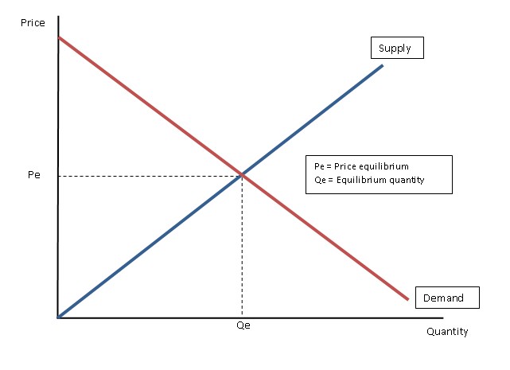

In a perfectly competitive market there are so many buyers and sellers that each individual buyer and seller has a negligible impact on the demand and supply within that market, and therefore the market price. A variety of factors which influence markets mean that not all markets are perfectly competitive.
Welfare in a perfectly competitive market
To study how an allocation of resources affects economic wellbeing or the welfare of market participants, economists use a measure of welfare known as consumer and producer surplus.
Consumer surplus is the difference between what a person is willing to pay for an additional unit of a good — the marginal benefit — and the market price of a good.

A consumer surplus occurs when the consumer is willing and able to pay more for a given product than the current market price.
Willingness to pay can be defined as the maximum amount buyer will pay for a good.
In defining willingness to pay, it is assumed that the person is not just willinging to pay, sacrifice or exchange something for a good, but is also able to. This means that a person cannot just be willing to pay but must also have the means, money or assets to do so.
Producer surplus is the difference between the price received by a firm for an additional item sold and the marginal cost of the item’s production.

A producer surplus occurs when the amount that a producer of a good receives exceeds the minimum amount that he or she would be willing to accept for the good. The difference, or surplus amount, is the benefit that the producer receives for selling the good in the market.
In an economic sense, the equilibrium of supply and demand in a market economy maximises the total welfare received by buyers and sellers. In doing this, both consumer and producer surplus are maximised as illustrated in Figure 2.
Figure 2: Consumer and producer surplus in a perfectly competitive market
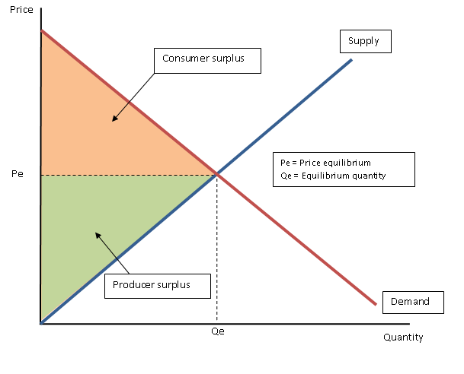

The demand curve illustrates the value of a good to buyers and the supply curve reflects the cost of a good to sellers. At any quantity below the equilibrium level of Qe the value to the marginal buyer exceeds the cost to the marginal seller, as demonstrated by Figure 3. In this situation, increasing the quantity produced and consumed raised total surplus, which continue until the quantity reaches the equilibrium level. At any quantity above the equilibrium level of Qe, the value to the marginal buyer is less than the cost to the marginal seller. At these quantities, decreasing the quantity produced and consumed raises total surplus, which continues until the quantity reaches the equilibrium level. Hence, total surplus is maximised where the supply and demand curves intersect.
Figure 3: The efficiency of the equilibrium quantity
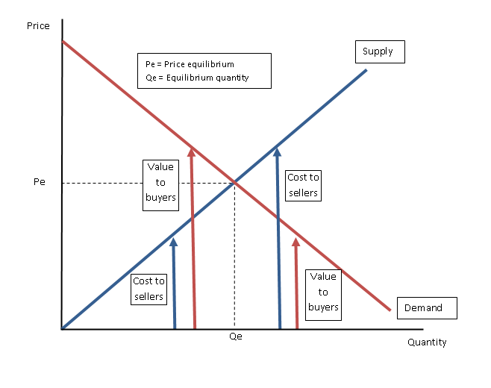

In a perfectly competitive market, there are three main market outcomes:
- Free markets allocate the supply of goods to the buyers who value them most highly, as measured by their willingness to pay.
- Free markets allocate the demand for goods to sellers who can produce them at least cost.
- Free markets produce the quantity of goods that maximises the sum of consumer and producer surplus.
The ticket market
The insights from a perfectly competitive market provide a basis for analysis that can be extended to other markets which do not exhibit perfect competition. The ticket market is one such market which does not exhibit identical characteristics to a perfectly competitive market.
The following representation of the ticket market is a simplified model representing the demand and supply for tickets to a one–off event. The model does not attempt to explain the pricing or supply decisions of event promoters; instead it provides a simplified analysis of the decisions of consumers and suppliers in the ticket market.
In the ticket market the supply of tickets to any given event is restricted as there is a maximum capacity for all events. In a perfectly competitive market, the law of supply states that other things being equal, the quantity supplied of a good rises when the price of the good rises. This means that if consumers are willing and able to pay a higher price than the current market price, suppliers will increase the supply of a good until the cost of producing the good is equal to the consumers’ willingness to pay for the good. However, due to the limited amount of tickets that can be sold to an individual event, the supplier cannot supply more tickets and therefore, the supply of tickets to that particular event will not be responsive to higher prices.
The flexibility of suppliers to alter the amount of a good they supply is described by the price elasticity of supply. If a supply curve is elastic, a supplier is highly responsive to a change in prices, that is, they will vary their supply of a good substantially in response to a change in prices. Conversely, a supply curve is described as inelastic if the quantity of a good supplied is not very responsive to a change in prices.
Figure 4: Demand and supply in the ticket market
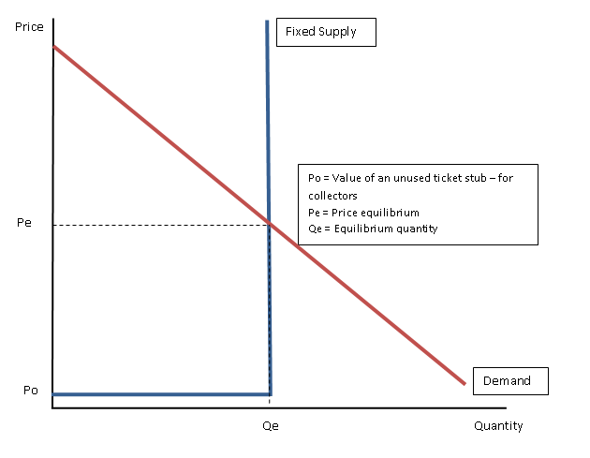

These characteristics of the ticket market are characterised by Figure 4. Since ticket suppliers cannot increase the amount of tickets available for a specific event the ticket market exhibits perfectly inelastic supply. A perfectly inelastic supply curve means that supply does not increase or decrease with a change in prices. Whilst producers can schedule additional shows, performances or events, the supply of tickets will still be finite due to the inability of identical events to be continuously repeated until all those who have demand for a ticket are satisfied. The limited nature of supply is particularly influential in one-off events such as grand finals.
Another distinctive feature of the ticket market supply curve shown in Figure 4 is that ticket stubs may still possess some value for collectors even after events are completed. Collectors may be willing to pay for ticket stubs or unused tickets even after expiry, to be used as memorabilia. The result of this is that a ticket may never be worthless; it may be worth at least slightly more than $0, represented by Po. Equilibrium in the ticket market is represented at price Pe and quantity Qe. At price Pe and quantity Qe, the cost of producing tickets is equal to the value of tickets to consumers.
Welfare in the ticket market
To evaluate the welfare of market participants and determine if this market represents an efficient allocation of resources, an analysis of consumer and producer surplus is required. The ticket market is in equilibrium at a price level of Pe, with the quantity of tickets demanded and supplied being Qe. At these levels consumer and producer surplus is maximised and hence total welfare is maximised, as represented in Figure 5.
Since the market is in equilibrium, all individuals who are willing and able to pay Pe for a ticket receive a ticket and all suppliers willing and able to supply a ticket at Pe do so. This has an important implication for the existence of ticket onselling. In this market, demand and supply are in equilibrium, all market participants are satisfied and there will not be an incentive for ticket onsellers to enter the market. In fact any ticket onselling would most likely be at a loss to the onseller, as they could only sell to someone with a lower willingness to pay.
Figure 5: Consumer and producer surplus in the ticket market
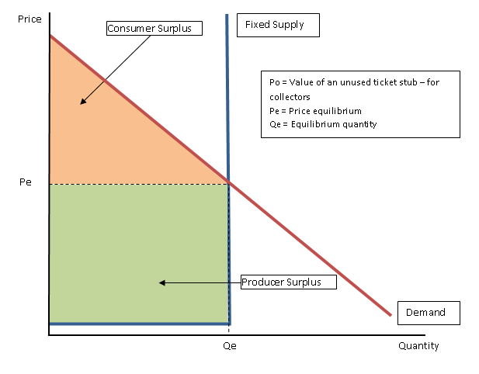

The ticket market if underpricing exists
The underpricing of tickets in the ticket market is often used to provide an explanation of ticket scalping in the ticket market.
Tickets are underpriced when suppliers — that is, performers or event promoters — set the ticket price below what market demand will support in equilibrium.

Suppliers may underprice tickets for a variety of reasons, such as:
- to lower risk by ensuring that tickets are priced to attract greater demand and to attract onsellers (who assume a degree of risk);
- to maximise long-term revenue by retaining the loyalty of existing fans, increasing the fan base and maintaining goodwill;
- to sell-out events to generate reliable revenue, positive publicity and added ambience at the event; or
- to secure other associated benefits often related to sell-out events, such as television rights, merchandise sales, sponsorship and food and beverage sales.
Figure 6: Demand and supply in the ticket market, when underpricing occurs
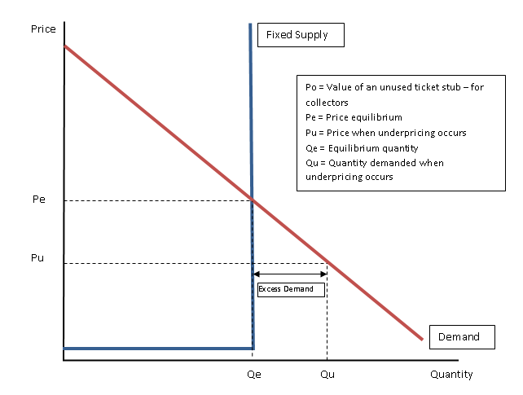

Figure 6 shows the impact of underpricing in the ticket market. The law of demand states that, other things being equal, the quantity demanded of a good falls when the price of the good rises. As shown in Figure 6, when tickets are underpriced, as denoted by Pu, demand for tickets increases from the market equilibrium level of Qe to Qu. However, since supply is inelastic or fixed, the quantity of tickets supplied remains at the level of Qe. The result of the combination of underpricing and fixed supply is that excess demand is created in the ticket market. Consumers demand a quantity of Qu tickets, whilst only a quantity of Qe is supplied. This leads to excess demand of Qu — Qe tickets.
Welfare in the ticket market if underpricing exists
When underpricing occurs, producers give up some of their surplus, which is reallocated to consumers as seen in Figure 7. If onsellers are prevented from entering the market, for instance through regulation, producer surplus will be reduced and consumer surplus increased, relative to the equilibrium outcome described in Figure 5. Total surplus, and hence total welfare, will remain the same as when underpricing does not occur, but there will be excess demand in the market.
Figure 7: Consumer and producer surplus in the ticket market, when underpricing occurs and scalping is illegal.
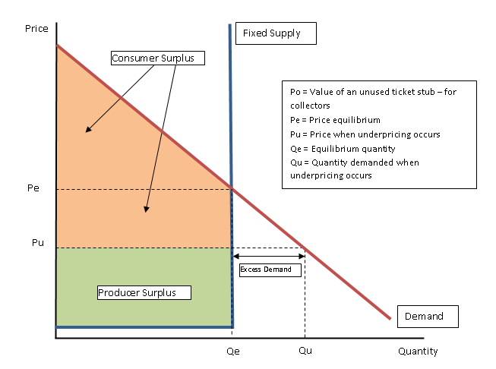

When underpricing occurs this creates possibilities for a secondary market for tickets where prices are often set higher than their face value. Where an event has been sold-out and ticket scalping or onselling is legal, the secondary market attracts and serves people who missed out on tickets initially and are willing and able to pay more than the original price to attend the event. Market forces generate the price movements needed to bring the quantity of tickets demanded in line with the quantity supplied. Ticket onsellers act in accordance with this notion, purchasing tickets and onselling them to those people with a higher willingness to pay.
Welfare in the ticket market with onselling
Figure 8 graphically illustrates the market when underpricing occurs and onsellers can participate. Onsellers will receive the level of surplus which is forgone by producers when they make the decision to underprice. There are a variety of reasons suppliers may be willing to transfer this surplus, as mentioned, including the transfer of risk to scalpers, to create positive externalities associated with sell-out events such as ambience and to maximise revenue from associated sales such as merchandise, food and beverages.
Onsellers will buy tickets either directly at Pu or from those individuals who value their tickets below Pe. They will then sell tickets to those who value tickets at Pe or higher. As such onsellers act as the market force which drives the price level upward until equilibrium is achieved. When underpricing exists and onsellers enter the ticket market, producer surplus remains the same as without onselling as evident in Figure 8. However, some of the consumer surplus is transferred from consumers to onsellers. In this situation, consumer surplus is returned to its original level, before underpricing occurs (as seen in Figure 5).
An important point is that the level of total welfare, as measured by total surplus remains unchanged. This insight shows that while onsellers do receive some surplus, the existence of onselling within the ticket market does not reduce total welfare.
Figure 8: Consumer, ticket scalper and producer surplus in the ticket market, when underpricing occurs and scalping is legal
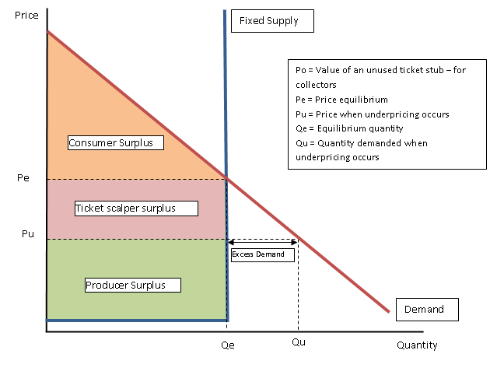

Whilst underpricing does not result in a loss of total welfare in the ticket market, the allocation of tickets may be different to the allocation of tickets if underpricing did not occur. The same quantity of tickets will be sold in total, however some tickets will most likely be sold to different people. The excess demand that is generated by underpricing means that more people are willing to purchase a ticket than there are tickets available. This raises the question: who will receive tickets? When underpricing does not occur, the consumers who are willing and able to pay Pe will receive tickets. With underpricing, it may be the same people who receive tickets, however it likely that some consumers who have a willingness to pay of greater than Pu but less than Pe will now obtain tickets.
It is therefore likely that some consumers — who without underpricing did not receive tickets — will now do so, displacing some consumers who would have received tickets when underpricing did not occur. In this situation, some consumers are better off, as they now receive tickets, whilst some consumers are worse off, as they will not receive a ticket, when without underpricing, they would have.
While onsellers do receive some economic surplus when this occurs, the existence of onselling within the ticket market does not reduce total welfare. Consumers may be better off when onsellers operate as those who place a greater value (as reflected by a higher price) will have access to onsold tickets, whilst those who value their tickets at a lower price (and are therefore willing to sell their tickets) may be able to sell their tickets at a profit. These gains are known economically as ‘gains from trade’. There can be net economic gains for the economy when these ‘gains from trade’ are realised, which lead to benefits for consumers.
Efficiency in the ticket market
In analysing whether this is beneficial or detrimental to the economy, we introduce a concept known as pareto efficiency.
A pareto improvement in a market is when there is a way to make some people better off without making others worse off. If an allocation of goods is such that no pareto improvements are possible, it is called pareto efficient. When a market is pareto inefficient, that is if an allocation allows for a pareto improvement, then there are ‘gains from trade’ which will make both parties better off.

It is important to note that if the onselling of tickets is illegal, then the ‘gains from trade’ which can be realised if underpricing occurs are prohibited and the allocation will not be pareto efficient. If onselling is legal then the market will generally move towards a pareto efficient allocation of resources, since there will be gains from trade that can be realised after the initial public offering, acting as an incentive to move consumers to an efficient equilibrium.
In a pareto efficient market, any consumer who holds tickets must have a higher willingness and ability to attend an event (and in an economic sense therefore have a higher willingness to pay), than any consumer who does not hold a ticket, as this leads to pareto efficiency. If this situation does not occur, consumers could make gains from trade which make both parties better off.
For example, suppose a ticket is purchased by John from an event promoter for $50, when the market equilibrium is $75 (that is, tickets are underpriced). Within the ticket market there is another consumer, Wendy who does not receive a ticket but is willing to pay $100. If Wendy purchases the ticket from John for any price between $50 and $100 both Wendy and John are better off and gains from trade have been realised.
Generally, underpricing within the market will not initially lead to a pareto efficient allocation of resources. This is such as the arbitrary assignment of ticket holders will generally involve someone holding a ticket who is willing to pay less for that ticket than someone who does not hold a ticket. Hence, these efficiency gains associated with allowing onselling provide benefits to consumers, by allocating tickets to those who value them most.
The ticket market when onsellers perfectly price discriminate
Price discrimination is the business practice of selling the same good at different prices to different customers.

Price discrimination occurs when a supplier charges a different price to different groups of consumers for an identical good or service, for reasons not associated with costs. The ideal form of price discrimination, from the seller's point of view, is to charge each buyer the maximum that the buyer is willing to pay. The seller will sell the economically efficient amount and capture the entire consumers' surplus.
When onsellers enter the market and charge every individual their exact willingness to pay, they are said to be engaging in perfect price discrimination. If onsellers price discriminate, consumer surplus will be completely transferred to scalpers as seen in Figure 9. The nature of the ticket market, specifically the existence of information asymmetry, may allow scalpers to perfectly price discriminate.
If we return to the case of Wendy and John, we know that Wendy will pay any amount up to $100 dollars to obtain a ticket. We also know the equilibrium price in the market is $75. If John knows that Wendy is willing to pay up to $100, then he will charge her exactly $100, maximising his profits and reducing her consumer surplus to zero. This is known as price discrimination.
Information asymmetry describes a situation where there is a difference in access to relevant knowledge.

Information asymmetry describes a situation in which one party in a transaction has more or superior information compared to another. The seller is often in a position to ascertain whether a good is value for money at the price being asked because they know all of the input costs. The consumer may not be aware of the input costs, only the selling price.
If consumers are not aware of the price of other tickets available in the market, then asymmetry of information exists and ticket onsellers may be able to charge each consumer their exactly willingness to pay, that is ticket onsellers may be able to perfectly price discriminate. The equilibrium price will be unable to be ascertained because there is imperfect knowledge in the market. Information asymmetry also suggests that a market is not efficient because buyers and sellers are not able to gauge whether price is equal to cost. That is, resources may not be assigned to their highest valued use and there will be allocative inefficiency.
Figure 9: Ticket scalper and producer surplus in the ticket market, when underpricing occurs, scalping is legal and scalpers perfectly price discriminate
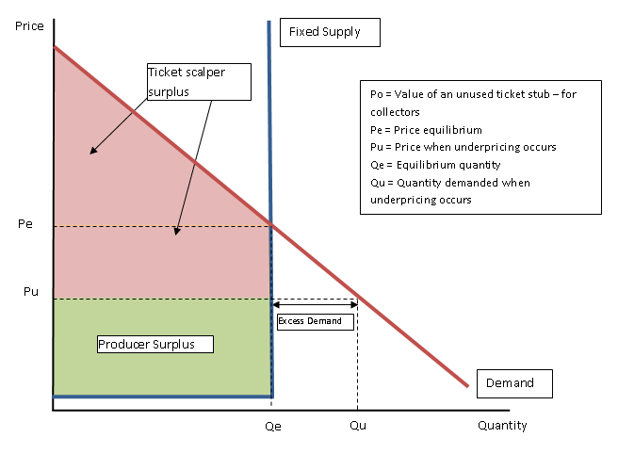

The occurrence of price discrimination by onsellers, reflected in some consumers paying a significantly higher price for tickets than their original face value, is often the cause of dissatisfaction for consumers in the ticket market. However, by allowing and promoting ticket onselling there may be benefits to consumers. This is such as it may increase competition within the secondary ticket market and reduce the existence of information asymmetry.
If there is increased competition in the secondary market, consumers may become better informed about the market equilibrium price, as to compete for buyers, onsellers may reduce prices. This would reduce the price of tickets until all tickets were being sold at the equilibrium price. The market would move into equilibrium, and the total surplus would be divided as seen in Figure 8. In this case, consumer surplus would be maximised, total welfare would be maximised and the ticket market would be pareto efficient. By having visible alternatives, consumers looking to purchase tickets in the secondary market can compare tickets available which may reduce the mark-up on tickets in the secondary market, benefiting consumers.

Appendix H: Australian legislation
General consumer protection laws
In Australia, Trade Practices Act 1974 (TPA), at a national level, and the fair trading and sale of good laws of the States and Territories, currently contain provisions which protect consumers from unfair trade practices, including:
- a general prohibition against misleading or deceptive conduct;
- specific protections against the making of false representations;
- component pricing requirements; and
- statutory conditions and warranties in consumer transactions.
From 1 January 2011, these provisions will broadly continue to apply in a nationally consistent manner under the new Australian Consumer Law.
Further information about the TPA and the ACL, including guidance about enforcement and remedies, is available at www.consumerlaw.gov.au.

The Australian Consumer Law
From 1 January 2011, the new Australian Consumer Law (ACL) will apply a nationally consistent system of generic consumer protection laws in all States and Territories. The ACL is a single, national consumer law and replaces provisions spread across 20 Commonwealth, State and Territory legislation, including in the TPA.
The ACL is based on the consumer protection laws in the TPA and draws on best practice in State and Territory laws and on the conclusions of the Productivity Commission in its 2008 Review of Australia’s Consumer Policy Framework.
The ACL is a key part of the regulatory reforms under the Council of Australian Governments’ (COAG’s) National Partnership To Deliver A Seamless National Economy. It will be applied in each State and Territory through application laws and is enforceable by all Australian courts and tribunals, including the courts and tribunals of the States and Territories. At the Commonwealth level, the ACL will operate as a schedule to the TPA, which will be renamed the Competition and Consumer Act 2010 (CCA) on 1 January 2011. The Trade Practices Amendment (Australian Consumer Law) Act (No. 1) 2010 is the first of two Acts to implement the ACL. It contains the new unfair contract terms law, enhanced enforcement powers, new penalties and improved consumer redress options. This first Act was passed by the Australian Parliament on 17 March 2010 and received the Royal Assent on 14 April 2010.
The remainder of the ACL is implemented by the Trade Practices Amendment (Australian Consumer Law) Act (No. 2) 2010, which was passed by the Australian Parliament on 24 June 2010 and received the Royal Assent on 13 July 2010. By the end of 2010, each State and Territory government will enact legislation to apply the entire ACL in its jurisdiction.

Protections against unfair sales practices
Currently, the TPA and the State and Territory fair trading laws contains a general ban on suppliers engaging in misleading or deceptive conduct. They also prohibit suppliers from making false representations to consumers, including claims relating to:
- the standard, quality or value of a good;
- the price of the good;
- whether the good is new;
- testimonials by any person relating to the good;
- sponsorship or approval for the good; and
- benefits and uses of the good.
From 1 January 2011, these prohibitions will form part of the ACL and be applied in a nationally consistent nature in all States and Territories.

Unfair contract terms
The unfair contract terms (UCT) law of the TPA, and in NSW and Victoria, makes void and unenforceable, a term in a standard form consumer contract that is deemed to be unfair by a court.
A ‘standard form consumer contract’ is an agreement for the supply of a good or service that is acquired wholly or predominantly for the purpose of personal, domestic or household use or consumption. A term is ‘unfair’ if it would cause a significant imbalance in the parties’ rights and obligations under the contract, is not reasonably necessary to protect the legitimate interests of the party who would be advantaged by the term, and would cause detriment (financial or non-financial) to a party if it was relied on. A relevant consideration as to whether a term is unfair is its transparency — that is, whether the term has been expressed in plain language, presented clearly, is legible and readily available. The UCT provisions do not apply to the upfront price under a contract or to the main subject matter of a contract.
Many tickets are standard form contracts between the original seller and the original buyer, and therefore may be subject to the UCT provisions. In situations where the ticket has been resold, the UCT law may not apply between the original ticket seller and the final ticketholder since the resold ticket may not be a standard form contract between the original seller and the ticketholder.
The UCT law commenced on 1 July 2010 in the TPA and in New South Wales and Victoria, and will apply in all other States and Territories as part of the ACL from 1 January 2011.

Statutory consumer guarantees
Currently, the TPA, and the fair trading and sale of goods laws of the States and Territories, imply certain statutory conditions and warranties into consumer transactions to ensure consumers are being provided with goods and services that are of a satisfactory quality and standard. These implied terms require suppliers to observe certain requirements when supplying goods or services.
From 1 January 2011, a new system of statutory consumer guarantees will operate as part of the ACL. This new system is based on the existing statutory conditions and warranties provisions of the TPA, which will be simplified and streamlined. The new statutory consumer guarantee regime, supported by effective redress, will make it easier for all consumers and suppliers to understand their rights and obligations. It also sets out the remedies available to consumers where a supplier fails to observe a guarantee.
With respect to goods, the following statutory guarantees apply:
- a guarantee that the supplier has a right to sell the goods;
- a guarantee that the goods sold will be of ‘acceptable quality’ — that is, the goods are safe, durable, free from defects, fit for the common purpose and acceptable in appearance, based on the nature, description and price of the goods;
- a guarantee that the goods sold will be fit for any purpose disclosed by the consumer to the supplier before purchase; and
- a guarantee that the goods will match any description, sample or demonstration model.

Component pricing requirements
The component pricing provisions of the TPA requires suppliers to prominently display a single figure price, where quantifiable, which represents the total price a consumer will have to pay in order to purchase a good or service outright, inclusive of any additional fees, charges or taxes. It effectively prevents suppliers from displaying a price that represents only part of the total amount payable to purchase the good or service. It helps to ensure consumers can make informed choices by requiring suppliers to provide the components of the total cost for buying a good or service which make up the total price payable.
The component pricing requirements will form part of the ACL.

Extended application to overseas
The TPA, and from 1 January 2011 the ACL, has extended application to conduct engaged in outside of Australia that is in trade or commerce by those who are incorporated or carrying on a business in Australia, or by Australian citizens or persons ordinarily resident within Australia. For example, the TPA (and the ACL) would apply to overseas conduct engaged in trade or commerce over the Internet that is directed at Australian consumers. Further, the Commonwealth Minister may grant or withhold consent to legal proceedings concerning conduct engaged in overseas that would breach the TPA (and the ACL), subject to foreign law and national interest considerations.

Enforcement powers, remedies and penalties
The Australian Competition and Consumer Commission (ACCC) is responsible for enforcing the TPA, and the State and Territory consumer agencies are responsible for enforcing the fair trading and sale of goods laws in their respective jurisdictions. When the ACL comes into effect on 1 January 2011, the ACCC and the State and Territory consumer agencies will jointly administer and enforce the ACL.
The ACL includes the existing civil remedies that are currently available in the TPA, such as damages, compensatory orders and injunctions, as well as new enforcement powers and penalties and improved consumer redress options. New national enforcement powers and penalties include enforceable undertakings, substantiation notices, infringement notices, public warning notices, civil pecuniary penalties and disqualification orders, and there will also be redress available for non-parties.
In addition, where a seller has failed to observe one of the new statutory consumer guarantees, the affected consumer may be entitled to a refund or replacement. As well, the ACL creates a criminal offence regime for certain contraventions and imposes a fine of up to $1.1 million for corporations and $220,000 for individuals.
State specific legislation

Victoria
Victoria has an event-specific legislation in place to regulate the staging of certain major sporting events within the state, including in relation to the ticketing process for these events.

Major Sporting Events Act 2009
The Major Sporting Events Act 2009 (MSEA) supports the staging and management of major sporting events in Victoria by including all provisions that control and protect an event within a single piece of legislation.
Under the MSEA, the responsible State Minister can recommend to the Governor in Council to make a major sporting event order. If and when made, the order is published in the Gazette and states the event and venue which is the subject of the order. The State Minister is required to consider certain criteria before making a recommendation and must be of the opinion that it is in the public interest that an order be made and that the event in question is a major event at an international, national or state level. In addition, the State Minister must consider certain features of the event before making a recommendation, such as the size of the event, the likely number of spectators, the likely media coverage, the projected economic impact and commercial arrangements for the event.
Sport event organisers are required to submit a ticketing scheme proposal, which complies with the ticketing guidelines, to the State Minister for approval once a declaration has been made in relation to an event that concerns them. The ticket guidelines specify the requirements for ticket scheme proposals, such as specifying a minimum proportion of tickets that are to be available for the public, placing conditions in relation to onselling and/or require certain information to be printed on tickets.
The State Minister can approve or refuse a proposed scheme and must inform the organiser of their decision. If it is a refusal then reasons is provided. The State Minister can refuse to approve a proposed scheme if it fails to comply with the ticketing guidelines, the organiser does not provide further details upon request or if the State Minister considers it is appropriate for any other reason. The State Minister can cancel the approval of a ticketing scheme at any time.
Organisers with an approved ticketing scheme are required to provide written authorisation to those who can sell or distribute tickets to the nominated event, and provide the contact details of these approved sellers or distributors to the State Minister. Once a scheme has been declared, it is an offence to sell a ticket otherwise than in compliance with the scheme, or to breach a ticket condition prohibiting sale by unauthorised persons. The MSEA is enforceable by fines.
The AFL Grand Final is declared annually under the MSEA, the 2009 Australian Masters Golf has been declared under the MSEA, while the 2007 World Swimming Championships was declared under the former Sports Event Ticketing (Fair Access) Act 2002.

Queensland
Queensland has venue-specific legislation that, amongst other things, deals with the selling of tickets near or at specific venues in the state.

Major Sports Facilities Act 2001
The Major Sports Facilities Act 2001 (MSFA) makes it an offence to sell or buy tickets to an event held at any one of the eight specified Stadiums Queensland venues for a price that is more than 10 per cent above the original ticket price. The MSFA was amended in 2006 to insert Part 4A which deals with the ‘Resale or purchase of tickets’.
Specifically, the MSFA makes it an offence for any person, within or outside of Queensland, to resell or purchase a ticket to a major sports facility event at a price greater than 10 per cent above the original ticket price — the maximum penalty for reselling is 20 penalty units and five penalty units for purchasing. However, it is not an offence to resell or purchase tickets to a major sports facility event by or for a non-profit organisation that is for fundraising purposes, such as charity auctions. The MSFA does not authorise the resale of a ticket to a major sports facility event, and preserves contractual obligations in the purchase of a ticket, such as a ticket’s terms and conditions on transferability.
Police officers are allowed to issue infringement notices for the unlawful resale or purchase of a ticket with a maximum of two penalty units for reselling and maximum 0.5 penalty units for purchasing.

Motor Racing Events Regulation 2003
The Motor Racing Events Regulation 2003 provides for general ticket sales conditions by the promoter. Whilst it does not directly refer to ticket onselling, it does prohibit a person from selling anything within a specified area that has been declared for the staging of a motor racing event during the declared period.

Mount Gravatt Showgrounds By-law 2001
Under the Mount Gravatt Showgrounds By-law 2001, a person must not sell anything or offer anything for sale on the showgrounds without authority.

New South Wales
New South Wales has venue-specific legislation which covers ticket selling near or at certain venues in the state.

Sydney Cricket Ground and Sydney Football Stadium By-law 2009
The Sydney Cricket Ground and Sydney Football Stadium By-law 2009 (the By-law) prohibits the unauthorised selling of tickets in the surrounds of the Sydney Cricket Ground (SCG) or the Sydney Football Stadium (SFS). The By-law was made under the Sydney Cricket and Sports Ground Act 1978 and commenced on 1 September 2009.
The By-law provides for the general conditions of entry to the SCG and the SFS, including in relation to behaviour that is prohibited and behaviour that justifies the removal of a person from these venues. The By-law prohibits a person from the SCG unless they are in lawful possession of a ticket of admission authorising entry.

Sydney Olympic Park Regulation 2001
The Sydney Olympic Park Regulation 2001 (SOPR) prohibits the unauthorised selling of tickets in the surrounds of Sydney Olympic Park. The SOPR, formerly the Homebush Bay Operations Regulation 1999, was enacted to principally facilitate the conduct of the Sydney Olympic Games in 2000.
The SOPR prohibits, amongst other things, specified commercial activities from being carried out at Sydney Olympic Park without authorisation, including collecting or attempting to collect money. The penalty for contravening this is a fine of $200.

South Australia
South Australia (SA) has venue-specific legislation that allow the SA Motor Sport Board to manage the sale of any matter, including tickets, within a certain area.

South Australia Motor Sports Regulations 1999
Under the South Australia Motor Sports Regulations 1999 (SAMSR), a person is not permitted to sell or offer anything for sale within a declared area, except with the permission of the SA Motor Sport Board. The SAMSR allows for conditions to be imposed on tickets by the Board or by the State Minister. Non-compliance with a condition carries a maximum penalty of $1,250. A person who is not the valid holder of a ticket to enter a reserved area cannot enter or remain in the area and must not occupy a reserved seat. The SAMSR also prohibits tickets marked as ‘non-transferable’ from being used by a person not identified on the ticket from entering a declared motor sport event area.
Anyone who sells or offers to sell a ticket at a price greater than that fixed by the Board, or sells or offers to sell an imitation ticket, commits an offence with a maximum penalty of $1,250.
Authorised persons may prevent a person from entering a declared area for a motor sport event, request a person to produce a ticket, remove a person from a declared area for a motor sport event and/or confiscate tickets suspected of being an imitation.

Appendix I: International legislation
The United States of America
Several states in the United States (US) have had anti-scalping laws in the past and while most states are moving towards deregulation, some still do regulate the practice of ticket onselling to some extent.

Historically
Due to the high demand for tickets and limited access to shows, the first anti-scalping laws in the US were passed in 1918. Following World War II, the first strong wave of anti-scalping legislation included various levels of restrictions for reselling tickets, such as limiting the resale price to $1 above the printed ticket price, having a maximum of $3 service charge to the original ticket price or placing percentage limits on the amount a ticket could be resold for. Other restrictions in the early wave of anti-scalping laws included requiring promoter authorisation for resale above the printed ticket price, restrictions on scalping locations, ticket sales and resales being limited to the printed price, deeming scalping to be illegal for specific events and licensing ticket brokers. Public nuisance laws, which prohibited scalping within a certain distance of a venue, also existed. Early laws in the 1970s and 1980s made scalping a misdemeanour offence and punishable by a fine, potential imprisonment or confiscation of tickets. These laws aimed to control the location, price and nuisance effects, however, enforcement was typically infrequent.

Ticket onselling legislation
Around 27 US states currently have laws relating to ticket reselling. Some states in the US prohibit the practice of reselling tickets for a profit, while ticket scalping is prohibited in Connecticut. Other states have left the issue to the state municipalities; the state municipalities in North Dakato, South Dakota, Ohio and Virginia deal with the law enforcement and regulation for ticket scalping.
Some US states require scalpers to be licensed while others only allow ticket brokers to resell tickets, for instance, states like Alabama, Georgia, Illinois, Massachusetts, New Jersey, New York and Pennsylvania have laws that require resellers to be licenced. Ticket brokers are also legal in some states and permitted to sell tickets for prices higher than face value. In these states, brokers must be registered and licensed in an effort to regulate them for fair business practices and for tax collection purposes, and brokers are exempt from anti-scalping laws. Some states have regulatory schemes for ticket resellers which require resellers to register with the state.
Authorised ticket agencies, such as Ticketmaster or Ticketron, are permitted to add a surcharge above the original ticket price without violating anti-scalping laws, although they will violate the law if they set ticket prices higher than that originally contracted with the event owner. Licensed agencies are allowed to increase the price of tickets only if they are included in a package that provides hotel accommodations and/or travel.
Many jurisdictions have laws that prohibit scalping within a certain distance from the events venue, although attempts to reduce scalping in this manner has often been viewed as weak since onsellers can simply sell tickets legally, for instance, 200 feet from the premises rather than illegally at 199 feet.
Some states, including Massachusetts, have restrictions on the prices that people are legally allowed to charge for the resale of tickets, although New York has recently moved to abolish its limits.
New Zealand
In New Zealand, the Major Events Management Act 2007 (the Act) manages the staging of major events, including the sale of tickets to these events. A ‘major event’ is an event of international significance and which has been deemed to be a major event under the Act. Two upcoming major events are the World Rowing Championships 2010 and the Rugby World Cup 2011. The Act does not prohibit the resale of tickets but it does prohibit tickets from being onsold for more than the original price plus cost.
The aim of the Act is to provide certain protections for events declared to be major events to obtain maximum benefits for members of the public, to prevent unauthorised commercial exploitation at the expense of event organisers or sponsors, and to ensure the smooth running of the major events. It does this by, amongst other things, establishing a procedure for appropriate events to be declared as major events, and prohibiting activities that might compromise the smooth running of a major event, such as ticket scalping.
The Act specifically prohibits any person from selling or trading a ticket to a major event for a price that is greater than its original price without prior authorisation of the event organiser. The original sale price of a ticket includes charges necessary to sell or trade the ticket, including, for example, booking fees and delivery charges. An offence is committed if a person knowingly sells or trades a ticket in breach of this prohibition. The Act is enforceable by an offence that is punishable by a fine of up to $5,000.
United Kingdom
The Criminal Justice and Public Order Act 1994 in the United Kingdom makes it an offence for an unauthorized person to sell (which includes offering and advertising for sale) or otherwise disposing of a ticket for a designated football match to another person. A person is unauthorized if they have not been authorised in writing to sell or dispose of tickets for the match by the match organiser.
Canada
The Competition Act in Canada contains provisions on price maintenance. Broadly, these provisions allow the Competition Tribunal to make an order prohibiting a person from directly or indirectly influencing upwards the resale price of a product that is supplied, offered for supply or advertised, within Canada, where this has or is likely to have an adverse effect on competition in the market.
The prohibition, however, does not apply where the parties involved are in a principal and agent relationship, are affiliated corporations, or are directors, agents, officers or employees of the same corporation or organisation. For the purposes of this prohibition, an advertisement of the resale price for a product by a producer or supplier of that product (but not the retailer) is evidence that they are attempting to influence upwards the resale price, unless it is clear in the advertisement that the product may be sold at a lower price.
European Union
The European Commission (EC) Directive 97/7/EC on the protection of consumers in respect of distance contracts (Directive), was passed by the European Parliament in 1997. The Directive applies to any consumer distance contract — those concluded by any means (such as online, over telephone, via email or by mobile phone) — which do not require the simultaneous physical presence of the parties to the contract made under the law of a European Union (EU) Member State as well as the European Economic Area.
The Directive provides a number of fundamental legal rights for consumers in order to ensure a high level of consumer protection throughout the EU, including provision of comprehensive information before purchase, cancellation and refund rights, delivery of goods within a certain time, and protection from fraudulent use of payment cards. Certain types of contracts, however, are excluded from the core provisions of the directive, such as cancellation rights, which include concert and travel tickets.
In another EU initiative, national enforcement authorities conducted an EU-wide sweep of online ticket selling websites in May 2010 to check for compliance with EU consumer laws. The sweep targeted websites selling tickets to cultural and sporting events following the large number of complaints received by EC consumer centres about online sales in this sector in 2009. Authorities checked 414 ticketing sites and 40 per cent complied with EU consumer protection laws with 60 per cent flagged for further investigation. Initial results were released in September 2010 and the main problems identified included missing or misleading price information and unfair terms and conditions relating to ticket delivery or refunds. The EC is expected to report back on the results in Autumn 2011

Appendix J: Non- regulatory approaches
Industry distribution methods
The table below outlines some of the distribution methods which promoters, sporting clubs and ticket providers have adopted to reduce the incidence of unauthorised onselling.
Distribution Method | Examples
Virtual tickets | - A 2009 Miley Cyrus concert tour was the first major concert tour to rely exclusively on virtual tickets. Tickets were difficult to sell or transfer because they could be redeemed only at the concert using the credit card with which they were bought. Ticketmaster also offered prime seats as part of premium packages that included other benefits, allowing Ms Cyrus and Ticketmaster to capture revenue that normally flows to scalpers.  - Moshtix offers a paperless ticketing service whereby tickets are delivered via email as a PDF with a unique bar code, or is stored on ‘moshcards’.
Allocating personalised tickets | - To respond to concerns that ‘Splendour in the Grass’ tickets were being resold by scalpers for profit, organisers put in place anti-scalping measures in 2006. All tickets were issued with the ticketholder’s name and date of birth printed on them and the ticketholder was required to bring matching ID that may be checked upon entry to the festival.  - The Glastonbury Festival, which sold out 137,500 tickets within less than two hours in 2007, introduced a system in the same year whereby tickets included photographic ID of the original buyer to enforce non-exchangeability.
Using random ballot allocations | - This process requires prospective buyers to enter a ballot where there are random winners, with the prize being the opportunity to purchase a small number of tickets.  - Events that have sold tickets by ballot include the 2007 Big Day Out festival, the Led Zeppelin reunion concert at The O₂ Arena in 2007 and the 2006 Commonwealth Games.
Auctioning tickets | - On eBay, consumers are provided with a choice of two forms as to how to buy tickets — where a ticket is offered at a fixed price format (‘Buy it Now’) which allows consumers to buy a ticket with price certainty or if they do not want to wait, or alternatively a ticket is offered in an auction format and consumers are able to bid how much they are willing to pay for the ticket.  - In September 2003, Ticketmaster announced plans to sell tickets in online auctions, which will bring the sale price of tickets closer to market prices. The New York Times reported that this could help the agency determine demand for a given event and more effectively compete with ticket resellers. As of 2009, Ticketmaster still sells tickets at auction in the US.
Limiting the maximum number of tickets that can be purchased by a single individual | Promoters have tried to limit the likelihood of onselling by reducing the ability for a single buyer to purchase a large quantity of tickets to an event by rationing the amount any one person can buy.  - Cricket Australia imposes a maximum limit each person can purchase for each match.
Releasing tickets in stages and delayed releases | Cricket Australia has delayed release of ticket stocks to buyers until later in the year.
Allowing fans to pre-register for early tickets | In 2005, the Football Federation of Australia (FFA) recognised that demand for tickets for the Australia v Uruguay World Cup Qualifier would exceed supply and created a ‘Football Family’ to allow soccer fans to pre-register and purchase up to six tickets for the game. In order to join the Family, fans had to either attend a less popular game between Australia and the Solomon Islands, or subscribe to become a member of one of the A-league clubs. It was believed that 30,000 tickets were purchased by Family members for the Australia v Uruguay game and only one ticket was listed for resale on eBay.
Providing approved resale avenues | - Moshtix provides a resale facility for ticketholders to securely sell tickets they can no longer use, at a small administrative fee to the ticketholder. The ticketholder gets their money back while the buyer gets a ticket guaranteed to be valid at the event. Moshtix estimates that on certain key events (mainly sell-out festivals), up to 10 per cent of ticket sales are resold on its ticket exchange service.  - Showbiz offers a resale service where unwanted tickets are sold on behalf of ticketholders for an administrative fee that works similar to a travel agency fee.  - Organisers of the London Olympics are planning to provide an official exchange system for those who buy tickets but are unable to use them, to sell the tickets at face value only with no markup above face value.
Putting on additional shows where feasible | Whether promoters put on additional shows depends on the level of demand for the first show, and that multiple shows are staged where the marginal cost of producing additional performance is small and there is sufficient demand to support extra shows.

Australian industry code
The Live Performance of Australia’s Code of Practice appears to currently be the only voluntary industry code in Australia which deals with the ticketing process for live entertainment and performance arts events.

Live Performance of Australia’s Code of Practice
Live Performance Australia (LPA) is the peak body for the live entertainment and performing arts industry in Australia, and has been a registered industrial organization since 1917. It has over 340 members nationally, including performing arts companies, commercial producers, concert promoters, festivals, venues and primary and secondary ticketing service providers.
LPA sets industry standards for consumer protection through its Code of Practice for the Ticketing of Live Entertainment Events in Australia (the LPA Code). The fourth edition of the Code took effect from 1 July 2010. The LPA Code provides a guide for members and consumers about what is best practice in the industry. The LPA Code is made up of four broad parts — Part A relates to the operation of the Code, including enforcement and compliance matters, Parts B and C sets out guidelines for consumers and members respectively, and Part D relates to review, monitoring and amendment arrangements.

Guidelines for LPA members (promoters, ticket providers, etc)
Part C of the LPA Code contains advice to members broadly about:
- disclosing information to consumers regarding the event, any main attraction(s) or performer(s), any supporting attraction(s) or performer(s), the name of the promoter, seating arrangements and venue configuration, any restricted viewing, scheduled event dates, ticket providers for the event and advance booking facilities;
- providing adequate booking facilities to consumers that aims to maximise fair access to tickets, provides as much information about the event and provides information about the seating area available for purchase;
- providing consumers with information about the venue, event date, commencement time and any specific conditions of entry;
- encouraging consumer understanding about the terms and conditions of sale and entry, including acceptance of the terms and conditions online, over the phone or in person;
- making consumers aware of any restrictions on their right to a refund or exchange, without limiting any statutory rights and without using unqualified and misleading statements (such as ‘no refunds or exchange’);
- event cancellations and rescheduling and offering refunds or reimbursement to consumers;
- refunds and exchanges for non-compliance by a member with the Code or when a consumer has been refused entry or been evicted;
- how to state the price on tickets, including stating the total price inclusive of any quantifiable additional charges;
- industry protocol for receiving payments from consumers in advance of the event, including setting up of separate accounts;
- protecting the privacy of consumer information;
- procedures for handling consumer complaints and disputes with consumers;
In relation to ticket onselling, clause 47 notes that the terms and conditions of sale and entry remain in effect despite the ticket being transferred by the original purchaser, and that the subsequent ticketholder is bound by those terms and conditions.

Guidelines for consumers
Part B of the LPA Code provides the following information to consumers and to members with respect to their dealings with consumers:
- that the terms and conditions of sale and entry should be printed clearly on tickets and brought to consumers’ attention at the point of sale;
- that terms and conditions are not nullified upon transfer of the ticket and the ticket may be cancelled if these are not complied with;
- how to deal with lost, stolen or invalid tickets;
- printing prices on tickets or indicating the ticket is part of a package;
- circumstances where the promoter or venue may refuse entry to consumers;
- circumstances where the promoter or venue may evict a consumer from the venue or to refuse them admission;
- how consumers can make a complaint about an event prior to, during or subsequent to the event;
- conditions for refunds and exchanges.
Clauses 20 and 21 relate specifically to ticket scalping, and provide:
20. LPA does not condone the resale (or offer for resale) at a premium of Tickets purchased from Members except where such resale is authorized by the Presenter. LPA considers that the unauthorised resale of tickets at a premium (commonly called ‘Ticket scalping’) constitutes a breach of the Terms and Conditions of sale of the Ticket and therefore supports LPA Members who cancel Tickets bought or sold in this manner without providing a refund. Members reserve the right to refuse to honour a Consumer’s rights under this Code of Practice if the Consumer has purchased their Ticket from an unauthorised source.
21. The resale of tickets in certain circumstances is governed by ticket sales legislation and may attract criminal penalties. Activities involving the resale of Tickets that come to the attention of Members may be referred to the relevant authorities.
Clause 47 states that where the ticket has been transferred, the subsequent ticketholder is not entitled to a refund or exchange.
Finally, Part C of the LPA Code provides details about how compliance with the Code will be monitored, the process for considering consumers’ complaints and the process for reviewing the Code.
Overseas industries
Peak industry bodies in several overseas countries have developed industry codes that contain practices and standards in relation to ticketing arrangements.

United Kingdom

Society of Ticket Agents and Retailers (STAR)
The Society of Ticket Agents and Retailers (STAR) was formed in 1997 by a number of companies and organisations within the ticketing industry to promote high standards of service to consumers, and to enhance and promote the public perception of the ticket agents' industry. STAR is the main trade association for primary ticket agents and other ticket sellers, such as venue box offices.
STAR has developed a Code of Practice which applies to signatories and aims to:
- promote confidence in the public who purchase from signatories;
- distinguish agents from touters who charge extortionate elevated prices;
- promote public perception of ticket agents; and
- self-regulate to promote high standards of service.
The STAR Code is designed to help protect customers when purchasing tickets. It was developed with the co-operation of the UK Office of Fair Trading and the intention of establishing an industry standard. Under the Code, STAR members are required to always:
- clearly identify the face value of tickets and any additional fees;
- provide a refund if the event is cancelled and the promoter agrees to a refund;
- highlight any terms and conditions of tickets, including transferability, cancellation and viewing restrictions; and
- handle bookings with high professional standards and service.
The STAR Code influences how its members provide price details to consumers purchasing over the phone or in person. It requires members to inform customers of the ticket’s face value and the total price including booking fees and service charges.
The STAR Code also sets out standards and procedures for dealing with the public, handling complaints and reviewing breaches. Only members of STAR can use the STAR logo. STAR also provides advice to consumers about buying tickets in person, over the phone and online to avoid purchasing dodgy tickets or falling victim to ticket scams and rogue ticket sellers.
The STAR Code is not legally binding but signatories are bound by existing laws and regulations, like the Consumer Protection Act 1987 (UK).

United States of America

National Association of Ticket Brokers (NATB)
The National Association of Ticket Brokers (NATB) was formed in 1994 and is a national organisation representing ticket brokers that resell tickets to sporting and entertainment events. Its objective is to represent the interests of legitimate ticket brokers by promoting consumer protection and educating the public about the industry. This is done by providing enhanced protection to consumers through self-governance, establishing industry-wide standards of conduct, assuring the public that they are transacting with a reliable ticket broker when dealing with a NATB member and providing the opportunity for members of the public to report unethical conduct by ticket brokers.
The NATB has worked in the past with law enforcement agencies, sporting leagues and teams to detect and fight against ticket scams; for instance, it worked with the NFL to fight against counterfeit and stolen tickets. The NATB has also established the website ‘Ticket Marketplace’ for the public to purchase tickets and for them to know they are buying directly from reliable sources that are NATB members.
NATB members are required to subscribe to the NATB’s Code of Ethics. The Code seeks to promote and maintain the highest standards of conduct among members to assure public confidence in the integrity and service of ticket brokers. The Code sets out principles, standards and procedures for members to subscribe to when selling tickets, which include:
- disclosing to buyers before the purchase, the seat location for the ticket and when tickets will be delivered or available for pick up;
- not deceiving, misleading, misinforming or misrepresenting information relating to seat location;
- ensuring that purchasers are advised where tickets have restricted viewing;
- maintaining accurate and complete records of all sales and refunds;
- informing buyers if there is no guarantee for the purchase;
- providing a refund equal to 200 per cent of the contract price for each ticket, if the purchase is guaranteed and no ticket is delivered, except in limited circumstances (for instance, due to a natural disaster or civil disturbance);
- offering the buyer a comparable ticket at the same or lower price if delivery becomes impossible;
- maintaining a refund, rescheduling and cancellation policy that is to be posted at the member’s place of business, and to advise all buyers of these policies upon request; and
- refunding tickets within 30 days of the event if tickets are not delivered, and to follow the refund policy of the original seller if there is an event cancellation.

Europe

Association of Secondary Ticket Agents (ASTA)
The Association of Secondary Ticket Agents (ASTA) is a national organisation established in 2005 to represent companies engaged in the selling tickets to entertainment and sporting events in the secondary ticket market and to represent ticket brokers across Europe. Members of ASTA are required to subscribe with a code of practice and a code of ethics.
ASTA seeks to promote greater transparency in the secondary ticket industry and endeavours for members to comply with UK and European consumer laws. Terms and conditions of members are drawn from the ASTA model and are submitted for approval to the Plain English campaign.
ASTA’s Code of Practice sets the standards of good business practice for all its members and aims to raise the standards of the resale ticket trade. The Code contains provisions for marketing and advertising, handling complaints and disciplinary procedures and breaches of the Code. The Code encourages high professional standards of service amongst ticket resellers by not employing methods that involve dishonesty, misrepresentation, deceit or harassment and free of discrimination. Information privacy and proper record keeping is also promoted as well as truthful and accurate advertising.
ASTA members are required to adopt and accord with the model terms and conditions for consumer contracts in all consumer transactions. Members are also required to have an in-house complaints procedure in place, while a process for investigating and resolving complaints is set out under the Code. The Code also sets out a disciplinary procedure for members which entail a disciplinary committee, a process to deal with non-compliant members (such as warnings, dismissals and punitive fines), and an appeals process.
ASTA’s Code of Ethics sets out principles to promote transparency in transactions with consumers and to ensure smooth, safe and secure transactions. For instance, it requires members to maintain regular business hours from a permanent business address in the UK with published contact details.

Appendix K: CCAAC members and the Review Secretariat
CCAAC members
Mr Colin Neave AM (Chair)
Ms Carolyn Bond
Professor Stephen Corones
Ms Deborah Healey
Mr Peter Kell (ex officio)
Mr Michael Malone
Mr Gordon Renouf
Mr Ray Steinwall
Review secretariat — Consumer Policy Unit, Infrastructure, Competition & Consumer Division, The Treasury
Ms Ann Bounds
Ms Shaz Naidu
Mr Alastair McArthur
NSW OFT Support
Mr William Murphy
Ms Madeline Boulton
Mr Jeremy Tucker
Ms Diana Holy

Appendix A Terms of Reference.
The consultation process is at Appendix B.
A list of submissions is at Appendix C. A summary of stakeholder submissions is at Appendix D.
Further details about the Ticket Scalping Consumer Survey and the Newspoll Ticket Scalping Study are at Appendix E.
Organisation for Economic Co-operation and Development 2010, Consumer Policy Toolkit, p 16.
A scalper is a seller who buys something (esp. a ticket) at a face value (or less) and then tries to resell it for a higher price: Garner, B 2004, Black’s Law Dictionary Eighth Edition, United States of America.
See, for example, Sport and Recreation, Victoria 2001, Controlling Ticket Scalping and Improving Major Event Ticketing Practices, A Discussion Paper, Victoria.
Live Performance Australia (LPA), May 2010, Size & Scope of the live entertainment industry.
Organisation for Economic Co-operation and Development 2010, Consumer Policy Toolkit, p 11.
Organisation for Economic Co-operation and Development 2010, Consumer Policy Toolkit, p 52.
See Appendix F.
Leslie, P and Sorensen, A 2009, The welfare effects of ticket resale, Stanford University, p 1. This is further supported by the Newspoll Ticket Scalping Study undertaken by NSW Fair Trading, which found that 73 per cent of people responding to the study think ticket scalping should not be allowed. See Appendix E.
Organisation for Economic Co-operation and Development 2010, Consumer Policy Toolkit, p 11.
http://forums.whirlpool.net.au/archive/829487’I hate scalpers’. Sourced 17 November 2010.
Details about the ACL are at www.consumerlaw.gov.au.
CHOICE, Ticketing – exposing hidden costs, last updated 30 March 2009, Available: http://www.choice.com.au/Reviews-and-Tests/Money/Shopping-and-Legal/Shopping/Ticketing-hidden-costs/P/Introduction.aspx (accessed 1 October 2010).
eBay, p 3.7.
Ticketek & Creative Festival Entertainment Pty Ltd, CCAAC face-to-face consultation, 6 October 2010; COMPPS, p 3.
Ticketek, CCAAC face-to-face consultation, 6 October 2010.
Leslie, P and Sorensen, A 2009, The welfare effects of ticket resale, Stanford University.
Showbiz, p 7.
eBay, p 3.9.
Showbiz, CCAAC face-to-face consultation, 6 October 2010
Moshtix, face-to-face consultations, 6 October 2010.
LPA, p 1.
LPA, p 1.
Showbiz, CCAAC face-to-face consultation, 6 October 2010.
eBay, p 3.2.5.
COMPPS, p 2.
eBay, p 2.2.
See Figure 2 ‘Defining ticket onselling’, page 13.
‘Authorised onselling’ is the practice of onselling tickets with the authorisation of the performer or promoter. This includes authorised secondary agents, individuals and vendors who on sell tickets in accordance with the terms and conditions outlined on the ticket.
Showbiz, p 4; Ticketek, CCAAC face-to-face consultation, 6 October 2010.
Tennis Australia, p 4.
COMPPS, p 4.
‘Unauthorised onselling’ is the practice of onselling tickets without the authorisation of the performer or promoter. See page 13.
Mr Denis West, p 1.
eBay, Section 2, p 3. eBay also notes that approximately one in four ticket listings on its site results in no sale.
eBay, p 3.19; CHOICE, p 2; Depken, CA 2006 ‘Another look at anti-scalping laws: Theory and evidence’, Public Choice Vol 130, pp 55-77; Courty, P 2000, ‘An economic guide to ticket pricing in the entertainment industry’, Recherches Economiques – Louvian Economic Review 66(1), p 185.
eBay, p 3.19; CHOICE, p 2; Depken, CA 2006 ‘Another look at anti-scalping laws: Theory and evidence’, Public Choice Vol 130, pp 55-77; Courty, P 2000, ‘An economic guide to ticket pricing in the entertainment industry’, Recherches Economiques – Louvian Economic Review 66(1), p 185.
NZ Ministry of Consumer Affairs, p 3.
Live Performance Australia 2006, Ticket Scalping Discussion Paper, Victoria, p 5.
COMPPS, p 1; Cricket Australia, pp 2-3.
COMPPS, p 1.
Courty, P 2000, ‘An economic guide to ticket pricing in the entertainment industry’, Recherches Economiques – Louvian Economic Review 66(1), p 186.
Live Performance Australia 2006, Ticket Scalping Discussion Paper, Victoria p 5; Seabrook, J 2009, ‘The price of a ticket’ The New Yorker, pp 34-42; COMPPS, p 1.
Courty, P 2000, ‘An economic guide to ticket pricing in the entertainment industry’, Recherches Economiques – Louvian Economic Review 66(1), p.186; Creative Festival Entertainment Pty Ltd, p 4.
COMPPS, p 3; Tennis Australia, p 2; Cricket Australia, pp 2-3.
Tennis Australia, p 2; Cricket Australia, p 3
NRL, CCAAC face-to-face consultation, 6 October 2010.
Tennis Australia, p 2.
eBay, p 3.2.5; Cricket Australia, p 10.
COMPPS, p 3.
Ticketek, Ticketmaster, Showbiz and Preferred Seating are some of the major online ticketing agencies that are being used by promoters to distribute tickets.
Grech, J 2010 ‘Selling tickets to posse of online pals offers returns’, Daily Telegraph, 7 September 2010.
Ticketek, CCAAC face-to-face consultations, 6 October 2010.
eBay, p 2.4.
Leslie, P personal communication, 2 September 2010. Further information about Dr Leslie is at http://gsbapps.stanford.edu/facultyprofiles/biomain.asp?id=28749749.
See Chapter 5.
Mosthix, CCCAAC face-to-face consultation, 6 October 2010.
Creative Festival Entertainment Pty Ltd, CCAAC face-to-face consultation, 6 October 2010.
Showbiz, CCAAC face-to-face consultations, 6 October 2010.
LPA, CCAAC teleconference, 8 October 2010.
NRL, CCAAC face-to-face consultations, 6 October 2010.
See Appendix F.
Organisation for Economic Co-operation and Development 2010, Consumer Policy Toolkit, p 11.
Organisation for Economic Co-operation and Development 2010, Consumer Policy Toolkit, p 11.
See Appendix G.
To examine the effect of underpricing in the ticket market see Appendix G.
Mr Lynden Griggs, p 1.
NZ Ministry of Consumer Affairs, p 3.
‘Willingness to pay’ can be defined as the maximum amount buyer will pay for a good. Gans, J, King, S, Stonecash, R, Mankiw, NG 2009 Principles of Economics(4th Edition), Cengage Learning Australia, p 135.
CHOICE, p 5.
‘Price discrimination’ is the business practice of selling the same good at different prices to different customers. Gans, J, King, S, Stonecash, R, Mankiw, NG 2009 Principles of Economics(4th Edition), Cengage Learning Australia, p 330.
‘Information asymmetry’ describes a situation where there is a difference in access to relevant knowledge. Gans, J, King, S, Stonecash, R, Mankiw, NG 2009 Principles of Economics(4th Edition), Cengage Learning Australia, p 517.
Cricket Australia, p 6.
See Appendix G, p 11.
eBay, CCAAC face-to-face consultations, 6 October 2010.
eBay Ticket Reseller, p 1.
Ms Sally Freeman, p 1.
Ms Sally Freeman, p 1.
CHOICE, p 5.
Tennis Australia, pp 2 & 4; CHOICE, p 5.
COMPPS, p 2.
eBay ticket reseller, p 1.
eBay ticket reseller, p 2.
CHOICE, p 5. eBay, Section 2, p 4.
Mr Kfoury, p 1.
See Tennis Australia, p 2, Live Performance Australia, p 2, eBay, Section 2, p 2, NZ Ministry of Consumer Affairs, p 3, Mr Lyndon Griggs, p 2.
Publishers’ Advertising Advisory Bureau, p 2.
Organisation for Economic Co-operation and Development 2010, Consumer Policy Toolkit, p 52.
Tennis Australia, p 5.
Cricket Australia, p 3.
Leslie, P personal communication, 2 September 2010.
NRL, CCAAC face-to-face consultation, 6 October 2010.
NRL, CCAAC face-to-face consultation, 6 October 2010.
Ms Debbie Cox, p 1.
CHOICE, p 5.
CHOICE, pp 1 and 5.
Live Performance Australia, p 5.
Tennis Australia, p 2. Cricket Australia, p 6.
Cricket Australia, p 3.
Cricket Australia, p 6.
eBay ticket reseller, p 2.
Ms Sally Freeman, p 1.
See Appendix E Online Consumer Survey; Appendix F Complaints Data.
Organisation for Economic Co-operation and Development 2010, Consumer Policy Toolkit, p 72.
ACCC, CCAAC teleconference, 18 October 2010.
Showbiz, CCAAC face-to-face consultation, 6 October 2010. While a submission from Mr John Le Mare claimed never to have come across a single case of scalping after selling tickets online for seven years.
Further details about the online survey are at Appendix E.
This is further supported by the Newspoll Ticket Scalping Study undertaken by NSW Fair Trading, which found that only 6 per cent of people responding to the study had bought tickets from a scalper. See Appendix E.
Creative Festival Entertainment, p 3.
Cricket Australia, p 4.
CCAAC notes work undertaken by consumer agencies in providing advice to consumers on scams through a range of publications available on their websites. See: http://www.consumerlaw.gov.au/content/Content.aspx?doc=current_consumer_laws.htm
eBay, p 2.3.
Klein, N ‘Fuming fans left outside’, The Daily Telegraph, 4 October 2010; ‘ Footy fans fleeced in online ticket scam’, ABC News, 5 October 2010, available at http://www.abc.net.au/news/stories/201010/05/3029942.htm
Live Performance Australia, p 4.
Live Performance Australia, p 4.
Live Performance Australia, p 5.
eBay, p 1.5.
See Live Performance Australia, p 4, Creative Festival Entertainment, p 2.
Creative Festival Entertainment, p 2.
Creative Entertainment Festival Pty Ltd, CCAAC face-to-face consultation, 6 October 2010.
Courty, P 2003, ‘Some Economics of Ticket Resale’, Journal of Economic Perspectives Vol 17 No 2, pp 85-97.
Showbiz, p 7.
CHOICE, p 5.
COMPPS, p 1.
Showbiz, p 7.
Ms Sally Freeman, p 1.
Harrington, DE 2009, ‘Lessons from a Scalper’, Regulation Spring 2009, pp 16-29.
Associated Press, ‘Internet sales prompt move to ease scalping restrictions’, 31 May 2007, sports.espn.go.com/espn/news/story?id=2887957.
Smith, E 2009,’ Concert Tickets Get Set Aside, Marked Up by Artists, Managers’The Wall Street Journal p 1.
www.posse.com.
Creative Festival Entertainment, p 2.
Tennis Australia, p 2.
Live Performance Australia, p 6.
For instance, in Australian Rugby Union v Hospitality Group [2001] FCA 1040, the Federal Court upheld the validity of the conditions of sale sought to be imposed by the Australian Rugby Union on its tickets, whereas in eBay v Creative Festival Entertainment [2006] FCA 1768, the Court found the conditions sought to be imposed by Creative Festival were not enforceable. Clearly the enforceability of such terms depends upon whether the wording effectively covers the circumstances at hand.
Part V, Division 1 of the TPA.
Additionally, the TPA prohibits businesses from engaging in certain anti-competitive practices, for instance, from engaging in the practice of exclusive dealing by placing restrictions on the resupply of a good or service where the effect of the restriction is to substantially lessen competition. See paragraph 47(2)(f) of the TPA.
Further information about the ACL is at Appendix H.
Trade Practices Amendment (Australian Consumer Law) Act (No.2) 2010.
Productivity Commission, Review of the Australian Consumer Policy Framework, Final Report, 2008, Vol.2, p 323. Available at http://www.pc.gov.au/projects/inquiry/consumer/docs/finalreport.
Further information about state-specific legislation see Appendix H.
COMPPS, p 4; Cricket Australia, p 11.
COMPPS, p 4.
For further information about overseas legislation see Appendix I.
eBay, p 4.7.
Simonson, R 2007, ‘Tickets Gone Wild: Broadway Braces Itself as NY Contemplates Deregulating Scalping’, available at: www.playbill.com/features/article/107425-Tickets-Gone-Wild-Broadway-Braces-Itself-as-NY-Contemplates-Deregulating-Scalping.
eBay, pp 4.4-4.10.
p 5, available at http://www.betterticketing.com/articles/Ticeket_Reseller_Report.pdf
eBay, p 4.5.
Simonson, R 2007, ‘Tickets Gone Wild: Broadway Braces Itself as NY Contemplates Deregulating Scalping’, available at: www.playbill.com/features/article/107425-Tickets-Gone-Wild-Broadway-Braces-Itself-as-NY-Contemplates-Deregulating-Scalping.
See Appendix I.
NZ Ministry of Consumer Affairs, p 1.
NZ Ministry of Consumer Affairs, p 2.
Section 166 of the Criminal Justice and Public Order Act 1994.
Hamacher, A ‘Secondary ticket market escapes UK crackdown’, EU Ticket News, 17 February 2010. Available at: http://www.euticketnews.com/20100217342/secondary-ticket-market-escapes-uk-crackdown.html (Accessed 12 November 2010).
Branch Jnr, A ‘Secondary ticket market in UK gets a boost’, Ticket News, 10 January 2010. Available at: http://www.ticketnews.com/news/Secondary-Ticket-Market-in-UK018100 (Accessed 12 November 2010).
97/7/EC Directive.
LPA, p 1; Cricket Australia, p 5.
Productivity Commission, Review of the Australian Consumer Policy Framework, Final Report, 2008, Vol.2, p 81. Available at http://www.pc.gov.au/projects/inquiry/consumer/docs/finalreport
According to the Commonwealth best practice requirements for regulation, to warrant any further regulation there is needs to be net benefit from government action and a strong case that the practice sought to be controlled is clearly needed in the interest of the public or a section of it; Office of Best Practice Regulation, available: http://www.finance.gov.au/obpr/proposal/index.html.
eBay, p 2.3.
Organisation for Economic Co-operation and Development 2010, Consumer Policy Toolkit, p 11.
Leslie, P personal communication, 2 September 2010.
Moshtix, p 6; Cricket Australia, p 6; LPA, p 2.
eBay, p 2.1; LPA, p 2; Showbiz, p 7.
CHOICE, pp 1 and 3.
NZ Ministry of Consumer Affairs, p 4; eBay, p 2.6; LPA, pp 4 and 7
NZ Ministry of Consumer Affairs, p 4; Showbiz, CCAAC face-to-face consultation, 15 October 2010.
Moshtix, p 7.
ACCC, CCAAC teleconference, 18 October 2010.
ACCC, CCAAC teleconference, 18 October 2010.
CHOICE, NSW Office of Fair Trading Roundtable Consultations, 17 November 2010.
eBay, p 4.1.
Moshtix, p 3; LPA, p 7; Mr Lynden Griggs, p 3; eBay, p 4.1.
Showbiz, page 3.
Source Ticketek ticket.
LPA, p 3.
eBay, p 3.13.
LPA, p 3.
CHOICE, p 3; Moshtix, p 4.
Mr Denis West p 1; Showbiz, CCAAC face-to-face consultation, 15 October 2010.
Publishers’ Advertising Advisory Bureau, p 2.
Kfoury, A p 1; Griggs, L., ‘Ticket scalping – its legal and economic effects on the illusion of perfect innocence’, (2006) Griffith Law Review, Vol 15 No 2, p. 299; Publishers’ Advertising Advisory Bureau, Submission, p 2.
Mr Lynden Griggs, p 2; Mr Andrew Kfoury, p 1.
Tennis Australia, p 2; COMPPS, p 4.
NRL, CCAAC consultations, 6 October 2010.
AFL, CCAAC teleconference, 15 October 2010.
COMPPS, p 4.
LPA, p 3.
LPA, CCAAC teleconference, 8 October 2010.
Paragraph 47(2)(f), sections 52 and 53 and Schedule 2 Part 2 of the TPA.
COMPPS, p 3; Tennis Australia, p 4; Cricket Australia, pp 6 & 8; Creative Festival Entertainment Pty Ltd, CCAAC face-to-face consultation, 6 October 2010.
COMPPS, p 4; Creative Festival Entertainment Pty Ltd, p 4.
Live Performance Australia, p 4.
LPA, p 4.
NSW Office of Fair Trading Roundtable Consultations, 17 November 2010.
See Chapter 2; eBay, p 3.19.
Moshtix, p 9.
Cricket Australia, p 10.
Creative Festival Entertainment Pty Ltd; p 4; Ticketek, CCAAC face-to-face consultation, 6 October 2010.
CHOICE, pp 1 and 5.
Leslie, P., personal communication, 2 September 2010. Further information about Dr Leslie is at http://gsbapps.stanford.edu/facultyprofiles/biomain.asp?id=28749749.
LPA, p 8.
COMPPS, p 3.
‘Foxtix to take on major event ticketing duopoly’, PerthNow, 18 October 2010. Available at http://www.perthnow.com.au/business/foxtix-to-take-on-major-event-ticketing-duopoly/story-e6frg2qc-1225940033093 (accessed 5 November 2010).
eBay, p 3.19; CHOICE, p 2; Depken, CA 2006 ‘Another look at anti-scalping laws: Theory and evidence’, Public Choice Vol 130, pp 55-77; Courty, P., 2000, ‘An economic guide to ticket pricing in the entertainment industry’, Recherches Economiques – Louvian Economic Review 66(1), p 185.
Leslie, P personal communication, 2 September 2010.
Creative Festival Entertainment Pty Ltd, CCAAC face-to-face consultation, 6 October 2010.
COMPPS, p 2.
Tennis Australia, pp 2 & 5; COMPPS, p 3.
Courty, P 2000, ‘An economic guide to ticket pricing in the entertainment industry’, Recherches Economiques – Louvian Economic Review 66(1), p 187.
Courty, P 2000, ‘An economic guide to ticket pricing in the entertainment industry’, Recherches Economiques – Louvian Economic Review 66(1), p 176.
Showbiz, CCAAC face-to-face consultation, 15 October 2010.
Creative Festival Entertainment Pty Ltd, p 2.
Moshtix, p 8.
Showbiz, pp 2 and 8; Moshtix, p 8; CHOICE, p 7; Cricket Australia, p 12; Mr Lynden Griggs, p 2.
CHOICE, p 7.
Showbiz, p 5.
Cricket Australia, p 12.
Appendix J contains further information about the LPA Code and overseas codes, such as the UK STAR Code.
Showbiz, CCAAC face-to-face consultation, 15 October 2010; LPA, CCAAC teleconference, 8 October 2010.
See Appendix J.
Branch Jnr, A ‘Secondary ticket market in UK gets a boost’, Ticket News, 10 January 2010. Available at: http://www.ticketnews.com/news/Secondary-Ticket-Market-in-UK018100 (Accessed 12 November 2010)
NZ Ministry of Consumer Affairs, p 4.
LPA, CCAAC teleconference, 8 October 2010.
LPA, CCAAC teleconference, 8 October 2010.
Gans, J, King, S, Stonecash, R, Mankiw, NG 2009 Principles of Economics(4th Edition), Cengage Learning Australia, p 64.
Taylor, J and Frost, L 2009 Microecomonics (4th Edition), John Wiley & Sons Australia, p 106.
Gans, J, King, S, Stonecash, R, Mankiw, NG 2009 Principles of Economics(4th Edition), Cengage Learning Australia, p 135.
Taylor, J and Frost, L 2009 Microecomonics(4th Edition), John Wiley & Sons Australia, p 129.
Gans, J, King, S, Stonecash, R, Mankiw, NG 2009 Principles of Economics(4th Edition), Cengage Learning Australia, p 147.
Gans, J, King, S, Stonecash, R, Mankiw, NG 2009 Principles of Economics(4th Edition), Cengage Learning Australia, p 146.
Gans, J, King, S, Stonecash, R, Mankiw, NG 2009 Principles of Economics(4th Edition), Cengage Learning Australia, p 71.
See for example, Depken, CA 2006 ‘Another look at anti-scalping laws: Theory and evidence’, Public Choice Vol 130, pp 55-77, Courty, P 2003, ‘Some Economics of Ticket Resale’, Journal of Economic Perspectives Vol 17 No 2, pp 85-97, Live Performance Australia 2006, Ticket Scalping Discussion Paper, Victoria, p 5.
Live Performance Australia 2006, Ticket Scalping Discussion Paper, Victoria, p 5.
Seabrook, J 2009, ‘The price of a ticket’ The New Yorker, pp 34-42.
Gans, J, King, S, Stonecash, R, Mankiw, NG 2009 Principles of Economics(4th Edition), Cengage Learning Australia, p 64.
Depken, CA 2006 ‘Another look at anti-scalping laws: Theory and evidence’, Public Choice Vol 130, pp 55-77.
Gans, J, King, S, Stonecash, R, Mankiw, NG 2009 Principles of Economics(4th Edition), Cengage Learning Australia, p 330.
Gans, J, King, S, Stonecash, R, Mankiw, NG 2009 Principles of Economics(4th Edition), Cengage Learning Australia, p 517.
Part V of the TPA.
Available at http://www.pc.gov.au/projects/inquiry/consumer/docs/finalreport.
Section 52 of the TPA.
Section 53 of the TPA.
Chapter 2, Part 2-1 and Chapter 3, Part 3-1 in Schedule 1 of the Trade Practices Amendment (Australian Consumer Law) Act (No.2) 2010.
Chapter 2, Part 2-3 in Schedule 1 of the Trade Practices Amendment (Australian Consumer Law) Act (No.1) 2010.
Part V, Division 2 of the TPA.
Chapter 3, Part 3-2, Division 1 in Schedule 1 of the Trade Practices Amendment (Australian Consumer Law) Act (No.2) 2010.
Section 53C of the TPA.
Section 48 in Schedule 1 of the Trade Practices Amendment (Australian Consumer Law) Act (No.1) 2010.
Sections 5 and 6 of the TPA.
Subsections 5(3) and 5(4) of the TPA.
Chapter 5 in Schedule 1 of the Trade Practices Amendment (Australian Consumer Law) Act (No.2) 2010.
The Major Events (Aerial Advertising) Act 2007, the Major Events (Crowd Management) Act 2003 and the Sports Event Ticketing (Fair Access) Act 2002 have been consolidated into the Major Sporting Events Act 2009.
Major Sports Facilities Amendment Bill 2006.
Subsections 30C(1) and 30C(2) of the Major Sports Facilities Act 2001.
Subsection 30C(3) of the Major Sports Facilities Act 2001.
Subsection 30C(4) of the Major Sports Facilities Act 2001.
Schedule 5 of the Major Sports Facilities Act 2001.
Clause 4 of the Sydney Cricket Ground and Sydney Football Stadium By-law 2009.
Clause 3 and Schedule 1 of the Sydney Olympic Park Regulation 2001.
Clause 12 of the South Australia Motor Sports Regulations 1999.
Clause 13 of the South Australia Motor Sports Regulations 1999.
Clause 14 of the South Australia Motor Sports Regulations 1999.
Clause 25 of the South Australia Motor Sports Regulations 1999.
See Chapter 5.
Cianfrone, B 2004, Legal issues associated with ticket scalping, Smart Online Journal, Fall 2004, Vol.1 (1), pp.20-25. For example, § 817.36 (2)(a) of the 2004 Florida Statute limits the resale price of tickets to $1 above the original retail admission price.
Cianfrone, B 2004, Legal issues associated with ticket scalping, Smart Online Journal, Fall 2004, Vol.1 (1), pp 20-25.
Cianfrone, B 2004, Legal issues associated with ticket scalping, Smart Online Journal, Fall 2004, Vol.1 (1), pp 20-25.
Cianfrone, B 2004, Legal issues associated with ticket scalping, Smart Online Journal, Fall 2004, Vol.1 (1), pp 20-25.
Cianfrone, B 2004, Legal issues associated with ticket scalping, Smart Online Journal, Fall 2004, Vol.1 (1), pp 20-25.
Cianfrone, B 2004, Legal issues associated with ticket scalping, Smart Online Journal, Fall 2004, Vol.1 (1), pp 20-25.
Cianfrone, B 2004, Legal issues associated with ticket scalping, Smart Online Journal, Fall 2004, Vol.1 (1), pp 20-25.
Cianfrone, B 2004, Legal issues associated with ticket scalping, Smart Online Journal, Fall 2004, Vol.1 (1), pp 20-25.
Isidore, C 2007, ‘In defence of $10,000 Super Bowl tickets’, CNNMoney.com.au, 31 January 2007. See also Chapter 4.
NZ Ministry of Consumer Affairs, p 1.
Section 7 of the Major Events Management Act 2007 (NZ).
Section 25 of the Major Events Management Act 2007 (NZ).
Section 26 of the Major Events Management Act 2007 (NZ).
Section 166 of the Criminal Justice and Public Order Act 1994.
Competition Act, R.S., 1985, c. C-34.
Subsection 76(1) of the Competition Act, R.S., 1985, c. C-34.
Subsection 76(4) of the Competition Act, R.S., 1985, c. C-34.
subsection 76(6) of the Competition Act, R.S., 1985, c. C-34.
http://ec.europa.eu/consumers/cons_int/safe_shop/dist_sell/index_en.htm (accessed 28 October 2010).
EU cracks down on online sales of concert, sports tickets’, 17 September 2010. Available at http://www.euractiv.com/en/food/eu-cracks-down-online-sales-concert-sports-tickets-news-497873 (accessed 28 October 2010). See also http://ec.europa.eu/consumers/enforcement/sweep/online_ticket_sales/index_en.htm (accessed 28 October 2010).
Smith, E 2009, ’Going ‘paperless’ to thwart scalpers’ The Wall Street Journal viewed at http://online.wsj.com/article/SB124441789931592507.html.
eBay, p 3.13.
Foxtix, NSW Office of Fair Trading Roundtable Consultations, 17 November 2010; eBay, p 3.15.
‘Glastonbury tickets snapped up’, BBC News, 1 April 200, available at: http://news.bbc.co.uk/1/hi/entertainment/6511115.stm (accessed 25 May 2010). See also http://www.bbc.co.uk/somerset/content/articles/2007/01/09/glastonbury_festival_2007_licence_feature.shtml (accessed 25 May 2010).
The 2006 Commonwealth Games in Melbourne used a ballot to allocate tickets – see: http://www.melbourne2006.com.au/Ticketing/About+the+Ticket+Ballot/ (accessed 25 February 2010)
http://www.bigdayout.com/news/pressreleases.php?PressReleaseId=4 (accessed 25 February 2010); http://www.melbourne2006.com.au/Ticketing/About+the+Ticket+Ballot/ (accessed 25 February 2010)
Nelson, C 2003, ‘Ticketmaster Auction Will Let Highest Bidder Set Concert Prices’, The New York Times, 1 September 2003. Available at: http://www.nytimes.com/2003/09/01/technology/01TICK.html?ex=1377748800&en=6c7bd8e0e69ad367&ei=5007&partner=USERLAND (accessed 27 September 2010). See also ‘Ticketmaster Auctions’ - http://www.ticketmaster.com/ticketauctions.
Courty, P., 2000, ‘An economic guide to ticket pricing in the entertainment industry’, Recherches Economiques – Louvian Economic Review 66(1), p 175.
Cricket Australia, p 10.
Cricket Australia, p 10.
eBay, p 3.2.5.
Foxtix, NSW Office of Fair Trading Roundtable Consultations, 17 November 2010
Moshtix, p 10; eBay, p 3.15.
Moshtix, CCAAC face-to-face consultation, 6 October 2010.
Showbiz, CCAAC face-to-face consultation, 15 October 2010.
‘2012 Olympic Officials to Create Secondary Ticket Marketplace – face value resale only’, 24 October 2010. Available at http://www.euticketnews.com/ (accessed 28 October 2010). See also http://www.telegraph.co.uk/sport/othersports/olympics/london2012/7496313/London-2012-Olympics-8m-tickets-available-to-public-says-Locog.html (accessed 28 October 2010).
Ticketek, CCAAC face-to-face consultation, 6 October 2010. See also Courty, P., 2000, ‘An economic guide to ticket pricing in the entertainment industry’, Recherches Economiques – Louvian Economic Review 66(1), p 182.
LPA, p 1.
Available at http://www.liveperformance.com.au/site/_content/document/00000023-source.pdf
See www.star.org.uk
The Code was updated in April 2010. Available at http://www.star.org.uk/media/964/cop.pdf
See www.star.org.uk
See www.natb.org
See http://www.asta-uk.org/about.php
See http://www.asta-uk.org/
See http://www.asta-uk.org/codeofpractice.php

