Introduction
This report is the first part of the 2013 State of Supply Report, which will be published in stages on the Council’s website throughout 2013. Some components of the phased 2013 State of Supply Report use provisional data and information. A compendium publication, including final data (where available), will be published at a later date.
Earlier this year, the Housing supply and affordability issues 2012–13 report noted changes to the Council’s terms of reference. One of the most significant changes is a greater emphasis on examining broader housing issues, including the interaction between new housing supply and infrastructure provision. As a first step, the Council recently commissioned a study into how the provision of transport infrastructure can impact on housing. The study found that ‘city shaping’ transport infrastructure projects can produce substantial community benefits, such as shorter travel times and improved access to employment, as well as significant uplift in land values, increased residential density and improvements in effective land supply. The final report from this study will be published on the Council website.
This phase of the 2013 State of Supply report includes analysis of changes in housing tenure across dwelling types (Chapter 2) and an assessment of the balance between underlying housing demand and supply (Chapter 3).
After reviewing its methodology for assessing the balance between housing supply and underlying demand, the Council found that there is still a shortage of homes in Australia based on previous years’ patterns of housing consumption. That is, the housing circumstances of the population, in particular the number of people per dwelling, have substantially changed in view of specific age cohorts and locations. The Council estimates that there were around 284,000 fewer households (occupied dwellings) in 2011 than there would have been if housing consumption patterns in 2011 were the same as in 2001.
Release of data from the 2011 Census provided the Council with an opportunity to benchmark its previous work against actual changes in how the population lives. Although 2011 Census data did not show a dramatically different situation from the Council’s previous estimates, the population distribution among states and territories did differ to some extent. The Council will publish further analysis of the change in housing consumption by state and territory later this year.
In Australia, the majority of change in housing circumstances occurred between 2001 and 2006, with less obvious changes between 2006 and 2011. The Council maintains that at least part of this shift is due to a lack of affordable and available housing, with the greatest impact likely to be felt particularly by those at the lower end of the rental market.

Chapter 1 Market demand
As the Council explains it, underlying demand is defined as the expected rate of household formation, assuming that previous relationships between housing consumption and the size and age structure of the population continued. Underlying demand is different from effective or market demand, which is observed in housing sales, leases, finance approvals, homes under construction and, ultimately, the number of dwellings actually occupied. It is expected that, in the long term, there would be a relationship between underlying and market demand because each affects the other.
Market demand is affected by a wide range of factors. These include the level of confidence in the housing market and broader economy; employment prospects and income growth; life-cycle factors; the cost and availability of mortgage finance; and public policy interventions, including cash assistance and tax preferences for first-time buyers. For investors, factors affecting market demand include expectations of rental growth and capital returns, as well as tax considerations for housing compared to other asset classes. The remainder of this chapter explores market demand for housing in more detail, and points to some of the key differences from underlying demand.

Market demand
Identifying a clear and comprehensive indicator of market demand for housing is challenging, primarily because it is not possible to point to a single number that fully encapsulates all the components affecting how demand is expressed in the market place.
There are varying short and long-term factors, and tenure types are affected in different ways. For example, a person on a short-term posting for construction work in a regional mining centre may increase short-term demand for rental accommodation in that place, but should have little (if any) impact on market demand to actually buy a property there.
Across the population, the demand for housing is made up of a range of elements. At its most basic level, housing consumption meets the need for shelter and refuge. For many people, even these basic objectives cannot be met adequately in the market place, so various forms of housing assistance, including social housing, are provided. Among people who can satisfy these basic needs, the demand for housing progresses and usually contains other priorities, such as location relative to jobs, schools and amenities, size and structure relative to the number of people in the household and the nature of their relationship with one another. As people’s ability to meet these criteria increases, the demand for housing incorporates elements of discretionary consumer-spending on larger homes, more expensive fit-outs, larger blocks with gardens, and so on. At the high end of the spectrum, such as for those with a second home, housing can take on more luxurious characteristics. For investors, however, housing has different considerations. The decision to purchase a property may be purely financial and, therefore, sensitive to expectations of rental and price growth and tax considerations.
When considering either market or underlying demand for new housing, it is important to remember that the new home market represents only a small proportion of overall housing stock. Transactions in existing properties will typically represent the vast majority of activity in the market as a whole. It will also be a key component in establishing the sale price of new homes.
Demand for purchase by owner occupiers and investors forms the main source of data on market demand for housing. While data on these sources do not include demand for rental housing, this is at least partly captured under investor demand.
The following analysis shows that, while it is difficult to summarise conditions across the entire market, most of the measures of these sources still broadly point to relatively weak levels of market demand, albeit with recent modest signs of improvement in some areas.

Mortgage approvals
The number of new mortgage commitments is an early indicator of change in market demand. Typically, around three-quarters of all housing transactions involve a mortgage and it is likely this share is even higher in the investor market due to the tax deductibility of interest payments.
Figure 1.1 Mortgage commitments for owner occupation (monthly), Australia
Source: ABS 2013 Housing Finance, Australia, cat no. 5609.0.

Figure 1.1 shows the number of mortgage commitments made by lenders to owner occupiers for home purchase, with activity in the existing dwellings market currently below that seen over most of the last 10 years. The decline in activity following the immediate aftermath of the GFC in 2008 is stark, as is the short-term rebound in the wake of stimulus measures (due to both raising grants for house purchase by first-home buyers and sharp interest rate reductions). Activity in late 2012 and early 2013 was up from the lows of early 2010 and 2011. Nevertheless, the current activity is only at levels last seen in the mid- to late-1990s, when there was significantly lower growth in population and household formation, despite reductions in interest rates.
The data for mortgage commitments for the construction of dwellings by owner occupiers show that there was an even sharper spike following the stimulus in 2009, above activity levels seen immediately before the GFC. However, even though some of the stimulus targeted the new build sector, the 2009 spike in these types of loans was still below the activity of the mid-1980s to mid-1990s. This may reflect the fact that such loans tended to be largely utilised by buyers building detached homes on blocks around the urban fringe, which has now shrunk to a smaller share of new builds. On a long-term comparison, overall mortgage commitment data for new dwellings show subdued market demand from the owner occupier sector.
Figure 1.2 Number of mortgage commitments for first home buyers and non-first home buyers (monthly). Australia
Source: ABS 2013 Housing Finance, Australia, cat no. 5609.0.
Note: Number of loans per month is a 12-month moving average of unadjusted data as seasonally adjusted first home buyer data are not available. The first home buyer share is measured against the right-hand scale.

An important factor when examining mortgage commitments is the role of first home buyers. New market entrants most closely reflect additional market demand, although they are not an exact reflection of demand for new dwellings. Households moving within the existing stock are not directly adding to overall housing demand, although some will add to market demand for new dwellings. Figure 1.2 shows the number of mortgage commitments for house purchase by first home buyers compared to the rest of the market (that is, existing owner occupiers). There was a clear spike and then an immediate drop in first home buyer loans, both in absolute terms and as a share of all owner occupier loans, following the GFC-induced stimulus measures in 2009.
The data in Figure 1.2 shows a modest improvement in activity among non-first home buyers, while first home buyer numbers remain subdued. Typically, first home buyer activity will increase in response to lower interest rates. However, despite mortgage rates declining by around 0.8 per cent in 2012, first home buyer activity has not noticeably picked up. The number of first home buyer loan commitments in the first quarter of 2013 was 21 per cent lower than the year before, but 2.5 per cent higher for non-first home buyers. One possible explanation for this could be the winding back of first home buyer grants on existing homes in several states. The first home buyer share of owner occupier loans fell to around 15 per cent in late 2012 and has continued to decline in the first quarter of 2013, which is the lowest in 20 years, apart from a brief period in 2003–4.
There are no equivalent data on the number of loans when analysing investor home purchase demand. However, Figure 1.3a shows the investor share of the value of all mortgage commitments for home purchase. As residential property became a more popular investment class in the 1990s and early 2000s, this share increased and has accounted for just over 40 per cent of activity since 2002. The exception to this was a brief decline in 2009, as owner occupier sector activity picked up following the GFC. There was a sharp rise in first home buyer activity over this period and the investor sector was more subdued, resulting in the investor share decline.
Since the mid-2000s, the investor sector has moved in line with the wider market and, more recently, investor demand has been a little stronger, as Figure 1.3b shows.
Overall, the mortgage finance data of late 2012 and early 2013 point to housing market demand slightly increasing, particularly in the investor sector. However, the level of demand in this sector remains subdued by historic comparison and, while demand has increased among existing homeowners and investors, it is weaker for first home buyers.
Figure 1.3a Investor share (by $) of mortgage commitments for home purchase (monthly), Australia
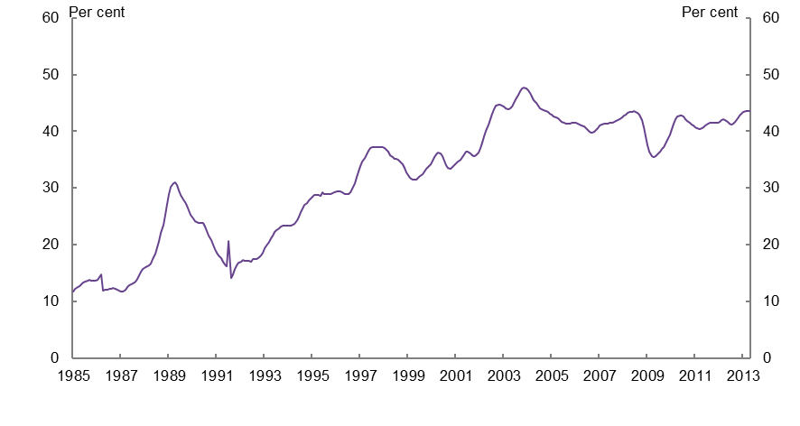

Figure 1.3b Investor value of mortgage commitments ($’000,000) for home purchase (monthly), Australia
Source: ABS 2013 Housing Finance (trend), Australia, cat no. 5609.0.

Mortgage terms not a clear reason for weak market demand
While the volume of mortgage activity provides a strong indication of activity in the market place, the terms on which mortgage commitments are made can have an impact on the overall amount of borrowing for housing purchase and, therefore, on broader activity in the market place. Evidence from overseas illustrates how market demand can significantly increase when credit conditions and accessibility are less constrictive. In particular, these factors led to the sub-prime build up in the US in the early and mid-2000s.
Leading up to the GFC, Australia did not experience the deterioration in lending standards seen in some other economies. While interest rates reduced in several other developed economies at the start of the 2000s, they rose steadily from 2002 until 2008 in Australia. This fact may have limited the appetite of more marginal borrowers to take out a mortgage (and the willingness of lenders to lend to them).
The way loans perform and, specifically, their levels of default, provides some indicator of lending standards. As Figure 1.4 shows, the share of mortgages in arrears has fallen steadily since 2011. Australian levels of arrears are low by international standards, remaining well below 1 per cent even at the recent peak, despite mortgage interest rates being higher than in most other countries. As expected, there is a correlation between mortgage default and interest rates. However, periods of rising rates in Australia have coincided with only modest increases in the share of mortgage holders defaulting. This supports the view that lending standards did not weaken in the early to mid-2000s and, where they may have, it was certainly not to the same degree as in many other developed economies.
Figure 1.4 Mortgage default rates (quarterly), Australia
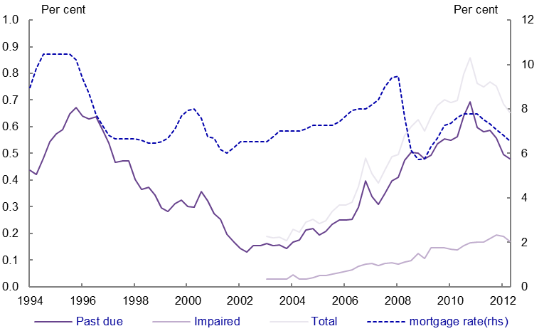
Source: Reserve Bank of Australia, Financial Stability Review, March 2013 and Indicator Lending Rates –F5.
Note: Past due is defined as a loan that is 90 days or more past due but is well secured. The mortgage rate is banks’ standard variable rate.

The share of loans taken out at high loan-to-value ratios (LVRs)—that is, 90 per cent plus—is a useful proxy for lender and borrower risk appetite. There was a clear tightening of risk appetites immediately after the GFC, with the share of loans that were taken at high LVRs by owner occupiers falling from 25 percent in early 2009 to around 11 per cent in mid-2010. This share returned to around 17 per cent in late 2011 and has held reasonably steady since.
Some of this change was driven by the changing composition of those who were taking out loans. First-home buyers are more likely than existing owners to take out high LVR loans. Their increase in the market share of mortgages following the GFC therefore would have boosted the share of high LVR loans.
The share of loans that were high LVR and taken by investors, however, fell from around 14 per cent in early 2009 to around 7 per cent in mid-2010. It then increased to 10 per cent in late 2011, where it has since held reasonably stable (Figure 1.5).
Figure 1.5 New mortgages by loan-to-value ratio (LVR) (quarterly), Australia
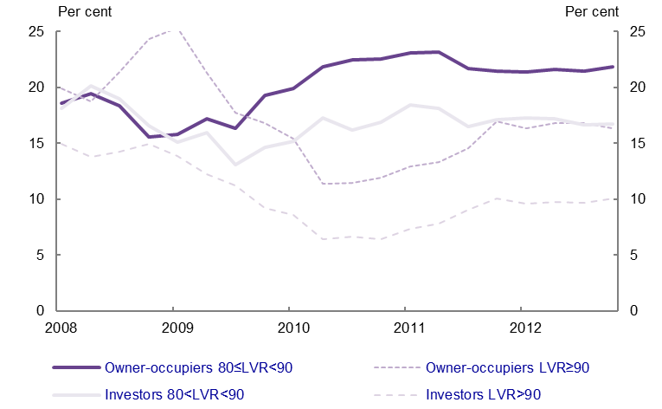
Source: Reserve Bank of Australia, Financial Stability Review, March 2013.
Note: LVR = loan-to-value ratio. Data are back-cast before December 2010 to adjust for a reporting change by one bank.

Changes in mortgage criteria alone do not necessarily indicate changes in market demand for housing. A wide range of factors influence financial institutions’ decisions on lending criteria and pricing. Mortgage availability and cost will influence market demand, but market demand will also influence financial institutions’ decisions around lending criteria. For example, a larger share of loans taken at high loan-to-value and loan-to-income ratios may indicate rising market demand. On the other hand, this may indicate financial institutions relaxing lending standards and looking to increase lending volumes, which in turn can fuel demand. A dramatic example of this occurred in the build-up to the sub-prime crisis in the US.
Broadly speaking, the terms of new mortgages have been relatively stable since 2011. Although there is a slight decline compared to activity before the GFC, this suggests the availability of mortgage credit is currently ‘neutral’ for market demand for housing.

Building approvals
In the past the Council has tended to view building approvals as a leading indicator of the volume of new housing supply. However, it is worth noting that building approvals also reflect additional market demand for housing not satisfied by the stock of existing dwellings. Such a measure of demand is closer to the Council’s current consideration of how housing supply responds to changes in aggregate demand.
Approvals are therefore a strong reflection of market demand for new homes. The construction of detached dwellings is now almost universally commissioned by a buyer rather than a developer or builder. The construction of apartments also now generally requires high levels of pre-sales before commencement. As such, most approvals feed through into a dwelling being financed and, ultimately, built. Analysis of ABS building data since 1984 indicates that around 96 per cent of approvals lead to a building commencement and about 98 per cent of commencements result in completed homes. Overall, around 93 per cent of approvals lead to a new dwelling actually being produced.
There is a considerable difference, however, between the share of detached dwellings (traditional houses) and other dwellings (mainly flats and apartments) that proceed from approval to completion. As might be expected, a larger share of approvals for detached homes (95 per cent) than for other dwellings (85 per cent) lead to new homes being built and there are a number of reasons for this. One reason is that detached homes typically only involve one house. If there is a reason to stop building or re-submit for approval, only one dwelling is affected. The same issue for a multi-dwelling structure, however, can lead to postponing or abandoning more than one dwelling. Given that approval granted for several dwellings in one structure is recorded as multiple dwelling approvals, the same issue disproportionately affects approvals of other dwellings.
As the mix of new dwellings changes, these different rates of flow from approval to completion will become more significant. Higher density dwellings, such as apartments and townhouses, have comprised an increasing proportion of new properties in recent years and are gradually accounting for a larger share of the overall stock. This changing mix is reflected in the approvals data. Nonetheless, according to past trends, this also means that a slightly lower share of all approvals will actually result in completed homes, and that approvals data may become a less accurate reflection of current market demand.
Figures 1.6a and 1.6b show how the distribution of approvals between detached houses and other dwellings (apartments and townhouses) has changed. Figure 1.6a shows the overall number of dwellings completed, which remains at a relatively subdued level. Approvals data show the number of new properties being produced and the number actually completed have been gradually declining over the last decade, apart from a brief pick-up in 2010. This decline is important particularly when it is assessed in the context of an increasing number of people and households. Figure 1.6b shows the proportionate split between housing approvals and other dwelling approvals. It is evident that, since 2009, other dwellings are making up a larger proportion of all approvals.
Figure 1.6a Approvals and expected ‘feed through’ (yearly), Australia
Source: ABS 2013, Building Activity, Australia, cat no 8752 and ABS 2013, Building Approvals, Australia, cat no 8731. NHSC calculations.
Note: Data for houses and for other dwellings are annual totals and include both public and private sector activity. Actual completions is final ABS data apart from 2012, where the fourth quarter is estimated by a typical feed-through into completions based on average rate of completions to approvals for data since 1984. These are gross additions to stock, and so take no account of losses (demolitions and vacant dwellings).

Figure 1.6b Approval proportions (yearly), Australia
Source: ABS 2013, Building Activity, Australia, cat no 8752 and ABS 2013, Building Approvals, Australia, cat no 8731. NHSC calculations.
Note: Data for houses and other dwellings include both public and private sector activity.

The analysis above includes approvals for homes being built for the public sector. Figure 1.6c below displays the level of approvals by sector. Figure 1.6a shows 178,000 new dwellings completed in 2012, up from an average of 147,000 per annum for each year since 1984. Using this measure, market demand was up by around 21 per cent in 2012 compared to the average over the previous 28 years. The 178,000 new homes in 2012 reflect the approval levels seen post-GFC under stimulus measures. It is also worth noting that this analysis is based on gross additions to the housing stock and takes no account of stock losses (demolitions and vacant dwellings).

Figure 1.6c Approvals and expected ‘feed through’ (yearly), Australia
Source: ABS 2013, Building Activity, Australia, cat no 8752 and ABS 2013, Building Approvals, Australia, cat no 8731. NHSC calculations.

Prices
Movements in dwelling prices are the most commonly cited indicator of the balance between market supply and demand. Transacted price data show what has happened to the price of properties that are bought and sold during a period. These data reflect how market demand and supply, across the entire purchase market, are reconciled. All other things being equal, when dwelling prices increase at a faster rate than incomes and prices for consumer goods, one should generally assume a shortage of supply relative to market demand. Yet all other things are rarely equal.
Figures 1.7 and 1.8 show how real median dwelling prices have evolved across the capital cities since 1990, after adjusting for consumer price inflation. For individual capital city median dwelling prices, see Figures A1.1 to A1.8 of the Appendix.

Figure 1.7 Real median dwelling prices, Sydney, Melbourne, Brisbane, Adelaide
Source: RP Data Rismark, unadjusted median price, all dwellings. ABS 2013, Consumer Price Index, Australia, June 2013, cat no 6401.
Note: Prices are benchmarked for March 2013 and adjusted to real terms using the Consumer Price Index (CPI) for each capital city. Monthly RP Data has been aggregated to quarterly data.

Figure 1.8 Real median dwelling prices (monthly), Perth, Hobart, Darwin, Canberra
Source: RP Data Rismark, unadjusted median price, all dwellings. ABS 2013, Consumer Price Index, Australia, June 2013, cat no 6401.
Note: Prices are benchmarked for March 2013 and adjusted to real terms using the Consumer Price Index (CPI) for each capital city. Monthly RP Data has been aggregated to quarterly data.

It is also important to recognise that dwelling prices and, indeed, a good proportion of market demand, are driven by much more than an individual’s or a family’s need for shelter. Dwelling prices also reflect changing aspirations for quality of life, changes in the desirability of particular locations, and anticipation of short and long-term returns on investment. Movements in price therefore merely indicate market demand for additional dwelling supply. They will be heavily influenced by the level, location and quality of existing supply, finance availability and cost, as well as by the needs and expectations of sellers. Moreover, the multitude of factors affecting prices could also mean that price changes might occasionally seem to be at odds with the balance between housing supply and demand.
Over the year to March 2013 broader inflation across Australia was 2.5 per cent, at this time nominal dwelling price growth was about 2 per cent across Australia and higher in Darwin, Perth, Canberra and Sydney , indicating market demand was comparatively strong in these cities. Prices were relatively stable in Melbourne and Adelaide and declined in Brisbane and Hobart, indicating somewhat weaker market demand in those cities.

Auction clearance rates
The activity in auction clearance rates is also relevant when assessing market demand. However, this is by no means a comprehensive measure and is a more important part of the market in Sydney and Melbourne than elsewhere. These two cities account for over 80 per cent of auctions across the country.
There was a pick-up in clearance rates towards the end of 2012, particularly in Sydney. This continued into 2013 when rates were at their highest when viewed against the previous three years (Figure 1.9). As with several other indicators, this points to demand having slightly recovered from recent lows.
Figure 1.9 Auction clearance rates (weekly), Sydney and Melbourne
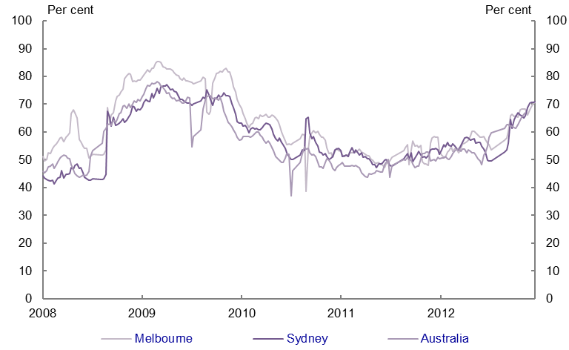
Source: RP Data Rismark, weekly auction data.
Note: Data are a four-week moving average, end year data are smoothed to account for 3-4 weeks of no data during this period.

Rental market
The final component of market demand is the rental market, which overlaps directly and indirectly with the demand to buy. Investors buying property to lease directly affect demand to buy, while tenure decisions determine demand for the occupation of investors’ dwellings.
Movements in rental prices and vacancy rates together help indicate the balance between supply and demand in this market. Figure 1.10 shows recent changes in the median rent for two-bedroom apartments and three-bedroom houses across capital cities. A breakdown of changes for two-bedroom apartments and three-bedroom houses is available for each capital city in Figures A1.9 to A1.17 of the Appendix.

Figure 1.10 Nominal median weekly rent on apartments and houses (quarterly), capital cities
Source: Real Estate Institute of Australia.
Note: Data are median weekly rents paid on three-bedroom houses and two-bedroom units. Based on weighted average of 8 capital cities.

Rental yields that are primarily driven by rents and dwelling values are obviously a key indicator of a property’s attractiveness to investors. While there was a significant drop in yields for all dwellings from 1996 to 2004, yields have since grown at a slow rate, see figure 1.11 and 1.12. As at May 2013, yields were highest in Darwin at 6.2 per cent, while Hobart (5.2 per cent), Brisbane (4.8 per cent), Canberra (4.7 per cent), Perth (4.6 per cent), Adelaide (4.4 per cent) and Sydney (4.4 per cent) were all above the national capital city average of 4.3 per cent. Melbourne yields were at a comparatively low 3.8 per cent.
Figure 1.11 Rental Yields (monthly), Sydney, Melbourne, Brisbane, and Adelaide
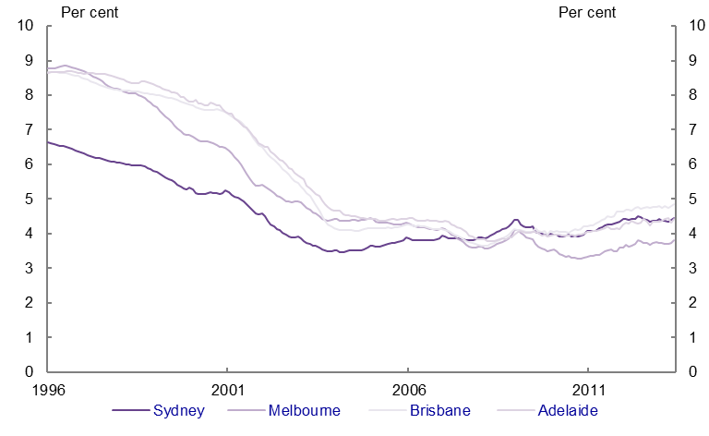
Source: RP Data Hedonic Gross rental yields (Imputation Method).
Note: Data are for all dwellings.

Figure 1.12 Rental Yields (monthly), Perth, Hobart, Darwin, and Canberra
Source: RP Data Hedonic Gross rental yields (Imputation Method).
Note: Data are for all dwellings.

The rental data indicate that national demand for apartments outstrips demand for houses, with rents rising faster in the multi-unit sector since 2006. Over the year to December 2012, the median rent across Australia for a two-bedroom apartment rose by 4.8 per cent to $399 per week, and by 2.5 per cent to $390 per week on a three-bedroom house. These increases were around or above the rate of inflation (2.2 per cent), which suggests relatively strong demand, despite being a little below the growth rates of average rents typical of the last decade.
Vacancy rates of 3 per cent generally indicate a market in equilibrium. By both market and historical standards, rates in all capital cities except Hobart are low, at around 2 per cent, which shows a relatively strong rental demand and a tight market. For a further breakdown of rental vacancy rates across capital cities, see Figures A1.18 to A1.25 in the Appendix.
It should be noted that, while this report has employed REIA data across a range of topics, the methodology used for its vacancy rate data has previously been questioned due to coverage and transparency issues. Another source of information on vacancies is the data used by Earthsharing Australia in its Speculative vacancies in Melbourne: 2012 report, which measures vacancy rates by estimating the number of long-term vacant properties that could potentially be placed on the rental market to increase supply. It thereby picks up not only rental vacancies, but also vacancies due to factors like second homes and normal transitions in ownership. The report establishes long-term vacant properties as those with a low water consumption rate over a six-month period.
The report, therefore, gives a potential measure of vacancy generally, rather than necessarily a measure of how many unoccupied properties are available for occupation. That said, the report estimates Melbourne's vacancy rate to have been 5.9 per cent in 2011, compared to REIA’s average over 2011 of 2.1 per cent.

Conclusions
A wide range of factors drive market demand. Market demand is far more volatile and cyclical in nature than underlying demand. However, these two types of demand do influence each other. On the one hand, population and household formation changes affect the long-term trajectory of housing supply. On the other, the drivers of market demand may affect the formation of new households. Market characteristics will therefore inevitably play a role in shaping both household formation decisions and underlying demand.
The challenge faced by the building industry is that its product must both respond to and work within market demand, which is established in relation to current costs and prices. Since the turn of the millennium, housing has clearly become more expensive in both absolute and relative terms, as well as in both the rental and owner occupier markets. It is therefore unsurprising to see relatively lower market demand.
There have been some signs that, when developers can produce housing at the more affordable end of the spectrum, there is a strong current demand that is ready to be tapped into. This indicates, among other things, that there is a pool of underlying demand that could become market demand if the cost of housing was lower.
Most market indicators continue to point to an environment of relative uncertainty and risk aversion fostering relatively low levels of demand. Prices have edged upward in many places. While activity levels have increased from GFC lows, they are slightly down on subsequent stimulus-induced activity, and slow by historic comparison.

SGS Economics and Planning, Infrastructure investment and housing supply, 2013.
The RBA cut its official cash rate by a cumulative 1.25 percentage points over 2012. Over the same period, average standard variable mortgages rates for the banks declined by 0.85 percentage points and three-year fixed rates by 0.80 percentage points (RBA Statistical tables, F5 Indicator Lending Rates).
While difficult to make direct comparisons due to different definitions, the RBA reported that around 0.8 per cent of mortgages were 90 days or more past due in Australia at the end of 2012 - see p.47 Financial Stability Review (http://www.rba.gov.au/publications/fsr/2013/mar/pdf/0313.pdf)The Mortgage Bankers Association reported a rate of around 7 per cent of mortgages being 90 days or more behind or in the process of foreclosure in the USA. The Council of Mortgage Lenders reports that around 1.9 per cent of mortgages are in arrears of at least three months in the UK.
It should be noted that this analysis is based on approvals, commencements and completions for the same periods over 28 years. In reality, there is a time-lag between each stage, and this lag will vary at different times. It is not possible to track cases individually, but the long-time period should ’iron out’ volatility. However, there is a small margin of error around the analysis and estimates should be taken as indicative rather than as precise.
RP data Stratified Median Indices at June 2013
Source: Analysis of data from RP Data-Rismark since 2008.
Real Estate Institute of Australia
ABS (2013) Consumer Price Index, Australia, Jun 2013, Cat no 6401.0
Source: Real Estate Institute of Australia.

