Monthly Pay As You Go Instalments
for Large Taxpayers

Consultation Paper
February 2013

© Commonwealth of Australia 2013
ISBN 978-0-642-74884-3
This publication is available for your use under a Creative Commons BY Attribution 3.0 Australia licence, with the exception of the Commonwealth Coat of Arms, the Treasury logo, photographs, images, signatures and where otherwise stated. The full licence terms are available from http://creativecommons.org/licenses/by/3.0/au/legalcode.
Use of Treasury material under a Creative Commons BY Attribution 3.0 Australia licence requires you to attribute the work (but not in any way that suggests that the Treasury endorses you or your use of the work).
Treasury material used 'as supplied'
Provided you have not modified or transformed Treasury material in any way including, for example, by changing the Treasury text; calculating percentage changes; graphing or charting data; or deriving new statistics from published Treasury statistics — then Treasury prefers the following attribution:
Source: The Australian Government the Treasury
Derivative material
If you have modified or transformed Treasury material, or derived new material from those of the Treasury in any way, then Treasury prefers the following attribution:
Based on The Australian Government the Treasury data
Use of the Coat of Arms
The terms under which the Coat of Arms can be used are set out on the It’s an Honour website (see www.itsanhonour.gov.au)
Other Uses
Inquiries regarding this licence and any other use of this document are welcome at:
Manager
Communications
The Treasury
Langton Crescent Parkes ACT 2600
Email: medialiaison@treasury.gov.au

Request for feedback and comments
The Government seeks your feedback and comments on the proposals outlined in this consultation paper. The information obtained through this process will inform the Government’s approach on the way forward and also assist in meeting the requirements of the Office of Best Practice Regulation.
While submissions may be lodged electronically or by post, electronic lodgement is preferred. For accessibility reasons, please email responses in a Word or RTF format. An additional PDF version may also be submitted.
All information (including name and address details) contained in submissions will be made available to the public on the Treasury website, unless you indicate that you would like all or part of your submission to remain in confidence. Automatically generated confidentiality statements in emails do not suffice for this purpose. Respondents who would like part of their submission to remain in confidence should provide this information marked as such in a separate attachment. A request made under the Freedom of Information Act 1982 for a submission marked ‘confidential’ to be made available will be determined in accordance with that Act.
Closing date for submissions: Wednesday, 13 March 2013
Email: | monthlyPAYG@treasury.gov.au
Mail: | General Manager  Corporate and International Tax Division  The Treasury  Langton Crescent  PARKES ACT 2600
Enquiries: | Enquiries can initially be directed to Chris Lyon
Phone: | 02 6263 3102

Contents
Foreword 1
1. Background 2
2. Timeline 2
3. Outline of the current Pay As You Go Instalment System 3
3.1 Intent 3
3.2 Application 3
3.3 Paying instalments 3
3.4 Operation of the PAYG instalment system 4
3.5 Varying instalment rates 6
4. Introducing monthly Pay As You Go Instalments 7
4.1 Proposed application 7
4.2 System operation 8
5. Entering and exiting monthly PAYG instalments 9
5.1 Entry and exit in transitional years 10
5.2 Entry and exit in the mature system 11
6. Improving the calculation of instalment income 13

Foreword

I am pleased to release this consultation paper on the Gillard Government’s proposed reform to the timing of tax instalments for large corporate tax entities. The total tax paid by large entities will not change, but they will be required to remit their PAYG instalments monthly, not quarterly.
This will make the tax system more responsive, efficient and consistent. It will better match tax collections with the economic conditions faced by business, and for many entities will align the timing of their income tax instalments with their GST payments.
Most large corporate tax entities are currently required to pay their income tax in four quarterly PAYG instalments, and their GST in monthly payments. Given that wage and salary earners have tax withheld from their income as it is earned, the Government believes that it is reasonable and logical for large corporate tax entities to do the same.
This change continues the reform of the company tax instalment system that began in the late 1980s and complements other initiatives the Government has announced to address timing disparities in the tax system, such as 'loss carry-back', which allows businesses to use losses more flexibly.
This paper sets out the proposed implementation and design details for the change to the timing of PAYG instalments for large corporate tax entities, and I encourage all interested parties to participate in the consultation process.

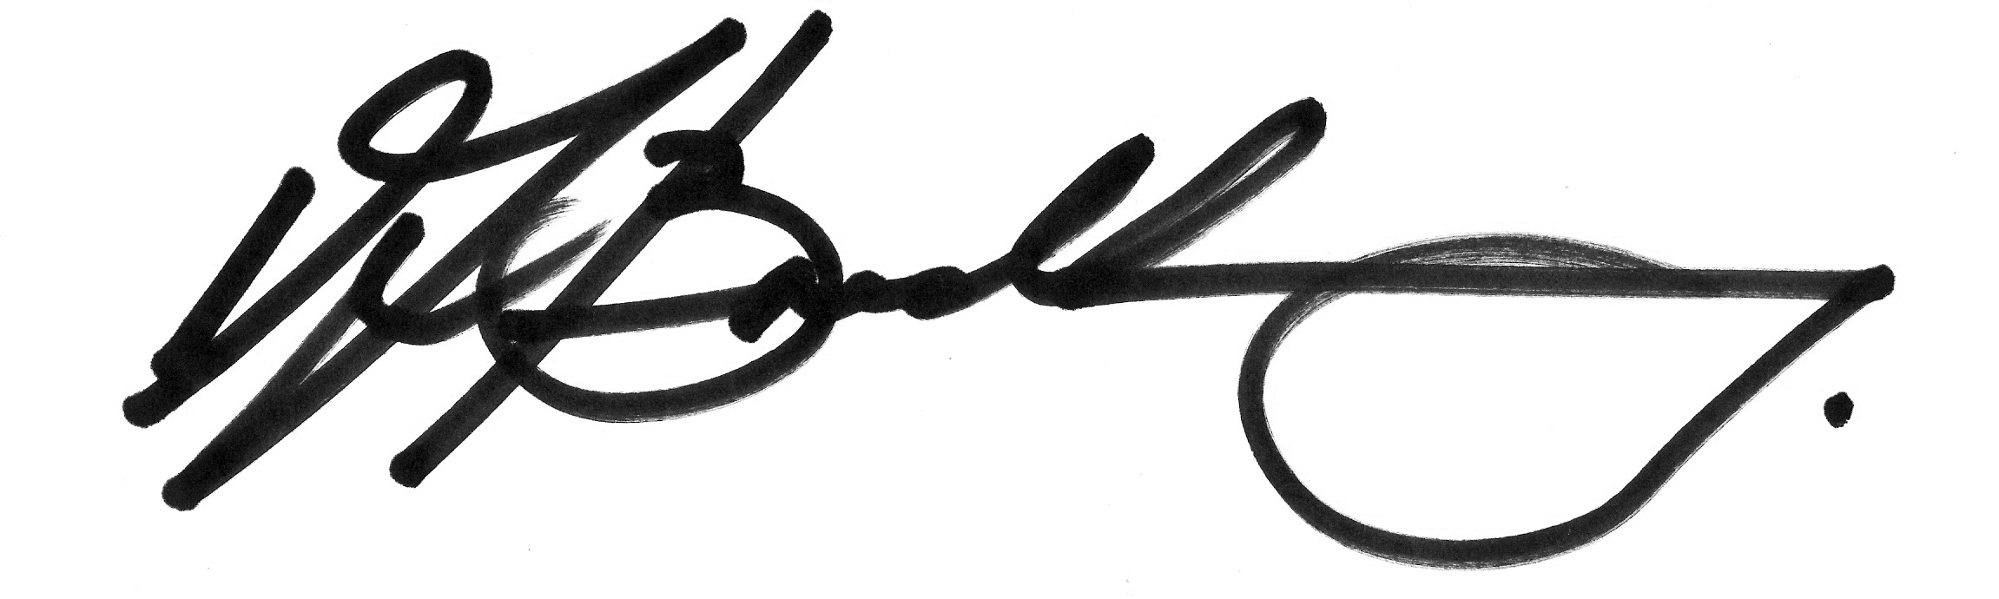
The Hon David Bradbury MP
Assistant Treasurer

Background
- On 22 October 2012, as part of the 2012-13 Mid-Year Economic and Fiscal Outlook (MYEFO), the Australian Government announced a three year process to reform the timing of large companies’ Pay As You Go (PAYG) instalments.
- The change continues the reform of the company tax instalment system that began in the late 1980s and complements other initiatives the Government has announced to address timing disparities in the tax system.
- The Government will better align tax instalments for large companies with their income and trading conditions by requiring them to make PAYG instalments monthly, rather than quarterly. This will make the tax system more responsive, efficient and consistent and will better match tax collections with the economic conditions faced by business.
- The total tax paid by companies will not change, but from 1 January 2014 companies who meet or exceed the threshold of $1 billion will be required to remit their PAYG instalments monthly, not quarterly. Companies that meet or exceed the threshold of $100 million will have a further one year period to prepare for this change, with monthly payments to start from 1 January 2015. Companies who meet or exceed the threshold of $20 million will have over three years to prepare for the change, with monthly payments to start from 1 January 2016.
- Through this consultation, the Government is consulting on additional reforms to the calculation of PAYG instalments that could complement this measure and ensure that total instalments paid throughout the year match the final tax liability as closely as possible.

Timeline
- Feedback and comments are sought on the issues outlined in this consultation paper by Wednesday, 13 March 2013.
- Exposure draft legislation (with explanatory material) will be released as soon as possible after consultation on this consultation paper closes. The intention is to provide a three week period for the public to comment on the exposure draft.
- The Bill will then be finalised with a view to being introduced and passed during the Winter 2013 Parliamentary sittings.

Outline of the current Pay As You Go Instalment System

Intent
- The PAYG withholding and instalments system was established in 1999 under the A New Tax System (Pay As You Go) Act 1999 and applied from the 2000-2001 income year. It replaced a number of income tax collection systems with one simplified system.
- An entity’s actual income tax liability is worked out at the end of the income year when that entity lodges its income tax return. The aim of instalment payments is for entities to make provisions for their final income tax liability by making instalment payments throughout the year. Any PAYG instalment amounts incurred throughout the year are then credited against the end of year assessment. The intent is that the amount payable, or refunded, upon assessment is as small as possible.

Application
- Companies are not the only entities captured by the PAYG system. If an entity earns business and/or investment income, they are required to pay PAYG instalments toward their income tax liability if they have been provided with an instalment rate by the Commissioner. The term ‘entity’ encompasses a number of different types of taxpayers, including companies, trusts, superannuation funds and individuals. In accordance with the Commissioner’s existing administrative policy, a taxpayer will be provided with an instalment rate if:
- the entity shows $2,000 or more in gross investment and business income (excluding any capital gains) in their last income tax return;
- the assessment of the entity’s last income tax return resulted in a tax bill of more than $500 (disregarding any voluntary payments or PAYG instalment credits that were applied);
- an entity’s notional tax is more than $250; and
- the entity is not entitled to the Seniors and Pensioners Tax Offset.

Paying instalments
- Most entities in the PAYG instalment system are required to pay quarterly PAYG instalments. Some are eligible to pay their PAYG instalments annually or twice annually if they meet certain criteria, although most of these entities will not exceed the turnover threshold to be affected by this measure.
- Entities paying quarterly PAYG instalments receive an instalment notice during the last month of the quarter in question. These notices are to be lodged in the month immediately following the end of the quarter.
- Some entities can pay their quarterly instalments on the 28th day following the end of the instalment period. However, most entities that will be affected by this measure are required to pay their instalments by the 21st day of the month immediately following the end of the quarter, in line with the diagram below.
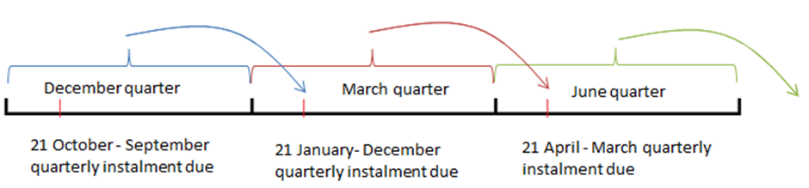
- Final income tax returns are to be lodged by the 15th day of the seventh month after the end of their income year.

Substituted Accounting periods
- Some entities in the PAYG instalment system do not have the standard 1 July to 30 June income year, but instead have substituted accounting periods. Such entities have income years that end on days other than 30 June, such as 30 September or 31 December. This affects when they are required to lodge their income tax returns and make their final income tax payments. It also means that changes that apply from the first day of their new income year would apply from dates like 1 October or 1 January, rather than 1 July.
- Most entities that use substituted accounting periods still have quarters that align with the standard January-March, April-June, July-September, October-December quarters. In these cases their instalments remain payable in the month immediately following the end of the quarter.
- However, a small number of entities use quarters that fall outside the standard schedule, and instead have quarters that encompass, for example, December-February or May-July. For these entities, their first PAYG instalment quarter is considered to constitute the first three months of their income year, quarter two will encompass months four, five and six, quarter three months seven, eight and nine, and quarter four the final three months of the income year. These entities still have instalments that remain payable in the month immediately following the end of their quarters.

Operation of the PAYG instalment system
- The aim of instalment payments is for entities to make provision for their final income tax liability for the year by paying instalments progressively throughout the year.
- The PAYG instalments system offers entities two reporting options to calculate and pay their instalments:
- pay a PAYG instalment amount (this amount is calculated using the gross domestic product (GDP)-adjusted notional tax method); or
- calculate and pay PAYG instalments using instalment income x instalment rate.
- An entity’s instalment income for a period includes the entity’s ordinary income derived during that period, but only to the extent that it is assessable during the income year under consideration. Ordinary income includes amounts such as sales, fees, interest, dividends (excluding franking credits) and royalties. Statutory income, such as capital gains, is not as a general rule included as part of a taxpayer’s instalment income.
- Full self–assessment entities (for example companies and superannuation funds) that choose the GDP-adjusted notional tax method as a basis upon which to calculate their instalments, must satisfy one of the following:
- their base assessment instalment income is $2 million or less;
- they have a base assessment instalment income of more than $2 million and also qualify to be an annual PAYG instalment payer; or
- they are a small business entity.
- In these cases, the Commissioner uses that entity’s GDP-adjusted notional tax as a basis upon which to calculate their instalments.
- However most entities that would be affected by the proposed changes are required to calculate their own quarterly instalment payments using the formula:
applicable instalment rate x instalment income for the quarter
- The applicable instalment rate will be either the latest instalment rate an entity has received from the Commissioner or a varied rate calculated by the entity.
- Generally, entities that use the instalment rate methodology receive a statement each quarter from the Commissioner that states their applicable instalment rate. At the end of the quarter, the entity is then required to record their instalment income for the quarter to calculate their quarterly liability. Under the proposed measure the calculation of instalment rates would remain the same. Entities would receive the instalment notices monthly and would enter their monthly instalment income instead of their quarterly instalment income.

Current annual timeline of quarterly PAYG instalment system operation (June balancer)
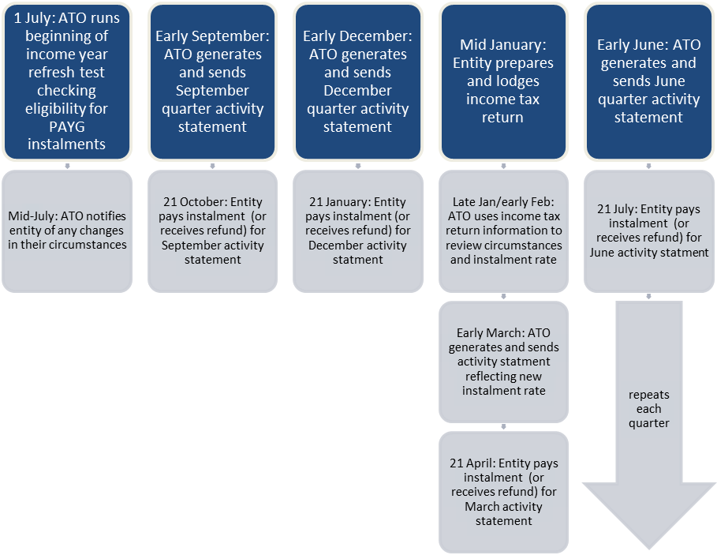

- Entities in the PAYG instalment system that use substituted accounting periods instead of the standard 1 July to 30 June income year follow the same process, just at different times of the year. As explained above, their first PAYG instalment quarter will encompass the first three months of their income year, the second will consist of months four, five and six, and so on. They will lodge their income tax returns by the 15th day of the seventh month after the end of their income year, like standard June balancers.

Varying instalment rates
- The Commissioner’s instalment rate is based on data from the most recent tax assessment or amendment. However, an entity that pays quarterly instalments may choose to calculate a different instalment rate if their circumstances change — for example they expect to undertake a significant program of expansion or investment — and they believe that the Commissioner’s rate is not appropriate for the current income year.
- If an entity chooses to vary their instalment rate they must choose a rate that closely reflects their anticipated income tax liability. The general interest charge (GIC) may be applied if an entity’s instalment rate is found to be less than 85 per cent of the benchmark instalment rate (which is determined by the Commissioner after the taxpayer’s income tax return is lodged). This is to avoid an entity deferring payment by varying their instalment rate down to far (such as to zero) and paying most or all of their tax after the end of the income year.
- Under the proposed changes, affected entities will retain the ability to vary instalment rates and will have more opportunities to vary throughout the year.

Introducing monthly Pay As You Go Instalments
- The tax system will be made more efficient, consistent and responsive by requiring large corporate tax entities, that is, companies and entities taxed like companies, to pay their PAYG instalments monthly rather than quarterly.
- This will make tax payments more contemporaneous with income earnings, and for many entities, will align their PAYG instalments with their GST payments.

Proposed application

Overview
- Monthly PAYG instalments will apply to large corporate tax entities. For the purposes of this measure, ‘large’ will be defined as having base assessment instalment income of $20 million or more.
- Corporate tax entities that meet or exceed the $20 million base assessment instalment income threshold but pay their GST quarterly or annually will not be required to move to monthly PAYG instalments unless:
- they are a head company of a consolidated group;
- they are a provisional head company of a multiple entry consolidated (MEC) group; or
- they meet or exceed the $100 million base assessment instalment income threshold.
- In order to make the transition as smooth as possible, large corporate tax entities will be moved to monthly PAYG instalments in three stages.
  - Corporate tax entities that meet or exceed the $1 billion base assessment instalment income threshold will pay their instalments monthly from their first instalment period commencing on or after 1 January 2014.
  - Corporate tax entities that meet or exceed the $100 million base assessment instalment income threshold will pay their instalments monthly from their first instalment period commencing on or after 1 January 2015.
  - Corporate tax entities that meet or exceed the $20 million base assessment instalment income threshold will pay their instalments monthly from their first instalment period commencing on or after 1 January 2016.
- After 1 January 2016, corporate tax entities that newly meet or exceed the $20 million base assessment instalment income threshold will pay their PAYG instalments monthly from the commencement of their subsequent income tax year.

Base Assessment Instalment Income Threshold Test
- For the purposes of this measure, entry to the PAYG instalment system will be based on a corporate tax entity’s base assessment instalment income. This basis is already used to calculate instalment rates for entities in the PAYG instalment system.
- A corporate tax entity’s base assessment instalment income is so much of that entity’s assessable income from their most recent tax assessment as is determined to be instalment income. Further information on the meaning of instalment income is available in section 45-120 of Schedule 1 to the Taxation Administration Act 1953.

Exceptions
- One effect of this change will be to align GST payments and PAYG instalment payments for many corporate tax entities. If an entity’s GST turnover is $20 million or more, they are required to pay their GST monthly. Entities may also elect to pay their GST monthly. The measure will not draw a distinction between entities that choose to pay their GST monthly and those that are required to pay their GST monthly.
- GST turnover is often different to base assessment instalment income. Therefore, there are a number of corporate tax entities who will meet the required base assessment instalment income threshold even though they have a lower GST turnover that allows them to make their GST payments quarterly or annually.
- To avoid imposing undue compliance burdens, corporate tax entities that pay their GST quarterly or annually and have a base assessment instalment income of $20 million to $100 million will not be required to move to a monthly PAYG instalment schedule unless they are also consolidated for income tax purposes. Corporate tax entities not registered for GST will also be required to make monthly payments.
- All corporate tax entities will be required to be monthly PAYG instalment payers, regardless of their GST payment cycle (if any) if:
- their base assessment instalment income is $100 million or more; or
- they are a head company or provisional head company with a base assessment instalment income of $20 million or more.

System operation
- Once established, the changes to the PAYG instalment system will operate much like the current PAYG instalment system.
- Once an entity is a monthly payer for PAYG instalment purposes, it will continue to receive instalment notices as described in part 3, only on a monthly rather than a quarterly schedule. Instalment notices will remain payable on or before the 21st (or 28th) day of the month immediately following the month in which the notice is issued. Final income tax returns will remain due by the 15th day of the seventh month after the end of the income tax year.
- The methodology used to determine a corporate tax entity’s instalment rate will remain the same, and the size of instalment payments will still be calculated by applying a corporate tax entity’s instalment rate to their instalment income for that period. However the period in question will change from ‘annual’ or ‘quarter’ to ‘month’. The formula for calculating instalment payments will become:
applicable instalment rate x instalment income for the month
- The ATO will still recalculate and re-issue instalment rates upon the receipt of a new income tax return or if an amended income tax assessment is issued. Corporate tax entities will retain the ability to vary their instalment rates and, with monthly instalments, will have more opportunities to vary throughout the year.
- Entities affected by this measure will be expected to report and pay their instalments electronically.

Operation of mature monthly PAYG instalment system (June balancer)
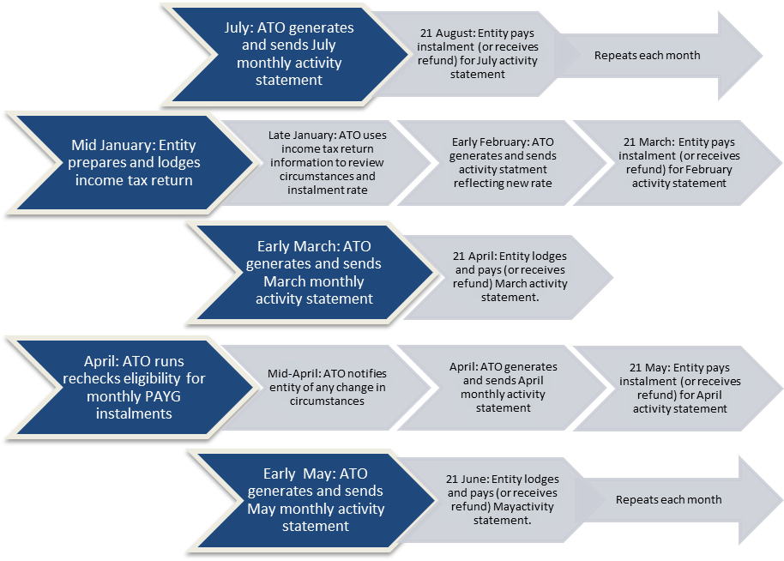

Entering and exiting monthly PAYG instalments
- Corporate tax entities that meet the relevant base assessment instalment income threshold will be required to become monthly payers for PAYG instalment purposes. This process will be different in the transitional years and in the mature system.

Entry and exit in transitional years
- The diagram below sets out an example of how a June-balancing corporate tax entity with a base assessment instalment income of $1.5 billion would be brought into the system on 1 January 2014.

Entry into the monthly PAYG instalment system — transitional year
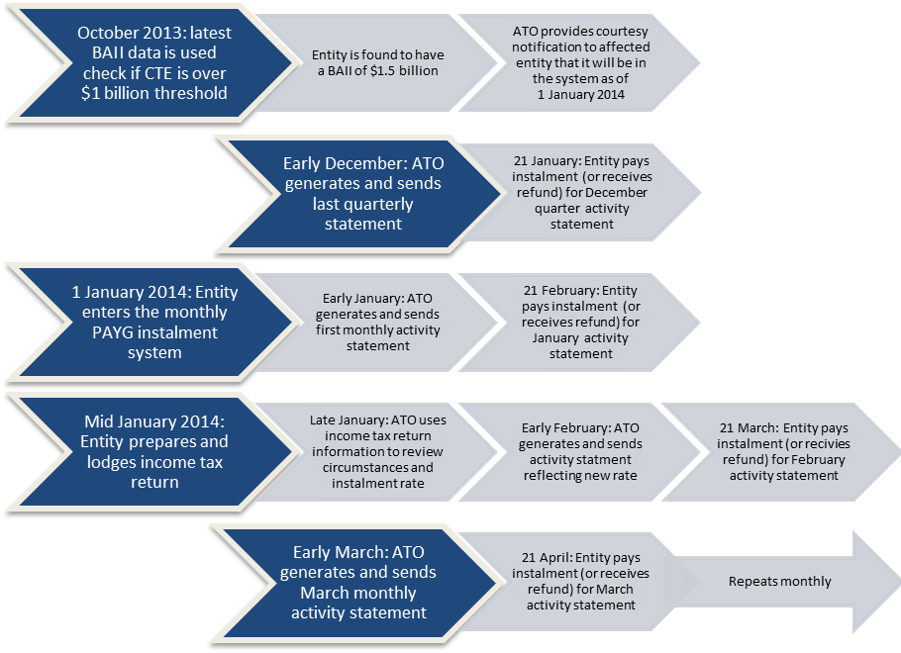
- CTEs will self-evaluate on 1 October 2013 whether they are required to pay their PAYG instalments monthly. This evaluation, known as the ‘interim test day’ will be based on the information available to the entity at the end of the day immediately prior to 1 October 2013. Thus it will be based on the most recent base assessment instalment income assessment and GST status of the entity on 30 September 2013.
- Where an entity is required to move to monthly PAYG instalments, the entity will move as of its first instalment period commencing on or after 1 January 2014.
- For entities that do not use substituted accounting periods, this first instalment period will commence on 1 January 2014. For corporate tax entities with substituted accounting periods this will be at the first instalment period that commences after 1 January 2014. This means that entities that are required to pay PAYG instalments monthly are not required to change their payments mid-instalment period.
- Corporate tax entities moving to a monthly payment schedule will receive their last quarterly instalment notice in early December 2013, payable on 21 (or in some cases 28) January 2014. They will then receive their first monthly instalment statement in early January 2014, to be paid by 21 (or 28) February 2014.
- Corporate tax entities that are June balancers will generally lodge an income tax return in January 2014. The Commissioner will use information from this return to recalculate the corporate tax entity’s base assessment instalment income and instalment rate. Unless the corporate tax entity has elected to vary their instalment rate, subsequent instalment notices will include the new instalment rate. The same process will be performed when corporate tax entities that use substituted accounting periods lodge their income tax returns or when a corporate tax entity lodges an amended assessment.
- Corporate tax entities will also be required to assess whether they are required to pay PAYG instalments monthly on the first day of the tenth month of their income tax year. This is known as the ‘test day’. This assessment will be based on the most recent base assessment instalment income and GST status of the entity at the end of the day immediately prior to the ‘test day’. For standard June balancers, the ‘test day’ will be on 1 April 2014.
- For corporate tax entities that assess that they are required to pay PAYG instalments monthly on the ‘test day’, they will commence monthly PAYG instalments from the start of the next income year. For June balancers this will be 1 July 2014.
- The 2014 ‘test day’ evaluation may show that some corporate tax entities that were obliged to become monthly PAYG instalment payers on 1 January 2014 have since fallen below the $1 billion threshold. For example, a corporate tax entity with a base assessment instalment income of $1.1 billion in October 2013 may lodge its tax return in January 2014 and find its base assessment instalment income has fallen to $950 million, below the 2014 threshold.
- Corporate tax entities that drop below one of the transitional thresholds during the transitional years will only be able to revert to quarterly payments if their base assessment instalment income drops below the final threshold of $20 million. This will avoid corporate tax entities reverting to quarterly instalments after six months, only to become obliged to return to making monthly instalment payments when the threshold is further reduced six months later.
- The process will then begin again in October 2014, when corporate tax entities undertake a second ‘interim test day’ to see if they are required to pay their PAYG instalments monthly based on a base assessment instalment income of $100 million or more, ready for the second tranche beginning on 1 January 2015. The transitional process will begin for a final time in October 2015 when corporate tax entities undertake a third ‘interim test day’ to see if they are required to pay their PAYG instalments monthly based on a base assessment instalment income of $20 million or more, ready for the final tranche of movement to begin on 1 January 2016.
- During this transitional period corporate tax entities will not be able to exit monthly PAYG instalments by an ‘interim test day’ assessment. Entities in the system will only be able to move to another PAYG instalment cycle by a ‘test day’ assessment.

Entry and exit in the mature system
- In the mature system, corporate tax entities will assess annually whether they are required to pay or to continue to pay their PAYG instalments monthly. This assessment will occur on the first day of the 10th month of their income year (the ‘test day’). For ordinary June balancers this check will be run on 1 April and affected entities will move into the monthly PAYG instalment system on 1 July of their next income year. The first monthly instalment notice will be received in the first month after the start of the new income year.
- For corporate tax entities currently paying PAYG instalments monthly, if the ‘test day’ assessment shows that the entity is no longer required to pay PAYG instalments monthly, because the corporate tax entity has fallen below the $20 million threshold or its GST status has changed, the corporate tax entity will be required to notify the Commissioner in the approved manner before the end of its current income tax year if it wishes to return to quarterly payments; otherwise it will remain a monthly PAYG instalment payer for the entire subsequent income tax year.

Exit from monthly PAYG instalments (June balancer) — mature system
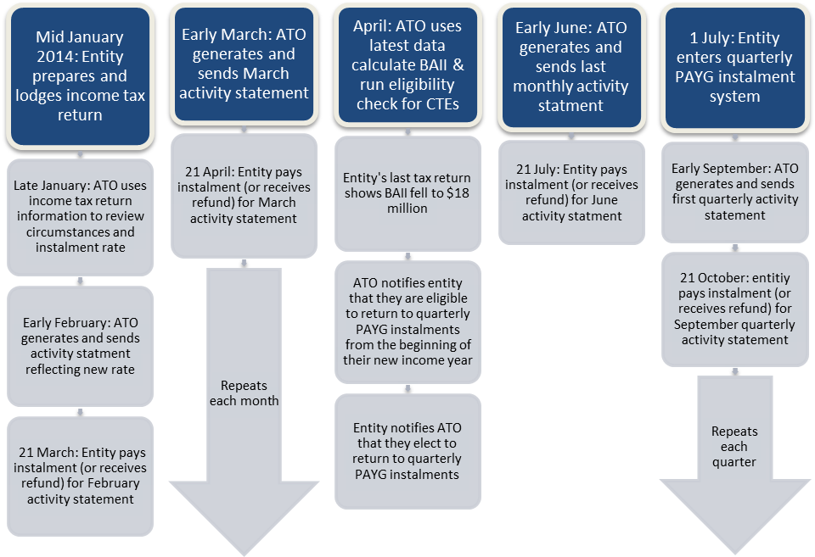
- Similar to the current PAYG instalments system, after the transitional period corporate tax entities will only be able to move into or out of the PAYG instalment system at the beginning of their income year. This is regardless of their GST registration or reporting status. Even if a corporate tax entity who is a voluntary monthly GST payer moves to quarterly GST payments mid-year, they will still not be able to become a quarterly payer for PAYG instalment purposes until the beginning of their next income year.

Improving the calculation of instalment income

Current instalment calculation method
- The purpose of the PAYG instalment system is for taxpayers to make provisions for their final income tax liability by paying instalments progressively throughout the year. Ideally, instalments should approximate the final tax that an entity will be liable for at the end of the income year — entities do not want to overpay their tax throughout the year or be left with an unexpectedly large tax bill at the end of the year.
- The Commissioner attempts to achieve this by giving entities in the PAYG instalment system an instalment rate to apply to instalment income earned in the relevant period.
- The instalment rate is calculated by the Commissioner using the formula:
notional tax / base assessment instalment income x 100
- Notional tax removes one-off income sources and tax offsets from the previous year’s assessment. By combining this with base assessment instalment income, which also removes one-offs, it seeks to approximate an entity’s effective tax rate. By applying this tax rate to a period’s instalment income, an entity can pay instalments that closely reflect their final tax liability for the year.
- Notional tax is calculated by subtracting the adjusted tax payable on adjusted withholding income from the adjusted tax payable on adjusted taxable income.
- Adjusted taxable income is an entity’s total assessable income from its most recent income tax assessment, reduced by deductions (except tax losses), capital gains, and tax losses that are carried forward to the next income year. Adjusted tax is the tax payable on adjusted taxable income, disregarding a number of tax offsets such as a tax offset for franking deficit tax liabilities.
- An entity’s instalment income for a period includes the entity’s ordinary income derived during that period, but only to the extent that it is assessable during the income year under consideration. Ordinary income includes amounts such as sales, fees, interest, dividends (excluding franking credits) and royalties. Statutory income, such as capital gains, is not as a general rule included as part of a taxpayer’s instalment income.

Possible areas for improvement
- Circumstances can change throughout the year, and instalment payments may not accurately reflect an entity’s actual income tax liability. While entities are able to vary their instalment rate throughout the year to better match their final income tax liability, many entities are reluctant to take advantage of this option.
- As such, improving the timing of payments is only one part of helping PAYG instalments to better reflect actual economic and trading conditions and seeks suggested additional measures that could be used to better match instalment liabilities to business conditions through this consultation process.
- A significant number of firms also choose to vary their instalments, reinforcing that individual entities have more information about their tax situations than the Commissioner. The Government is interested in ways this information can be better communicated to the Commissioner and better reflected in the calculation of instalment rates.
- Although it is usually not possible to perfectly determine a corporate tax entity’s tax liability each instalment period, the PAYG instalment system is instead designed to give an approximation through the use of instalment income and instalment rates.
- The Government welcomes suggestions as to how it could refine the calculation of instalment income and instalment rates to make this approximation more accurate. Entities varying their instalment rates reinforces that individual entities have more information about their tax situations than the Commissioner, and the Government welcomes suggestions of ways this information can be better communicated to the Commissioner.
- For instance, recent developments in technology and business capabilities have allowed more timely data to be available to both businesses and the ATO. As such, the Government is interested to see how these developments may be harnessed to provide a more accurate method of calculating corporate tax entities’ PAYG instalment rates and reduce compliance and administration costs for businesses.

Further discussion of calculating instalment income and instalment rates is included at Part 7.
Base assessment instalment income is so much of the taxpayer’s income as was taken into account for the taxpayers ‘base year’. The base year is the latest income year for which an assessment has been made (or the latest year where no assessment was lodged as the entity did not have taxable income that year). It is also referenced to as BAII.

