Australian Taxation Office
Investigating Superannuation: Quantitative Investigation with Superannuation Consumers
Final Quantitative Report

Prepared for:
Colmar Brunton undertakes all research projects to the highest possible standards, and in accord with the principles detailed in the ESOMAR Code of Conduct for Market Research. All findings contained in Project Reports are provided solely for use by the client. Copyright is reserved by Colmar Brunton.
www.cbr.com.au
Australian Taxation Office

CONTACTS:
Corey Fisher and James Wunsch

Colmar Brunton Social Research
PHONE
(02) 6249 8566

Issue date:
21 February 2010

Table of Contents

Executive Summary 11
Personal Interest in Superannuation 11
Changes to personal superannuation arrangements 11
Adequacy of Superannuation funds for retirement 11
Employer Super Contributions 12
Choice of super fund 12
Annual statements 13
Range of Investment profiles offered 13
Voluntary Contributions 14
Main Reason for Choosing a Self-Managed Superannuation Fund (SMSF) 17
Level of Activity in Managing SMSF 17
SMSF Reporting Obligations 17
Main Report 18
Interpretative notes 21
Tables and percentages 21
Classification of ratings 21
Significance testing 21
Interpretative notes 22
Tables and percentages 22
Classification of ratings 22
Significance testing 22
Interest 23
Interest in Personal Super Affairs 23
Change in Interest in Personal Super Affairs 25
Reason for Change in Interest in Personal Super Affairs 27
Change to Personal Super Arrangements 29
Advice Regarding Super 31
Source of Advice Regarding Super 33
Super for Retirement 35
Money Needed for Retirement 37
Sufficiency of Super to Fund Retirement 41
Awareness 43
Awareness of Employer Super Contributions 43
Awareness of Employer Super Contribution Payments 45
Main Reason for not checking Super 47
If employer had not contributed to super account 49
Super Fund Choices 51
Choice of super fund 51
Type of super fund chosen 53
Importance 57
Other factors influencing choice of super fund 62
Identification of other influencing factors 64
Annual Statements 65
Received annual statement 65
Use of annual statement 67
Retaining annual statement 69
Main reason for not reading statement 71
Satisfaction with annual statement 72
Investment Profiles 78
Range of Investment profiles offered 78
Voluntary Super Contributions 82
Making Voluntary Contributions 82
Level of voluntary contributions 84
Insurance 90
Super Fund Performance 97
Fees and Charges 111
Sources of information for comparison of fees & charges 116
Investment Performance Tables 119
Retirement Savings Account (RSA) 124
Regulation of the Super Industry 129
Merging Super Funds 131
Lost Super Funds 138
Self-Managed Super Funds 149
Main Reason for Choosing a Self-Managed Superannuation Fund 149
Regularity of Contributions 150
Satisfaction with SMSF 151
Reasons for Satisfaction Level 152
Level of Activity in Managing the Fund 153
Sources of Information on Investment Options for the Fund 154
Perception of Reporting Obligations 155
Assistance with Reporting Obligations 155
Sources of Assistance with Reporting Obligations 156
Encouraging Others to Establish a SMSF 157
Comparison of Fund Performance 157
Reasons for Not Comparing Fund Performance 158
Source of Comparative Information 159
Satisfaction with Information Accessed 160
Interest in Detailed Fund Performance Comparison 161
Perceptions of the Level of Regulation of Superannuation 162
Knowledge of Account Consolidation 163
Interest in Information about Merging Accounts 163
Perceived Benefits of Consolidating Superannuation Accounts 164
Reasons for not Consolidating Accounts 165
Lost Superannuation 165
APPENDIX A: Sample Profile 166
APPENDIX B: Questionnaire – 169

Table of Figures
Figure 1: Survey quotas and sample achieved 19
Figure 2: Interest in Personal Super Affairs 23
Figure 3: Interest in Personal Super Affairs by Employment Status 23
Figure 4: Interest in Personal Super Affairs by Age 24
Figure 5: Interest in Personal Super Affairs by Number of Accounts 24
Figure 6: Change in Interest in Personal Super Affairs 25
Figure 7: Change in Interest in Personal Super Affairs by Employments Status 25
Figure 8: Change in Interest in Personal Super Affairs by Age 26
Figure 9: Change in Interest in Personal Super Affairs by Number of Accounts 26
Figure 10: Reason for Change in Interest in Personal Super Affairs 27
Figure 11: Reason for Change in Interest in Personal Super Affairs by Employment Status 27
Figure 12: Reason for Change in Interest in Personal Super Affairs by Age 28
Figure 13: Reason for Change in Interest in Personal Super Affairs by Number of Accounts 28
Figure 14: Changes to Personal Super Arrangements 29
Figure 15: Changes to Personal Super Arrangements by Employment Status 29
Figure 16: Changes to Personal Super Arrangements by Age 30
Figure 17: Changes to Personal Super Arrangements by Number of Accounts 30
Figure 18: Advice Regarding Super Sought Over Past 12 Months 31
Figure 19: Advice Regarding Super Sought Over Past 12 Months by employment status 31
Figure 20: Advice Regarding Super Sought Over Past 12 Months by Age 32
Figure 21: Advice Regarding Super Sought Over Past 12 Months by Number of Accounts 32
Figure 22: Sources of Advice Regarding Super 33
Figure 23: Sources of Advice Regarding Super by Employment Status 33
Figure 24: Sources of Advice Regarding Super by Age 34
Figure 25: Sources of Advice Regarding Super by Number of Accounts 34
Figure 26: Super for Retirement 35
Figure 27: Super for Retirement by Employment Status 35
Figure 28: Super for Retirement by Age 36
Figure 29: Super for Retirement by Number of Accounts 36
Figure 30: Money Needed for Retirement 37
Figure 31: Money Needed for Retirement by Employment Status 38
Figure 32: Money Needed for Retirement by Age 39
Figure 33: Money Needed for Retirement by Number of Accounts 40
Figure 34: Sufficiency of Super to Fund Retirement 41
Figure 35: Sufficiency of Super to Fund Retirement by Employment Status 41
Figure 36: Sufficiency of Super to Fund Retirement by Age 42
Figure 37: Sufficiency of Super to Fund Retirement by Number of Accounts 42
Figure 38: Awareness of Employer Contributions 43
Figure 39: Awareness of Employer Contributions by Employment Status 43
Figure 40: Awareness of Employer Contributions by Age 44
Figure 41: Awareness of Employer Contributions by Number of Accounts 44
Figure 42: Awareness of Employer Super Contributions Payments 45
Figure 43: Awareness of Employer Super Contributions Payments by Employment Status 45
Figure 44: Awareness of Employer Super Contributions Payments by Age 46
Figure 45: Awareness of Employer Super Contributions Payments by Number of Accounts 46
Figure 46: Main Reason for not Checking Super 47
Figure 47: Main Reason for not Checking Super by Employment Status 47
Figure 48: Main Reason for not Checking Super by Age 48
Figure 49: Main Reason for not Checking Super by Number of Accounts 48
Figure 50: Action if Employer had not Contributed to Super Account 49
Figure 51: Action if Employer had not Contributed to Super Account by Employment Status 49
Figure 52: Action if Employer had not Contributed to Super Account by Age 50
Figure 53: Action if Employer had not Contributed to Super Account by Number of Accounts 50
Figure 54: Choose Own Super Fund 51
Figure 55: Choose Own Super Fund by Employment Status 51
Figure 56: Choose Own Super Fund by Age 52
Figure 57: Choose Own Super Fund by Number of Accounts 52
Figure 58: Type of Super Fund Chosen 53
Figure 59: Type of Super Fund Chosen by Employment Status 54
Figure 60: Type of Super Fund Chosen by Age 55
Figure 61: Type of Super Fund Chosen by Number of Accounts 56
Figure 62: Importance of Factors when Choosing a Super Fund 57
Figure 63: Importance of Factors when Choosing a Super Fund among those who are Employed 58
Figure 64: Importance of Factors when Choosing a Super Fund among those who are Self Employed 58
Figure 65: Importance of Factors when Choosing a Super Fund among non-working consumers 59
Figure 66: Importance of Factors when Choosing a Super Fund among 18-24 year olds 59
Figure 67: Importance of Factors when Choosing a Super Fund among 30-44 year olds 60
Figure 68: Importance of Factors when Choosing a Super Fund among 45+ year olds 60
Figure 69: Importance of Factors when Choosing a Super Fund among those who have a single account 61
Figure 70: Importance of Factors when Choosing a Super Fund among those who have multiple accounts 61
Figure 71: Other Factors Influencing Choice of Super Fund 62
Figure 72: Other Factors Influencing Choice of Super Fund by Employment Status 62
Figure 73: Other Factors Influencing Choice of Super Fund by Age 63
Figure 74: Other Factors Influencing Choice of Super Fund by Number of Accounts 63
Figure 75: Other Influencing Factors 64
Figure 76: Received an Annual Statement 65
Figure 77: Received an Annual Statement by Employment Status 65
Figure 78: Received an Annual Statement by Age 66
Figure 79: Received an Annual Statement by Number of Accounts 66
Figure 80: Use of Annual Statement by Employment Status 67
Figure 81: Use of Annual Statement by Age 68
Figure 82: Use of Annual Statement by Number of Accounts 68
Figure 83: Retaining Annual Statement 69
Figure 84: Retaining Annual Statement by Employment Status 69
Figure 85: Retaining Annual Statement by Age 70
Figure 86: Retaining Annual Statement by Number of Accounts 70
Figure 87: Main Reason for Not Reading Annual Statement 71
Figure 88: Satisfaction with Annual Statement 72
Figure 89: Satisfaction with Annual Statement among those who are Employed 73
Figure 90: Satisfaction with Annual Statement among those who are Self Employed 73
Figure 91: Satisfaction with Annual Statement among those who are Unemployed, Student or Welfare 74
Figure 92: Satisfaction with Annual Statement among those who are 18-29 yrs 75
Figure 93: Satisfaction with Annual Statement among those who are 30-44 yrs 76
Figure 94: Satisfaction with Annual Statement among those who are 45+ yrs 76
Figure 95: Satisfaction with Annual Statement among those with a Single Super Account 77
Figure 96: Satisfaction with Annual Statement among those with Multiple Accounts 77
Figure 97: Range of Investment Profiles Offered 78
Figure 98: Range of Investment Profiles Offered by Employment Status 78
Figure 99: Range of Investment Profiles Offered by Age 79
Figure 100: Range of Investment Profiles Offered by Number of Accounts 79
Figure 101: Type of Investment Profile 80
Figure 102: Type of Investment Profile by Employment Status 80
Figure 103: Type of Investment Profile by Age 81
Figure 104: Type of Investment Profile by Number of Accounts 81
Figure 105: Making Voluntary Contributions 82
Figure 106: Making Voluntary Contributions by Employment Status 82
Figure 107: Making Voluntary Contributions by Age 83
Figure 108: Making Voluntary Contributions by Number of Accounts 83
Figure 109: Level of Voluntary Contributions 84
Figure 110: Level of Voluntary Contributions by Employment Status 84
Figure 111: Level of Voluntary Contributions by Age 85
Figure 112: Level of Voluntary Contributions by Number of Accounts 85
Figure 113: Reasons for change in level of voluntary super contributions in the past 12 months 86
Figure 114: Reasons for change in level of voluntary super contributions in the past 12 months by Number of Accounts 87
Figure 115: Intention to Change Level of Voluntary Super Contributions 88
Figure 116: Intention to Change Level of Voluntary Super Contributions by Employment Status 88
Figure 117: Intention to Change Level of Voluntary Super Contributions by Age 89
Figure 118: Intention to Change Level of Voluntary Super Contributions by Number of Accounts 89
Figure 119: Life Insurance/Total & Permanent Disability Insurance 90
Figure 120: Life Insurance/Total & Permanent Disability Insurance by Employment Status 91
Figure 121: Life Insurance/Total & Permanent Disability Insurance by Age 91
Figure 122: Life Insurance/Total & Permanent Disability Insurance by Number of Accounts 92
Figure 123: Policy Coverage 93
Figure 124: Policy Coverage by Employment Status 93
Figure 125: Policy Coverage by Age 94
Figure 126: Policy Coverage by Number of Accounts 94
Figure 127: Compared Cost & Coverage of Policies with Other Insurers 95
Figure 128: Compared Cost & Coverage of Policies with Other Insurers by Employment Status 95
Figure 129: Compared Cost & Coverage of Policies with Other Insurers by Age 96
Figure 130: Compared Cost & Coverage of Policies with Other Insurers by Number of Accounts 96
Figure 131: Investment Return of Super Fund Last Financial Year 97
Figure 132: Return of Investment of Super Fund Last Financial Year by Employment Status 97
Figure 133: Investment Return of Super Fund Last Financial Year by Age 98
Figure 134: Investment Return of Super Fund Last Financial Year by Number of Accounts 98
Figure 135: Compare Funds Performance Against Investment Benchmarks 99
Figure 136: Compare Funds Performance Against Investment Benchmarks by Employment Status 99
Figure 137: Compare Funds Performance Against Investment Benchmarks by Age 100
Figure 138: Compare Funds Performance Against Investment Benchmarks by Number of Accounts 100
Figure 139: Main Reason for Not Comparing Super Fund Performance Against Other Super Funds or Investment Benchmarks 101
Figure 140: Main Reason for Not Comparing Super Fund Performance Against Other Super Funds or Investment Benchmarks by Employment Status 102
Figure 141: Main Reason for Not Comparing Super Fund Performance Against Other Super Funds or Investment Benchmarks by Age 103
Figure 142: Main Reason for Not Comparing Super Fund Performance Against Other Super Funds or Investment Benchmarks by Number of Accounts 104
Figure 143: Sources of Information - Investment Performance 105
Figure 144: Sources of Information - Investment Performance by Age 106
Figure 145: Sources of Information - Investment Performance by Number of Accounts 106
Figure 146: Satisfaction with Sources of Information 107
Figure 147: Satisfaction with Sources of Information - by those who are employed 108
Figure 148: Satisfaction with Sources of Information - by those aged 30-44 years 108
Figure 149: Satisfaction with Sources of Information - by those aged 45+ years 109
Figure 150: Satisfaction with Sources of Information - by those with a single super account 109
Figure 151: Satisfaction with Sources of Information - by those with multiple super accounts 110
Figure 152: Comparison of Fees and Charges 111
Figure 153: Comparison of Fees and Charges by Employment Status 111
Figure 154: Comparison of Fees and Charges by Age 112
Figure 155: Comparison of Fees and Charges by Number of Accounts 112
Figure 156: Reason for Not Comparing Fees & Charges 113
Figure 157: Reason for Not Comparing Fees & Charges by Age 114
Figure 158: Reason for Not Comparing Fees & Charges by Number of Accounts 115
Figure 159: Information Source - Fees & Charges 116
Figure 160: Satisfaction – Fees & Charges 117
Figure 161: Satisfaction with Fees & Charges by those with a single super fund 117
Figure 162: Satisfaction with Fees & Charges by those with multiple super funds 118
Figure 163: Interest in Accessing Detailed Table of Super Fund Investment Performance 119
Figure 164: Interest in Accessing Detailed Table of Super Fund Investment Performance by employment Status 120
Figure 165: Interest in Accessing Detailed Table of Super Fund Investment Performance by Age 120
Figure 166: Interest in Accessing Detailed Table of Super Fund Investment Performance by Number of Accounts 121
Figure 167: Willingness for Increase of Super Fund Fees 121
Figure 168: Acceptance of fee increase to cover cost of super fund investment performance information by employment status 122
Figure 169: Acceptance of fee increase to cover cost of super fund investment performance information by age 122
Figure 170: Acceptance of fee increase to cover cost of super fund investment performance information by number of accounts 123
Figure 171: Retirement Saving Account Awareness 124
Figure 172: Retirement Saving Account Awareness by Employment Status 124
Figure 173: Retirement Saving Account Awareness by Age 125
Figure 174: Retirement Saving Account Awareness by Number of Accounts 125
Figure 175: Appeal of Retirement Savings Account 126
Figure 176: Appeal of Retirement Savings Account by Employment Status 127
Figure 177: Appeal of Retirement Savings Account by Age 127
Figure 178: Appeal of Retirement Savings Account by Number of Accounts 128
Figure 179: Regulation of the Super Industry 129
Figure 180: Regulation of the Super Industry by Employment Status 129
Figure 181: Regulation of the Super Industry by Age 130
Figure 182: Regulation of the Super Industry by Number of Accounts 130
Figure 183: Merging Super Fund Accounts 131
Figure 184: Merging Super Fund Accounts by Employment Status 131
Figure 185: Merging Super Fund Accounts by Age 132
Figure 186: Interest in Merging Accounts (self employed and non-working) 132
Figure 187: Interest in Merging Accounts (employed) 133
Figure 188: Benefits of Merging Super Accounts 133
Figure 189: Benefits of Merging Super Accounts by Employment Status 134
Figure 190: Benefits of Merging Super Accounts by Age 134
Figure 191: Reasons for Not Merging Super Accounts 135
Figure 192: Reasons for Not Merging Super Accounts by Employment Status 136
Figure 193: Reasons for Not Merging Super Accounts by Age 137
Figure 194: Lost Super Fund Account 138
Figure 195: Lost Super Fund Account by Employment Status 138
Figure 196: Lost Super Fund Account by Age 139
Figure 197: Lost Super Fund Account by Number of Accounts 139
Figure 198: Reason for Losing Contact with Super Account 140
Figure 199: Reason for Losing Contact with Super Account by Employment Status 140
Figure 200: Reason for Losing Contact with Super Account by Age 141
Figure 201: Reason for Losing Contact with Super Account by Number of Accounts 141
Figure 202: Knowledge of how to Find Lost Super 142
Figure 203: Knowledge of how to Find Lost Super by Employment Status 142
Figure 204: Knowledge of how to Find Lost Super by Age 143
Figure 205: Knowledge of how to Find Lost Super by Number of Accounts 143
Figure 206: Superseeker Awareness 144
Figure 207: Superseeker Awareness by Employment Status 144
Figure 208: Superseeker Awareness by Age 145
Figure 209: Superseeker Awareness by Number of Accounts 145
Figure 210: Use of Register to Search For Lost Super 146
Figure 211: Use of Register to Search For Lost Super by Number of Accounts 146
Figure 212: Reason for Not Using the Register to Locate Lost Super 147
Figure 213: Register Usefulness 147
Figure 214: Main reason for choosing a SMSF 149
Figure 215: Regularity of contributions 150
Figure 216: Satisfaction with SMSF 151
Figure 217: Reasons for satisfaction level 152
Figure 218: Level of activity in managing the fund 153
Figure 219: Sources of information on investment options for the fund 154
Figure 220: Perception of reporting obligations 155
Figure 221: Assistance with reporting obligations 155
Figure 222: Sources of assistance with reporting obligations 156
Figure 223: Encouraging others to establish a SMSF 157
Figure 224: Comparison of fund performance 157
Figure 225: Reasons for not comparing fund performance 158
Figure 226: Source of comparative information 159
Figure 227: Satisfaction with information accessed 160
Figure 228: Interest in detailed fund performance comparison 161
Figure 229: Perceptions of the level of regulation of superannuation 162
Figure 230: Account consolidation 163
Figure 231: Interest in information about merging accounts 163
Figure 232: Perceived benefits of consolidating superannuation accounts 164
Figure 233: Reasons for not consolidating accounts 165

Executive Summary

Personal Interest in Superannuation
Overall, 38% of consumers take a reasonably high level of interest in their personal super affairs (7 or higher on a scale of 0 to 10, where 0 is not at all interested and 10 is very interested), while 29% expressed lower interest (a rating of 3 or below) and 33% moderate interest (a rating between 4 and 6). Interest levels vary markedly by age, with older consumers far more likely to take an interest in their personal super affairs compared to younger consumers. Among those aged 45 years and older, 58% show a higher level of interest , compared to 30% of those aged 30-44 years and only 17% of those aged 18-29 years. Similarly, those who are older are less likely to express lower interest (15% of those aged 45 years and older) while those who are younger are more likely to express lower interest in their personal superannuation affairs (46% of those aged 18-29 years).
Over the past 12 months, level of interest in personal super affairs has increased for 36% of consumers. In the same period level of interest has decreased for a small proportion (6%) while there has been no change in interest level for about half (56%). Older consumers are more likely to indicate that their level of interest in personal super affairs has increased over the past 12 months (44% of those aged 45 years and older) while younger consumers (those aged 18-29) are less likely to indicate that their level of interest has increased (28%).
Among those who indicate a change in their level of interest in their own personal super affairs, 33% attribute this change to the global financial crisis/market crash/economic climate, a further 19% indicate it is due to others having lost money or low returns. Nineteen percent attribute this change to their age or being close to retirement while a further 6% attribute it to a want or need to have a sufficient amount of super for the future.

Changes to personal superannuation arrangements

The most common change to personal super arrangements made by consumers over the past 12 months was a variation in the level of voluntary contributions they are making to their super (16%), followed by a consolidation of all super accounts into one account (12%), a change in investment strategy within their primary super account (10%) and a change in primary super account (9%). Six percent varied the insurance cover options within their primary super account.
The majority (76%) of consumers have not sought advice regarding their super affairs over the past 12 months while around one quarter (26%) have. For consumers who sought advice regarding super, the most common source of advice was a financial planner with 45% seeking advice from this source. Twenty three percent sought advice from an accountant, whilst 22% sought advice from a super fund. Fewer sought advice from family or friends (8%), government agencies (3%) or the internet (1%).

Adequacy of Superannuation funds for retirement
In line with the findings above regarding personal interest in superannuation matters, just over half (54%) of consumers have thought about how much super they will need when they retire. Those who are self employed are more likely to indicate that they have thought about how much super they will need when they retire (65%) compared to those who are employed (54%) and those who are unemployed, students or welfare recipients (51%). Older consumers (those aged 45 years and older) were also far more likely to have thought about how much super they will need when they retire (76%), compared to 50% of those aged 30-44 and only 26% of those aged 18-29 years.
In terms of estimating how much they will need to support themselves per year in retirement, about one third of consumers (33%) thought they would need between $30,001 and $50,000 per year. Another third (33%) thought they would need more than this; made up of 20% who thought they would need $50,001 to $70,000, 9% who thought they would need $70,001 to $100,000 and 4% who thought they would need $100,001 to $200,000. Seven percent thought they would need less than $30,000 while 24% indicated they did not know how much they would need.
Just over one third (37%) of consumers are confident of having sufficient super to fund their retirement, 29% are not confident and 35% are neither confident nor unconfident. Younger consumers (those aged 18-29) are more likely to indicate that they are confident that their super will be sufficient to fund their retirement, with almost half (46%) believing this to be the case, compared to only 32% of 30-44 year olds and 35% of those aged 45 years and older. Younger consumers are also less likely to not be confident that their super will be sufficient to fund their retirement, possibly reflecting the time they still have left to contribute to super over their working life.

Employer Super Contributions
The majority of employees and those not in paid employment (88%) are aware that employers are required to contribute 9% on top of staff salary into super. Eleven percent were not aware that an employer has this obligation, while 1% said they do not know either way. Younger respondents are more likely to be unaware that employers are required to contribute 9% on top of staff salary into super (20%) compared to older respondents (11% of those aged 30-44 and 8% of those aged 45 years and older were unaware).
About three quarters (77%) of consumers check that their employer has paid into their super account, the remaining 23% do not. Older consumers are more likely to check that their employer has paid into their super account compared to those who are younger with 82% of those aged 45+, 77% of those aged 30-44 and 65% of those aged 18-29 doing so.
Consumers were asked what they would do if they became aware their employer had not contributed the 9% of salary into their nominated account. The most likely action consumers would take would be to raise it with their employer or payroll officer (67% would do so). Thirteen percent would report it to the Tax Office while 8% do not know what they would do.
A greater proportion of younger respondents (76%) compared to older consumers (61%) indicated that they would raise it with their employer or payroll officer if they became aware that their employer had not contributed to their super account. Furthermore, younger consumers were less likely to indicate that they would report it to the Tax Office (9%) compared to those aged 30 to 44 (14%) and those aged 45 years and older (16%).

Choice of super fund
About one third (31%) of employed and non-working consumers chose their own super fund when they joined their most recent employer. Sixty eight percent chose their employer’s default fund while 2% could not remember.
Among employed, self-employed and non-working consumers, about one third (36%) most recently chose an industry fund, 16% a public sector fund, 13% a retail fund, 8% a corporate fund and 6% a self managed super fund. Twenty one percent did not know the name of or type of fund that they chose when they joined their most recent employer. Self-employed consumers are more likely to have chosen a self managed super fund (32%) compared to 4% of employed and 5% of non-working consumers.
Among those who chose their own super fund, factors considered to be important to fund selection by the greatest percentage of consumers included ‘low fees charged’ (important to 70%) and ‘high/strong investment returns’ (important to 63%).
Other factors believed to be important by about half of those who chose their own super fund included ‘multiple and flexible investment’ options (51%), and ‘a large membership base’ and ‘brand name or having heard of them’ (both 48%).
Forty three percent indicated that being the ‘fund specific to my industry’ was important while 37% indicated ‘insurance options offered’ were important. ‘Recommendation from family / friends’ was considered important to 28% of those who chose their own super fund.
Consumers aged 18-24 were less likely indicate that ‘multiple and flexible investment options’ were important in choosing a fund (33%) while those aged 45+ were more likely to indicate this was important (63%). Those aged 45 years and older were also more likely to indicate that having a ‘large membership base’ was important.
Other factors influencing choice of super fund include ‘fund from previous employment/first fund consumer was with’ (26%), ‘convenience/ease of use’ (20%), ‘performance’ (13%), ‘knowing the fund manager/fund’ (9%), a ‘recommendation from a financial advisor/accountant’ (9%), and ‘a safe/steady return history’ (7%).

Annual statements
Among consumers who chose to have their super paid to their employers default fund or who chose a fund but did not chose a SMSF, the majority (86%) recalled receiving an annual statement from their primary super fund covering the 2008/09 financial year. Among those who recall receiving an annual statement, approximately half (54%) flicked through the statement, while about one third (37%) read it thoroughly. Seven percent did not read the annual statement and the remaining 2% could not remember what they did with it.
Among those who did not read their statement, the main reason was a lack of interest (60%) followed by lack of time (34%). Five percent did not give a reason.
Among those who at least flicked through their statement, about two third of consumers were satisfied that their super fund’s statement was easy to read (69%), contained the required information (73%), was useful (65%), clearly explained the fund’s investment performance over the previous financial year (66%), clearly explained fees charged (65%) and left them feeling fully informed about their super (67%). Approximately one quarter were unsure about each of these statements while between 3% and 7% were not satisfied their annual statement delivered on these requirements.
Older consumers (aged 45 years and older) were more likely to agree with four of the six statements about their super fund’s statement including the fund contained the required information (80% of those aged 44+ agreed compared to 73% overall); the statement was useful (74% agreed compared to 65% overall); the statement clearly explained fees charged (73% compared to 66%) and the statement left them feeling fully informed (76% agreed compared to 67% overall).

Range of Investment profiles offered
Sixty percent of those who do not have a SMSF indicated that their fund offers a range of investment profiles to choose from. Thirteen percent indicated that their fund did not, while 27% did not know.
Older consumers who do not have a SMSF are more likely to indicate that their fund offers a range of investment profiles to choose from while younger consumers are more likely to not know. Among those aged 45 years and older, 76% indicate that their fund offers a range of investment profiles to choose from, compared to 58% of those aged 30-44 and 43% of those aged 18-29. Among those aged 18-29, almost half (47%) do not know if their super fund offers a range of investment profiles compared to 27% of those aged 30-44 and 15% of those aged 45 years and older.

Those whose fund offered a range of investment profiles were asked what kind of investment profile their active account is managed under. Twenty eight percent (28%) indicated their account is managed under a balanced profile, 19% indicated low risk/ cash/capital guaranteed, 19% indicated assertive/moderate risk and 12% indicated their account is managed under a high growth/high risk profile. Twenty percent did not know.

Of interest, younger consumers (aged 18-29) more frequently indicated their active account is managed under a low risk/cash/capital guaranteed profile and less frequently mentioned an assertive/moderate risk profile. They are also more likely to not know what kind of investment profile their active account is managed under (36% do not know compared to 19% of consumers aged 30-44 years and 16% of those aged 45+ years).

Voluntary Contributions
Seventy four percent of employed and non-working consumers do not make any voluntary contribution to their super account over and above the 9% of salary that their employer must contribute on their behalf while 24% do make additional, voluntary contributions. The remaining 2% said they did not know whether they were making any voluntary contributions.
Older consumers are more likely to make additional, voluntary contributions compared to younger consumers. Thirty nine percent of those aged 45 years and older make additional, voluntary contributions compared to 18% of those aged 30-44 years and only 9% of those aged 18-29 years.
The majority (71%) of employed and non-working consumers have not changed the level of their voluntary contributions in the past 12 months. Just over a quarter have, including 18% who increased their voluntary contributions and 10% who decreased their voluntary contributions. One percent do not know.
Consumers who have changed their level of voluntary super contributions in the past 12 months are most likely to indicate the main reason for doing so was to increase their final super payout (21%). A further 16% indicate they did so due to their age / closeness to retirement, 14% due to new super laws or policies, 12% because they could afford to, 11% for tax purposes, 11% due to employer / government contributions, 7% because they could not afford their previous level of contribution, 5% each due to previous or current negative returns and a change in job. A further 5% do not know why they changed their level of voluntary contributions.
About half (49%) of employed and non-working consumers who did not choose a self managed super fund indicate that they intend to increase their current level of voluntary contribution in the next 10 years. A small proportion (1%) intends to decrease their contribution while 38% do not intend to change it. Twelve percent do not know.
Insurance coverage within fund
Sixty two percent of consumers who did not choose a self managed super fund indicate that their super fund offers both life insurance and total and permanent disability insurance. Six percent indicate their fund offers life insurance only while 3% indicate their fund offers total and permanent disability insurance only. Twenty five percent do not know while 4% indicate their fund offers neither of these types of insurance.
Among those whose fund offers life insurance and/or total and/or permanent disability insurance over half (57%) indicate that they are automatically covered by these policies as a member of the fund, while 18% indicate that they actively chose to be covered by the fund. Sixteen percent indicate they are not covered by the fund and 9% do not know.
Just twenty one percent of those automatically covered by their fund’s policy indicate that they have compared the cost and coverage of their policy to other similar insurance products offered directly by insurers, suggesting many do not actively consider or compare the value offer of this insurance coverage.
Super Investment Returns
Twenty six percent of consumers who did not chose a self managed super fund know what the investment return of their super fund was over the last financial year. About one third (36%) of consumers who know the investment return of their super fund over the last financial year compared performance of their fund against other super funds or investment benchmarks.
For those who didn’t compare investment performance, main reasons cited for this included because they were not interested or didn’t care while 20% indicate this is because they believed there was no point because they (super funds) are all about the same. Nine percent did not compare performance because they were satisfied or happy with their current fund’s performance, 8% because the comparison was too hard or difficult to make and 6% did not know how to compare.
For those that did compare, the sources of information used to facilitate this comparison included general media including TV, newspapers and radio (43% mentioned general media). A further 9% mention financial media or press. About a quarter (23%) compared their fund against other funds they held, or family, friends, or colleagues funds and 16% indicate that their fund provided commentary about its comparative performance. Very few of those who made such a comparison were dissatisfied with availability of information to compare investment performance (6% are dissatisfied), the quality of information available to compare investment performance (10% are dissatisfied), and the usefulness of information available to compare investment performance (12% are dissatisfied).
Respondents were subsequently asked their level of interest in, and willingness to pay for, a more detailed comparison table that would be compiled by Government. Overall interest in a more detailed ‘league table’ or superannuation performance was only moderate (49% interested, 25% neutral, 26% not interested), and 71% said they would not be willing to have their management fees increased by 5% to cover the cost of producing such a compilation of performance data (just 18% said they would be willing to wear such an increase).
Fees and Charges
Twenty eight percent of those who knew the investment return of their super fund over the past financial year compared the fees and charges of their investment fund against other funds. Seventy percent did not, while 2% said they did not know whether or not they had done this. The primary information source accessed to facilitate such a comparison was general media including TV, newspapers and radio (34%). Twenty three percent compared their fund against other funds of their own or funds of family, friends or colleagues, 14% were provided with commentary about comparative fees and charges by their super fund, 8% made their own comparisons and 6% directly contacted other funds.
Those that did not compare fees and charges were asked the main reasons for this. Eighteen percent (18%) indicated this was because they do not care, 14% indicated it was because there is no point, 4% did not know how to, another 4% found it too difficult or hard to make meaningful comparisons and 2% could not access the relevant information.
Just over half of consumers who knew what the investment return of their super fund was and compared the fees and charges against other super funds are satisfied with the availability of information to compare fees and charges (63% are satisfied), the quality of information available to compare fees and charges (58% are satisfied) and the usefulness of information available to compare fees and charges (59% are satisfied). Dissatisfaction was low across all three information attributes was generally low at around just 10%.

Retirement saving accounts
The majority (72%) of consumers had not heard of a retirement savings account. Twenty five percent had and 3% said they were not sure.
About one in five consumers (21%) indicate that a retirement savings account is appealing to them compared to their current super investment type. About a third (32%) indicate a retirement savings account is not appealing and about half (47%) find it neither appealing nor unappealing.
Level of regulation of the super industry
Almost half (46%) of consumers feel that the level of regulation of the super industry by the Government is about right, about a quarter (24%) feel there is not enough while 11% feel there is too much regulation.
Merging super fund accounts
Among those consumers with more than one super account, the majority (72%) stated that if they wanted to merge these accounts into one account they would know how to. Twenty two percent would not know how to, and 7% were unsure whether they would know how to merge their accounts.
Among the consumers who have more than one super account, 38% indicate that one of the benefits to merging their accounts would be to be better organised/know where their super is. Thirty five percent mention saving fees/paying only one fee, and 9% mention getting better investment returns as a benefit in merging their super accounts. Twenty eight percent do not indicate that they perceive any benefit in merging their super accounts.
When consumers with multiple super accounts were asked the main reason they had not merged super accounts, almost a quarter (23%) said they can’t be bothered or feel it’s not worth merging their accounts into a single account. Seventeen percent indicate they haven’t gotten around to it, 13% have accounts that cannot be rolled into over/merged into other funds and 9% state they have no time to merge their accounts. Eight percent of consumers indicate that it is not hard having more than one account or they don’t want to merge their accounts and they ‘like it as it is’.
Lost super fund accounts
Seventy percent of consumers are not aware of any ‘lost super’, 12% are aware they have ‘lost super’ and 11% are not sure whether they have any ‘lost super’ accounts. Older consumers are less likely to indicate they have ‘lost super’ compared to younger consumers. Only 8% of those 45 years and older have ‘lost super’ compared to 16% of 18-29 year olds and 14% of 30-44 year olds.
About half (48%) of consumers believe they would know how to find their lost super if they wanted to, however almost as many (46%) would not. Six percent are unsure.
Among those who have lost contact with a super account, about half (49%) have heard of the lost super register administered by the Tax Office, a similar proportion (46%) have not and 5% are unsure.
Twenty three percent of consumers who had lost contact with a super account and were aware of the lost super register administered by the Tax Office have used the register to search for their lost super, the remaining 77% have not used the register.
Among those who had lost contact with a super account and were aware of the lost super register administered by the Tax Office but had not used it, 21% indicated this is because they had ‘no time’ to do so, 19% could not be bothered, 16% had not gotten around to it, 7% believed there was too much administration for the amount of money involved, and 7% did not know how to do so. Twenty three percent gave other reasons while 7% did not know why they had used the register to locate their super.
Of the 13 consumers had used the register, two found it to be very useful and five indicated it was quite useful. One indicated it was not very useful and four indicated it was not useful at all. One consumer who had used the register did not know how useful it was.

Main Reason for Choosing a Self-Managed Superannuation Fund (SMSF)
The key driver for setting up a SMSF is to have direct control over investments (35%). Other drivers are the better management of money if self-managed (18%), the ability to incorporate existing investments (12%) and to follow a recommendation by a tax agent, accountant or financial adviser (10%).
More than half of those with a SMSF make regular contributions to their fund (59%). There is a much lower incidence of making ad hoc contributions or of making both ad hoc and regular contributions. 25% of those with a SMSF are not aware of the regularity of their contributions to the fund.
The majority of SMSF trustees are satisfied with their decision to establish a self-managed super fund (71%). Very few SMSF trustees reported dissatisfaction (6%). The main driver of satisfaction with having chosen to establish as SMSF is the increased control (38%). Other benefits of the SMSF are seen to be general performance (21%) and the reduced level of fees and costs (15%).

Level of Activity in Managing SMSF
Thirty three percent of SMSF trustees are passive in their management of their fund while 40% actively manage their funds. The remainder described their investment approach as neither active nor passive.
The main source of information for investment options among SMSF trustees are financial advisors (51%). General media (25%), financial media (12%) and family/friends (12%) are other sources of information commonly used.

SMSF Reporting Obligations
More than half of SMSF trustees find it easy to meet the reporting obligations of their SMSF (58%). Just 13% indicated that this was difficult. 90% of those with a SMSF managed their fund with the assistance of others. 10% of SMSF trustee managed their account solely on their own.
The most common sources of fund management are tax agents/accountants (41%) and financial advisors (28%). A further 15% have assistance with the reporting obligations for the SMSF from friends and family.

Main Report

Background
The global financial crisis has recently had an effect on superannuation balances and wealth and may cause some people to retire later than they had originally intended. Furthermore a number of self funded retirees may chose to come out of retirement and return to the work force. However, as the global financial crisis causes the income and capital of the self-funded retirees to diminish, increasing numbers are likely to access the aged pension. In late 2008 and early 2009, the number of people applying for the age pension has increased from 2000 to 3000 a week as more retirees qualified due to reduced income and value of assets.
Global financial crisis aside, due to recent changes to superannuation and a relaxation of means-testing, there have already been significant increases in the number of new entrants to the age pension receiving a part-rate pension. For example in the three months to 30 June 2008 57% of age pension entrants were granted part-rate pensions as compared to the 44% of all age pension recipients (which itself was eight percentage points higher than in 2004).
Historically, stock markets have overcome downturns and have provided solid investment returns over the longer term. The Association of Superannuation Funds of Australia (ASFA) notes that even for those of retirement age (who may feel most concerned regarding current market conditions), growing life expectancy means on average people spend more than 15 years in retirement – historically, this time period offers significant scope to recoup recent losses.
If the Government is to sustain confidence and participation levels in superannuation, it is critical to understand how the current market situation has impacted on attitudes and behaviours in relation to superannuation holdings. Has the media’s love of a crisis and a focus on the ‘doom and gloom’ of recent negative returns influenced decisions making? Or are most Australians not engaged enough with the system to be actively considering how they could be personally affected by these recent developments? And how has the crisis impacted on the relationship between investors and key intermediaries (such as financial planners)? Is there scope to better empower Australians to take a more active interest in their superannuation savings? This research project will be critical in presenting an accurate picture of the mindset of Australians, which in turn will provide a robust evidence –based platform for potential Government intervention (through either policy or public education channels).
This report outlines the findings of the quantitative stage of a multi-stage research project investigating the perceptions of superannuation among Consumers. This report covers the findings of quantitative research conducted with consumers who are employed, self employed and non-working.

Research Aim
The Tax Office, in partnership with Treasury and the Minister, is seeking research on current attitudes and values towards superannuation. The research is to inform the analysis and reform in the structure and regulation, contributions, tax treatment, rates of returns and related matters of superannuation system and its impact. This research could enable the fine tuning of the superannuation system for modern employer practices and consumer needs.

Specific Research Objectives
This research includes focus on consumers (community), employers and industry participants, exploring issues such as:
- Attitudes and values towards superannuation, particularly in the context of actions taken over the past 12 months;
- Factors driving super fund selection;
- Knowledge of investment performance;
- Knowledge of fees and charges paid;
- Attitudes and behaviours with regards to voluntary contributions;
- Attitudes and behaviours in relation to multiple super funds, including identification of barriers to merging super funds;
- Behaviours and intentions in regards to lost super accounts;
- Attitudes among different members of different fund types, for example Retail, Industry, Public Sector Funds, Corporate Funds and Self Managed Superannuation Funds (SMSF)
- Information needs and sources
- Attitudes among demographic groups – age groups, socioeconomic status, gender, etc.

Methodology
The survey was conducted via CATI (Computer Assisted Telephone Interviewing) with sample being drawn from random digit dialling (RDD) Australia wide.
The survey consisted of n=1,011 interviews. To ensure sufficient representation, quotas were set for set by age and gender in line with Australian Bureau of Statistics population data. Soft quotas were also set by state to ensure a good state and regional / metro location representation.
Survey quotas and the sample achieved are summarised in the table below.
Figure 1: Survey quotas and sample achieved
 | Males  Quota | Males  Achieved | Females  Quota | Females  Achieved | Total  Quota | Total  Achieved
18-24 years | 76 | 58 | 74 | 47 | 151 | 105
25-29 years | 51 | 44 | 52 | 59 | 103 | 103
30-34 years | 55 | 59 | 57 | 62 | 112 | 121
35-39 years | 57 | 62 | 60 | 66 | 118 | 128
40-44 years | 58 | 61 | 60 | 66 | 118 | 127
45-49 years | 57 | 60 | 59 | 64 | 116 | 124
50-54 years | 52 | 55 | 54 | 59 | 106 | 114
55-59 years | 49 | 52 | 50 | 53 | 99 | 105
60-64 years | 39 | 41 | 38 | 43 | 77 | 84
Total | 495 | 492 | 505 | 519 | 1000 | 1011
For questions asked of the entire sample, data was post-weighted to ensure the findings were representative of the target population as a whole (Australians aged 18 and above who were not retired at the time of survey). Comparisons made between sub-segments were conducted using unweighted data.
Colmar Brunton worked in close consultation with the Tax Office and Department of Treasury to design the survey instrument. The benchmark questionnaire is included at Appendix B.

Interpretative notes

Tables and percentages
Where they have been used in this report, percentages have been rounded to whole numbers. Because of this rounding, sums of the component items in figures or tables may not equal the subtotals and totals shown.
Base sizes and question details for each question are shown under each figure or table.

Classification of ratings
Although satisfaction scales are measured on an 11-point scale, these scales have been collapsed to three points for ease and clarity of analysis.
- a rating of 0, 1, 2, or 3 is classified as negative;
- a rating of 4, 5 or 6 is classified as neither negative nor positive; and
- a rating of 7, 8, 9 or 10 is classified as positive.

Significance testing
Significance testing was conducted on the data. Where a particular group or segment is shown to have a significantly higher difference than the others CBSR has used ↑. Where a segment is shown to have a significantly lower difference than the others CBSR has used ↓.

Interpretative notes

Tables and percentages
Where they have been used in this report, percentages have been rounded to whole numbers. Because of this rounding, sums of the component items in figures or tables may not equal the subtotals and totals shown.
Base sizes and question details for each question are shown under each figure or table.

Classification of ratings
Although satisfaction scales are measured on an 11-point scale, these scales have been collapsed to three points for ease and clarity of analysis.
- a rating of 0, 1, 2, or 3 is classified as negative;
- a rating of 4, 5 or 6 is classified as neither negative nor positive; and
- a rating of 7, 8, 9 or 10 is classified as positive.

Significance testing
Significance testing was conducted on the data. Where a particular group or segment is shown to have a significantly higher difference than the others CBSR has used ↑. Where a segment is shown to have a significantly lower difference than the others CBSR has used ↓.

Interest

Interest in Personal Super Affairs
Overall, 38% of consumers take an interest in their personal super affairs, while 29% are disinterested and 33% are neither interested nor disinterested.
Figure 2: Interest in Personal Super Affairs
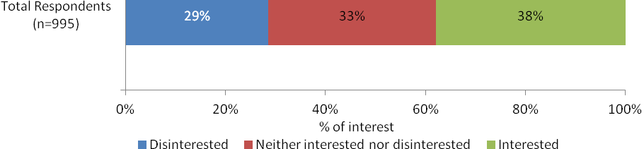
Q1.1 On a scale of 0 to 10, where 0 is very disinterested and 10 is very interested, how much interest do you take in your personal superannuation affairs?
Base: All respondents (n=995)

By employment status
Interest in personal super affairs is similar whether consumers are employed (40% are interested) or self-employed (40% are interested). However, those who are unemployed, students or welfare recipients are less likely to be interested in their personal super affairs (27%) and more likely to be disinterested (37% compared to 26% of those who are employed and 32% of those who are self employed).
Figure 3: Interest in Personal Super Affairs by Employment Status
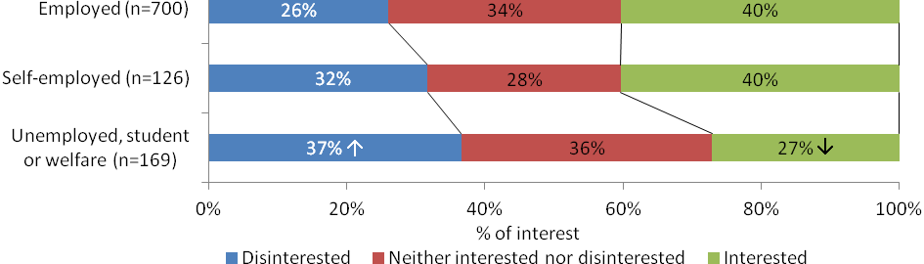
Q1.1 On a scale of 0 to 10, where 0 is very disinterested and 10 is very interested, how much interest do you take in your personal superannuation affairs?
Base: All respondents (n=995)

By age
Older consumers are more likely to take an interest in their personal super affairs compared to younger consumers. Among those aged 45 years and older, 58% are interested in their personal super affairs, compared to 30% of those aged 30-44 years and only 17% of those aged 18-29 years. Similarly, those who are older are less likely to be disinterested (15% of those aged 45 years and older) while those who are younger are more likely to be disinterested in their personal super affairs (46% of those aged 18-29 years).
Figure 4: Interest in Personal Super Affairs by Age
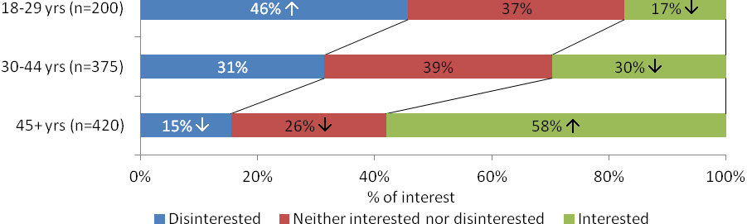
Q1.1 On a scale of 0 to 10, where 0 is very disinterested and 10 is very interested, how much interest do you take in your personal superannuation affairs?
Base: All respondents (n=995)

By number of accounts
There is no indication that interest in one’s personal super affairs is related to number of accounts with a similar proportion of those who have one account (39%) indicating they are interested in their personal super affairs compared to those who have multiple accounts (37%).
Figure 5: Interest in Personal Super Affairs by Number of Accounts
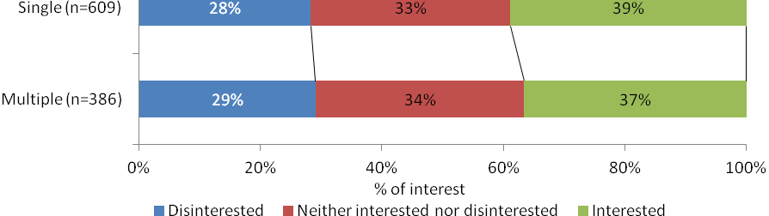
Q1.1 On a scale of 0 to 10, where 0 is very disinterested and 10 is very interested, how much interest do you take in your personal superannuation affairs?
Base: All respondents (n=995)

Change in Interest in Personal Super Affairs
Over the past 12 months, level of interest in personal super affairs has increased for 36% of consumers. In the same period level of interest has decreased for a small proportion (6%) while there has been no change in interest level for about half (56%).
Figure 6: Change in Interest in Personal Super Affairs
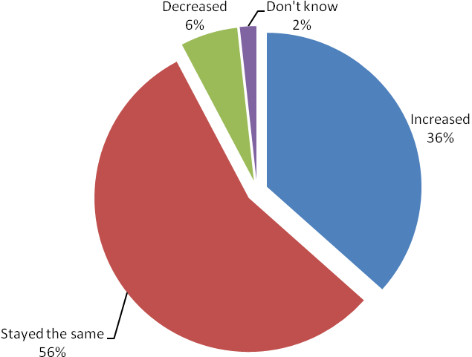
Q1.2 And has the level of interest you take in your personal super affairs increased, decreased or remained the same over the past 12 months?
Base: All respondents (n=1011)

By employment status
Those who are unemployed, students or welfare recipients are more likely to indicate that their level of interest in personal super affairs has decreased over the past 12 months (12%) compared to those who are employed (5%) or self-employed (4%).
Figure 7: Change in Interest in Personal Super Affairs by Employments Status
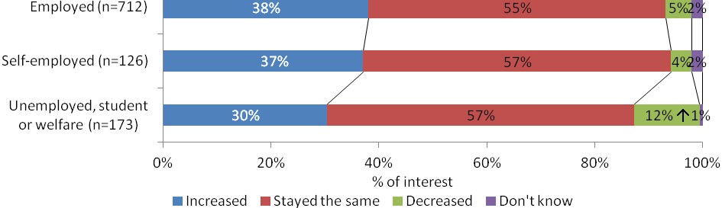
Q1.2 And has the level of interest you take in your personal super affairs increased, decreased or remained the same over the past 12 months?
Base: All respondents (n=1011)

By age
Older consumers are more likely to indicate that their level of interest in personal super affairs has increased over the past 12 months (44% of those aged 45 years and older) while younger consumers (those aged 18-29) are less likely to indicate that their level of interest has increased (28%).
Figure 8: Change in Interest in Personal Super Affairs by Age
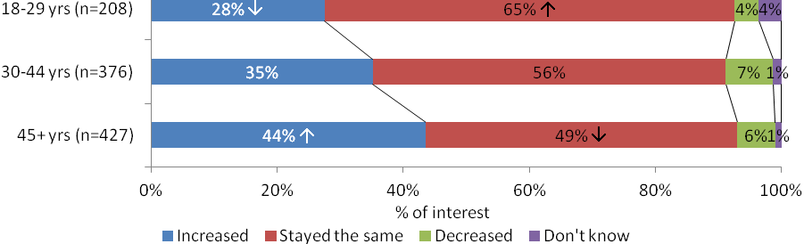
Q1.2 And has the level of interest you take in your personal super affairs increased, decreased or remained the same over the past 12 months?
Base: All respondents (n=1011)

By number of accounts
Change in level of interest does not seem to be related to number of accounts with a similar proportion of those with single accounts indicating their level of interest has increased (35%) compared to the proportion of consumers with multiple accounts (39%).
Figure 9: Change in Interest in Personal Super Affairs by Number of Accounts
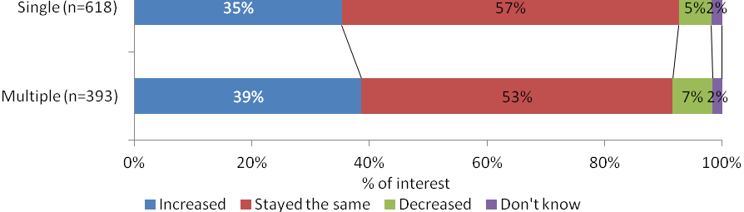
Q1.2 And has the level of interest you take in your personal super affairs increased, decreased or remained the same over the past 12 months?
Base: All respondents (n=1011)

Reason for Change in Interest in Personal Super Affairs
Among those who indicate a change in their level of interest in their own personal super affairs, 33% attribute this change to the global financial crisis/market crash/economic climate, a further 19% indicate it is due to others having lost money or low returns. Nineteen percent attribute this change to their age or being close to retirement while a further 6% attribute it to a want or need to have a sufficient amount of super for the future.
Figure 10: Reason for Change in Interest in Personal Super Affairs
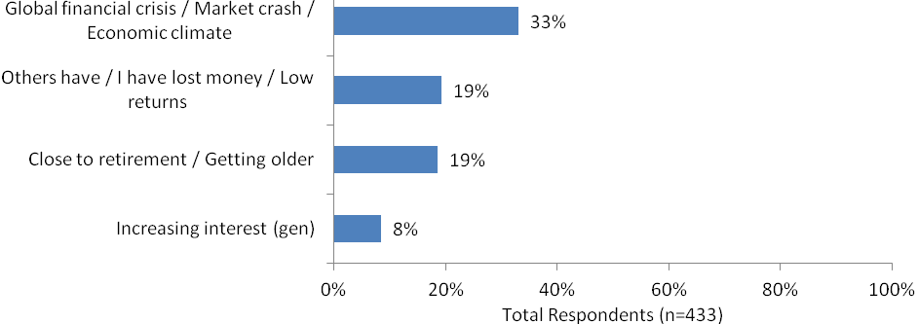
Q1.3 Why is that? [OPEN ENDED]
Base: Those whose interest in personal super affairs increased or decreased over the past 12 months (n=433)

By employment status
Reasons for change in interest in personal super affairs are similar irrespective of employment status, however, those who are unemployed, students, or welfare recipients are less likely to attribute this change to their age or nearness to retirement (10% compared to 21% of employed consumers and 19% of self-employed consumers).
Figure 11: Reason for Change in Interest in Personal Super Affairs by Employment Status
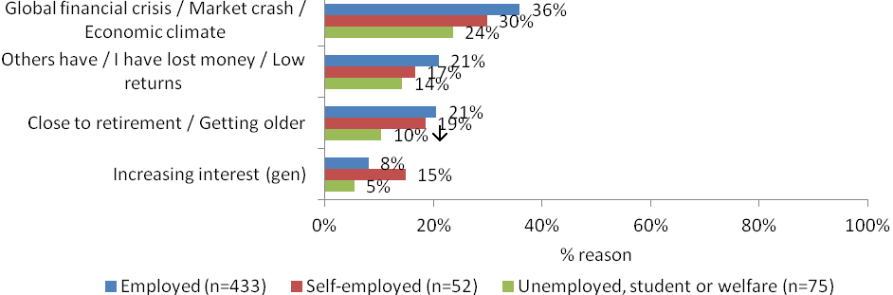
Q1.3 Why is that? [OPEN ENDED]
Base: Those whose interest in personal super affairs increased or decreased over the past 12 months (n=433)

By age
Consistent with the increased likelihood for older consumers to indicate that their level of interest in personal super affairs has increased over the past 12 months, a greater proportion of consumers aged 45 years and older attribute the change in interest to their age / being close to retirement (27% compared to 7% of those aged 18-29 and 13% of those aged 30-44).
Figure 12: Reason for Change in Interest in Personal Super Affairs by Age
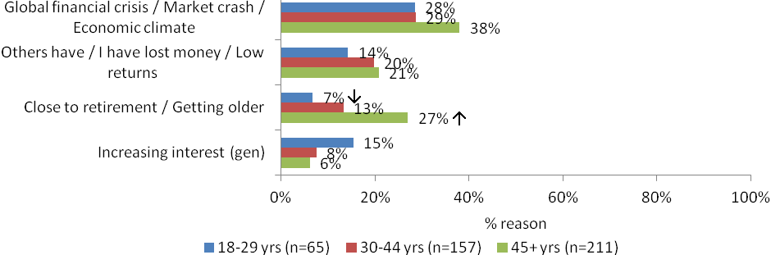
Q1.3 Why is that? [OPEN ENDED]
Base: Those whose interest in personal super affairs increased or decreased over the past 12 months (n=433)

By number of accounts
Those with a single account are more likely to attribute their change in level of interest in their personal super to the global financial crisis, market crash, or economic climate (25%) compared to those with multiple accounts (38%).
Figure 13: Reason for Change in Interest in Personal Super Affairs by Number of Accounts
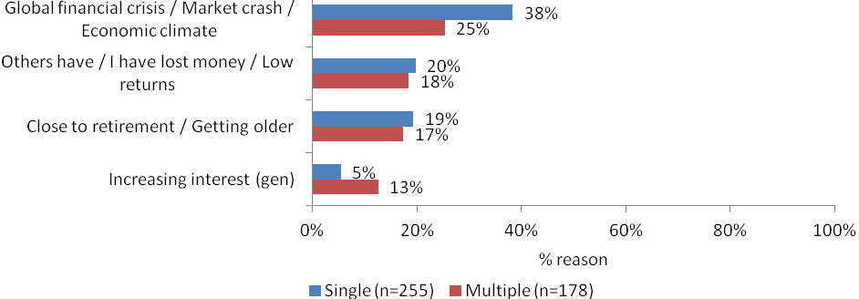
Q1.3 Why is that? [OPEN ENDED]
Base: Those whose interest in personal super affairs increased or decreased over the past 12 months (n=433)

Change to Personal Super Arrangements
The most common change to personal super arrangements made by consumers over the past 12 months was a variation in the level of voluntary contributions they are making to their super (16%), followed by a consolidation of all super accounts into one account (12%), a change in investment strategy within their primary super account (10%) and a change in primary super account (9%). Six percent varied the insurance cover options within their primary super account.
Figure 14: Changes to Personal Super Arrangements
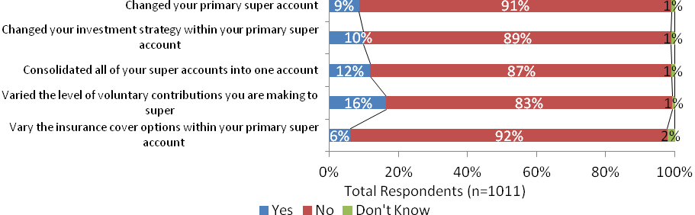
Q1.4 Have you made any of the following changes to your personal super arrangements over the past 12 months?
Base: All Respondents (n=1011)

By employment status
Those who are unemployed, students or welfare recipients were less likely to have varied the level of contribution over the past 12 months (10%) compared to consumers overall (16% as indicated above).
Figure 15: Changes to Personal Super Arrangements by Employment Status
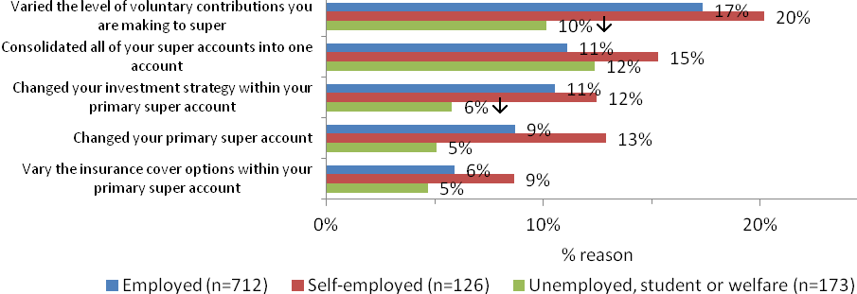
Q1.4 Have you made any of the following changes to your personal super arrangements over the past 12 months?
Base: All Respondents (n=1011)

By age
Younger consumers (those aged 18-29 years) were less likely to have changed their investment strategy within their primary super account (5% compared to 10% overall). They were also less likely to have varied the level of voluntary contributions they are making to their super (5%) while older consumers (those aged 45 years and older) were more likely to have done so (26%) compared to 16% overall.

Figure 16: Changes to Personal Super Arrangements by Age
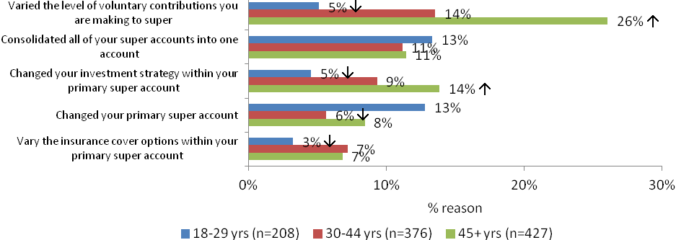
Q1.4 Have you made any of the following changes to your personal super arrangements over the past 12 months?
Base: All Respondents (n=1011)

By number of accounts
Those with multiple accounts were less likely to have consolidated their super accounts into one account in the past 12 months (7% compared to 12% overall).
Figure 17: Changes to Personal Super Arrangements by Number of Accounts
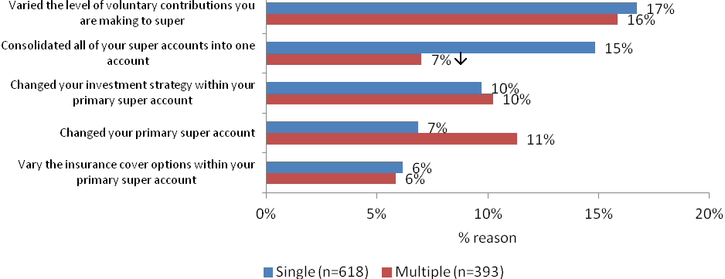
Q1.4 Have you made any of the following changes to your personal super arrangements over the past 12 months?
Base: All Respondents (n=1011)

Advice Regarding Super

The majority (76%) of consumers have not sought advice regarding their super affairs over the past 12 months while just under one quarter (24%) have.
Figure 18: Advice Regarding Super Sought Over Past 12 Months
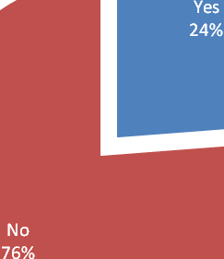
Q1.5 Have you sought advice regarding your super affairs over the past 12 months?
Base: All Respondents (n=1011)

By employment status
Those who are self employed were more likely to indicate that they sought advice regarding their super affairs (38%) compared to those who are employed (22%) or are unemployed, students or welfare recipients (22%).
Figure 19: Advice Regarding Super Sought Over Past 12 Months by employment status
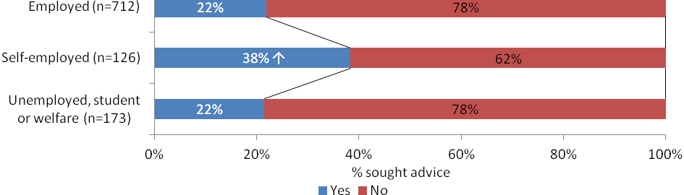
Q1.5 Have you sought advice regarding your super affairs over the past 12 months?
Base: All Respondents (n=1011)

By age
The likelihood that a consumer would have sought advice regarding their super affairs over the past 12 months increased with age with 36% of those aged 45 years and older doing so compared to 19% of those aged 30-44 and only 12% of those aged 18-29.
Figure 20: Advice Regarding Super Sought Over Past 12 Months by Age
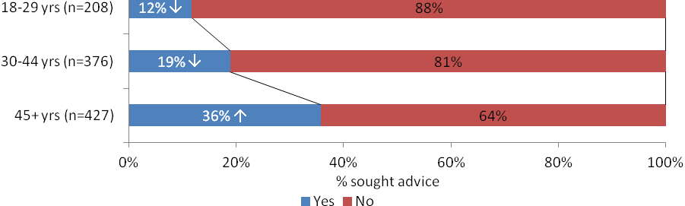
Q1.5 Have you sought advice regarding your super affairs over the past 12 months?
Base: All Respondents (n=1011)

By number of accounts
Propensity to seek advice regarding super did not vary significantly according to number of accounts held, with 23% of consumers with one account and 24% of those with multiple accounts seeking advice regarding their super over the past 12 months.
Figure 21: Advice Regarding Super Sought Over Past 12 Months by Number of Accounts
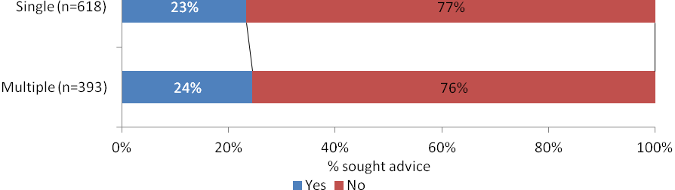
Q1.5 Have you sought advice regarding your super affairs over the past 12 months?
Base: All Respondents (n=1011)

Source of Advice Regarding Super
For consumers who sought advice regarding super, the most common source of advice was a financial planner with 44% seeking advice from this source. Twenty three percent sought advice from an accountant whilst 22% sought advice from a super fund. Fewer sought advice from family or friends (9%), government agencies (3%) or the internet (1%).
Figure 22: Sources of Advice Regarding Super
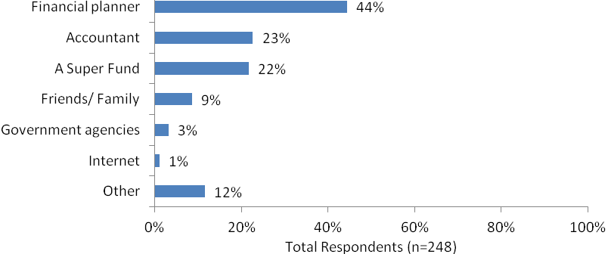
Q1.6 Who did you seek advice from?
Base: Those who had sought advice in the past 12 months (n=248)

By employment status
Self employed consumers were more likely to have sought advice from an accountant (44%) compared to those who are employed (17% sought advice from an accountant) or unemployed, students or welfare recipients (20%).
Figure 23: Sources of Advice Regarding Super by Employment Status
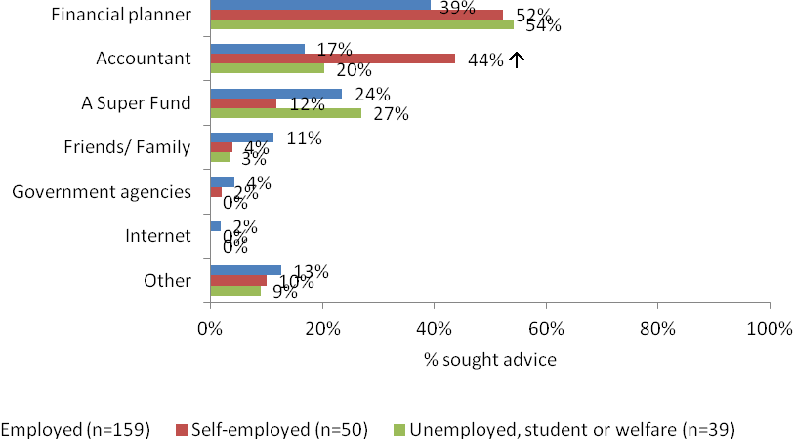
Q1.6 Who did you seek advice from?
Base: Those who had sought advice in the past 12 months (n=248)

By age
Among those who sought advice in the past 12 months, those aged 30-44 were more likely to have sought advice on super from an accountant (33%) compared to those aged 45 years and older (20%) whilst those aged 45 years and older were more likely to have sought advice from a government agency (5%) compared to those aged 30-44 years (1%).
Figure 24: Sources of Advice Regarding Super by Age
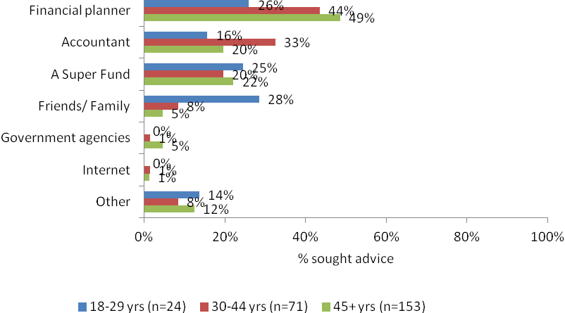
Q1.6 Who did you seek advice from?
Base: Those who had sought advice in the past 12 months (n=248)

By number of accounts
Among those who sought advice in the past 12 months, those who had had a single account were more likely to seek advice from a financial planner (51%) compared to those with multiple accounts (34% of whom sought advice from a financial planner).
Figure 25: Sources of Advice Regarding Super by Number of Accounts
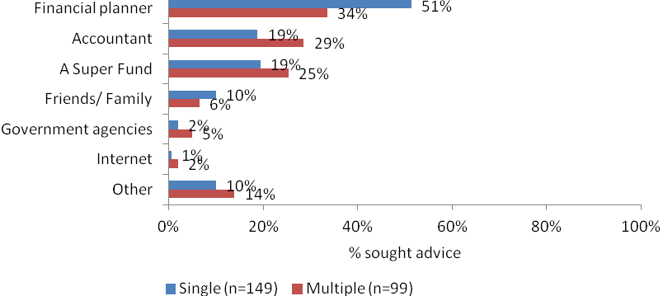
Q1.6 Who did you seek advice from?
Base: Those who had sought advice in the past 12 months (n=248)

Super for Retirement
Just over half (54%) of consumers have thought about how much super they will need when they retire.
Figure 26: Super for Retirement
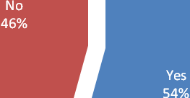
1.7 Have you thought about how much super you will need when you retire?
Base: All Respondents (n=1011)

By employment status
Those who are self employed are more likely to indicate that they have thought about how much super they will need when they retire (65%) compared to those who are employed (54%) and those who are unemployed, students or welfare recipients (48%).
Figure 27: Super for Retirement by Employment Status
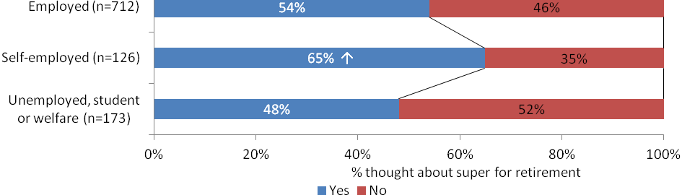
1.7 Have you thought about how much super you will need when you retire?
Base: All Respondents (n=1011)

By age
Older consumers (those aged 45 years and older) were more likely to have thought about how much super they will need when they retire (76%), compared to 50% of those aged 30-44 and only 26% of those aged 18-29 years.
Figure 28: Super for Retirement by Age
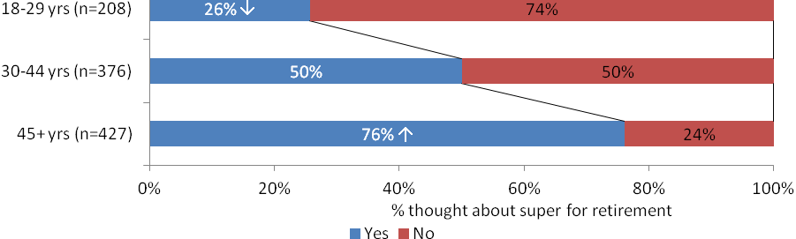
1.7 Have you thought about how much super you will need when you retire?
Base: All Respondents (n=1011)

By number of accounts
There was no significant difference in the propensity to think about how much super one would need upon retirement based on number of accounts, with those holding multiple accounts about as likely to think about this compared to those with one account (56% and 53% respectively).
Figure 29: Super for Retirement by Number of Accounts
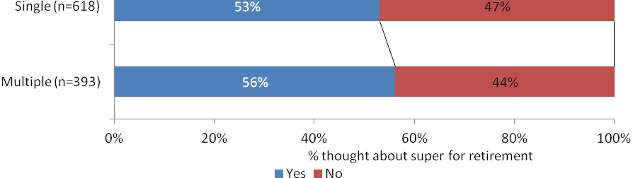
1.7 Have you thought about how much super you will need when you retire?
Base: All Respondents (n=1011)

Money Needed for Retirement
Figure 30: Money Needed for Retirement
About one third of consumers (33%) thought they would need between $30,001 and $50,000 per year upon retirement. Another third (33%) thought they would need more than this; made up of 20% who thought they would need $50,001 to $70,000, 9% who thought they would need $70,001 to $100,000 and 4% who thought they would need $100,001 to $200,000. Eight percent thought they would need less than $30,000 while 24% indicated they did not know how much they would need.
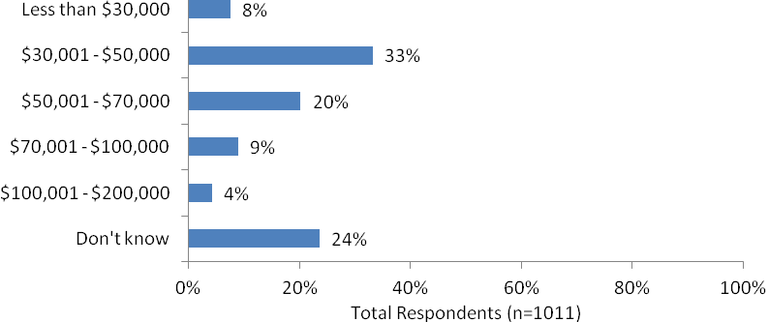
1.8 At a broad level how much money do you think you will need per year in retirement?
Base: All Respondents (n=1011)

By employment status
Estimates of money needed per year in retirement did not vary significantly according to employment status.
Figure 31: Money Needed for Retirement by Employment Status
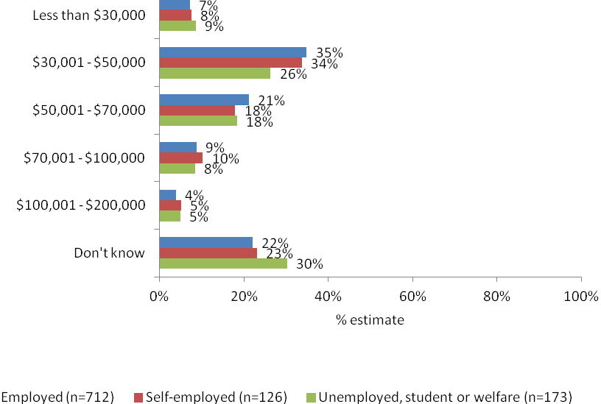
1.8 At a broad level how much money do you think you will need per year in retirement?
Base: All Respondents (n=1011)

By age
Compared to older consumers, younger consumers were more likely to indicate that they would need less than $30,000 per year in retirement (12% compared to 6% of those aged 30-44 or 45+). Those aged 45 years and older were more likely to indicate that they would need $30,001 to $50,000 per year in retirement (38%) compared to younger respondents (29% of 18-29 year olds and 31% of those aged 30 to 34 years).
Figure 32: Money Needed for Retirement by Age
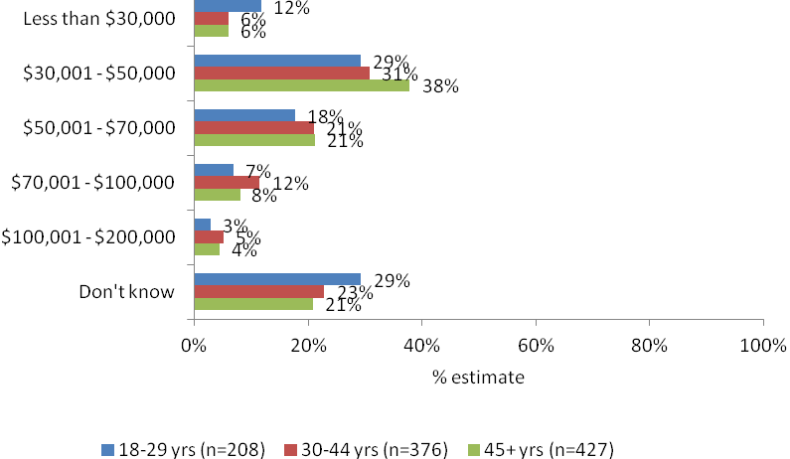
1.8 At a broad level how much money do you think you will need per year in retirement?
Base: All Respondents (n=1011)

By number of accounts
There were no significant differences in the estimate of funds required in retirement between multiple and single account holders.
Figure 33: Money Needed for Retirement by Number of Accounts
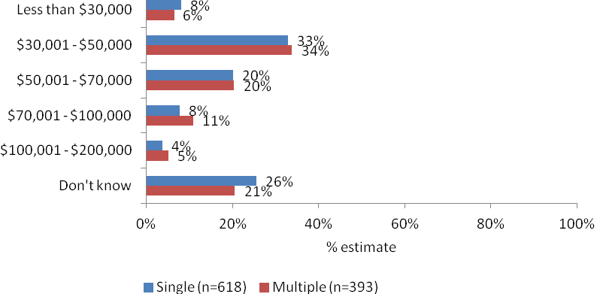
1.8 At a broad level how much money do you think you will need per year in retirement?
Base: All Respondents (n=1011)

Sufficiency of Super to Fund Retirement
About one third (37%) of consumers are confident of having sufficient super to fund their retirement, 29% are not confident and 35% are neither confident nor unconfident.
Figure 34: Sufficiency of Super to Fund Retirement
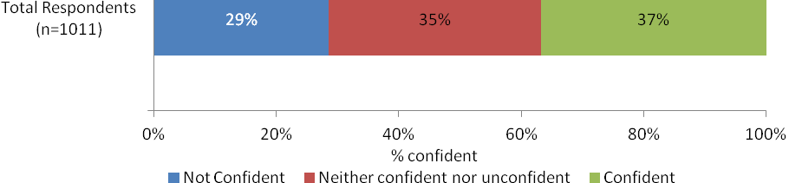

Q1.9 Do you believe that your superannuation will be sufficient to fund your retirement?
Base: All Respondents (n=1011)

By employment status
Those who are unemployed, students or welfare recipients are most likely to indicate that they are not confident that their super is sufficient to fund their retirement (35%) compared to 28% of those who are employed and 27% of those who are self employed.
Figure 35: Sufficiency of Super to Fund Retirement by Employment Status

Q1.9 Do you believe that your superannuation will be sufficient to fund your retirement?
Base: All Respondents (n=1011)

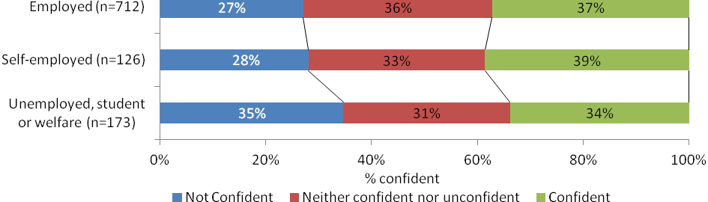

By age
Younger consumers (those aged 18-29) are more likely to indicate that they are confident that their super will be sufficient to fund their retirement, with almost half (46%) believing this to be the case, compared to only 32% of 30-44 year olds and 35% of those aged 45 years and older. Younger consumers are also less likely to not be confident that their super will be sufficient to fund their retirement. Across all age groups, about one third are neither confident or unconfident of the sufficiency of their super to fund their retirement.
Figure 36: Sufficiency of Super to Fund Retirement by Age
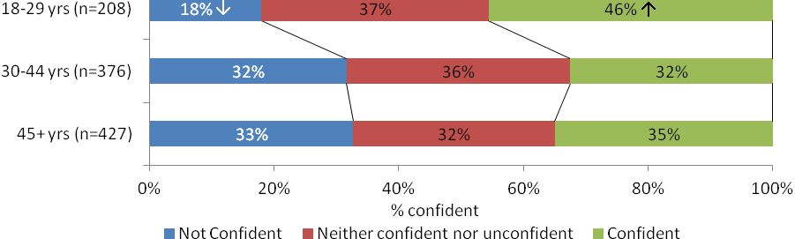
Q1.9 Do you believe that your superannuation will be sufficient to fund your retirement?
Base: All Respondents (n=1011)

By number of accounts
Belief that super will be sufficient to find one’s retirement does not vary significantly according to whether a consumer has one or multiple accounts.
Figure 37: Sufficiency of Super to Fund Retirement by Number of Accounts
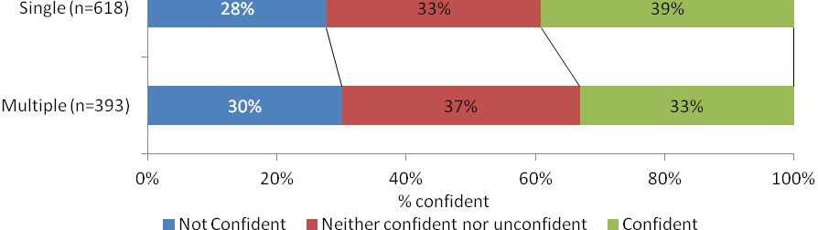
Q1.9 Do you believe that your superannuation will be sufficient to fund your retirement?
Base: All Respondents (n=1011)

Awareness

Awareness of Employer Super Contributions
The majority of consumers (88%) are aware that employers are required to contribute 9% on top of staff salary into super. Eleven percent were not aware, while 1% do not know.
Figure 38: Awareness of Employer Contributions

Q2.3/4.1 Are you aware that employers are required to contribute 9% on top of staff salary into super?
Base: Employed and non-working consumers (n=885)
Includes 2 two non-working respondents who have never been in paid employment

By employment status
Employed consumers are more likely to be aware that employers are required to contribute 9% on top of staff salary into super (90% are aware) compared to those who are unemployed, students or welfare recipients (only 79% are aware). Conversely, 20% of those who are unemployed, students or welfare recipients are unaware that employers are required to contribute 9% on top of staff salary into super.
Figure 39: Awareness of Employer Contributions by Employment Status
Q2.3/4.1 Are you aware that employers are required to contribute 9% on top of staff salary into super?
Base: Employed and non-working consumers (n=885)
Includes 2 two non-working respondents who have never been in paid employment

By age
Younger respondents are more likely to be unaware that employers are required to contribute 9% on top of staff salary into super (20%) compared to older respondents (11% of those aged 30-44 and 8% of those aged 45 years and older were unaware).
Figure 40: Awareness of Employer Contributions by Age
Q2.3/4.1 Are you aware that employers are required to contribute 9% on top of staff salary into super?
Base: Employed and non-working consumers (n=885)
Includes 2 two non-working respondents who have never been in paid employment

By number of accounts
Awareness that employers are required to contribute 9% on top of staff salary into super did not vary significantly among consumers with one account and those with multiple accounts.
Figure 41: Awareness of Employer Contributions by Number of Accounts
Q2.3/4.1 Are you aware that employers are required to contribute 9% on top of staff salary into super?
Base: Employed and non-working consumers (n=885)
Includes 2 two non-working respondents who have never been in paid employment

Awareness of Employer Super Contribution Payments
About three quarters (77%) of consumer’s check that their employer has paid into their super account, the remaining 23% do not.
Figure 42: Awareness of Employer Super Contributions Payments
Q2.4/4.2 Do you check that your employer has paid into your super account?
Base: Employed and non-working consumers (n=883)

By employment status
Employed consumers are more likely to check that their employer has paid into their super account (80% do so) compared to those who are unemployed, student or welfare recipients (only 64% of whom check).
Figure 43: Awareness of Employer Super Contributions Payments by Employment Status
Q2.4/4.2 Do you check that your employer has paid into your super account?
Base: Employed and non-working consumers (n=883)

By age
Older consumers are more likely to check that their employer has paid into their super account compared to those who are younger with 82% of those aged 45+, 77% of those aged 30-44 and 65% of those aged 18-29 doing so.
Figure 44: Awareness of Employer Super Contributions Payments by Age
Q2.4/4.2 Do you check that your employer has paid into your super account?
Base: Employed and non-working consumers (n=883)

By number of accounts
Those with multiple accounts are as likely as those with one account to check that their employer has paid into their super account with 80% of those with one account and 72% of those with multiple accounts doing so.
Figure 45: Awareness of Employer Super Contributions Payments by Number of Accounts
Q2.4/4.2 Do you check that your employer has paid into your super account?
Base: Employed and non-working consumers (n=883)

Main Reason for not checking Super
Among those who did not check that their employer has paid super contributions, the main reason for not doing so was that the consumer trusted their employer to do the right thing (54%). Twenty four percent indicated that they were not interested or did not care while 10% did not know how to check, a further 7% did not know why they did not check.
Figure 46: Main Reason for not Checking Super

Q2.5A/Q4.3A What is the main reason you didn’t check that your super had been paid by your employer? [SR]
Base: Employed and non-working consumers who did not check employer has paid super contributions (n=206)

By employment status
Among those who did not check that their super had been paid by their employer, unemployed, student and welfare recipient consumers are significantly more likely compared to employed consumers to indicate that they did not check because they did not know how to (19% compared to 6%).
Figure 47: Main Reason for not Checking Super by Employment Status
Q2.5A/Q4.3A What is the main reason you didn’t check that your super had been paid by your employer? [SR]
Base: Employed and non-working consumers who did not check employer has paid super contributions (n=206)

By age
Among those who did not check that their super had been paid by their employer, older consumers were more likely to indicate they did not check because they trusted their employer to do the right thing (69% of those aged 45 years and older) compared to younger consumers (37% of those aged 18-29 and 56% of those aged 30-44). Those aged 18-29 were more likely to indicate this was because they were not interested or did not care (37% compared to 21% of those aged 30-44 and 14% of those aged 45+) or because they did not know how to (19% compared to 4% of those aged 30-44 and 6% of those aged 45 years and older).
Figure 48: Main Reason for not Checking Super by Age
Q2.5A/Q4.3A What is the main reason you didn’t check that your super had been paid by your employer? [SR]
Base: Employed and non-working consumers who did not check employer has paid super contributions (n=206)

By number of accounts
Reasons for not checking that super had been paid be one’s employer did not vary significantly according to whether the consumer held one or multiple accounts.
Figure 49: Main Reason for not Checking Super by Number of Accounts
Q2.5A/Q4.3A What is the main reason you didn’t check that your super had been paid by your employer? [SR]
Base: Employed and non-working consumers who did not check employer has paid super contributions (n=206)

If employer had not contributed to super account
The most likely action consumers would take if they became aware that their employer had not contributed to their super account would be to raise it with their employer or payroll officer (67% would do so). Thirteen percent would report it to the Tax Office while 8% do not know what they would do.
Figure 50: Action if Employer had not Contributed to Super Account
Q2.5B/Q4.3B What would you do if you became aware that your employer had not contributed to your super account? [SR]
Base: Employed and non-working consumers (n=883)

By employment status
Anticipated response to an employer’s failure to contribute to one’s super account does not vary significantly according to employment status with 68% of employed consumers and 60% of unemployed, student and welfare recipient consumers indicating that they would raise it with their employer or payroll officer.
Figure 51: Action if Employer had not Contributed to Super Account by Employment Status
Q2.5B/Q4.3B What would you do if you became aware that your employer had not contributed to your super account? [SR]
Base: Employed and non-working consumers (n=883)

By age
A greater proportion of younger respondents (76%) compared to older consumers (61%) indicated that they would raise it with their employer or payroll officer if they became aware that their employer had not contributed to their super account. Furthermore, younger consumers were less likely to indicate that they would report it to the Tax Office (9%) compared to those aged 30 to 44 (14%) and those aged 45 years and older (16%).
Figure 52: Action if Employer had not Contributed to Super Account by Age
Q2.5B/Q4.3B What would you do if you became aware that your employer had not contributed to your super account? [SR]
Base: Employed and non-working consumers (n=883)

By number of accounts
Propensity to raise a failure to contribute to super with one’s employer or payroll officer or the Tax office was similar among those with multiple compared to single account holders.
Figure 53: Action if Employer had not Contributed to Super Account by Number of Accounts
Q2.5B/Q4.3B What would you do if you became aware that your employer had not contributed to your super account? [SR]
Base: Employed and non-working consumers (n=883)

Super Fund Choices

Choice of super fund
About one third (31%) of employed and non-working consumers chose their own super fund when they joined their most recent employer. Sixty eight percent chose their employer’s default fund while 2% could not remember.
Figure 54: Choose Own Super Fund
Q2.6/Q4.4 When you joined your most recent employer, did you choose your own super fund, or did you choose the employer’s default fund? [SR]
Base: Employed and non-working consumers (n=883)

By employment status
While there was no significant difference in the proportion of employed versus non-working consumers who chose their own super fund when they joined their most recent employer, non-working consumers were more likely to indicate that they did not know or could not remember (4% compared to 1%).
Figure 55: Choose Own Super Fund by Employment Status
Q2.6/Q4.4 When you joined your most recent employer, did you choose your own super fund, or did you choose the employer’s default fund? [SR]
Base: Employed and non-working consumers (n=883)

By age
Among employed and non-working consumers, the propensity to chose one’s own super fund did versus having super paid into the employer’s default fund did not vary significantly according to age.
Figure 56: Choose Own Super Fund by Age
Q2.6/Q4.4 When you joined your most recent employer, did you choose your own super fund, or did you choose the employer’s default fund? [SR]
Base: Employed and non-working consumers (n=883)

By number of accounts
Those with only one super fund were more likely to indicate that they chose their own super fund when they joined their most recent employer (34%) compared to those with multiple accounts (only 27% chose their own fund). Similarly, those with multiple funds were more likely to indicate that they had super paid into their employer’s default fund (72% compared to 65% of those with a single fund).
Figure 57: Choose Own Super Fund by Number of Accounts
Q2.6/Q4.4 When you joined your most recent employer, did you choose your own super fund, or did you choose the employer’s default fund? [SR]
Base: Employed and non-working consumers (n=883)

Type of super fund chosen
Among employed, self-employed and non-working consumers, about one third (36%) most recently chose an industry fund, 16% a public sector fund, 13% a retail fund, 8% a corporate fund and 6% a self managed super fund. Twenty one percent did not know the name of or type of fund that they chose when they joined their most recent employer.
Figure 58: Type of Super Fund Chosen
Q2.7A/Q3.2A/Q4.5A What type of super fund did you choose? [SR]
Base: Employed, self-employed (who regularly contribute to a super fund) and non-working consumers (n=942)

By employment status
Type of fund chosen varies according to whether a consumer is employed, self-employed or non-working.
Self-employed consumers are more likely to have chosen a self managed super fund (32%) compared to 4% of employed and 5% of non-working consumers. Employed consumers are more likely to have chosen a corporate fund compared to self-employed and non-working consumers (10% compared to 3% and 5%). Employed and non-working consumers are more likely to have chosen a public sector fund (19% and 12% respectively compared to none of the self-employed consumers interviewed).
Non-working consumers are most likely to not know the name of or type of fund they chose (28% compared to 20% of employed and 14% of self-employed consumers).
Figure 59: Type of Super Fund Chosen by Employment Status
Q2.7A/Q3.2A/Q4.5A What type of super fund did you choose? [SR]
Base: Employed, self-employed (who regularly contribute to a super fund) and non-working consumers (n=942)

By age
Consumers aged 18-29 are least the likely to have chosen a public sector fund (7% compared to 19% of those aged 30 to 44 and those aged 45 years and older). Furthermore, these younger consumers are most likely to not know the name or type of fund they chose (32% compared to 18% of 30 to 44 year olds and 17% of those aged 45 years and older).
Figure 60: Type of Super Fund Chosen by Age
Q2.7A/Q3.2A/Q4.5A What type of super fund did you choose? [SR]
Base: Employed, self-employed (who regularly contribute to a super fund) and non-working consumers (n=942)

By number of accounts
Type of fund chosen does not vary according to whether the consumer has one or multiple funds.
Figure 61: Type of Super Fund Chosen by Number of Accounts
Q2.7A/Q3.2A/Q4.5A What type of super fund did you choose? [SR]
Base: Employed, self-employed (who regularly contribute to a super fund) and non-working consumers (n=942)

Importance
Among those who chose their own super fund, factors considered to be important by the greatest percentage of consumers included ‘low fees charged’ (important to 70%) and ‘high/strong investment returns’ (important to 63%).
Other factors believed to be important by about half of those who chose their own super fund included ‘multiple and flexible investment’ options (51%), and ‘a large membership base’ and ‘brand name or having heard of them’ (both 48%).
Forty three percent indicated that being the ‘fund specific to my industry’ was important while 37% indicated ‘insurance options offered’ were important. ‘Recommendation from family / friends’ was considered important to 28% of those who chose their own super fund.
Figure 62: Importance of Factors when Choosing a Super Fund
Q2.7B/Q3.3/Q4.5B On a scale of 0 to 10, where 0 is very unimportant and 10 is very important, how important were the following factors in terms of your choice of super fund? [SR]
Base: Employed, self-employed (who regularly contribute to a super fund) and non-working consumers who did not have their super paid into their employers default fund (excludes those who chose a SMSF) (n=268)
Excludes those who answered ‘Don’t know’

By employment status
Importance of factors when choosing insurance options is similar irrespective of whether the consumer is employed, self-employed or unemployed, a student or welfare recipient with ‘low fees’ and ‘high/strong investment returns’ considered important by the greatest proportion of each of these groups.
Figure 63: Importance of Factors when Choosing a Super Fund among those who are Employed
Q2.7B/Q3.3/Q4.5B On a scale of 0 to 10, where 0 is very unimportant and 10 is very important, how important were the following factors in terms of your choice of super fund? [SR]
Base: Employed consumers who did not have their super paid into their employers default fund (excludes those who chose a SMSF) (n=268)
Excludes those who answered ‘Don’t know’
Figure 64: Importance of Factors when Choosing a Super Fund among those who are Self Employed
Q2.7B/Q3.3/Q4.5B On a scale of 0 to 10, where 0 is very unimportant and 10 is very important, how important were the following factors in terms of your choice of super fund? [SR]
Base: Self-employed consumers (who regularly contribute to a super fund) who did not have their super paid into their employers default fund (excludes those who chose a SMSF) (n=35)
Excludes those who answered ‘Don’t know’
Figure 65: Importance of Factors when Choosing a Super Fund among non-working consumers
Q2.7B/Q3.3/Q4.5B On a scale of 0 to 10, where 0 is very unimportant and 10 is very important, how important were the following factors in terms of your choice of super fund? [SR]
Base: Non-working consumers who did not have their super paid into their employers default fund (excludes those who chose a SMSF) (n=37)
Excludes those who answered ‘Don’t know’

By age
Consumers aged 18-24 were less likely indicate that ‘multiple and flexible investment options’ were important in choosing a fund (33%) while those aged 45+ were more likely to indicate this was important (63%). Those aged 45 years and older were also more likely to indicate that having a ‘large membership base’ was important.
Figure 66: Importance of Factors when Choosing a Super Fund among 18-24 year olds
Q2.7B/Q3.3/Q4.5B On a scale of 0 to 10, where 0 is very unimportant and 10 is very important, how important were the following factors in terms of your choice of super fund? [SR]
Base: Employed, self-employed (who regularly contribute to a super fund) and non-working consumers aged 18-24 years who did not have their super paid into their employers default fund (excludes those who chose a SMSF) (n=55)
Excludes those who answered ‘Don’t know’

Figure 67: Importance of Factors when Choosing a Super Fund among 30-44 year olds
Q2.7B/Q3.3/Q4.5B On a scale of 0 to 10, where 0 is very unimportant and 10 is very important, how important were the following factors in terms of your choice of super fund? [SR]
Base: Employed, self-employed (who regularly contribute to a super fund) and non-working consumers aged 30-44 who did not have their super paid into their employers default fund (excludes those who chose a SMSF) (n=112)
Excludes those who answered ‘Don’t know’
Figure 68: Importance of Factors when Choosing a Super Fund among 45+ year olds
Q2.7B/Q3.3/Q4.5B On a scale of 0 to 10, where 0 is very unimportant and 10 is very important, how important were the following factors in terms of your choice of super fund? [SR]
Base: Employed, self-employed (who regularly contribute to a super fund) and non-working consumers aged 45+ who did not have their super paid into their employers default fund (excludes those who chose a SMSF) (n=95)
Excludes those who answered ‘Don’t know’

By number of accounts
Those with multiple super accounts were less likely to indicate that ‘it is the fund specific to my industry’ is important when choosing a super fund (32% compared to 43% overall).
Figure 69: Importance of Factors when Choosing a Super Fund among those who have a single account
Q2.7B/Q3.3/Q4.5B On a scale of 0 to 10, where 0 is very unimportant and 10 is very important, how important were the following factors in terms of your choice of super fund? [SR]
Base: Employed, self-employed (who regularly contribute to a super fund) and non-working consumers with a single account who did not have their super paid into their employers default fund (excludes those who chose a SMSF) (n=172)
Excludes those who answered ‘Don’t know’
Figure 70: Importance of Factors when Choosing a Super Fund among those who have multiple accounts
Q2.7B/Q3.3/Q4.5B On a scale of 0 to 10, where 0 is very unimportant and 10 is very important, how important were the following factors in terms of your choice of super fund? [SR]
Base: Employed, self-employed (who regularly contribute to a super fund) and non-working consumers with multiple accounts who did not have their super paid into their employers default fund (excludes those who chose a SMSF) (n=92)
Excludes those who answered ‘Don’t know’

Other factors influencing choice of super fund
Among employed, self-employed and non-working consumers who did not have their super paid into their employers default fund, 16% indicated that factors other than those mentioned above influenced their choice of fund.
Figure 71: Other Factors Influencing Choice of Super Fund
Q2.8/Q3.4/Q4.6 Were there any other factors not already mentioned that influenced your choice of fund? [SR]
Base: Employed, self-employed (who regularly contribute to a super fund) and non-working consumers who did not have their super paid into their employers default fund (excludes those who chose a SMSF) (n=290)

By employment status
Employed (18%) and self-employed (15%) consumers were more likely to indicate that ‘other factors’ influenced choice of super fund compared to unemployed, student or welfare recipient consumers (10%) however, these differences were not statistically significant.
Figure 72: Other Factors Influencing Choice of Super Fund by Employment Status
Q2.8/Q3.4/Q4.6 Were there any other factors not already mentioned that influenced your choice of fund? [SR]
Base: Employed, self-employed (who regularly contribute to a super fund) and non-working consumers who did not have their super paid into their employers default fund (excludes those who chose a SMSF) (n=290)

By age
Older consumers (those aged 45 years and older) were not significantly more likely to indicate that ‘other factors’ influenced their choice of super (18%) compared to those aged 30-44 years (16%) and 18-29 years (13%).
Figure 73: Other Factors Influencing Choice of Super Fund by Age
Q2.8/Q3.4/Q4.6 Were there any other factors not already mentioned that influenced your choice of fund? [SR]
Base: Employed, self-employed (who regularly contribute to a super fund) and non-working consumers who did not have their super paid into their employers default fund (excludes those who chose a SMSF) (n=290)

By number of accounts
Those with a single account indicated a similar propensity to indicate that other factors influenced choice of super fund (17%) compared to those with multiple accounts (14%).
Figure 74: Other Factors Influencing Choice of Super Fund by Number of Accounts
Q2.8/Q3.4/Q4.6 Were there any other factors not already mentioned that influenced your choice of fund? [SR]
Base: Employed, self-employed (who regularly contribute to a super fund) and non-working consumers who did not have their super paid into their employers default fund (excludes those who chose a SMSF) (n=290)

Identification of other influencing factors
Other factors influencing choice of super fund include ‘fund from previous employment/first fund consumer was with’ (26%), ‘convenience/ease of use’ (20%), ‘performance’ (13%), ‘knowing the fund manager/fund’ (9%), a ‘recommendation from a financial advisor/accountant’ (9%), and ‘a safe/steady return history’ (7%).
Figure 75: Other Influencing Factors
Q2.9A/Q3.5/Q4.7 What were these? [OE]
Base: Employed, self-employed (who regularly contribute to a super fund) and non-working consumers who did not have their super paid into their employers default fund (excludes those who chose a SMSF) and who indicated that ‘other’ factors influenced their choice of super fund (n=46)

Annual Statements

Received annual statement
Among consumers who chose to have their super paid to their employers default fund or who chose a fund but did not chose a SMSF, the majority (86%) recalled receiving an annual statement from their primary super fund covering the 2008/09 financial year.
Figure 76: Received an Annual Statement
Q2.10/Q3.6/Q4.8 Do you recall receiving an annual statement from your primary super fund covering the 2008/09 financial year? [SR]
Base: Employed, self employed (who regularly contribute to a super fund) and non-working consumers who did not choose a SMSF (n=891)

By employment status
Employed and self-employed consumers were more likely to recall receiving an annual statement from their primary super fund compared to non working consumers (89% and 90% respectively compared to 75%).
Figure 77: Received an Annual Statement by Employment Status
Q2.10/Q3.6/Q4.8 Do you recall receiving an annual statement from your primary super fund covering the 2008/09 financial year? [SR]
Base: Employed, self employed (who regularly contribute to a super fund) and non-working consumers who did not choose a SMSF (n=891)

By age
Older consumers were more likely to recall receiving an annual statement from their primary super fund compared to younger consumers. Eighty eight percent of 30-44 year olds and 90% of those aged 45 and older compared to 77% of those aged 18-29 years recalled receiving an annual statement.
Figure 78: Received an Annual Statement by Age
Q2.10/Q3.6/Q4.8 Do you recall receiving an annual statement from your primary super fund covering the 2008/09 financial year? [SR]
Base: Employed, self employed (who regularly contribute to a super fund) and non-working consumers who did not choose a SMSF (n=891)

By number of accounts
Those with a single account were about equally likely to recall receiving an annual statement from their primary super fund as those with multiple accounts.
Figure 79: Received an Annual Statement by Number of Accounts
Q2.10/Q3.6/Q4.8 Do you recall receiving an annual statement from your primary super fund covering the 2008/09 financial year? [SR]
Base: Employed, self employed (who regularly contribute to a super fund) and non-working consumers who did not choose a SMSF (n=891)

Use of annual statement
Among those who recall receiving an annual statement, approximately half (54%) flicked through the statement, while about one third (37%) read it thoroughly. Seven percent did not read the annual statement and the remaining 2% could not remember what they did with it.
Q2.11A/Q3.7A/Q4.9A Which of the following best describes what you did with the annual statement? [SR]
Base: Employed, self employed (who regularly contribute to a super fund) and non-working consumers who did not choose a SMSF and who recall receiving an annual statement (n=770)

By employment status
There was no significant difference in propensity to read annual statements among employed consumers compared to self-employed and non-working consumers with about half of each group flicking through the statement and just over one third (37% of employed and non-working consumers and 42% of self-employed consumers) reading it thoroughly.
Figure 80: Use of Annual Statement by Employment Status
Q2.11A/Q3.7A/Q4.9A Which of the following best describes what you did with the annual statement? [SR]
Base: Employed, self employed (who regularly contribute to a super fund) and non-working consumers who did not choose a SMSF and who recall receiving an annual statement (n=770)

By age
Consumers aged 45 years and older were significantly more likely to read the statement thoroughly (54%) compared to those aged 18-29 years (23%) and 30-44 (26%). Younger consumers were more likely to flick through it (59% of 18-29 year olds and 64% of those aged 30-44 compared to 42% of those aged 45 years and older) while the youngest consumers (aged 18-29) were more likely to not read it at all (14% compared to 9% of those aged 30-44 and 3% of those aged 45 years and older).
Figure 81: Use of Annual Statement by Age
Q2.11A/Q3.7A/Q4.9A Which of the following best describes what you did with the annual statement? [SR]
Base: Employed, self employed (who regularly contribute to a super fund) and non-working consumers who did not choose a SMSF and who recall receiving an annual statement (n=770)

By number of accounts
There was no significant difference in propensity to read the statement among those with a single account compared to those with multiple accounts.
Figure 82: Use of Annual Statement by Number of Accounts
Q2.11A/Q3.7A/Q4.9A Which of the following best describes what you did with the annual statement? [SR]
Base: Employed, self employed (who regularly contribute to a super fund) and non-working consumers who did not choose a SMSF and who recall receiving an annual statement (n=770)

Retaining annual statement
The majority (93%) of consumers kept their annual statement, while 6% threw it away and 1% could not recall what they did with it.
Figure 83: Retaining Annual Statement
Q2.11B/Q3.7B/Q4.9B And did you keep the annual statement or did you throw it away? [SR]
Base: Employed, self employed (who regularly contribute to a super fund) and non-working consumers who did not choose a SMSF and who recall receiving an annual statement (n=770)

By employment status
Likelihood to keep annual statement does not vary according to employment status.

Figure 84: Retaining Annual Statement by Employment Status
Q2.11B/Q3.7B/Q4.9B And did you keep the annual statement or did you throw it away? [SR]
Base: Employed, self employed (who regularly contribute to a super fund) and non-working consumers who did not choose a SMSF and who recall receiving an annual statement (n=770)

By age
Propensity to keep annual statement does not vary according to age with the majority of consumers in all age groups keeping their annual statement.
Figure 85: Retaining Annual Statement by Age
Q2.11B/Q3.7B/Q4.9B And did you keep the annual statement or did you throw it away? [SR]
Base: Employed, self employed (who regularly contribute to a super fund) and non-working consumers who did not choose a SMSF and who recall receiving an annual statement (n=770)

By number of accounts
Multiple and single account holders are also equally likely to have kept their annual statement (95% and 93% respectively keeping their statement).
Figure 86: Retaining Annual Statement by Number of Accounts
Q2.11B/Q3.7B/Q4.9B And did you keep the annual statement or did you throw it away? [SR]
Base: Employed, self employed (who regularly contribute to a super fund) and non-working consumers who did not choose a SMSF and who recall receiving an annual statement (n=770)

Main reason for not reading statement
Among those who did not read their statement, the main reason was a lack of interest (60%) followed by lack of time (34%). Five percent did not give a reason.
Small sample size prevents an analysis of reasons for not reading statement by employment status, age, and number of accounts.
Figure 87: Main Reason for Not Reading Annual Statement
Q2.11C/Q3.7C/Q4.9C What was the main reason you didn’t read it? [SR]
Base: Employed, self employed (who regularly contribute to a super fund) and non-working consumers who did not choose a SMSF and who recall receiving an annual statement but did not read it (n=58)

Satisfaction with annual statement
Among those who had an opinion, about two third of consumers were satisfied that their super fund’s statement was easy to read (69%), contained the required information (73%), was useful (65%), clearly explained the fund’s investment performance over the previous financial year (66%), clearly explained fees charged (65%) and left them feeling fully informed about their super (67%). Approximately one quarter were unsure about each of these statements while between 3% and 7% were not satisfied.
Figure 88: Satisfaction with Annual Statement
Q2.12/Q3.8/Q4.10 On a scale of 0 to 10, where 0 is very dissatisfied and 10 is very satisfied, how satisfied were you that your super fund’s annual statement… [SR]
Base: Employed, self employed (who regularly contribute to a super fund) and non-working consumers who did not choose a SMSF and who recall receiving an annual statement that they read (n=677)
Excludes those who answered ‘Don’t know’

By employment status
Satisfaction with each of the aspects of the annual statement charted below, did not differ significantly according to whether the consumer was employed, self-employed or non-working.
Figure 89: Satisfaction with Annual Statement among those who are Employed
Q2.12/Q3.8/Q4.10 On a scale of 0 to 10, where 0 is very dissatisfied and 10 is very satisfied, how satisfied were you that your super fund’s annual statement… [SR]
Base: Employed consumers who did not choose a SMSF and who recall receiving an annual statement that they read (n=541)
Excludes those who answered ‘Don’t know’
Figure 90: Satisfaction with Annual Statement among those who are Self Employed
Q2.12/Q3.8/Q4.10 On a scale of 0 to 10, where 0 is very dissatisfied and 10 is very satisfied, how satisfied were you that your super fund’s annual statement… [SR]
Base: Self employed consumers (who regularly contribute to a super fund) who did not choose a SMSF and who recall receiving an annual statement that they read (n=32)
Excludes those who answered ‘Don’t know’

Figure 91: Satisfaction with Annual Statement among those who are Unemployed, Student or Welfare
Q2.12/Q3.8/Q4.10 On a scale of 0 to 10, where 0 is very dissatisfied and 10 is very satisfied, how satisfied were you that your super fund’s annual statement… [SR]
Base: Non-working consumers (who regularly contribute to a super fund) who did not choose a SMSF and who recall receiving an annual statement that they read (n=99)
Excludes those who answered ‘Don’t know’

By age
Younger consumers (those aged 18-29 years) were less likely to agree that their super fund’s statement was useful to them (55% compared to 65% overall) and more likely to be unsure about this (37% compared to 27% overall). This age group was also more likely to be unsure whether the statement contained the information they required (33% compared to 23% overall).
Those aged 30-44 were less likely to be satisfied that their super fund’s statement left them feeling fully informed (59% were satisfied compared to 67% overall) but otherwise indicated similar levels of agreement to the overall sample.
Older consumers (aged 45 years and older) were more likely to agree with four of the six statements about their super fund’s statement including the fund contained the required information (80% of those aged 44+ agreed compared to 73% overall); the statement was useful (74% agreed compared to 65% overall); the statement clearly explained fees charged (73% compared to 66%) and the statement left them feeling fully informed (76% agreed compared to 67% overall).
Figure 92: Satisfaction with Annual Statement among those who are 18-29 yrs
Q2.12/Q3.8/Q4.10 On a scale of 0 to 10, where 0 is very dissatisfied and 10 is very satisfied, how satisfied were you that your super fund’s annual statement… [SR]
Base: Employed, self employed (who regularly contribute to a super fund) and non-working consumers who are 18-29 years, who did not choose a SMSF and who recall receiving an annual statement that they read (n=116)
Excludes those who answered ‘Don’t know’

Figure 93: Satisfaction with Annual Statement among those who are 30-44 yrs
Q2.12/Q3.8/Q4.10 On a scale of 0 to 10, where 0 is very dissatisfied and 10 is very satisfied, how satisfied were you that your super fund’s annual statement… [SR]
Base: Employed, self employed (who regularly contribute to a super fund) and non-working consumers who are 30-44 years, who did not choose a SMSF and who recall receiving an annual statement that they read (n=258)
Excludes those who answered ‘Don’t know’
Figure 94: Satisfaction with Annual Statement among those who are 45+ yrs
Q2.12/Q3.8/Q4.10 On a scale of 0 to 10, where 0 is very dissatisfied and 10 is very satisfied, how satisfied were you that your super fund’s annual statement… [SR]
Base: Employed, self employed (who regularly contribute to a super fund) and non-working consumers who are 45+ years, who did not choose a SMSF and who recall receiving an annual statement that they read (n=294)
Excludes those who answered ‘Don’t know’

By number of accounts
Agreement with statements regarding their fund’s annual statement did not differ significantly according to whether the consumer held one or multiple super accounts.
Figure 95: Satisfaction with Annual Statement among those with a Single Super Account
Q2.12/Q3.8/Q4.10 On a scale of 0 to 10, where 0 is very dissatisfied and 10 is very satisfied, how satisfied were you that your super fund’s annual statement… [SR]
Base: Employed, self employed (who regularly contribute to a super fund) and non-working consumers with a single super account, who did not choose a SMSF and who recall receiving an annual statement that they read (n=392)
Excludes those who answered ‘Don’t know’
Figure 96: Satisfaction with Annual Statement among those with Multiple Accounts
Q2.12/Q3.8/Q4.10 On a scale of 0 to 10, where 0 is very dissatisfied and 10 is very satisfied, how satisfied were you that your super fund’s annual statement… [SR]
Base: Employed, self employed (who regularly contribute to a super fund) and non-working consumers with multiple super accounts, who did not choose a SMSF and who recall receiving an annual statement that they read (n=281)
Excludes those who answered ‘Don’t know’

Investment Profiles

Range of Investment profiles offered
Sixty percent of those who do not have a SMSF indicated that their fund offers a range of investment profiles to choose from. Thirteen percent indicated that their fund did not, while 27% did not know.
Figure 97: Range of Investment Profiles Offered
Q2.13/Q3.9/Q4.11 Does your super fund offer a range of investment profiles to choose from? [SR]
Base: Employed, self employed (who regularly contribute to a super fund) and non-working consumers who did not choose a SMSF (n=891)

By employment status
Self-employed consumers who do not have a SMSF are more likely to indicate that their super fund offers a range of investment profiles to choose from (85% indicated a range of profiles was available) while those who are unemployed, students or welfare recipients are less likely to indicate this is the case (50% indicated a range of profiles was available). Furthermore, self employed consumers are less likely to not know if their super fund offers a range of investment profiles to choose from (8% do not know compared to 26% of employed consumers and 35% of unemployed, student or welfare recipient consumers).
Figure 98: Range of Investment Profiles Offered by Employment Status
Q2.13/Q3.9/Q4.11 Does your super fund offer a range of investment profiles to choose from? [SR]
Base: Employed, self employed (who regularly contribute to a super fund) and non-working consumers who did not choose a SMSF (n=891)

By age
Older consumers who do not have a SMSF are more likely to indicate that their fund offers a range of investment profiles to choose from while younger consumers are more likely to not know. Among those aged 45 years and older, 76% indicate that their fund offers a range of investment profiles to choose from, compared to 58% of those aged 30-44 and 43% of those aged 18-29. Among those aged 18-29, almost half (47%) do not know if their super fund offers a range of investment profiles compared to 27% of those aged 30-44 and 15% of those aged 45 years and older.
Figure 99: Range of Investment Profiles Offered by Age
Q2.13/Q3.9/Q4.11 Does your super fund offer a range of investment profiles to choose from? [SR]
Base: Employed, self employed (who regularly contribute to a super fund) and non-working consumers who did not choose a SMSF (n=891)

By number of accounts
Those with single versus multiple accounts are similarly likely to indicate their fund offers a range of investment profiles.
Figure 100: Range of Investment Profiles Offered by Number of Accounts
Q2.13/Q3.9/Q4.11 Does your super fund offer a range of investment profiles to choose from? [SR]
Base: Employed, self employed (who regularly contribute to a super fund) and non-working consumers who did not choose a SMSF (n=891)

Type of investment profile
Those whose fund offered a range of investment profiles were asked what kind of investment profile their active account is managed under. Twenty eight percent indicated their account is managed under a balanced profile, 19% indicated low risk/ cash/capital guaranteed, 19% indicated assertive/moderate risk and 12% indicated their account is managed under a high growth/high risk profile. Twenty percent did not know.
Figure 101: Type of Investment Profile
Q2.14/Q3.10/Q4.12 What kind of investment profile is your active account managed under? [SR]
Base: Employed, self employed (who regularly contribute to a super fund) and non-working consumers who did not choose a SMSF whose fund offered a range of investment profiles (n=540)

By employment status
Unemployed, student or welfare recipient consumers are less likely to indicate their active account is managed under an assertive/moderate risk profile compared to employed and self-employed consumers.
Figure 102: Type of Investment Profile by Employment Status
Q2.14/Q3.10/Q4.12 What kind of investment profile is your active account managed under? [SR]
Base: Employed, self employed (who regularly contribute to a super fund) and non-working consumers who did not choose a SMSF whose fund offered a range of investment profiles (n=540)

By age
Younger consumers (aged 18-29) more frequently indicate their active account is managed under a low risk/cash/capital guaranteed profile and less frequently mention an assertive/moderate risk profile. They are also more likely to not know what kind of investment profile their active account is managed under (36% do not know compared to 19% of consumers aged 30-44 years and 16% of those aged 45+ years).
Figure 103: Type of Investment Profile by Age
Q2.14/Q3.10/Q4.12 What kind of investment profile is your active account managed under? [SR]
Base: Employed, self employed (who regularly contribute to a super fund) and non-working consumers who did not choose a SMSF whose fund offered a range of investment profiles (n=540)

By number of accounts
Type of investment profile did not differ significantly between single and multiple account holders.
Figure 104: Type of Investment Profile by Number of Accounts
Q2.14/Q3.10/Q4.12 What kind of investment profile is your active account managed under? [SR]
Base: Employed, self employed (who regularly contribute to a super fund) and non-working consumers who did not choose a SMSF whose fund offered a range of investment profiles (n=540)

Voluntary Super Contributions

Making Voluntary Contributions
Seventy four percent of employed and non-working consumers do not make any voluntary contribution to their super account over and above the 9% of salary that their employer must contribute on their behalf while 24% do make additional, voluntary contributions.
Figure 105: Making Voluntary Contributions
Q2.15/Q4.13 Do you make any voluntary contributions to your super account, over and above the 9% of salary that your employer must contribute on your behalf? [SR]
Base: Employed and non-working consumers who did not choose a SMSF (n=851)

By employment status
Employed consumers are more likely than non-working consumers to make additional, voluntary contributions (27% compared to 14%).
Figure 106: Making Voluntary Contributions by Employment Status
Q2.15/Q4.13 Do you make any voluntary contributions to your super account, over and above the 9% of salary that your employer must contribute on your behalf? [SR]
Base: Employed and non-working consumers who did not choose a SMSF (n=851)

By age
Older consumers are more likely to make additional, voluntary contributions compared to younger consumers. Thirty nine percent of those aged 45 years and older make additional, voluntary contributions compared to 18% of those aged 30-44 years and only 9% of those aged 18-29 years.
Figure 107: Making Voluntary Contributions by Age
Q2.15/Q4.13 Do you make any voluntary contributions to your super account, over and above the 9% of salary that your employer must contribute on your behalf? [SR]
Base: Employed and non-working consumers who did not choose a SMSF (n=851)

By number of accounts
The propensity to make additional, voluntary contributions over and above the 9% of salary that an employer must contribute does not appear to differ between those with one versus those with multiple accounts.
Figure 108: Making Voluntary Contributions by Number of Accounts
Q2.15/Q4.13 Do you make any voluntary contributions to your super account, over and above the 9% of salary that your employer must contribute on your behalf? [SR]
Base: Employed and non-working consumers who did not choose a SMSF (n=851)

Level of voluntary contributions
The majority (76%) of employed and non working consumers have not changed the level of their voluntary contributions in the past 12 months. Just over a quarter have, including 18% who increased their voluntary contributions and 10% who decreased their voluntary contributions. One percent do not know.
Figure 109: Level of Voluntary Contributions
Q2.17A/Q4.15A Have you changed the level of your voluntary super contributions in the past 12 months? [SR]
Base: Employed and non-working consumers who make voluntary super contributions (n=206)

By employment status
A smaller proportion of non working consumers indicate they changed their level of voluntary contributions in the past 12 months.
Figure 110: Level of Voluntary Contributions by Employment Status
Q2.17A/Q4.15A Have you changed the level of your voluntary super contributions in the past 12 months? [SR]
Base: Employed and non-working consumers who make voluntary super contributions (n=206)
*Caution – base too small for significance testing

By age
None of the 18-29 year old respondents who make voluntary contributions indicate that they increased those contributions.
Figure 111: Level of Voluntary Contributions by Age
Q2.17A/Q4.15A Have you changed the level of your voluntary super contributions in the past 12 months? [SR]
Base: Employed and non-working consumers who make voluntary super contributions (n=206)
*Caution – base too small for significance testing

By number of accounts
Multiple account holders are similarly likely to have increased their level of voluntary contributions in the past 12 months compared to those with one account (22% and 15% respectively).
Figure 112: Level of Voluntary Contributions by Number of Accounts
Q2.17A/Q4.15A Have you changed the level of your voluntary super contributions in the past 12 months? [SR]
Base: Employed and non-working consumers who make voluntary super contributions (n=206)

Reasons for change of level in voluntary super contributions in the past 12 months
Consumers who have changed their level of voluntary super contributions in the past 12 months are most likely to indicate the main reason for doing so was to increase their final super payout (21%). A further 16% indicate they did so due to their age / closeness to retirement, 14% due to new super laws or policies, 12% because they could afford to, 11% for tax purposes, 11% due to employer / government contributions, 7% because they could not afford their previous level of contribution, 5% each due to previous or current negative returns and a change in job. A further 5% do not know why they changed their level of voluntary contributions.
Figure 113: Reasons for change in level of voluntary super contributions in the past 12 months

Q2.18A/Q4.15B What was the main reason for this? [OE]
Base: Employed and non-working consumers who have changed their level of voluntary super contributions in the past 12 months (n=57)

By number of accounts
Those with a single account gave similar reasons for changing their voluntary super contributions compared to those with multiple accounts.
Figure 114: Reasons for change in level of voluntary super contributions in the past 12 months by Number of Accounts
Q2.18A/Q4.15B What was the main reason for this? [OE]
Base: Employed and non-working consumers who have changed their level of voluntary super contributions in the past 12 months (n=57)

Intention to change level of voluntary super contributions
About half (49%) of employed and non-working consumers who did not choose a self managed super fund indicate that they intend to increase their current level of voluntary contribution in the next 10 years. A small proportion (1%) intends to decrease their contribution while 38% do not intend to change it. Twelve percent do not know.
Figure 115: Intention to Change Level of Voluntary Super Contributions
Q2.18B/Q4.15C Thinking about the future/ the next 10 years, do you intend to change your current level of voluntary contribution?
Base: Employed and non-working consumers who did not choose a SMSF (n=851)

By employment status
Intention to change current level of voluntary contribution does not differ according to whether the consumer was employed or non-working.
Figure 116: Intention to Change Level of Voluntary Super Contributions by Employment Status
Q2.18B/Q4.15C Thinking about the future/ the next 10 years, do you intend to change your current level of voluntary contribution?
Base: Employed and non-working consumers who did not choose a SMSF (n=851)

By age
Younger employed and non-working consumers are more likely to indicate that they intended to increase their current level of voluntary contribution compared to older consumers (64% of 18-29 year olds, 51% of 30-44 year olds and 39% of those aged 45 years and older)
Figure 117: Intention to Change Level of Voluntary Super Contributions by Age
Q2.18B/Q4.15C Thinking about the future/ the next 10 years, do you intend to change your current level of voluntary contribution?
Base: Employed and non-working consumers who did not choose a SMSF (n=851)

By number of accounts
Intention to change current level of voluntary contributions does not vary significantly according to whether the consumer has one or a number of accounts.
Figure 118: Intention to Change Level of Voluntary Super Contributions by Number of Accounts
Q2.18B/Q4.15C Thinking about the future/ the next 10 years, do you intend to change your current level of voluntary contribution?
Base: Employed and non-working consumers (n=851)

Insurance
Life insurance/total & permanent disability insurance
Sixty two percent of consumers who did not choose a self managed super fund indicate that their super fund offers both life insurance and total and permanent disability insurance. Six percent indicate their fund offers life insurance only while 3% indicate their fund offers total and permanent disability insurance only. Twenty five percent do not know while 4% indicate their fund offers neither of these types of insurance.
Figure 119: Life Insurance/Total & Permanent Disability Insurance
Q2.19 /Q3.11/ Q4.16 Does your super fund offer Life Insurance and or Total & Permanent Disability Insurance?
Base: Employed, self employed (who regularly contribute to a super fund) and non-working consumers who did not choose a SMSF (n=891)

By employment status
Non-working consumers are less likely to indicate that their fund offers both life and total and permanent disability insurance (41% compared to 67% of employed and 75% of self-employed consumers) and are more likely to indicate that their fund offers neither (9% compared to 3% of employed and 5% of self-employed consumers) or not know (36% compared to 23% of employed and 15% of self-employed consumers).
Figure 120: Life Insurance/Total & Permanent Disability Insurance by Employment Status
Q2.19 /Q3.11/ Q4.16 Does your super fund offer Life Insurance and or Total & Permanent Disability Insurance?
Base: Employed, self employed (who regularly contribute to a super fund) and non-working consumers who did not choose a SMSF (n=891)

By age
Younger consumers are less likely to indicate that their fund offers both life and total and permanent disability insurance (43% of 18-29 year olds, compared to 66% of 30-44 year olds and 70% of those aged 44 years and older) and more likely to not know (44% of 18-29 year olds, compared to 24% of 30-44 year olds and 15% of those aged 44 years and older).
Figure 121: Life Insurance/Total & Permanent Disability Insurance by Age
Q2.19 /Q3.11/ Q4.16 Does your super fund offer Life Insurance and or Total & Permanent Disability Insurance?
Base: Employed, self employed (who regularly contribute to a super fund) and non-working consumers who did not choose a SMSF (n=891)

By number of accounts
Those with a single account and those with multiple accounts are equally likely to indicate their fund offers life and total permanent disability insurance.
Figure 122: Life Insurance/Total & Permanent Disability Insurance by Number of Accounts
Q2.19 /Q3.11/ Q4.16 Does your super fund offer Life Insurance and or Total & Permanent Disability Insurance?
Base: Employed, self employed (who regularly contribute to a super fund) and non-working consumers who did not choose a SMSF (n=891)

Policy coverage
Among those whose fund offers life insurance and/or total and/or permanent disability insurance over half (57%) indicate that they are automatically covered by these policies as a member of the fund, while 18% indicate that they actively chose to be covered by the fund. Sixteen percent indicate they are not covered by the fund and 9% do not know.
Figure 123: Policy Coverage
Q2.20 /Q3.12/ Q4.17 Are you covered under any of these policies offered by your super fund?
Base: Employed, self employed (who regularly contribute to a super fund) and non-working consumers who did not choose a SMSF and whose super fund offers Life Insurance and or Total & Permanent Disability Insurance (n=634)

By employment status
Employed, self-employed and non-working consumers whose fund offered total and/or permanent disability life insurance are not significantly more or less likely to indicate they are covered by the fund (either automatically or by choice).
Figure 124: Policy Coverage by Employment Status
Q2.20 /Q3.12/ Q4.17 Are you covered under any of these policies offered by your super fund?
Base: Employed, self employed (who regularly contribute to a super fund) and non-working consumers who did not choose a SMSF and whose super fund offers Life Insurance and or Total & Permanent Disability Insurance (n=634)

By age
Older consumers whose fund offers total and/or permanent disability life insurance are less likely to not know if they are covered by the policy (5% of those aged 45 years and older did not know compared to 13% of those aged 18-29 and 11% of those aged 30-44 years). However, all age groups are equally likely to be covered, either automatically or by choice.
Figure 125: Policy Coverage by Age
Q2.20 /Q3.12/ Q4.17 Are you covered under any of these policies offered by your super fund?
Base: Employed, self employed (who regularly contribute to a super fund) and non-working consumers who did not choose a SMSF and whose super fund offers Life Insurance and or Total & Permanent Disability Insurance (n=634)

By number of accounts
Those whose fund offers total and/or permanent disability life insurance are equally likely to be covered by the policy whether they have a single or multiple accounts.
Figure 126: Policy Coverage by Number of Accounts
Q2.20 /Q3.12/ Q4.17 Are you covered under any of these policies offered by your super fund?
Base: Employed, self employed (who regularly contribute to a super fund) and non-working consumers who did not choose a SMSF and whose super fund offers Life Insurance and or Total & Permanent Disability Insurance (n=634)

Compared cost & coverage of policies with other insurers
Twenty one percent of those automatically covered by their fund’s policy indicate that they have compared the cost and coverage of their policy to other similar insurance products offered directly by insurers.
Figure 127: Compared Cost & Coverage of Policies with Other Insurers
Q2.21 /Q3.13/ Q4.18 Have you ever compared the cost and coverage of these policies versus other similar insurance products offered directly by insurers?
Base: Employed, self employed and non-working consumers (who regularly contribute to a super fund) who did not chose a SMSF and who are automatically covered by Life Insurance and or Total & Permanent Disability Insurance by their super fund (n=363)

By employment status
The propensity to compare one’s own fund’s policy to the cost and coverage of other similar insurance products offered directly by insurers does not vary according to employment status.
Figure 128: Compared Cost & Coverage of Policies with Other Insurers by Employment Status
Q2.21 /Q3.13/ Q4.18 Have you ever compared the cost and coverage of these policies versus other similar insurance products offered directly by insurers?
Base: Employed, self employed and non-working consumers (who regularly contribute to a super fund) who did not chose a SMSF and who are automatically covered by Life Insurance and or Total & Permanent Disability Insurance by their super fund (n=363)
*Caution – base too small for significance testing

By age
The propensity to compare one’s own fund’s policy to the cost and coverage of other similar insurance products offered directly by insurers does not vary according to age.
Figure 129: Compared Cost & Coverage of Policies with Other Insurers by Age
Q2.21 /Q3.13/ Q4.18 Have you ever compared the cost and coverage of these policies versus other similar insurance products offered directly by insurers?
Base: Employed, self employed and non-working consumers (who regularly contribute to a super fund) who did not chose a SMSF and who are automatically covered by Life Insurance and or Total & Permanent Disability Insurance by their super fund (n=363)

By number of accounts
The propensity to compare the cost and coverage of one’s own fund’s policy to other similar insurance products offered directly by insurers is similar irrespective of whether the consumer holds one or a number of accounts.
Figure 130: Compared Cost & Coverage of Policies with Other Insurers by Number of Accounts
Q2.21 /Q3.13/ Q4.18 Have you ever compared the cost and coverage of these policies versus other similar insurance products offered directly by insurers?
Base: Employed, self employed and non-working consumers (who regularly contribute to a super fund) who did not chose a SMSF and who are automatically covered by Life Insurance and or Total & Permanent Disability Insurance by their super fund (n=363)

Super Fund Performance
Investment Return of Super Fund Last Financial Year
Twenty six percent of consumers who did not chose a self managed super fund know what the investment return of their super fund was over the last financial year.
Figure 131: Investment Return of Super Fund Last Financial Year
Q2.22 /Q3.14/ Q4.19 Do you know what the investment return of your super fund was over the last financial year?
Base: Employed, self employed (who regularly contribute to a super fund) and non-working consumers who did not choose a SMSF with a single super account (n=891)

By employment status
Compared to non-working consumers, self employed consumers are more likely to know what the investment return of their super fund was over the last financial year.
Figure 132: Return of Investment of Super Fund Last Financial Year by Employment Status
Q2.22 /Q3.14/ Q4.19 Do you know what the investment return of your super fund was over the last financial year?
Base: Employed, self employed (who regularly contribute to a super fund) and non-working consumers who did not choose a SMSF with a single super account (n=891)

By age
Older consumers are more likely to know what the investment return of their super fund was over the last financial year compared to younger consumers (27% of those aged 30-44 and 34% of those aged 45 years and over know, compared to 11% of those aged 18-24).
Figure 133: Investment Return of Super Fund Last Financial Year by Age
Q2.22 /Q3.14/ Q4.19 Do you know what the investment return of your super fund was over the last financial year?
Base: Employed, self employed (who regularly contribute to a super fund) and non-working consumers who did not choose a SMSF with a single super account (n=891)

By number of accounts
Knowledge of investment return of one’s super fund does not differ among consumers with a single account versus those with multiple accounts.
Figure 134: Investment Return of Super Fund Last Financial Year by Number of Accounts
Q2.22 /Q3.14/ Q4.19 Do you know what the investment return of your super fund was over the last financial year?
Base: Employed, self employed (who regularly contribute to a super fund) and non-working consumers who did not choose a SMSF with a single super account (n=891)

Compare funds performance against investment benchmarks
About one third (36%) of consumers who know the investment return of their super fund over the last financial year compared performance of their fund against other super funds or investment benchmarks.
Figure 135: Compare Funds Performance Against Investment Benchmarks
Q2.23 /Q3.15/ Q4.20/ Q5.10B Did you compare the performance of your fund against other super funds or any investment benchmarks?
Base: Employed, self employed (who regularly contribute to a super fund) and non-working consumers (including those with a SMSF) who know what the investment return of their super fund was over the last financial year (n=287)

By employment status
Propensity to compare performance of one’s fund against other super funds or investment benchmarks does not differ significantly according to employment status.
Figure 136: Compare Funds Performance Against Investment Benchmarks by Employment Status
Q2.23 /Q3.15/ Q4.20/ Q5.10B Did you compare the performance of your fund against other super funds or any investment benchmarks?
Base: Employed, self employed (who regularly contribute to a super fund) and non-working consumers (including those with a SMSF) who know what the investment return of their super fund was over the last financial year (n=287)

By age
Younger consumers (those aged 18-29) are less likely to compare performance of their fund against other super funds or investment benchmarks (11% compared to 39% of those aged 30-44 and 36% of those aged 45 years and older).
Figure 137: Compare Funds Performance Against Investment Benchmarks by Age
Q2.23 /Q3.15/ Q4.20/ Q5.10B Did you compare the performance of your fund against other super funds or any investment benchmarks?
Base: Employed, self employed (who regularly contribute to a super fund) and non-working consumers (including those with a SMSF) who know what the investment return of their super fund was over the last financial year (n=287)
*Caution – base too small for significance testing

By number of accounts
Single and multiple account holders are equally likely to indicate that they compared performance of their fund against other super funds or investment benchmarks.
Figure 138: Compare Funds Performance Against Investment Benchmarks by Number of Accounts
Q2.23 /Q3.15/ Q4.20/ Q5.10B Did you compare the performance of your fund against other super funds or any investment benchmarks?
Base: Employed, self employed (who regularly contribute to a super fund) and non-working consumers (including those with a SMSF) who know what the investment return of their super fund was over the last financial year (n=287)

Main reason for not comparing super fund performance against other super funds or investment benchmarks
Among those who did not compare their super fund performance against other super funds or investment benchmarks, about one third (31%) indicate this was because they were not interested or didn’t care while 20% indicate this is because they believed there was no point because they (super funds) are all about the same. Nine percent did not compare performance because they were satisfied or happy with their current fund’s performance, 8% because the comparison was too hard or difficult to make and 6% did not know how to compare.
Figure 139: Main Reason for Not Comparing Super Fund Performance Against Other Super Funds or Investment Benchmarks
Q2.24/Q3.16/Q4.21/Q5.11 What is the main reason you did not compare the investment performance of your super fund against other super funds or investment benchmarks?
Base: Employed, self employed (who regularly contribute to a super fund) and non-working consumers (including those with a SMSF) who did not compare their super fund performance against other funds or investment benchmarks (n=181)

By employment status
Figure 140: Main Reason for Not Comparing Super Fund Performance Against Other Super Funds or Investment Benchmarks by Employment Status
Q2.24/Q3.16/Q4.21/Q5.11 What is the main reason you did not compare the investment performance of your super fund against other super funds or investment benchmarks?
Base: Employed, self employed (who regularly contribute to a super fund) and non-working consumers (including those with a SMSF) who did not compare their super fund performance against other funds or investment benchmarks (n=181)
*Caution – base too small for significance testing

By age
Reasons for not comparing performance of one’s fund against other super funds or investment benchmarks does not vary significantly between those aged 30-44 and those aged 45 years and older. Whilst those aged 18-29 years may have been more likely to attribute this to a lack of interest, significance testing cannot be conducted to determine if there is a real difference due to the small number of 18-29 year olds responding to this question.
Figure 141: Main Reason for Not Comparing Super Fund Performance Against Other Super Funds or Investment Benchmarks by Age
Q2.24/Q3.16/Q4.21/Q5.11 What is the main reason you did not compare the investment performance of your super fund against other super funds or investment benchmarks?
Base: Employed, self employed (who regularly contribute to a super fund) and non-working consumers (including those with a SMSF) who did not compare their super fund performance against other funds or investment benchmarks (n=181)
*Caution – base too small for significance testing

By number of accounts
Reasons for not comparing performance of their fund against other super funds or investment benchmarks do not vary significantly according to whether one has a single or multiple super accounts.
Figure 142: Main Reason for Not Comparing Super Fund Performance Against Other Super Funds or Investment Benchmarks by Number of Accounts
Q2.24/Q3.16/Q4.21/Q5.11 What is the main reason you did not compare the investment performance of your super fund against other super funds or investment benchmarks?
Base: Employed, self employed (who regularly contribute to a super fund) and non-working consumers (including those with a SMSF) who did not compare their super fund performance against other funds or investment benchmarks (n=181)

Sources of information - investment performance
Among those who know what the investment return of their super fund was over the last financial year, the most frequently mentioned source of investment performance mentioned is general media including TV, newspapers and radio (43% mentioned general media). A further 9% mention financial media or press. About a quarter (24%) compared their fund against other funds they held, or family, friends, or colleagues funds and 16% indicate that their fund provided commentary about its comparative performance.
Figure 143: Sources of Information - Investment Performance
Q2.25/Q3.17/ Q4.22/ Q5.12 What information did you access to allow comparison of investment performance?
Base: Employed, self employed (who regularly contribute to a super fund) and non-working consumers (including those with a SMSF) who know what the investment return of their super fund was over the last financial year and compared the performance against other super funds or any investment benchmarks (n=102)

Note: splits by employment status not included due to very small base sizes of two out of the three sub groups.

By age
Figure 144: Sources of Information - Investment Performance by Age
Among those who know what the investment return of their super fund was over the last financial year, those aged 30-44 and 45 years and older use the various sources of comparative information to a similar degree.
Q2.25/Q3.17/ Q4.22/ Q5.12 What information did you access to allow comparison of investment performance?
Base: Employed, self employed (who regularly contribute to a super fund) and non-working consumers (including those with a SMSF) who know what the investment return of their super fund was over the last financial year and compared the performance against other super funds or any investment benchmarks (n=102)
*Caution – base too small for significance testing

By number of accounts
Among those who know what the investment return of their super fund was over the last financial year, ppropensity to use each of the mentioned sources of information to compare fund performance does not vary significantly according to whether one or multiple accounts are held.
Figure 145: Sources of Information - Investment Performance by Number of Accounts
Q2.25/Q3.17/ Q4.22/ Q5.12 What information did you access to allow comparison of investment performance?
Base: Employed, self employed (who regularly contribute to a super fund) and non-working consumers (including those with a SMSF) who know what the investment return of their super fund was over the last financial year and compared the performance against other super funds or any investment benchmarks (n=102)

Satisfaction with Sources of Information
Among those who are aware of the investment return of their super fund over the last financial year and compared the performance of their fund against other super funds or investment benchmarks about on third are satisfied with; the availability of information to compare investment performance (63% are satisfied), the quality of information available to compare investment performance (58% are satisfied), and the usefulness of information available to compare investment performance (59% are satisfied). About one third are dissatisfied with each of these sources of information and from 6% to 12% are dissatisfied with each of these sources (ranging from 6% not satisfied with the availability of information to compare investment performance to 12% not satisfied with the usefulness of information available to compare investment performance.
Figure 146: Satisfaction with Sources of Information
Q2.26A/Q3.18A/ Q4.23A/ Q5.13 Overall, on a scale where 0 is very dissatisfied and 10 is very satisfied, how satisfied were you with….
Base: Employed, self-employed (who regularly contribute to a super fund) and non-working consumers who know what the investment return of their super fund was over the last financial year and compared the performance against other super funds or any investment benchmarks - includes those with a SMSF (n=99)
Excludes those who responded “Don’t Know”

By employment status
Those who are employed are less likely to be not satisfied with the availability of information to compare investment performance (3% compared to 6% overall).
Figure 147: Satisfaction with Sources of Information - by those who are employed
Q2.26A/Q3.18A/ Q4.23A/ Q5.13 Overall, on a scale where 0 is very dissatisfied and 10 is very satisfied, how satisfied were you with….
Base: Employed consumers who know what the investment return of their super fund was over the last financial year and compared the performance against other super funds or any investment benchmarks - includes those with a SMSF (n=76)
Excludes those who responded “Don’t Know”
Note: base sizes of self employed and non-working groups too small to chart

By age
Those aged 30-44 and those aged 45 years and older indicate similar levels of satisfaction with the availability, quality and usefulness of information used to compare their fund’s performance.
Figure 148: Satisfaction with Sources of Information - by those aged 30-44 years
Q2.26A/Q3.18A/ Q4.23A/ Q5.13 Overall, on a scale where 0 is very dissatisfied and 10 is very satisfied, how satisfied were you with….
Base: Employed, self employed (who regularly contribute to a super fund) and non-working consumers aged 30-44 years who know what the investment return of their super fund was over the last financial year and compared the performance against other super funds or any investment benchmarks - includes those with a SMSF (n=40)
Excludes those who responded “Don’t Know

Figure 149: Satisfaction with Sources of Information - by those aged 45+ years
Q2.26A/Q3.18A/ Q4.23A/ Q5.13 Overall, on a scale where 0 is very dissatisfied and 10 is very satisfied, how satisfied were you with….
Base: Employed, self employed (who regularly contribute to a super fund) and non-working consumers aged 44+ years who know what the investment return of their super fund was over the last financial year and compared the performance against other super funds or any investment benchmarks - includes those with a SMSF (n=54)
Excludes those who responded “Don’t Know

By number of accounts
Those with a single account indicate similar levels of satisfaction with the availability, quality and usefulness of information used to compare their fund’s performance compared to those with multiple accounts.
Figure 150: Satisfaction with Sources of Information - by those with a single super account
Q2.26A/Q3.18A/ Q4.23A/ Q5.13 Overall, on a scale where 0 is very dissatisfied and 10 is very satisfied, how satisfied were you with….
Base: Employed, self employed (who regularly contribute to a super fund) and non-working consumers with a single super account who know what the investment return of their super fund was over the last financial year and compared the performance against other super funds or any investment benchmarks - includes those with a SMSF (n=58)
Excludes those who responded “Don’t Know

Figure 151: Satisfaction with Sources of Information - by those with multiple super accounts
Q2.26A/Q3.18A/ Q4.23A/ Q5.13 Overall, on a scale where 0 is very dissatisfied and 10 is very satisfied, how satisfied were you with….
Base: Employed, self employed (who regularly contribute to a super fund) and non-working consumers with multiple super accounts who know what the investment return of their super fund was over the last financial year and compared the performance against other super funds or any investment benchmarks - includes those with a SMSF (n=41)
Excludes those who responded “Don’t Know

Fees and Charges
Comparison of fees and charges
Twenty eight percent of those who knew the investment return of their super fund over the past financial year compared the fees and charges of their investment fund against other funds. Seventy percent did not, while 2% did not know.
Figure 152: Comparison of Fees and Charges
Q2.26B /Q3.18B/ Q4.23B Did you compare the fees and charges of your fund against other super funds?
Base: Employed, self employed (who regularly contribute to a super fund) and non-working consumers, who did not chose a SMSF, and who know what the investment return of their super fund was over the last financial year (n=236)

By employment status
Non working consumers who knew the investment return of their super fund over the past financial year were about as likely to compare the fees and charges of their investment fund against other funds compared to employed consumers (36% and 28% respectively did so).
Figure 153: Comparison of Fees and Charges by Employment Status
Q2.26B /Q3.18B/ Q4.23B Did you compare the fees and charges of your fund against other super funds?
Base: Employed, self employed (who regularly contribute to a super fund) and non-working consumers, who did not chose a SMSF, and who know what the investment return of their super fund was over the last financial year (n=236)
*Caution – base too small for significance testing

By age
While likelihood to compare the fees and charges of one’s investment fund against other funds appears to increase with age (11% of those aged 18-29, 21% of those aged 30-44 and 35% of those aged 45 years and older did so), these differences are not statistically significant.
Figure 154: Comparison of Fees and Charges by Age
Q2.26B /Q3.18B/ Q4.23B Did you compare the fees and charges of your fund against other super funds?
Base: Employed, self employed (who regularly contribute to a super fund) and non-working consumers, who did not chose a SMSF, and who know what the investment return of their super fund was over the last financial year (n=236)
*Caution – base too small for significance testing

By number of accounts
Those with a single account are about as likely as those with multiple accounts to compare the fees and charges of their investment fund against other funds (24% and 32% respectively did so).
Figure 155: Comparison of Fees and Charges by Number of Accounts
Q2.26B /Q3.18B/ Q4.23B Did you compare the fees and charges of your fund against other super funds?
Base: Employed, self employed (who regularly contribute to a super fund) and non-working consumers, who did not chose a SMSF, and who know what the investment return of their super fund was over the last financial year (n=236)

Reason for not comparing fees & charges
Among those who did not compare fees and charges of their investment fund against other funds, 18% indicate this was because they do not care, 14% indicate it was because there is no point, 4% do not know how to, another 4% indicated it is too difficult or hard to make meaningful comparisons and 2% could not access the relevant information.
Figure 156: Reason for Not Comparing Fees & Charges
Q2.26C/Q3.18C/ Q4.23C What is the main reason you did not compare the fees and charges of your super fund against other super funds?
Base: Employed, self employed (who regularly contribute to a super fund) and non-working consumers who did not compare the fees and charges of their super fund against other super funds (n=166)

By age
Among those who did not compare fees and charges of their investment fund against other funds, those aged 30-44 are less likely to indicate this is because they did not care compared to respondents aged 45 years and older (10% and 23% respectively).
Figure 157: Reason for Not Comparing Fees & Charges by Age
Q2.26C/Q3.18C/ Q4.23C What is the main reason you did not compare the fees and charges of your super fund against other super funds?
Base: Employed, self employed (who regularly contribute to a super fund) and non-working consumers who did not compare the fees and charges of their super fund against other super funds (n=166)
*Caution – base too small for significance testing

By number of accounts
Reasons for not comparing fees and charges of their investment fund against other funds do not appear to differ according to whether the consumer has one or a number of super accounts.
Figure 158: Reason for Not Comparing Fees & Charges by Number of Accounts
Q2.26C/Q3.18C/ Q4.23C What is the main reason you did not compare the fees and charges of your super fund against other super funds?
Base: Employed, self employed (who regularly contribute to a super fund) and non-working consumers who did not compare the fees and charges of their super fund against other super funds (n=166)

Sources of information for comparison of fees & charges
Consumers who know what the investment return of their super fund is and compared the fees and charges against other super funds commonly access information for that comparison from the general media including TV, newspapers and radio (34%). Twenty three percent compared their fund against other funds of their own or funds of family, friends or colleagues, 14% were provided with commentary about comparative fees and charges by their super fund, 8% made their own comparisons and 6% directly contacted other funds.
Figure 159: Information Source - Fees & Charges
Q2.26D/Q3.18D/ Q4.23TH What information did you access to allow comparison of fees and charges?
Base: Employed, self employed (who regularly contribute to a super fund) and non-working consumers who knew what the investment return of their super fund was and compared the fees and charges against other super funds (n=65)

Satisfaction with fees and charges
Just over half of consumers who knew what the investment return of their super fund was and compared the fees and charges against other super funds are satisfied with the availability of information to compare fees and charges (58% are satisfied), the quality of information available to compare fees and charges (57% are satisfied) and the usefulness of information available to compare fees and charges (59% are satisfied).
Figure 160: Satisfaction – Fees & Charges
Q2.26E/Q3.18E/Q4.23E Overall, on a scale where 0 is very dissatisfied and 10 is very satisfied, how satisfied were you with…
Base: Employed, self employed (who regularly contribute to a super fund) and nonworking consumers who knew what the investment return of their super fund was and compared the fees and charges against other super funds (n=64)

Note: splits by employment status and age not included due to very small base sizes of sub groups.

By number of accounts
Compared to those with multiple accounts, a similar proportion of those with a single account indicate satisfaction with the availability, quality and usefulness of information available to compare fees and charges.
Figure 161: Satisfaction with Fees & Charges by those with a single super fund
Q2.26E/Q3.18E/Q4.23E Overall, on a scale where 0 is very dissatisfied and 10 is very satisfied, how satisfied were you with…
Base: Employed, self employed (who regularly contribute to a super fund) and nonworking consumers with a single super account who knew what the investment return of their super fund was and compared the fees and charges against other super funds (n=33)

Figure 162: Satisfaction with Fees & Charges by those with multiple super funds
Q2.26E/Q3.18E/Q4.23E Overall, on a scale where 0 is very dissatisfied and 10 is very satisfied, how satisfied were you with…
Base: Employed, self employed (who regularly contribute to a super fund) and nonworking consumers with multiple super accounts who knew what the investment return of their super fund was and compared the fees and charges against other super funds (n=31)

Investment Performance Tables
Interest in accessing detailed table of super fund investment performance
Forty nine percent of consumers indicate they would be interested in accessing a detailed table of super investment performance, including a comparison of funds based on different investment strategies. About a quarter (26%) would not be interested while 25% indicate they would be neither interested nor disinterested.
Figure 163: Interest in Accessing Detailed Table of Super Fund Investment Performance
Q2.27/Q3.19/Q4.24 On a scale of 0 to 10, where 0 is completely disinterested and 10 is very interested, how interested would you be in accessing a detailed table of super fund investment performance, including a comparison of between different funds based on different investment strategies?
Base: Employed, self employed (who regularly contribute to a super fund) and non-working consumers (n=862)
Excludes those who answered ‘Don’t know’

By employment status
Level of interest in accessing a detailed table of super investment performance, including a comparison of funds based on different investment strategies is similar among employed, self employed and non-working consumers ranging from 43% of non-working consumers interested to 55% of self employed consumers.
Figure 164: Interest in Accessing Detailed Table of Super Fund Investment Performance by employment Status
Q2.27/Q3.19/ Q4.24 On a scale of 0 to 10, where 0 is completely disinterested and 10 is very interested, how interested would you be in accessing a detailed table of super fund investment performance, including a comparison of between different funds based on different investment strategies?
Base: Employed, self employed (who regularly contribute to a super fund) and non-working consumers (n=862)
Excludes those who answered ‘Don’t know’

By age
Interest in accessing a detailed table of super investment performance, including a comparison of funds based on different investment strategies does not appear to differ according to age.
Figure 165: Interest in Accessing Detailed Table of Super Fund Investment Performance by Age
Q2.27/Q3.19/ Q4.24 On a scale of 0 to 10, where 0 is completely disinterested and 10 is very interested, how interested would you be in accessing a detailed table of super fund investment performance, including a comparison of between different funds based on different investment strategies?
Base: Employed, self employed (who regularly contribute to a super fund) and non-working consumers (n=862)
Excludes those who answered ‘Don’t know’

By number of accounts
A greater proportion of those with multiple accounts indicated an interest in accessing a detailed table of super investment performance, including a comparison of funds based on different investment strategies (55% interested compared to 44% of those with a single account).
Figure 166: Interest in Accessing Detailed Table of Super Fund Investment Performance by Number of Accounts
Q2.27/Q3.19/ Q4.24 On a scale of 0 to 10, where 0 is completely disinterested and 10 is very interested, how interested would you be in accessing a detailed table of super fund investment performance, including a comparison of between different funds based on different investment strategies?
Base: Employed, self employed (who regularly contribute to a super fund) and non-working consumers (n=862)
Excludes those who answered ‘Don’t know’

Acceptance of fee increase to cover cost of super fund investment performance information
Whilst about half of consumers indicate they would be interested in receiving the information, the majority (74%) of consumers would not be willing to accept a 5% fee increase to cover the cost of the provision of data to the government for preparation of detailed investment performance tables. Eighteen percent would be willing to accept this fee increase, while 8% are not sure.
Figure 167: Willingness for Increase of Super Fund Fees
Q2.28 /Q3.20/Q4.25 Would you be willing for super funds to increase their fees by 5% to cover the cost of the provision of this data to Government for preparation of the detailed investment performance tables?
Base: Employed, self employed (who regularly contribute to a super fund) and non-working consumers who did not choose a SMSF (n=891)

By employment status
Those who are employed or self-employed are more likely to indicate they would not be willing to accept this fee increase (75% and 83% respectively) compared to non-working consumers (65%). While non-working consumers are more likely to be unsure whether they would willingly accept this increase (15% compared to 7% of employed and 3% of self employed consumers).
Figure 168: Acceptance of fee increase to cover cost of super fund investment performance information by employment status
Q2.28/Q3.20/ Q4.25 Would you be willing for super funds to increase their fees by 5% to cover the cost of the provision of this data to Government for preparation of the detailed investment performance tables?
Base: Employed, self employed (who regularly contribute to a super fund) and non-working consumers who did not choose a SMSF (n=891)

By age
Younger consumers are more likely to indicate a willingness to accept a 5% fee increase to cover the cost of the provision of data to the government for preparation of detailed investment performance tables. Twenty nine percent of 18-29 year olds indicated they would be willing to accept the fee compared to only 15% of those aged 30-44 or 44 and older.
Figure 169: Acceptance of fee increase to cover cost of super fund investment performance information by age
Q2.28 /Q3.20/ Q4.25 Would you be willing for super funds to increase their fees by 5% to cover the cost of the provision of this data to Government for preparation of the detailed investment performance tables?
Base: Employed, self employed (who regularly contribute to a super fund) and non-working consumers who did not choose a SMSF (n=891)

By number of accounts
Those a single account are as likely as those with multiple accounts to indicate a willingness to accept a 5% fee increase to cover the cost of the provision of data to the government for preparation of detailed investment performance tables (18% of each group indicating they would agree to such a fee).
Figure 170: Acceptance of fee increase to cover cost of super fund investment performance information by number of accounts
Q2.28 /Q3.20/ Q4.25 Would you be willing for super funds to increase their fees by 5% to cover the cost of the provision of this data to Government for preparation of the detailed investment performance tables?
Base: Employed, self employed (who regularly contribute to a super fund) and non-working consumers who did not choose a SMSF (n=891)

Retirement Savings Account (RSA)
Retirement saving account awareness
The majority (72%) of consumers had not heard of a retirement savings account. Twenty five percent had and 3% were not sure.
Figure 171: Retirement Saving Account Awareness
Q2.29 /Q3.21/ Q4.26 Have you heard of a retirement saving account, or RSA?
Base: Employed, self employed (who regularly contribute to a super fund) and non-working consumers who did not choose a SMSF (n=891)

By employment status
Thirty three percent of self employed consumers, 24% of employed and 23% of non working consumers indicated they had heard of a retirement savings account.
Figure 172: Retirement Saving Account Awareness by Employment Status
Q2.29 /Q3.21/ Q4.26 Have you heard of a retirement saving account, or RSA?
Base: Employed, self employed (who regularly contribute to a super fund) and non-working consumers who did not choose a SMSF (n=891)

By age
Awareness of retirement savings accounts does not vary significantly according to age of consumer, with 22% of 18-29 year olds and 30-44 year olds and 28% of those aged 45 an older indicating they have heard of a retirement savings account.
Figure 173: Retirement Saving Account Awareness by Age
Q2.29 /Q3.21/ Q4.26 Have you heard of a retirement saving account, or RSA?
Base: Employed, self employed (who regularly contribute to a super fund) and non-working consumers who did not choose a SMSF (n=891)

By number of accounts
Awareness of retirement savings accounts does not differ according to whether the consumer has one or multiple super accounts. Twenty three percent of those with a single account and 26% of those with multiple accounts had heard of retirement savings accounts.
Figure 174: Retirement Saving Account Awareness by Number of Accounts
Q2.29 /Q3.21/ Q4.26 Have you heard of a retirement saving account, or RSA?
Base: Employed, self employed (who regularly contribute to a super fund) and non-working consumers who did not choose a SMSF (n=891)

Appeal of retirement savings account
About one in five consumers (21%) indicate that a retirement savings account is appealing to them compared to their current super investment type. About a third (32%) indicate a retirement savings account is not appealing and about half (47%) find it neither appealing nor unappealing.

Note: those not aware or not sure if they had heard of retirement savings accounts were read the following description before being asked if the idea appealed to them.
Retirement Savings Accounts are offered as an investment option with retail super funds. As the name suggests, these operate similar to bank accounts. The funds are capital guaranteed by the institutions that offer them (meaning your savings balance will not decline), but also offer generally lower investment returns over the longer term.
Figure 175: Appeal of Retirement Savings Account
Q2.30/Q3.22/ Q4.27 On a scale of 0 to 10, where 0 is very unappealing and 10 is very appealing, how appealing is a retirement savings account to you compared to your current super investment type?
Base: Employed, self employed (who regularly contribute to a super fund) and non-working consumers who did not choose a SMSF (n=811)
Excludes those who answered ‘Don’t know’

By employment status
Employed, self-employed and non-working consumers are similarly likely to indicate they find a retirement savings account appealing (20%, 24% and 25% respectively). Self employed consumers are the most likely to find the idea not appealing (46% compared to 31% of employed and 32% of non-working consumers).
Figure 176: Appeal of Retirement Savings Account by Employment Status
Q2.30/Q3.22/ Q4.27 On a scale of 0 to 10, where 0 is very unappealing and 10 is very appealing, how appealing is a retirement savings account to you compared to your current super investment type?
Base: Employed, self employed (who regularly contribute to a super fund) and non-working consumers who did not choose a SMSF (n=811)
Excludes those who answered ‘Don’t know’

By age
Appeal of a retirement savings account does not differ significantly according to age of consumer. However younger consumers (aged 18-29) are more likely to indicate that a retirement savings account is neither appealing nor unappealing compared to older consumers (55% compared to 43%).

Figure 177: Appeal of Retirement Savings Account by Age
Q2.30/Q3.22/ Q4.27 On a scale of 0 to 10, where 0 is very unappealing and 10 is very appealing, how appealing is a retirement savings account to you compared to your current super investment type?
Base: Employed, self employed (who regularly contribute to a super fund) and non-working consumers who did not choose a SMSF (n=811)
Excludes those who answered ‘Don’t know’

By number of accounts
Appeal of a retirement savings account does not differ significantly according to whether a consumer has one or multiple accounts with 20% of those with one account and 23% of those with multiple accounts indicating the idea appealed to them.
Figure 178: Appeal of Retirement Savings Account by Number of Accounts
Q2.30/Q3.22/ Q4.27 On a scale of 0 to 10, where 0 is very unappealing and 10 is very appealing, how appealing is a retirement savings account to you compared to your current super investment type?
Base: Employed, self employed (who regularly contribute to a super fund) and non-working consumers who did not choose a SMSF (n=811)
Excludes those who answered ‘Don’t know’

Regulation of the Super Industry
Level of regulation of the super industry
Almost half (46%) of consumers feel that the level of regulation of the super industry by the Government is about right, about a quarter (24%) feel there is not enough while 11% feel there is too much regulation.
Figure 179: Regulation of the Super Industry
Q2.32/Q3.23B/Q4.28/ Q5.16B Do you feel that the level of regulation of the super industry by the Government is too much, about right or too little?
Base: Employed, self employed (who regularly contribute to a super fund) and non-working consumers includes those who chose a SMSF (n=942)

By employment status
Those who are unemployed, students or welfare recipients are significantly less likely to feel that there is too much Government regulation of the super industry (6%) compared to consumers overall (11%).
Figure 180: Regulation of the Super Industry by Employment Status
Q2.32/Q3.23B/Q4.28/ Q5.16B Do you feel that the level of regulation of the super industry by the Government is too much, about right or too little?
Base: Employed, self employed (who regularly contribute to a super fund) and non-working consumers includes those who chose a SMSF (n=942)

By age
Younger consumers (those aged 18-29 years) are more likely to feel that the level of Government regulation of the super industry is about right (56%) compared to those aged 30-44 (45%) and those aged 45 years and older (42%). Younger consumers are also less likely than older consumers to feel there is not enough regulation (16% of those aged 18-29, compared to 25% of those aged 30-44 and 27% of those aged 45 years and older) or too much regulation (6% of those aged 18-29, compared to 10% of those aged 30-44 and 14% of those aged 45 years and older).
Figure 181: Regulation of the Super Industry by Age
Q2.32/Q3.23B/Q4.28/ Q5.16B Do you feel that the level of regulation of the super industry by the Government is too much, about right or too little?
Base: Employed, self employed (who regularly contribute to a super fund) and non-working consumers includes those who chose a SMSF (n=942)

By number of accounts
Consumer’s feelings about the level of Government regulation of the super industry do not vary significantly according to whether they have a single or multiple accounts.
Figure 182: Regulation of the Super Industry by Number of Accounts
Q2.32/Q3.23B/Q4.28/ Q5.16B Do you feel that the level of regulation of the super industry by the Government is too much, about right or too little?
Base: Employed, self employed (who regularly contribute to a super fund) and non-working consumers includes those who chose a SMSF (n=942)

Merging Super Funds
Merging super fund accounts
Among those consumers with more than one super account, the majority (72%) stated that if they wanted to merge these accounts into one account they would know how to. Twenty two percent would not know how to, and 7% were unsure whether they would know how to merge their accounts.
Figure 183: Merging Super Fund Accounts
Q2.33 /Q3.24/ Q4.29/ Q5.17 You mentioned earlier you have more than one super fund. If you wanted to merge these accounts into one account, would you know how to?
Base: Employed, self employed (who regularly contribute to a super fund) and non-working consumers who have more than one super fund - includes those who chose a SMSF (n=383)

By employment status
Knowing how to merge super accounts does not vary significantly according to the employment status of consumers.
Figure 184: Merging Super Fund Accounts by Employment Status
Q2.33 /Q3.24/ Q4.29/ Q5.17 You mentioned earlier you have more than one super fund. If you wanted to merge these accounts into one account, would you know how to?
Base: Employed, self employed (who regularly contribute to a super fund) and non-working consumers who have more than one super fund - includes those who chose a SMSF (n=383)
*Caution – base too small for significance testing

By age
Younger consumers (those aged 18-29 years) are less likely to know how to merge their multiple super accounts (57%) compared to both those aged 30-44 years (72%) and those aged 45+ years (79%).
Figure 185: Merging Super Fund Accounts by Age
Q2.33 /Q3.24/ Q4.29/ Q5.17 You mentioned earlier you have more than one super fund. If you wanted to merge these accounts into one account, would you know how to?
Base: Employed, self employed (who regularly contribute to a super fund) and non-working consumers who have more than one super fund - includes those who chose a SMSF (n=383)
Interest in merging accounts
Among those who do not know how to merge their multiple super funds, or are unsure if they know how to, the majority (59% of self employed and non-working consumers, and 75% of employed consumers) are interested in finding out how to do so. However, almost a quarter (23% of self employed and non-working consumers and 24% of employed consumers) are not interested in finding out this information.
Figure 186: Interest in Merging Accounts (self employed and non-working)
Q3.25/ Q4.30/ Q5.18 How interested are you in finding out how to merge these accounts into one account?
Base: Self employed (who regularly contribute to a super fund) and non-working consumers with multiple accounts who do not know or are unsure how to merge super accounts - includes those who chose a SMSF (n=22*)
Excludes those who answered “Don’t Know”
*Caution – base too small for significance testing
Figure 187: Interest in Merging Accounts (employed)
Q2.34 How interested are you in finding out how to merge these accounts into one account?
Base: Employed consumers with multiple accounts who do not know or are unsure how to merge super accounts (n=78)
Excludes those who answered “Don’t Know”
Note: further splits by employment status and splits by age not included due to very small base sizes of two out of the three sub groups.
Benefits of merging super accounts
Among the consumers who have more than one super account, 38% indicate that one of the benefits to merging their accounts would be to be better organised/know where their super is. Thirty five percent mention saving fees/paying only one fee, and 9% mention getting better investment returns as a benefit in merging their super accounts. Twenty eight percent do not indicate that they perceive any benefit in merging their super accounts.
Figure 188: Benefits of Merging Super Accounts
Q2.35/Q3.26/Q4.31/Q5.19 Are there any benefits to merging your super accounts into one account that you can think of?
Employed, self employed (who regularly contribute to a super fund) and non-working consumers who have more than one super fund - includes those who chose a SMSF (n=383)

By employment status
The benefits stated by consumers for merging their multiple super accounts do not vary significantly between employed and non working consumers.
Figure 189: Benefits of Merging Super Accounts by Employment Status
Q2.35/Q3.26/ Q4.31/ Q5.19 Are there any benefits to merging your super accounts into one account that you can think of?
Employed, self employed (who regularly contribute to a super fund) and non-working consumers who have more than one super fund - includes those who chose a SMSF (n=383)
*Caution – base too small for significance testing

By age
Younger consumers with multiple super accounts (those aged 18-29 years) are more likely to mention ‘saving fees/paying only one fee’ as a benefit to merging their super accounts (49%), while those aged 45+ years are less likely to mention this benefit (27%).
Figure 190: Benefits of Merging Super Accounts by Age
Q2.35/Q3.26/ Q4.31/ Q5.19 Are there any benefits to merging your super accounts into one account that you can think of?
Employed, self employed (who regularly contribute to a super fund) and non-working consumers who have more than one super fund - includes those who chose a SMSF (n=383)
*Caution – base too small for significance testing

Reasons for not merging super accounts
Among those consumers with multiple super accounts, almost a quarter (23%) can’t be bothered or feel it’s not worth merging their accounts into a single account. Seventeen percent indicate they haven’t gotten around to it, 13% have accounts that cannot be rolled into over/merged into other funds and 9% state they have no time to merge their accounts. Eight percent of consumers indicate that it is not hard having more than one account or they don’t want to merge their accounts and they like it as it is’.
Figure 191: Reasons for Not Merging Super Accounts
Q2.36/ Q3.27/ Q4.32 Q5.20 What is the main reason you have not merged these accounts into a single account?
Employed, self employed (who regularly contribute to a super fund) and non-working consumers who have more than one super fund - includes those who chose a SMSF (n=383)

By employment status
Employed and non-working consumers give similar reasons for not merging super accounts. Too few self-employed consumers were asked this question to draw any conclusions regarding their reasons for not merging super accounts.
Figure 192: Reasons for Not Merging Super Accounts by Employment Status
Q2.36/ Q3.27/ Q4.32 Q5.20 What is the main reason you have not merged these accounts into a single account?
Employed, self employed (who regularly contribute to a super fund) and non-working consumers who have more than one super fund - includes those who chose a SMSF (n=383)
*Caution – base too small for significance testing

By age
Older consumers (aged 45 years and older) are more likely to indicate they have not merged super accounts because they have accounts that cannot be rolled over or merged into other funds (19% compared to 5% of 18-29 year olds and 11% of 30-44 year olds). These older consumers are also more likely to indicate they have not merged accounts because they don’t want to (15% compared to 7% of 18-29 year olds and 3% of 30-44 year olds), because they want to keep the insurance policies of other accounts (7% compared to 0% of 18-29 year olds and 3% of 30-44 year olds), or because it spreads the risk of negative returns (7% compared to 1% of 18-29 year olds and 1% of 30-44 year olds).
Younger consumers are more likely to indicate they have not merged super accounts because they do not know how to (15% compared to 7% of 30-44 year olds and 4% of those aged 45 years and older)
Figure 193: Reasons for Not Merging Super Accounts by Age
Q2.36/ Q3.27/ Q4.32 Q5.20 What is the main reason you have not merged these accounts into a single account?
Employed, self employed (who regularly contribute to a super fund) and non-working consumers who have more than one super fund - includes those who chose a SMSF (n=383)

Lost Super Funds
Lost super fund account
Seventy percent of consumers are not aware of any ‘lost super’, 12% are aware they have ‘lost super’ and 11% are not sure.
Figure 194: Lost Super Fund Account
Q2.37 /Q3.28/ Q4.33/ Q5.21 As far as you know, do you have any ‘lost super’ – that is, funds in a super account you no longer receive information on?
Base: Employed, self-employed (who regularly contribute to a super fund) and non-working consumers (n=942)

By employment status
Non-working consumers are more likely than self-employed consumers to indicate they have ‘lost super’ (16% of non-working compared to 12% of employed and 7% of self-employed consumers have ‘lost super’).
Figure 195: Lost Super Fund Account by Employment Status
Q2.37 /Q3.28/ Q4.33/ Q5.21 As far as you know, do you have any ‘lost super’ – that is, funds in a super account you no longer receive information on?
Base: Employed, self-employed (who regularly contribute to a super fund) and non-working consumers (n=942)

By age
Older consumers are less likely to indicate they have ‘lost super’ compared to younger consumers. Only 8% of those 45 years and older have ‘lost super’ compared to 16% of 18-29 year olds and 14% of 30-44 year olds.
Figure 196: Lost Super Fund Account by Age
Q2.37 /Q3.28/ Q4.33/ Q5.21 As far as you know, do you have any ‘lost super’ – that is, funds in a super account you no longer receive information on?
Base: Employed, self-employed (who regularly contribute to a super fund) and non-working consumers (n=942)

By number of accounts
Those with multiple accounts are more likely to indicate they have ‘lost super (19%) compared to those with a single account among whom only 7% have ‘lost super’.
Figure 197: Lost Super Fund Account by Number of Accounts
Q2.37 /Q3.28/ Q4.33/ Q5.21 As far as you know, do you have any ‘lost super’ – that is, funds in a super account you no longer receive information on?
Base: Employed, self-employed (who regularly contribute to a super fund) and non-working consumers (n=942)

Reason for losing contact with super account
The most common explanation consumers give for having lost contact with a super account is changing jobs (40% of those who had lost super). Nineteen percent indicate they lost super due to changing their details such as name and/or address, 13% indicate the super was ‘from a long time ago’ and 11% indicate they lost super because it was a very small amount and/or not worth worrying about. Six percent did not know why they had lost contact with a super account.
Figure 198: Reason for Losing Contact with Super Account
Q2.38/Q3.29/ Q4.34/ Q5.22 What is the main reason you have lost contact with that super account? Base: Employed, self-employed (who regularly contribute to a super fund) and non-working consumers who have lost contact with a super account (n=114)

By employment status
Employed and non-working consumers indicate they lost contact with a super account for similar reasons. Results from self-employed consumers are from too small a base to interpret separately.
Figure 199: Reason for Losing Contact with Super Account by Employment Status
Q2.38/Q3.29/ Q4.34/ Q5.22 What is the main reason you have lost contact with that super account? Base: Employed, self-employed (who regularly contribute to a super fund) and non-working consumers who have lost contact with a super account (n=114)
*Caution – base too small for significance testing

By age
Younger consumers are more likely to indicate they lost contact with a super fund due to changing jobs (63% of those aged 18-29 compared to 42% of those aged 30-44 and 16% of those aged 45 years and older).
Figure 200: Reason for Losing Contact with Super Account by Age
Q2.38/Q3.29/ Q4.34/ Q5.22 What is the main reason you have lost contact with that super account? Base: Employed, self-employed (who regularly contribute to a super fund) and non-working consumers who have lost contact with a super account (n=114)

By number of accounts
Reasons for losing contact with a super fund are similar irrespective of whether the consumer has one or a number of accounts.
Figure 201: Reason for Losing Contact with Super Account by Number of Accounts

Q2.38/Q3.29/ Q4.34/ Q5.22 What is the main reason you have lost contact with that super account?
Base: Employed, self-employed (who regularly contribute to a super fund) and non-working consumers who have lost contact with a super account (n=114)
Knowledge of how to find lost super
About half (48%) of consumers believe they would know how to find their lost super if they wanted to, however almost as many (46%) would not. Six percent are unsure.
Figure 202: Knowledge of how to Find Lost Super
Q2.39 /Q3.30/ Q4.35/ Q5.23 If you wanted to find your ‘lost super’, would you know how to?

Base: Employed, self-employed (who regularly contribute to a super fund) and non-working consumers who have lost contact with a super account (n=114)

By employment status
Employed and non-working consumers are similarly likely to believe they would know how to find their lost super if they wanted (54% and 36% respectively indicate they would know how to find their lost super if they wanted to).
Figure 203: Knowledge of how to Find Lost Super by Employment Status
Q2.39 /Q3.30/ Q4.35/ Q5.23 If you wanted to find your ‘lost super’, would you know how to?

Base: Employed, self-employed (who regularly contribute to a super fund) and non-working consumers who have lost contact with a super account (n=114)
*Caution – base too small for significance testing

By age
Thirty four percent of consumers aged 18-29, 52% of those aged 30-44 and 56% of those aged 45 years and older believe they would know how to find their lost super if they wanted to.
Figure 204: Knowledge of how to Find Lost Super by Age
Q2.39 /Q3.30/ Q4.35/ Q5.23 If you wanted to find your ‘lost super’, would you know how to?

Base: Employed, self-employed (who regularly contribute to a super fund) and non-working consumers who have lost contact with a super account (n=114)

By number of accounts
Those with one account are about as likely as those with multiple accounts to believe they would know how to find their lost super if they wanted to (54% and 45% respectively).
Figure 205: Knowledge of how to Find Lost Super by Number of Accounts
Q2.39 /Q3.30/ Q4.35/ Q5.23 If you wanted to find your ‘lost super’, would you know how to?

Base: Employed, self-employed (who regularly contribute to a super fund) and non-working consumers who have lost contact with a super account (n=114)

Superseeker awareness
Among those who have lost contact with a super account, about half (49%) have heard of the lost super register administered by the Tax Office, a similar proportion (46%) have not and 5% are unsure.
Figure 206: Superseeker Awareness
Q2.40 /Q3.31/ Q4.36/ Q5.24 Have you heard of the lost super register (called Superseeker), administered by the Australian Taxation Office?

Base: Employed, self-employed (who regularly contribute to a super fund) and non-working consumers who have lost contact with a super account (n=114)

By employment status
Employed and non-working consumers who have lost contact with super are similarly likely to have heard of the lost super register administered by the Tax Office (52% and 50% respectively).
Figure 207: Superseeker Awareness by Employment Status
Q2.40 /Q3.31/ Q4.36/ Q5.24 Have you heard of the lost super register (called Superseeker), administered by the Australian Taxation Office?

Base: Employed, self-employed (who regularly contribute to a super fund) and non-working consumers who have lost contact with a super account (n=114)
*Caution – base too small for significance testing

By age
Figure 208: Superseeker Awareness by Age
Q2.40 /Q3.31/ Q4.36/ Q5.24 Have you heard of the lost super register (called Superseeker), administered by the Australian Taxation Office?

Base: Employed, self-employed (who regularly contribute to a super fund) and non-working consumers who have lost contact with a super account (n=114)

By number of accounts
Awareness of the lost super register administered by the Tax Office does not vary according to whether the consumer who has lost super has one or multiple accounts.
Figure 209: Superseeker Awareness by Number of Accounts
Q2.40 /Q3.31/ Q4.36/ Q5.24 Have you heard of the lost super register (called Superseeker), administered by the Australian Taxation Office?

Base: Employed, self-employed (who regularly contribute to a super fund) and non-working consumers who have lost contact with a super account (n=114)

Use of register to search for lost super
Twenty three percent of consumers who had lost contact with a super account and were aware of the lost super register administered by the Tax Office have used the register to search for their lost super, the remaining 77% have not used the register.
Figure 210: Use of Register to Search For Lost Super
Q2.41 /Q3.32/ Q4.37/ Q5.25 Have you used the register to search for your lost super?
Base: Employed, self-employed (who regularly contribute to a super fund) and non-working consumers who have heard of the lost super register (Superseeker) (n=56)
Note: splits by employment status and age not included due to very small base sizes of sub groups.

By number of accounts
Those with one account are as likely to have used the lost super register administered by the Tax Office as are those with multiple super accounts.
Figure 211: Use of Register to Search For Lost Super by Number of Accounts
Q2.41 /Q3.32/ Q4.37/ Q5.25 Have you used the register to search for your lost super?
Base: Employed, self-employed (who regularly contribute to a super fund) and non-working consumers who have heard of the lost super register (Superseeker) (n=56)
*Caution – base too small for significance testing

Reason for not using the register to locate lost super
Among those who had lost contact with a super account and were aware of the lost super register administered by the Tax Office but had not used it, 21% indicated this is because they had ‘no time’ to do so, 19% could not be bothered, 16% had not gotten around to it, 7% believed there was too much administration for the amount of money involved, and 7% did not know how to do so. Twenty three percent gave other reasons while 7% did not know why they had used the register to locate their super.
Figure 212: Reason for Not Using the Register to Locate Lost Super
Q2.42/Q3.33/ Q4.38/ Q5.26 What is the main reason you have not yet used the register to locate your lost super?
Base: Employed, self-employed (who regularly contribute to a super fund) and non-working consumers who have heard of the lost super register, but not used it to locate their super (n=43)

Register usefulness
Of the 13 consumers had used the register, two found it to be very useful and five indicated it was quite useful. One indicated it was not very useful and four indicated it was not useful at all. One consumer who had used the register did not know how useful it was.
Figure 213: Register Usefulness
Q2.43/Q3.34**/ Q4.39/ Q5.27** How useful was the register is assisting you to find your lost super?
Base: Employed, and non-working consumers who have used the register to locate their super (n=13)
*Caution – base too small for significance testing
**These questions were not asked because no self employed SMSF or self employed non-SMSF consumers had used the register (at Q3.33 and 5.26)

Self-Managed Super Funds

Main Reason for Choosing a Self-Managed Superannuation Fund
The key driver for setting up a SMSF is to have direct control over investments (35%). Other drivers are better management of money if self-managed (18%), ability to incorporate existing investments (12%) and based on a recommendation by a tax agent, accountant or financial adviser (10%).
Figure 214: Main reason for choosing a SMSF
Q5.1A What was the main reason you decided to set up a self-managed super fund?
Base: Those with a SMSF (n=51)

Regularity of Contributions
More than half of those with a SMSF make regular contributions to their fund (59%). There is a much lower incidence of making ad hoc contributions or of making both ad hoc and regular contributions. 25% of those with a SMSF are not aware of the regularity of their contributions to the fund.
Figure 215: Regularity of contributions
Q5.1B Do you make regular contributions to your self-managed super fund (such as on a weekly, fortnightly or monthly basis), or do you make contributions on an ad hoc basis?
Base: All SMSF (n=51)

Satisfaction with SMSF
The majority of SMSF trustees are satisfied with their decision to establish a self-managed super fund (71%). Very few SMSF trustees reported dissatisfaction (6%).
Figure 216: Satisfaction with SMSF
Q5.2 Overall, how satisfied are you with your decision to establish a self managed super fund? Excludes don’t know.
Base: All SMSF (n=51)

Reasons for Satisfaction Level
The main driver of satisfaction with having chosen to establish as SMSF is the increased control (38%). Other benefits of the SMSF are seen to be general performance (21%) and the reduced level of fees and costs (15%).
Figure 217: Reasons for satisfaction level
Q5.3 For what reasons do you say that?
Base: All SMSF (n=48)

Level of Activity in Managing the Fund
Thirty three percent of SMSF trustees are passive in their management of their fund while 40% actively manage their funds.
Figure 218: Level of activity in managing the fund
Q5.5 On a scale of 0 to 10, where 0 is completely passive and 10 is very active, how actively do you manage the investments held within your self-managed super fund?
Base: All SMSF (n=51)

Sources of Information on Investment Options for the Fund
The main source of information for investment options among SMSF trustees are financial advisors (51%). General media (25%), financial media (12%) and family/friends (12%) are other sources of information commonly used.
Figure 219: Sources of information on investment options for the fund
Q5.6 Where do you get information on investment options for your fund?
Base: All SMSF (n=51)

Perception of Reporting Obligations
More than half of those with a SMSF find it easy to meet the reporting obligations of their SMSF (58%). Just 13% indicated that this was difficult.
Figure 220: Perception of reporting obligations
Q5.7 How would you describe the reporting obligations you must meet as a trustee of a self managed super fund?
Excludes don’t know
Base: All SMSF n=51

Assistance with Reporting Obligations
90% of those with a SMSF managed their fund with the assistance of others. 10% of SMSF trustee managed their account solely on their own.
Figure 221: Assistance with reporting obligations
Q5.8 Do you manage the reporting obligations for your super fund yourself or with the assistance of others?
Base: Those with SMSF (n=51)

Sources of Assistance with Reporting Obligations
The most common sources of fund management are tax agents/accountants (41%) and financial advisors (28%). A further 15% have assistance with the reporting obligations for the SMSF from friends and family.
Figure 222: Sources of assistance with reporting obligations
Q5.9 Who assists you with the reporting obligations for your fund?
Base: Those with a SMSF (n=51)

Encouraging Others to Establish a SMSF
Forty seven percent (47%) of those with a SMSF would encourage others to establish a SMSF if the person had the required financial literacy. A further 18% would recommend regardless of financial literacy. Twenty-two percent would not recommend a SMSF and 14% were unsure.
Figure 223: Encouraging others to establish a SMSF
Q5.10A Based on your experience, would you encourage others in a similar situation to establish a self managed super fund?
Base: Those with a SMSF (n=51)

Comparison of Fund Performance
Thirty five percent of those with an SMSF had compared the performance of their fund against other super funds or any other investment benchmarks.
Figure 224: Comparison of fund performance
Q5.10B Did you compare the performance of your fund against other super funds or any investment benchmarks?
Base: Those with a SMSF (n=51)

Reasons for Not Comparing Fund Performance
Among those who did not compare fund performance, the main reason was a lack of interest (38%). Nineteen percent trusted the advice they received. Nine percent of those with a SMSF did know how to source comparative performance information.
Figure 225: Reasons for not comparing fund performance
Q5.11 What is the main reason you did not compare investment performance of your super fund against other super funds or investment benchmarks?
Base: SMSF trustees who did not compare fund performance (n=32)

Source of Comparative Information
Among the eighteen SMSF operators that had sourced comparative information the main sources were general media (33%), comparisons with the performance of the funds of friends/ family/ colleagues (28%) and the financial media (22%).
Figure 226: Source of comparative information
Q5.12 What information did you access to allow comparison of investment performance?
Base SMSF who had compared fund performance (n=18)

Satisfaction with Information Accessed
Sixty seven percent of those with a SMSF who had compared fund performance were satisfied with the availability of information to make comparisons. Incidence of satisfaction with the quality and usefulness of the information was slight lower at 50% and 47% respectively.
Figure 227: Satisfaction with information accessed
Q5.13 Overall, on a scale where 0 is very dissatisfied and 10 is very satisfied, how satisfied were you with….
Excludes don’t know
Base SMSF who had compared fund performance (n=18)

Interest in Detailed Fund Performance Comparison
Half of those with a SMSF would be interested in accessing a detailed table of super fund investment performance, down to the investment option level within super funds (47%) Thirty seven percent were not interested in this concept.
Figure 228: Interest in detailed fund performance comparison
Q5.14 On a scale of 0 to 10, where 0 is completely disinterested and 10 is very interested, how interested would you be in accessing a detailed table of super fund investment performance, down to the investment option level within super funds?
Base: Those with a SMSF (n=51)

Perceptions of the Level of Regulation of Superannuation
Forty five percent of those with a SMSF feel that there is an appropriate level of regulation of the superannuation industry. Thirty three percent consider there to be too much regulation and 16% feel there is insufficient regulation of superannuation.
Figure 229: Perceptions of the level of regulation of superannuation
Q5.16B Do you feel that the level of regulation of the super industry by the Government is too much, about right or too little?
Base: All SMSF (n=51)

Knowledge of Account Consolidation
Thirty seven percent of those with a SMSF with multiple accounts indicated that they knew how to merge multiple accounts.
Figure 230: Account consolidation
Q5.17 You mentioned earlier you have more than one super fund. If you wanted to merge these accounts into one account, would you know how to?
Base: SMSF with multiple accounts(n=51)

Interest in Information about Merging Accounts
Among those who did not know how to merge multiple accounts, 78% did not know if they would be interested in finding out this information.
Figure 231: Interest in information about merging accounts
Q5.18 How interested are you in finding out how to merge these accounts into one account?
Base: Those with SMSF who did not know how to merge accounts (n=32)

Perceived Benefits of Consolidating Superannuation Accounts
The two main perceived benefits of consolidating super accounts were to be better organised/ have better knowledge of super accounts (25%) and to save fees by having only one set of fees (14%).
Figure 232: Perceived benefits of consolidating superannuation accounts
Q5.19 Are there any benefits to merging your super accounts into one account that you can think of?
Base: All SMSF (n=51)

Reasons for not Consolidating Accounts
One third of SMSFs do not know why they have chosen to not consolidate multiple accounts (33%). Twenty five percent have since merged accounts or were in the process of merging accounts. Ten percent felt they had no time, and the same proportion, that they wanted to keep the insurance policies of the other accounts.
Figure 233: Reasons for not consolidating accounts
Q5.20 What is the main reason you have not merged these accounts into a single account?
Base: All SMSF (n=51)

Lost Superannuation
Just three of those with a SMSF had lost super (4%). One of these trustees had lost track of super due to moving address, one due to changing jobs and one due to lack of monitoring the account. None of these people were confident that they would know how to find lost super if they wanted to. Despite two of them having heard of the Lost Super Register, neither of them had used it. Neither of these respondents felt merging the accounts was worth the time or effort.

APPENDIX A: Sample Profile
This section describes the demographic characteristics of the survey sample.

QS3A | Record Gender | N=1011
 | Male | 49%
 | Female | 51%

QS3B | Which one of the following age groups do you fall into? READ (SR) | N=1011
 | Under 18 years | 0%
 | 18-19 | 2%
 | 20-24 | 8%
 | 25-29 | 10%
 | 30-34 | 12%
 | 35-39 | 13%
 | 40-44 | 13%
 | 45-49 | 12%
 | 50-54 | 11%
 | 55-59 | 10%
 | 60-64 | 8%
 | 65 years or older | 0%
 | I prefer not to answer | 0%

QS4 | What is your current employment status? READ (SR) | N=1011
 | Employed, working full time (more than 35 hours a week) | 49%
 | Employed, working part time (less than 35 hours a week) | 23%
 | Self employed | 12%
 | Unemployed, looking for full time work (more than 35 hours a week) | 3%
 | Unemployed, looking for part time work (less than 35 hours a week) | 1%
 | Not employed, and not looking for work | 2%
 | Student | 3%
 | Beneficiary/welfare | 1%
 | Retired | 0%
 | Look after the house full time | 7%
 | Other (specify Q4STH) | 0%
 | I prefer not to answer | 0%

Q5S | How many superannuation accounts do you have? READ (SR) | 1011
 | None | 0%
 | One | 61%
 | Two | 26%
 | Three or more | 12%
 | Don t know | 0%

Q6.2 | What is your marital status? READ (SR) | N=1009
 | Never married | 22%
 | Widowed | 1%
 | Divorced | 6%
 | Separated but not divorced | 2%
 | Married/de facto | 68%
 | I prefer not to answer | 1%

Q6.3 | Are you of Aboriginal or Torres Strait Island origin? DO NOT READ (MR) | N=1009
 | No | 98%
 | Yes, Aboriginal | 1%
 | Yes, Torres Strait Islander | 0%
 | I prefer not to answer | 0%

Q6.4 | Do you speak a language, other than English at home? DO NOT READ (SR) | N=1009
 | Yes | 14%
 | No, English only | 85%
 | I prefer not to answer | 0%

Q6.5 | What is the highest level of education you have attained? DO NOT READ (SR) | N=1009
 | Year 8 or below | 2%
 | Year 9 or equivalent | 3%
 | Year 10 or equivalent | 11%
 | Year 11 or equivalent | 6%
 | Year 12 or equivalent | 22%
 | Still attending school | 0%
 | Trade certificate or apprenticeship | 8%
 | Diploma, certificate etc | 14%
 | Bachelor or Honours degree | 23%
 | Post-graduate qualifications (eg, Masters, PhD) | 10%
 | Other (specify Q65TH) | 0%
 | I prefer not to answer | 1%

Q6.6 | What is the total of all wages/salaries. Government benefits, pensions, allowances and other income that YOUR HOUSEHOLD usually receives (Gross – before tax and super deductions)? READ (SR) | N=1009
 | $1-$149 per week ($1-$7,799 per year) | 0%
 | $150-$249 per week ($7,800-$12,999 per year) | 1%
 | $250-$399 per week ($13,000-$20,799 per year) | 2%
 | $400-$599 per week ($20,800-$31,199 per year) | 3%
 | $600-$799 per week ($31,200-$41,599 per year) | 5%
 | $800-$999 per week ($41,600-$51,999 per year) | 7%
 | $1,000-$1,299 per week ($52,000-$67,599 per year) | 8%
 | $1,300-$1,599 per week ($67,600-$83,199 per year) | 10%
 | $1,600-$1,999 per week ($83,200-$103,999 per year) | 11%
 | $2,000 or more per week ($104,000 or more per year) | 25%
 | No income | 1%
 | Negative income | 0%
 | I prefer not to answer | 26%

APPENDIX B: Questionnaire –
While we’d prefer that you answer all the questions, if there are any questions that you’d prefer not to answer, that’s fine, just let me know.
S2 EMPLOY
S2. Firstly, could you please tell me if you, or anyone you know well, are employed
by…READ OUT (MR)
1. An ad agency or are involved in advertising in anyway
2. A company involved in public relations or marketing
3. A company involved in banking & finance
4. A market research company?
95. None of the above
IF 1, 3 OR 4 IN Q2, ABORT
S3A GENDER
S3A. NOTE GENDER. DO NOT READ (SR), OBSERVE QUOTAS
1. Male
2. Female
S3B. Which one of the following age groups do you fall into? READ (SR), OBSERVE QUOTAS
1. Under 18 years - TERMINATE
2. 18-19
3. 20-24
4. 25-29
5. 30-34
6. 35-39
7. 40-44
8. 45-49
9. 50-54
10. 55-59
11. 60-64
12. 65 years or older
99. I prefer not to answer TERMINATE
S4 EMPLOYMENTSTATUS
S4. What is your current employment status? READ (SR)
1. Employed, working full time (more than 35 hours a week)
2. Employed, working part time (less than 35 hours a week)
3. Self employed
4. Unemployed, looking for full time work (more than 35 hours a week)
5. Unemployed, looking for part time work (less than 35 hours a week)
6. Not employed, and not looking for work
7. Student
8. Beneficiary/welfare
9. Retired - TERMINATE
10. Look after the house full time
11. Other – please specify
99. I prefer not to answer

IF S4=1 OR 2, CONTINUE TO S4A. OTHERWISE GO TO S5.

S4A. How long have you been with your current employer?
Record in years (E.G. 3 months=0.25 years)____________________________________
Q5. How many superannuation accounts do you have?
READ (SR)
1. None - TERMINATE
2. One
3. Two
4. Three or more
5. Don’t know - TERMINATE
IF UNSUCCESSFUL
[Mandatory] Thank you for your time in answering these questions. Unfortunately, we do not need you to participate in our research this time, but we sincerely appreciate your time and assistance.
[IF COLD CALLING]
Q5 INTEREST
Q5. Is anyone else in your household who might be interested in participating? DO NOT READ (SR)

1. Yes
2. No
IF 1 in Q5, ASK TO SPEAK TO THEM (MUST REPEAT INTRO TO NEW INDIVIDUAL)
IF 2 in Q5, ABORT
IF SUCCESSFUL, CONTINUE
1. MAIN BODY OF QUESTIONNAIRE
Q1.1 On a scale of 0 to 10, where 0 is very disinterested and 10 is very interested, how much interest do you take in your personal superannuation affairs?
0 | 1 | 2 | 3 | 4 | 5 | 6 | 7 | 8 | 9 | 10 | DK

Q1.2 And has the level of interest you take in your personal super affairs increased, decreased or remained the same over the past 12 months?
1. Increased
2. Stayed the same
3. Decreased
4. Don’t know

IF 1 OR 3 TO 1.2 ABOVE, CONTINUE. OTHERWISE GO TO 1.4 BELOW.

Q1.3 Why is that? [OPEN ENDED]

Q1.4 Have you made any of the following changes to your personal super arrangements over the past 12 months?
Changed your primary super account | Yes | No | DK
Changed your investment strategy within your primary super account | 1 | 0 | 97
Consolidated all of your super accounts into one account | 1 | 0 | 97
Varied the level of voluntary contributions you are making to super | 1 | 0 | 97
Vary the insurance cover options within your primary super account | 1 | 0 | 97

Q1.5 Have you sought advice regarding your super affairs over the past 12 months?
1. Yes
2. No

If YES AT Q1.5, CONTINUE. OTHERWISE, GO TO RELEVANT SECTION AS PER INSTRUCTIONS BELOW.

Q1.6 Who did you seek advice from?
1. A Super Fund
2. Accountant
3. Friends/ Family
4. Financial planner
5. Government agencies (if yes, who)
6. Internet
7. Other (specify)

1.7 Have you thought about how much super you will need when you retire?
1. Yes
2. No

1.8 At a broad level how much money do you think you will need per year in retirement?
(IF RESPONDENT SAYS DON’T KNOW, ASK FOR AN ESTIMATE).
- Less than $30,000
- $30,001 - $50,000
- $50,001 - $70,000
- $70,001 - $100,000
- $100,001 - $200,000
- $200,001 - $300,000
- $300,001 - $500,001
- $500,001 - $750,000
- $750,001 - $1,000,000
- 11. $1 million - $2 million
- 12. $2 million -$5 million
- 13. More than $5 million
- 14. Don’t know

Q1.9 Do you believe that your superannuation will be sufficient to fund your retirement?
- Yes
- No
- Don’t know

IF EMPLOYED – SCREENER 4= 1 (FULL TIME) OR 2 (PART TIME) GO TO SECTION 2
IF SELF EMPLOYED – SCREENER =3, GO TO SECTION 3
IF UNEMPLOYED, STUDENT OR WELFARE BENEFIT – Screener= 4,5,6,7,8,10 or 11, GO TO SECTION 4.
Section 2: Employees (full time or part time)

Q2.3 Are you aware that employers are required to contribute 9% on top of staff salary into super?
1. Yes
2. No
3. Don’t know
Q2.4 Do you check that your employer has paid into your super account?
1. Yes
2. No
IF 2.4=2, CONTINUE TO 2.5A. OTHERWISE GO TO 2.5B BELOW.
Q2.5A What is the main reason you don’t check that your super has been paid by your employer? [DO NOT READ OUT]
Not interested/don’t care | 1
Trust my employer to do the right thing | 2
Don’t know how to check whether this is being paid | 3
Other (SPECIFY) | 96
Don’t know | 97

Q2.5B What would you do if you became aware that your employer had not contributed to your super account? DO NOT READ OUT
1. Raise it with the employer/payroll officer
2. Report it to the Tax Office
3. Seek advice from friends/family
4. Would not do anything
5. Other (specify)
6. Don’t know

Q2.6 When you joined your current employer, did you choose your own super fund, or did you join the employer’s default fund?
1. Chose my own super fund
2. Had super paid to the employer’s default fund
3. Don’t know/Can’t remember

Q2.7A Which of the following types of super fund did you choose? READ OUT 1 TO 5
1. Industry fund
2. Retail fund
3. Corporate fund
4. Public sector fund
5. Self-managed super fund
6. Other (specify, including name of fund)
7. DON’T KNOW TYPE OF FUND (Get respondent to specify name of fund)
8. DON’T KNOW TYPE OR NAME OF FUND

IF 2.7A=5, GO TO SECTION 5 BELOW. IF Q2.6=2 GO TO 2.9B BELOW, OTHERWISE CONTINUE.

Q2.7B On a scale of 0 to 10, where 0 is very unimportant and 10 is very important, how important were the following factors in terms of your choice of super fund? READ OUT
 | Record 0-10 | DK/NA
High/strong investment returns
Low fees charged
Insurance options offered (life insurance or TPD)
Recommendation from friends/family
Brand name/Had heard of them
Large membership base
It is the fund specific to my industry
Multiple and flexible investment options
Q2.8 Were there any other factors not already mentioned that influenced your choice of fund?
1. YES
2. NO
3. DON’T KNOW
IF YES TO 2.8 ABOVE, CONTINUE. OTHERWISE GO TO 2.10 BELOW.
Q2.9A What were these? [OPEN ENDED]

Q2.9B What is the main reason you did not choose your own super fund? [DO NOT READ OUT]
Too confusing/wouldn’t know where to start | 1
No time to choose a fund | 2
Couldn’t be bothered/no interest in choosing fund | 3
They are all the same/very little difference | 4
I had no choice/had to pay into my employer’s default fund | 5
Didn’t know I could chose/employer didn’t offer a choice | 6
The default fund was/is a strong performer | 7
Other (SPECIFY) | 96
Don’t know [DO NOT READ OUT] | 97

Q2.10 Do you recall receiving an annual statement from your primary super fund covering the 2008/09 financial year?
1. YES
2. NO

IF YES, CONTINUE TO 2.11A. IF NO, GO TO 2.13.

Q2.11A Which of the following best describes what you did with the annual statement?

- Did not read
- Flicked through
- Read thoroughly
- Don’t know/can’t recall

Q2.11B And did you keep the annual statement or did you throw it away?
- Kept
- Threw away
- Don’t know / can’t recall

IF 2.11A=1 , CONTINUE. OTHERWISE GO TO 2.12

Q2.11C What was the main reason you didn’t read it? [DO NOT READ OUT]
Not interested/don’t care | 1
No time | 2
Other (specify) | 96
Don’t know/No reason | 97

NOW GO TO Q2.13 BELOW.
Q2.12 On a scale of 0 to 10, where 0 is very dissatisfied and 10 is very satisfied, how satisfied were you that your super fund’s annual statement…
 | Record 0-10 | DK/NA
Was easy to understand
Contained the information you required
Was useful to you
Clearly explained investment performance of the fund over the previous financial year
Clearly explained fees charged
Left you feeling fully informed about your super

Q2.13 Does your super fund offer a range of investment profiles to choose from?
1. YES
2. NO
3. DON’T KNOW

IF NO, GO TO 2.15 BELOW. OTHERWISE CONTINUE TO 2.14.

Q2.14 What kind of investment profile is your active account managed under?
1. Low risk/cash/capital guaranteed
2. Balanced
3. Assertive/moderate risk
4. High growth/high risk
5. Don’t know
6. Other [PLEASE SPECIFY]

Q2.15 Do you make any voluntary contributions to your super account, over and above the 9% of salary that your employer must contribute on your behalf?
1. YES
2. NO
3. DON’T KNOW

IF YES TO 2.15, CONTINUE TO 2.16. OTHERWISE, GO TO 2.18B BELOW.

Q2.16. What percentage of your salary do you voluntarily contribute to super?
- RECORD PERCENT________________________
- Don’t know/not sure

Q2.17A Have you changed the level of your voluntary super contributions in the past 12 months?
1. Yes – I’ve increased them
2. Yes – I’ve decreased them
3. No
4. Don’t know

IF Q2.17A =1 OR 2, CONTINUE TO 2.18A. OTHERWISE GO TO 2.18B BELOW.

Q2.18A What was the main reason for this?
OPEN ENDED

Q2.18B Thinking about the future, do you intend to change your current level of voluntary contribution? [DO NOT READ OUT. IF CHANGE, PROBE INCREASE OR DECREASE]
1. Yes - Increase
2. Yes - Decrease
3. No
4. Don’t know

Q2.19 Does your super fund offer Life Insurance and or Total & Permanent Disability Insurance? INTERVIEWER TO PROBE TO CODE APPROPRIATELY
1. Life Insurance only
2. TPD Insurance only
3. Both Life Insurance and TPD
4. Neither
5. Don’t know

IF Q2.19=4 OR 5, SKIP TO Q2.22 BELOW. OTHERWISE CONTINUE.

Q2.20 Are you covered under any of these policies offered by your super fund? [IF YES, PROBE AS TO WHETHER AUTOMATICALLY COVERED OR HAD TO OPT IN]
1. Yes – I’m automatically covered as a member of the fund
2. Yes – I actively chose to be covered by the fund
3. No
4. Don’t know

IF Q2.20 = 1 CONTINUE TO 2.21. OTHERWISE GO TO 2.22.

Q2.21 Have you ever compared the cost and coverage of these policies versus other similar insurance products offered directly by insurers?
1. YES
2. NO

Q2.22 Do you know what the investment return of your super fund was over the last financial year?
1. YES
2. NO

IF YES, CONTINUE TO 2.23. IF NO, GO TO 2.27 BELOW.

Q2.23 Did you compare the performance of your fund against other super funds or any investment benchmarks?
1. YES
2. NO
3. DON’T KNOW

IF NO OR DON’T KNOW, CONTINUE TO 2.24. IF YES, SKIP TO 2.25 BELOW.

Q2.24 What is the main reason you did not compare the investment performance of your super fund against other super funds or investment benchmarks? [DO NOT READ OUT]
Don’t know how to | 1
Couldn’t access relevant information | 2
Too hard/difficult to make meaningful comparisons | 3
Not interested/don’t care | 4
No point-they are all about the same | 5
Other [SPECIFY] | 96
Don’t know/no reason | 97

NOW GO TO 2.26.

Q2.25 What information did you access to allow comparison of investment performance? [DO NOT READ OUT]
Australian Prudential Regulation Authority/APRA website | 1
Other Government website | 2
Financial media/press | 3
My super fund provided commentary about its comparative performance | 4
Media in general (TV, newspapers, radio etc.) | 5
Accountant/financial planner | 6
Other [SPECIFY] | 96
Don’t know/Can’t recall | 97

Q.2.26A Overall, on a scale where 0 is very dissatisfied and 10 is very satisfied, how satisfied were you with….
 | Record 0-10 | Don’t know
The availability of information to compare investment performance
The quality of information available to compare investment performance
The usefulness of information available to compare investment performance

Q2.26B Did you compare the fees and charges of your fund against other super funds?
1. YES
2. NO
3. DON’T KNOW

IF YES, GO TO 2.26D BELOW. IF NO OR DON’T KNOW, CONTINUE.

Q2.26C What is the main reason you did not compare the fees and charges of your super fund against other super funds? [DO NOT READ OUT]
Don’t know how to | 1
Couldn’t access relevant information | 2
To hard/difficult to make meaningful comparisons | 3
Don’t care | 4
No point-they are all about the same | 5
Other [SPECIFY] | 96
Don’t know/no reason | 97

NOW GO TO 2.27 BELOW.

Q2.26D What information did you access to allow comparison of fees and charges? [DO NOT READ OUT]
Australian Prudential Regulation Authority/APRA website | 1
Other Government website | 2
Financial media/press | 3
My super fund provided commentary about its comparative fees & charges | 4
Media in general (TV, newspapers, radio etc.) | 5
Accountant/financial planner | 6
Other [SPECIFY] | 96
Don’t know/Can’t recall | 97

Q2.26E Overall, on a scale where 0 is very dissatisfied and 10 is very satisfied, how satisfied were you with….
 | Record 0-10 | Don’t know
The availability of information to compare fees and charges
The quality of information available to compare fees and charges
The usefulness of information available to compare fees and charges

Q2.27 On a scale of 0 to 10, where 0 is completely disinterested and 10 is very interested, how interested would you be in accessing a detailed table of super fund investment performance, including a comparison of between different funds based on different investment strategies?
0 | 1 | 2 | 3 | 4 | 5 | 6 | 7 | 8 | 9 | 10 | DK

Q2.28 Would you be willing for super funds to increase their fees by 5% to cover the cost of the provision of this data to Government for preparation of the detailed investment performance tables?
1. YES
2. NO
3. NOT SURE

Q2.29 Have you heard of a retirement saving account, or RSA?
1. Yes
2. No
3. Not sure

IF NO OR NOT SURE AT Q2.29, READ OUT BELOW. OTHERWISE GO TO Q2.30

Retirement Savings Accounts are offered as an investment option with retail super funds. As the name suggests, these operate similar to bank accounts. The funds are capital guaranteed by the institutions that offer them (meaning your savings balance will not decline), but also offer generally lower investment returns over the longer term.

Q2.30 On a scale of 0 to 10, where 0 is very unappealing and 10 is very appealing, how appealing is a retirement savings account to you compared to your current super investment type?
0 | 1 | 2 | 3 | 4 | 5 | 6 | 7 | 8 | 9 | 10 | DK

Q2.31 How confident are you that you will have sufficient super when you retire? DO OT READ OUT
- Very confident
- Confident
- Not particularly confident
4. Not at all confident
5. Don’t know

Q2.32 Do you feel that the level of regulation of the super industry by the Government is too much, about right or too little??
There is too much government regulation | 1
The level of government regulation of super is about right | 2
There is not enough government regulation of super | 3
Don’t know [DO NOT READ OUT] | 97

IF S5=2 OR 3 OR 4, CONTINUE. OTHERWISE GO TO SECTION 6.
Q2.33 You mentioned earlier you have more than one super fund. If you wanted to merge these accounts into one account, would you know how to?
1. Yes
2. No
3. Not sure
IF NO OR NOT SURE TO Q2.33, CONTINUE. OTHERWISE GO TO Q2.34 BELOW.
Q2.34 How interested are you in finding out how to merge these accounts into one account?
1. Very interested
2. Quite interested
3. Quite disinterested
4. Very disinterested
6. Don’t know

Q2.35 Are there any benefits to merging your super accounts into one account that you can think of?
Save fees/pay only one fee | 1
To be better organised/know where my super is | 2
To get better investment returns | 3
Other (specify) | 96
Don’t know/can’t think of anything | 97

Q2.36 What is the main reason you have not merged these accounts into a single account?
No time | 1
Can’t be bothered | 2
Don’t know how to | 3
Haven’t gotten around to it | 4
It spreads the risk of negative returns | 5
I have accounts that can’t be rolled over/merged into other funds | 6
Other (specify) | 96
Don’t know/no reason | 97
I want to keep the insurance policies of my other account(s) | 7

Q2.37 As far as you know, do you have any ‘lost super’ – that is, funds in a super account you no longer receive information on?
1. Yes
2. No
3. Not sure

IF Q2.37=1, CONTINUE TO Q2.38. OTHERWISE GO TO SECTION 6.

Q2.38 What is the main reason you have lost contact with that super account?
Changed jobs | 1
Moved address | 2
Was from a long time ago | 3
Very small amount of money in the account/not worth worrying about | 4
Other (specify) | 96
Don’t know/no reason | 97

Q2.39 If you wanted to find your ‘lost super’, would you know how to?
1. Yes
2. No
3. Not sure
Q2.40 Have you heard of the lost super register (called Superseeker), administered by the Australian Taxation Office?
1. Yes
2. No
3. Not sure

IF YES, CONTINUE TO Q2.41. OTHERWISE GO TO SECTION 6.

Q2.41 Have you used the register to search for your lost super?
1. Yes
2. No

IF Q2.41=2, CONTINUE. OTHERWISE GO TO Q2.43.

Q2.42 What is the main reason you have not yet used the register to locate your lost super?
No time | 1
Can’t be bothered | 2
Too much administration for the amount of money involved | 3
Don’t know how to | 4
Haven’t gotten around to it | 5
Other (specify) | 96
Don’t know/no reason | 97

NOW GO TO SECTION 6

Q2.43 How useful was the register is assisting you to find your lost super?
1. Very useful
2. Quite useful
3. Not very useful
4. Not at all useful
5. Don’t know

Section 3 – Self employed

Q3.1A Do you contribute regularly to a super fund?
1. YES
2. NO
3. NOT SURE

IF NO, CONTINUE TO 3.1B BELOW. IF YES, GO TO 3.2 BELOW.

Q3.1B What is the main reason you don’t contribute to a super fund?
Not legally required to do so | 1
Prefer to invest saving in other assets (e.g. property, shares etc.) directly | 2
Need the money in my business/to maintain cash flow | 3
When I sell the business it will become my super | 4
Other [SPECIFY] | 96
Don’t know/No reason | 97

Q3.1C On a scale of 0 to 10, where 0 is not at all concerned and 10 is very concerned, how concerned are you about having sufficient funds to support yourself in retirement?
0 | 1 | 2 | 3 | 4 | 5 | 6 | 7 | 8 | 9 | 10 | DK

NOW GO TO SECTION 6.

Q3.2 Which of the following types of super fund did you choose? READ OUT 1 TO 5
1. Industry fund
2. Retail fund
3. Corporate fund
4. Public sector fund
5. Self-managed super fund
6. Other (specify, including name of fund)
7. DON’T KNOW TYPE OF FUND (Get respondent to specify name of fund)
8. DON’T KNOW TYPE OR NAME OF FUND

IF Q3.2=5, GO TO SECTION 5. OTHERWISE CONTINUE.

Q3.3 On a scale of 0 to 10, where 0 is not at all important and 10 is very important, how important were the following factors in terms of your choice of super fund? READ OUT, RANDOMISE
 | Record 0-10 | DK/NA
High/strong investment returns
Low fees charged
Insurance options offered (life insurance or TPD)
Recommendation from friends/family
Brand name/Had heard of them
Large membership base
It is the fund specific to my industry
Multiple and flexible investment options

Q3.4 Were there any other factors not already mentioned that influenced your choice of fund?
1. YES
2. NO
3. DON’T KNOW
IF YES TO Q3.4 ABOVE, CONTINUE. OTHERWISE GO TO Q3.6 BELOW.
Q3.5 What were these? [OPEN ENDED]

Q3.6 Do you recall receiving an annual statement from your primary super fund covering the 2008/09 financial year?
1. YES
2. NO

IF YES, CONTINUE TO 3.7A. IF NO, GO TO 3.9.

Q3.7A Which of the following best describes what you did with the annual statement? READ OUT

- Did not read
- Flicked through
- Read thoroughly
- Don’t know/can’t recall

Q3.7B And did you keep the annual statement or did you throw it away?
- Kept
- Threw away
- Don’t know / can’t recall

IF Q3.7A=1 , GO TO 3.7C. OTHERWISE GO TO Q3.8 BELOW.

Q3.7C What was the main reason you didn’t read it? [DO NOT READ OUT]
Not interested/don’t care | 1
No time | 2
Other (specify) | 96
Don’t know/No reason | 97

NOW GO TO Q3.9 BELOW.

Q3.8 On a scale of 0 to 10, where 0 is very dissatisfied and 10 is very satisfied, how satisfied were you that your super fund’s annual statement…[READ OUT, RANDOMISE]
 | Record 0-10 | DK/NA
Was easy to understand
Contained the information you required
Was useful to you
Clearly explained investment performance of the fund over the previous financial year
Clearly explained fees charged
Left you feeling fully informed about your super

Q3.9 Does your super fund offer a range of investment profiles to choose from?
1. YES
2. NO
3. DON’T KNOW

IF NO, GO TO 3.11 BELOW. OTHERWISE CONTINUE TO 3.10.

Q3.10 What kind of investment profile is your active account managed under? READ OUT
1. Low risk/cash/capital guaranteed
2. Balanced
3. Assertive/moderate risk
4. High growth/high risk
5. Don’t know
6. Other [PLEASE SPECIFY]

Q3.11 Does your super fund offer Life Insurance and or Total & Permanent Disability Insurance? INTERVIEWER TO PROBE TO CODE APPROPRIATELY
1. Life Insurance only
2. TPD Insurance only
3. Both Life Insurance and TPD
4. Neither
5. Don’t know

IF Q3.11=4 OR 5, GO TO Q3.14 BELOW. OTHERWISE CONTINUE.

Q3.12 Are you covered under any of these policies offered by your super fund? [PROBE IF RESPONSE IS YES AS TO WHETHER AUTO OR SELF SELECT]
1. Yes – I’m automatically covered as a member of the fund
2. Yes – I actively chose to be covered by the fund
3. No
4. Don’t know

IF Q3.12 = 1 CONTINUE TO 3.13. OTHERWISE GO TO 3.14.

Q3.13 Have you ever compared the value of these policies versus other similar insurance products offered directly by insurers?
1. YES
2. NO

Q3.14 Do you know what the investment return of your super fund was over the last financial year, that is, to June 30, 2009?
1. YES
2. NO

IF YES, CONTINUE TO Q3.15. IF NO, GO TO Q3.19 BELOW.

Q3.15 Did you compare the performance of your fund against other super funds or any investment benchmarks?
1. YES
2. NO
3. DON’T KNOW

IF NO OR DON’T KNOW, CONTINUE TO 3.16. IF YES, SKIP TO 3.17 BELOW.

Q3.16 What is the main reason you did not compare the investment performance of your super fund against other super funds or investment benchmarks? [DO NOT READ OUT]
Don’t know how to | 1
Couldn’t access relevant information | 2
Too hard/difficult to make meaningful comparisons | 3
Not interested/don’t care | 4
No point-they are all about the same | 5
Other [SPECIFY] | 96
Don’t know/no reason | 97

NOW GO TO Q3.18B.

Q3.17 What information did you access to allow comparison of investment performance? [DO NOT READ OUT, MULTIPLE RESPONSE]
Australian Prudential Regulation Authority/APRA website | 1
Other Government website | 2
Financial media/press | 3
My super fund provided commentary about its comparative performance | 4
Media in general (TV, newspapers, radio etc.) | 5
Other [SPECIFY] | 96
Don’t know/Can’t recall | 97

Q3.18A Overall, on a scale where 0 is very dissatisfied and 10 is very satisfied, how satisfied were you with….
 | Record 0-10 | Don’t know
The availability of information to compare investment performance
The quality of information available to compare investment performance
The usefulness of information available to compare investment performance

Q3.18B Did you compare the fees and charges of your fund against other super funds?
1. YES
2. NO
3. DON’T KNOW

IF YES, GO TO 3.18D BELOW. IF NO OR DON’T KNOW, CONTINUE.

Q3.18C What is the main reason you did not compare the fees and charges of your super fund against other super funds? [DO NOT READ OUT]
Don’t know how to | 1
Couldn’t access relevant information | 2
To hard/difficult to make meaningful comparisons | 3
Don’t care | 4
No point-they are all about the same | 5
Other [SPECIFY] | 96
Don’t know/no reason | 97

NOW GO TO 3.19 BELOW.

Q3.18D What information did you access to allow comparison of fees and charges? [DO NOT READ OUT, MULTPLE RESPONSE]
Australian Prudential Regulation Authority/APRA website | 1
Other Government website | 2
Financial media/press | 3
My super fund provided commentary about its comparative fees & charges | 4
Media in general (TV, newspapers, radio etc.) | 5
Accountant/financial planner | 6
Other [SPECIFY] | 96
Don’t know/Can’t recall | 97

Q3.18E Overall, on a scale where 0 is very dissatisfied and 10 is very satisfied, how satisfied were you with….
 | Record 0-10 | Don’t know
The availability of information to compare fees and charges
The quality of information available to compare fees and charges
The usefulness of information available to compare fees and charges

Q3.19 On a scale of 0 to 10, where 0 is completely disinterested and 10 is very interested, how interested would you be in accessing a detailed table of super fund investment performance, including a comparison between different funds based on different investment strategies?
0 | 1 | 2 | 3 | 4 | 5 | 6 | 7 | 8 | 9 | 10 | DK

Q3.20 Would you be willing for super funds to increase their fees by 5% to cover the cost of the provision of this data to Government for preparation of the detailed investment performance league tables?
1. YES
2. NO
3. NOT SURE

Q3.21 Have you heard of a retirement saving account, or RSA?
1. Yes
2. No
3. Not sure

IF NO OR NOT SURE AT Q3.21, READ OUT BELOW. OTHERWISE GO TO Q3.22

Retirement Savings Accounts are offered as an investment option with retail super funds. As the name suggests, these operate similar to bank accounts. The funds are capital guaranteed by the institutions that offer them (meaning your savings balance will not decline), but also offer generally lower investment returns over the longer term.

Q3.22 On a scale of 0 to 10, where 0 is not appealing at all and 10 is very appealing, how appealing is a retirement savings account to you compared to your current super investment type?
0 | 1 | 2 | 3 | 4 | 5 | 6 | 7 | 8 | 9 | 10 | DK

Q3.23B Do you feel that the level of regulation of the super industry by the Government is too much, about right or too little??
There is too much government regulation | 1
The level of government regulation of super is about right | 2
There is not enough government regulation of super | 3
Don’t know [DO NOT READ OUT] | 97

IF S5=2 OR 3 OR 4, CONTINUE. OTHERWISE GO TO SECTION 6.
Q3.24 You mentioned earlier you have more than one super fund. If you wanted to merge these accounts into one account, would you know how to?
1. Yes
2. No
3. Not sure
IF NO OR NOT SURE TO Q3.25, CONTINUE. OTHERWISE GO TO Q3.26 BELOW.
Q3.25 On a scale of 0 to 10, where 0 is very disinterested and 10 is very interested, how interested are you in finding out how to merge these accounts into one account?
0 | 1 | 2 | 3 | 4 | 5 | 6 | 7 | 8 | 9 | 10 | DK

Q3.26 Are there any benefits to merging your super accounts into one account that you can think of? [MULTIPLE RESPONSE]
Save fees/pay only one fee | 1
To be better organised/know where my super is | 2
To get better investment returns | 3
Other (specify) | 96
Don’t know/can’t think of anything | 97

Q3.27 What is the main reason you have not merged these accounts into a single account? [IF RESPONDENT GIVES MORE THAN ONE RESPONSE, ASK FOR MAIN REASON. SINGLE RESPONSE]
No time | 1
Can’t be bothered | 2
Don’t know how to | 3
Haven’t gotten around to it | 4
It spreads the risk of negative returns | 5
I have accounts that can’t be rolled over/merged into other funds | 6
Other (specify) | 96
Don’t know/no reason | 97
I want to keep the insurance policies of my other account(s) | 7

Q3.28 As far as you know, do you have any ‘lost super’ – that is, funds in a super account you no longer receive information on?
1. Yes
2. No
3. Not sure

IF Q3.28=1, CONTINUE TO Q3.29. OTHERWISE GO TO SECTION 6.

Q3.29 What is the main reason you have lost contact with that super account?
Changed jobs | 1
Moved address | 2
Was from a long time ago | 3
Very small amount of money in the account/not worth worrying about | 4
Other (specify) | 96
Don’t know/no reason | 97

Q3.30 If you wanted to find your ‘lost super’, would you know how to?
1. Yes
2. No
3. Not sure

Q3.31 Have you heard of the lost super register (called Superseeker), administered by the Australian Taxation Office?
1. Yes
2. No
3. Not sure

IF YES TO Q3.31, CONTINUE TO Q3.32. OTHERWISE GO TO SECTION 6.

Q3.32 Have you used the register to search for your lost super?
1. Yes
2. No

IF Q3.32=2, CONTINUE. OTHERWISE GO TO Q3.34 BELOW.

Q3.33 What is the main reason you have not yet used the register to locate your lost super?
No time | 1
Can’t be bothered | 2
Too much administration for the amount of money involved | 3
Don’t know how to | 4
Haven’t gotten around to it | 5
Other (specify) | 96
Don’t know/no reason | 97

NOW GO TO SECTION 6

Q3.34 How useful was the register is assisting you to find your lost super?
1. Very useful
2. Quite useful
3. Not very useful
4. Not at all useful
5. Don’t know

NOW GO TO SECTION 6.

SECTION 4 – Non-working
Q4.1 Are you aware that employers are required to contribute nine percent (9%) on top of staff salary into super?
1. Yes
2. No
3. Don’t know
Q4.2 When you were last in paid employment, did you check that your employer had paid this nine percent (9%) into your super account?
1. Yes
2. No
3. Never been in paid employment before
IF 4.2=2, CONTINUE TO 4.3A. IF Q4.2=1 GO TO 4.3B BELOW. IF 4.2=3, GO TO CLOSE.
Q4.3A What is the main reason you didn’t check that your super had been paid by your employer? [DO NOT READ OUT]
Not interested/don’t care | 1
Trusted my employer to do the right thing | 2
Didn’t know how to check whether this is being paid | 3
Other (SPECIFY) | 96
Don’t know | 97

Q4.3B What would you do if you became aware that your employer had not contributed to your super account? DO NOT READ OUT, MULTIPLE RESPONSE
1. Raise it with the employer/payroll officer
2. Report it to the Tax Office
3. Seek advice from friends/family
4. Would not do anything
5. Other (specify)
6. Don’t know

Q4.4 When you joined your most recent employer, did you choose your own super fund, or did you choose the employer’s default fund?
1. Chose my own super fund
2. Had super paid to the employer’s default fund
3. Don’t know/Can’t remember

Q4.5A When you were with your most recent employer, what kind of super fund did you contribute to? READ OUT 1 TO 5
1. Industry fund
2. Retail fund
3. Corporate fund
4. Public sector fund
5. Self-managed super fund
6. Other (specify, including name of fund)
7. DON’T KNOW TYPE OF FUND (Get respondent to specify name of fund)
8. DON’T KNOW TYPE OR NAME OF FUND

IF 4.5A=5, GO TO SECTION 5 BELOW. IF Q4.4=2 GO TO 4.8 BELOW, OTHERWISE CONTINUE.

Q4.5B On a scale of 0 to 10, where 0 is not at all important and 10 is very important, how important were the following factors in terms of your choice of super fund? READ OUT, RECORD 0-10 FOR EACH FACTOR, RANDOMISE

 | Record 0-10 | DK/NA
Investment returns
Fees charged
Insurance options offered (life insurance or TPD)
Recommendation from friends/family
Brand name/Had heard of them
Large membership base
It is the fund specific to my industry
Multiple and flexible investment options

Q4.6 Were there any other factors not already mentioned that influenced your choice of fund?
1. YES
2. NO
3. DON’T KNOW
IF YES TO 4.6 ABOVE, CONTINUE. OTHERWISE GO TO 4.8 BELOW.
Q4.7 What were these? [OPEN ENDED]

Q4.8 Do you recall receiving an annual statement from your primary super fund covering the 2008/09 financial year?
1. YES
2. NO

IF YES, CONTINUE TO Q4.9A. IF NO, GO TO Q4.11.

Q4.9A Which of the following best describes what you did with the annual statement? [READ OUT]

- Did not read
- Flicked through
- Read thoroughly
- Don’t know/can’t recall

Q4.9B And did you keep the annual statement or did you throw it away?
- Kept
- Threw away
- Don’t know / can’t recall

IF Q4.9A=1, CONTINUE TO 4.9C. IF Q4.9A=2 OR 3, GO TO Q4.10. IF Q4.9A=4, GO TO Q4.11.

Q4.9C What was the main reason you didn’t read it? [DO NOT READ OUT]
Not interested/don’t care | 1
No time | 2
Other (specify) | 96
Don’t know/No reason | 97

NOW GO TO Q4.11.

Q4.10 On a scale of 0 to 10, where 0 is very dissatisfied and 10 is very satisfied, how satisfied were you that your super funds’ annual statement…[READ OUT]
 | Record 0-10 | DK/NA
Was easy to understand
Contained the information you required
Was useful to you
Clearly explained investment performance of the fund over the previous financial year
Clearly explained fees charged
Left you feeling fully informed about your super

Q4.11 Does your primary super fund offer a range of investment profiles to choose from?
1. YES
2. NO
3. DON’T KNOW

IF NO AT Q4.11, GO TO 4.13 BELOW. OTHERWISE CONTINUE TO Q4.12.

Q4.12 What kind of investment profile is your active account managed under?
1. Low risk/cash/capital guaranteed
2. Balanced
3. Assertive/moderate risk
4. High growth/high risk
5. Don’t know
6. Other [PLEASE SPECIFY]

Q4.13 Do you make any voluntary contributions to your primary super account?
1. YES
2. NO
3. DON’T KNOW

IF YES TO 4.13, CONTINUE TO 4.14. OTHERWISE, GO TO 4.15A BELOW.

Q4.14 What percentage of your income or benefits do you contribute to super, if at all?
- RECORD PERCENT________________________ (IF NONE, RECORD 0%)
- Don’t know

Q4.15A Have you changed the level of your voluntary super contributions in the past 12 months?
1. Yes – I’ve increased them
2. Yes – I’ve decreased them
3. No
4. Don’t know

IF Q4.15A =1 OR 2, CONTINUE TO 4.15B. OTHERWISE GO TO 4.15C BELOW.

Q4.15B What was the main reason for this?
OPEN ENDED

Q4.15C Thinking about the next 10 years, do you intend to change your current level of voluntary contribution? [DO NOT READ OUT. IF CHANGE, PROBE INCREASE OR DECREASE]
1. Yes - Increase
2. Yes - Decrease
3. No
4. Don’t know

Q4.16 Does your super fund offer Life Insurance and or Total & Permanent Disability Insurance? INTERVIEWER TO PROBE TO CODE APPROPRIATELY
1. Life Insurance only
2. TPD Insurance only
3. Both Life Insurance and TPD
4. Neither
5. Don’t know

IF Q4.16=4 OR 5, SKIP TO 4.19 BELOW. OTHERWISE CONTINUE.

Q4.17 Are you covered under any of these policies offered by your super fund? [IF YES, PROBE AS TO WHETHER AUTOMATICALLY COVERED OR HAD TO OPT IN]
1. Yes – I’m automatically covered as a member of the fund
2. Yes – I actively chose to be covered by the fund
3. No
3. No
4. Don’t know

IF Q4.17 = 1 CONTINUE TO Q4.18. OTHERWISE GO TO Q4.19.

Q4.18 Have you ever compared the cost and coverage of these policies versus other similar insurance products offered directly by insurers?
1. YES
2. NO

Q4.19 Do you know what the investment return of your primary super fund was over the last financial year?
1. YES
2. NO

IF YES, CONTINUE TO 4.20. IF NO, GO TO Q4.24 BELOW.

Q4.20 Did you compare the performance of your fund against other super funds or any investment benchmarks?
1. YES
2. NO
3. DON’T KNOW

IF NO TO Q4.20, CONTINUE TO Q4.21. IF YES, SKIP TO Q4.22 BELOW. IF DON’T KNOW, GO TO 4.23B.

Q4.21 What is the main reason you did not compare the investment performance of your super fund against other super funds or investment benchmarks? [DO NOT READ OUT]
Don’t know how to | 1
Couldn’t access relevant information | 2
To hard/difficult to make meaningful comparisons | 3
Not interested/don’t care | 4
No point-they are all about the same | 5
Other [SPECIFY] | 96
Don’t know/no reason | 97

NOW GO TO Q4.23B.

Q4.22 What information did you access to allow comparison of investment performance? [DO NOT READ OUT, MULTIPLE RESPONSE]
Australian Prudential Regulation Authority/APRA website | 1
Other Government website | 2
Financial media/press | 3
My super fund provided commentary about its comparative performance | 4
Media in general (TV, newspapers, radio etc.) | 5
Other [SPECIFY] | 96
Don’t know/Can’t recall | 97

Q4.23A Overall, on a scale where 0 is very dissatisfied and 10 is very satisfied, how satisfied were you with….
 | Record 0-10 | Don’t know
The availability of information to compare investment performance
The quality of information available to compare investment performance
The usefulness of information available to compare investment performance

Q4.23B Did you compare the fees and charges of your fund against other super funds?
1. YES
2. NO
3. DON’T KNOW

IF YES, GO TO 4.23D BELOW. IF NO, CONTINUE. IF DON’T KNOW, GO TO Q4.24.

Q4.23C What is the main reason you did not compare the fees and charges of your super fund against other super funds? [DO NOT READ OUT]
Don’t know how to | 1
Couldn’t access relevant information | 2
To hard/difficult to make meaningful comparisons | 3
Don’t care | 4
No point-they are all about the same | 5
Other [SPECIFY] | 96
Don’t know/no reason | 97

NOW GO TO 4.24 BELOW.

Q4.23D What information did you access to allow comparison of fees and charges? [DO NOT READ OUT, MULTIPLE RESPONSE]
Australian Prudential Regulation Authority/APRA website | 1
Other Government website | 2
Financial media/press | 3
My super fund provided commentary about its comparative fees & charges | 4
Media in general (TV, newspapers, radio etc.) | 5
Accountant/financial planner | 6
Other [SPECIFY] | 96
Don’t know/Can’t recall | 97

Q4.23E Overall, on a scale where 0 is very dissatisfied and 10 is very satisfied, how satisfied were you with….
 | Record 0-10 | Don’t know
The availability of information to compare fees and charges
The quality of information available to compare fees and charges
The usefulness of information available to compare fees and charges

Q4.24 On a scale of 0 to 10, where 0 is completely disinterested and 10 is very interested, how interested would you be in accessing a detailed table of super fund investment performance, including a comparison of between different funds based on different investment strategies?
0 | 1 | 2 | 3 | 4 | 5 | 6 | 7 | 8 | 9 | 10 | DK
Q4.25 Would you be willing for super funds to increase their fees by 5% to cover the cost of the provision of this data to Government for preparation of the detailed investment performance league tables?
1. YES
2. NO
3. NOT SURE

Q4.26 Have you heard of a retirement saving account, or RSA?
1. Yes
2. No
3. Not sure

IF NO OR NOT SURE AT Q4.26, READ OUT BELOW. OTHERWISE GO TO Q4.27

Retirement Savings Accounts are offered as an investment option with retail super funds. As the name suggests, these operate similar to bank accounts. The funds are capital guaranteed by the institutions that offer them (meaning your savings balance will not decline), but also offer generally lower investment returns over the longer term.

Q4.27 On a scale of 0 to 10, where 0 is not appealing at all and 10 is very appealing, how appealing is a retirement savings account to you compared to your current super investment type?
0 | 1 | 2 | 3 | 4 | 5 | 6 | 7 | 8 | 9 | 10 | DK

Q4.28 Do you feel that the level of regulation of the super industry by the Government is too much, about right or too little??
There is too much government regulation | 1
The level of government regulation of super is about right | 2
There is not enough government regulation of super | 3
Don’t know [DO NOT READ OUT] | 97

IF S5=2 OR 3 OR 4, CONTINUE. OTHERWISE GO TO SECTION 6.
Q4.29 You mentioned earlier you have more than one super fund. If you wanted to merge these accounts into one account, would you know how to?
1. Yes
2. No
3. Not sure
IF NO OR NOT SURE TO Q4.30, CONTINUE. OTHERWISE GO TO Q4.31 BELOW.
Q4.30 On a scale of 0 to 10, where 0 is very disinterested and 10 is very interested, how interested are you in finding out how to merge these accounts into one account?
0 | 1 | 2 | 3 | 4 | 5 | 6 | 7 | 8 | 9 | 10 | DK

Q4.31 Are there any benefits to merging your super accounts into one account that you can think of? [MULTIPLE RESPONSE]
Save fees/pay only one fee | 1
To be better organised/know where my super is | 2
To get better investment returns | 3
Other (specify) | 96
Don’t know/can’t think of anything | 97

Q4.32 What is the main reason you have not merged these accounts into a single account? [IF RESPONDENT GVES MORE THAN ONE REASON, PROBE FOR MAIN REASON. SINGLE RESPONSE]
No time | 1
Can’t be bothered | 2
Don’t know how to | 3
Haven’t gotten around to it | 4
It spreads the risk of negative returns | 5
I have accounts that can’t be rolled over/merged into other funds | 6
Other (specify) | 96
Don’t know/no reason | 97
I want to keep the insurance policies of my other accounts | 7

Q4.33 As far as you know, do you have any ‘lost super’ – that is, funds in a super account you no longer receive information on?
1. Yes
2. No
3. Not sure

IF Q4.33=1, CONTINUE TO Q4.34. OTHERWISE GO TO SECTION 6.

Q4.34 What is the main reason you have lost contact with that super account?
Changed jobs | 1
Moved address | 2
Was from a long time ago | 3
Very small amount of money in the account/not worth worrying about | 4
Other (specify) | 96
Don’t know/no reason | 97

Q4.35 If you wanted to find your ‘lost super’, would you know how to?
1. Yes
2. No
3. Not sure

Q4.36 Have you heard of the lost super register (called Superseeker), administered by the Australian Taxation Office?
1. Yes
2. No
3. Not sure

IF YES TO Q4.36, CONTINUE TO Q4.37. OTHERWISE GO TO SECTION 6.

Q4.37 Have you used the register to search for your lost super?
1. Yes
2. No

IF Q4.37=2, CONTINUE. OTHERWISE GO TO Q4.39 BELOW.

Q4.38 What is the main reason you have not yet used the register to locate your lost super?
No time | 1
Can’t be bothered | 2
Too much administration for the amount of money involved | 3
Don’t know how to | 4
Haven’t gotten around to it | 5
Other (specify) | 96
Don’t know/no reason | 97

NOW GO TO SECTION 6

Q4.39 How useful was the register is assisting you to find your lost super?
1. Very useful
2. Quite useful
3. Not very useful
4. Not at all useful
5. Don’t know

NOW GO TO SECTION 6.

SECTION 5 – Self Managed Super Funds

Q5.1A What was the main reason you decided to set up a self managed super fund?
To have direct control over investments | 1
Thought I could manage my money better myself | 2
Lower fees/no fees/lower cost | 3
It was recommended by my accountant/tax agent/financial adviser | 4
Tax advantages | 5
Able to incorporate existing investments (i.e. own business) | 6
Other (SPECIFY) | 96
Don’t know | 97

Q5.1B Do you make regular contributions to yourself managed super fund (such as on a weekly, fortnightly or monthly basis), or do you make contributions on an ad hoc basis?
1. Regular contributions
2. Ad hoc contributions
3. Both regular and ad hoc contributions
4. Don’t know

Q5.2 Overall, on a scale of 0 to 10, where 0 is very dissatisfied and 10 is very satisfied, how satisfied are you with your decision to establish a self managed super fund?
0 | 1 | 2 | 3 | 4 | 5 | 6 | 7 | 8 | 9 | 10 | DK

IF DON’T KNOW TO Q5.2, GO TO Q5.4. OTHERWISE CONTINUE.

Q5.3 For what reasons do you say that? [Open ended]

Q5.4 On average, approximately how many hours do you spend per month managing yourself managed super fund? [IF RESPONDENT SAYS DON’T KNOW, ASK FOR APPROXIMATE NUMBER OF HOURS]
1. Record number of hours_______________________
2. Don’t know

Q5.5 On a scale of 0 to 10, where 0 is completely passive and 10 is very active, how actively do you manage the investments held within yourself managed super fund?
0 | 1 | 2 | 3 | 4 | 5 | 6 | 7 | 8 | 9 | 10 | DK

Q5.6 Where do you get information on investment options for your fund? [DO NOT READ OUT, MULTIPLE RESPONSE]
Financial advisor | 1
Tax agent/accountant | 2
Financial press | 3
Friends & family | 4
Other (specify) | 96
Don’t know | 97

Q5.7 Overall, on a scale of 0 to 10, where 0 is very difficult and 10 is very easy, how easy or difficult would you describe the reporting obligations you must meet as a trustee of a self managed super fund?
0 | 1 | 2 | 3 | 4 | 5 | 6 | 7 | 8 | 9 | 10 | DK

Q5.8 Do you manage the reporting obligations for your super fund yourself, or with assistance from others?
1. Myself
2. With assistance from others

IF 2 AT Q5.8, CONTINUE. OTHERWISE GO TO Q5.10A BELOW.

Q5.9 Who assists you with the reporting obligations for your fund?
Specialist SMSF administration company | 1
Financial advisor | 2
Tax agent/accountant | 3
Friends & family | 4
No-one/ I do it all myself | 5
Other (specify) | 96
Don’t know | 97

Q5.10A Based on your experience, would you encourage others in a similar situation to establish a self managed super fund? [IF YES, PROBE AS TO WHETHER FINANCIAL LITERACY REQUIRED]
1. Yes, if they had the financial literacy required
2. Yes, regardless of financial literacy level
3. No
4. Not sure

Q5.10B Did you compare the performance of your fund against other super funds or any investment benchmarks?
1. YES
2. NO
3. DON’T KNOW

IF NO TO Q5.10B, CONTINUE TO Q5.11. IF YES, SKIP TO Q5.12 BELOW. IF DON’T KNOW, GO TO Q5.14.

Q5.11 What is the main reason you did not compare the investment performance of your super fund against other super funds or investment benchmarks? [DO NOT READ OUT]
Don’t know how to | 1
Couldn’t access relevant information | 2
Too hard/difficult to make meaningful comparisons | 3
Not interested/don’t care | 4
As long as it’s positive it doesn’t matter | 5
Other [SPECIFY] | 96
Don’t know/no reason | 97

NOW GO TO Q5.14.

Q5.12 What information did you access to allow comparison of investment performance? [DO NOT READ OUT]
Australian Prudential Regulation Authority/APRA website | 1
Other Government website | 2
Financial media/press | 3
Commentary provided by major fund managers about their comparative performance | 4
Media in general (TV, newspapers, radio etc.) | 5
Other [SPECIFY] | 96
Don’t know/Can’t recall | 97

Q5.13 Overall, on a scale where 0 is very dissatisfied and 10 is very satisfied, how satisfied were you with….
 | Record 0-10 | Don’t know
The availability of information to compare investment performance of your SMSF with other funds
The quality of information available to compare investment performance of your SMSF with other funds
The usefulness of information available to compare investment performance of your SMSF with other funds

Q5.14 On a scale of 0 to 10, where 0 is completely disinterested and 10 is very interested, how interested would you be in accessing a detailed table of super fund investment performance, down to the investment option level within super funds?
0 | 1 | 2 | 3 | 4 | 5 | 6 | 7 | 8 | 9 | 10 | DK

Q5.16B Do you feel that the level of regulation of the super industry by the Government is too much, about right or too little?
There is too much government regulation | 1
The level of government regulation of super is about right | 2
There is not enough government regulation of super | 3
Don’t know [DO NOT READ OUT] | 97

IF S5=2 OR 3 OR 4, CONTINUE. OTHERWISE GO TO SECTION 6.

Q5.17 You mentioned earlier you have more than one super fund. If you wanted to merge these accounts into one account, would you know how to?
1. Yes
2. No
3. Not sure
IF NO OR NOT SURE TO Q5.17, CONTINUE. OTHERWISE GO TO Q5.19 BELOW.

Q5.18 On a scale of 0 to 10, where 0 is very disinterested and 10 is very interested, how interested are you in finding out how to merge these accounts into one account?
0 | 1 | 2 | 3 | 4 | 5 | 6 | 7 | 8 | 9 | 10 | DK

Q5.19 Are there any benefits to merging your super accounts into one account that you can think of? [MULTIPLE RESPONSE]
Save fees/pay only one fee | 1
To be better organised/know where my super is | 2
To get better investment returns | 3
Other (specify) | 96
Don’t know/can’t think of anything | 97

Q5.20 What is the main reason you have not merged these accounts into a single account?
No time | 1
Can’t be bothered | 2
Don’t know how to | 3
Haven’t gotten around to it | 4
It spreads the risk of negative returns | 5
I have accounts that can’t be rolled over/merged into other funds | 6
Other (specify) | 96
Don’t know/no reason | 97
I want to keep the insurance policies of my other accounts | 7

Q5.21 As far as you know, do you have any ‘lost super’ – that is, funds in a super account you no longer receive information on?
1. Yes
2. No
3. Not sure

IF Q5.21=1, CONTINUE TO Q5.22. OTHERWISE GO TO SECTION 6.

Q5.22 What is the main reason you have lost contact with that super account?
Changed jobs | 1
Moved address | 2
Was from a long time ago | 3
Very small amount of money in the account/not worth worrying about | 4
Other (specify) | 96
Don’t know/no reason | 97

Q5.23 If you wanted to find your ‘lost super’, would you know how to?
1. Yes
2. No
3. Not sure

Q5.24 Have you heard of the lost super register (called Superseeker), administered by the Australian Taxation Office?
1. Yes
2. No
3. Not sure

IF YES TO Q5.24, CONTINUE TO Q5.25. OTHERWISE GO TO SECTION 6.

Q5.25 Have you used the register to search for your lost super?
1. Yes
2. No

IF Q5.25=2, CONTINUE. OTHERWISE GO TO Q5.27 BELOW.

Q5.26 What is the main reason you have not yet used the register to locate your lost super?
No time | 1
Can’t be bothered | 2
Too much administration of the amount of money involved
Don’t know how to | 3
Haven’t gotten around to it | 4
Other (specify) | 96
Don’t know/no reason | 97

NOW GO TO SECTION 6

Q5.27 How useful was the register is assisting you to find your lost super?
1. Very useful
2. Quite useful
3. Not very useful
4. Not at all useful
5. Don’t know

Q5.28 Do you have any Life or Total and Permanent Disability insurance cover provided by yourself managed super fund?
1. Yes – insured through a policy purchased through the self managed fund
2. Yes – self-insured through setting aside assets within the fund for insurance purposes
3. No – insured through a policy in a retail/ industry super fund account
4. No – insurance purchased directly from providers
5 No – no insurance cover
6. Don’t know

NOW GO TO SECTION 6.
Section 6: Demographics

Finally a few questions about you to ensure that we survey a proper cross section of people.
Q6.1 AGE
Q6.1 Which one of the following age groups do you fall into? READ (SR)
1. Under 18 years
2. 18-19
3. 20-24
4. 25-29
5. 30-34
6. 35-39
7. 40-44
8. 45-49
9. 50-54
10. 55-59
11. 60-64
12. 65 years or older
99. I prefer not to answer

Q6.2 MARITAL
Q6.2 What is your marital status? READ (SR)
1. Never married
2. Widowed
3. Divorced
4. Separated but not divorced
5. Married/de facto
99. I prefer not to answer

Q6.3 ATS
Q6.3 Are you of Aboriginal or Torres Strait Island origin? DO NOT READ (MR)
1. No
2. Yes, Aboriginal
3. Yes, Torres Strait Islander
99. I prefer not to answer
Q6.4 ENGLISH
Q6.4. Do you speak a language, other than English at home? DO NOT READ (SR)
1. Yes
2. No, English only
99. I prefer not to answer
Q6.5 EDUCATION
Q6.5. What is the highest level of education you have attained? DO NOT READ (SR)
1. Year 8 or below
2. Year 9 or equivalent
3. Year 10 or equivalent
4. Year 11 or equivalent
5. Year 12 or equivalent
6. Still attending school
7. Trade certificate or apprenticeship
8. Diploma, certificate etc
9. Bachelor or Honours degree
10. Post-graduate qualifications (eg, Masters, PhD)
11. Other – please specify
99. I prefer not to answer
Q6.6 HOUSEHOLDINCOME
Q6.6. What is the total of all wages/salaries. Government benefits, pensions, allowances and other income that YOUR HOUSEHOLD usually receives (Gross – before tax and super deductions)? READ (SR)
1. $1-$149 per week ($1-$7,799 per year)
2. $150-$249 per week ($7,800-$12,999 per year)
3. $250-$399 per week ($13,000-$20,799 per year)
4. $400-$599 per week ($20,800-$31,199 per year)
5. $600-$799 per week ($31,200-$41,599 per year)
6. $800-$999 per week ($41,600-$51,999 per year)
7. $1,000-$1,299 per week ($52,000-$67,599 per year)
8. $1,300-$1,599 per week ($67,600-$83,199 per year)
9. $1,600-$1,999 per week ($83,200-$103,999 per year)
10. $2,000 or more per week ($104,000 or more per year)
11. No income
12. Negative income
99. I prefer not to answer

That’s the end of the survey. Thank you so much for your time, it has been greatly appreciated!

John Collett (2009) “Government acts to help stricken self-funded retires” The Age 25/02/2009 Accessed from http://www.theage.com.au/articles/2009/02/23/1235237554093.html
Department of Families, Housing, Community Services and indigenous Affairs (2008). Output Group 2.1 Annual Report 2007-2008 Commonwealth of Australia.
ASFA Superannuation Stakeholder Joint Communiqué 3rd February 2009
Note: Question Q2.34 was asked on a 5 point rating scale and questions Q3.25/Q4.30/Q5.18 were asked on a 10 point rating scale. Therefore, question Q2.34 is charted separately as it cannot be directly compared against those questions asked on a 10 point rating scale.

