

Stocktake of Regulation

Final Report

March 2015
© Commonwealth of Australia 2015
ISBN 978-1-925220-45-2
This publication is available for your use under a Creative Commons BY Attribution 3.0 Australia licence, with the exception of the Commonwealth Coat of Arms, the Treasury logo, photographs, images, signatures and where otherwise stated. The full licence terms are available from http://creativecommons.org/licenses/by/3.0/au/legalcode.

Use of Treasury material under a Creative Commons BY Attribution 3.0 Australia licence requires you to attribute the work (but not in any way that suggests that the Treasury endorses you or your use of the work).
Treasury material used ‘as supplied’.
Provided you have not modified or transformed Treasury material in any way including, for example, by changing the Treasury text; calculating percentage changes; graphing or charting data; or deriving new statistics from published Treasury statistics — then Treasury prefers the following attribution:
Source: The Australian Government the Treasury.
Derivative material
If you have modified or transformed Treasury material, or derived new material from those of the Treasury in any way, then Treasury prefers the following attribution:
Based on The Australian Government the Treasury data.
Use of the Coat of Arms
The terms under which the Coat of Arms can be used are set out on the It’s an Honour website (see www.itsanhonour.gov.au).
Other Uses
Inquiries regarding this licence and any other use of this document are welcome at:
Manager
Communications
The Treasury
Langton Crescent Parkes ACT 2600
Email: medialiaison@treasury.gov.au

Table of Contents
Executive Summary 2
Main Findings 2
Count of Regulation 2
Cost of Regulation 2
Burden of Regulation 3
Overview of the Stocktake Process 4
Stage One — the Qualitative Assessment 4
Taking a ‘user perspective’ 4
Developing ‘groups’ of regulation 4
Evaluating the Burden of Regulation 5
Consultation with MACs — Stage One 6
Stage Two — the Quantitative Assessment 6
Methodology 6
Consultation with MACs — Stage Two 7
Results of the Qualitative Assessment 8
Overall Assessment 8
The Count of Regulations 9
Total Count of Regulations — Whole of Portfolio 9
Breakdown of Quasi-Regulation by Portfolio Agency 9
The Count of Groups of Regulatory Obligations 10
Total Count of Groups of Regulatory Obligations 10
Count of Groups — Taxation System (Administered by the ATO) 10
Count of Groups — Financial Sector 10
Count of Groups — Competition and Consumer Regulation 10
Count of Groups — Tax Agent Regulation 10
Count of Groups — Other 10
Regulatory Burden by Sector 11
The Financial Sector — Banking 12
The Financial Sector — Superannuation 13
The Financial Sector — Insurance 14
The Financial Sector — Financial Services 15
The Financial Sector — Corporations and Capital Markets 16
The Financial Sector — Foreign Investment 17
Competition and Consumer Regulation 18
Results of the Quantitative Assessment — Tax Regulation 19
Overall Assessment — The Tax System — Taxpayers and Taxes 19
Results of the Quantitative Assessment – Non-Tax Regulation 22
Methodology 22
Findings 24
Validation and Assurance 25
Conclusion 26
Appendix 1: List of regulations identified as imposing a high burden 27

Executive Summary
As part of its red tape reduction agenda, the Government committed that each portfolio would conduct a stocktake of Commonwealth regulation in existence as at 3 October 2013. The process was designed to establish a broad baseline for measuring reductions in red tape and identify and prioritise areas for future reform.
The stocktake for each portfolio was divided into two main stages. The first stage involved counting the number of pieces of legislation, legislative instruments and quasi-regulation in the portfolio and undertaking a qualitative assessment of the intensity of regulatory burden they imposed. The second stage sought to quantify total Commonwealth regulatory compliance costs, by selecting appropriate samples of regulation in each portfolio and extrapolating these to estimate the total.
This report provides an explanation of the stocktake process and an overview of the results for the Treasury portfolio.

Main Findings

Count of Regulation
There are around 51,000 pieces of legislation, regulation and quasi-regulation in the Treasury portfolio, comprising:
- 1,015 Acts;
- 1,847 legislative instruments; and
- 47,820 pieces of quasi-regulation (such as guidance notes, forms and codes of practice).
  - Of these, around 24,000 relate to the Australian Taxation Office (ATO) and around 22,000 to the Australian Securities and Investments Commission (ASIC).

Cost of Regulation
The total cost of complying with Treasury portfolio regulation is estimated at around $47 billion per year. This consists of:
- $40 billion for regulation of taxes administered by the ATO;
- $6.3 billion for corporate and financial sector regulation;
- $600 million for competition and consumer regulation;
- $35 million for tax agent regulation; and
- $200 million for other areas of regulation.

Burden of Regulation
The costings have been conducted in accordance with the Government’s Regulatory Burden Measurement (RBM) framework. The costings are subject to two main caveats:
- RBM costings focus on the time it takes regulated entities to comply with regulation and the costs they pay to non-government entities, such as solicitors or accountants, for assistance. RBM costings do not take into account opportunity costs, or the financial costs of payments to government entities (such as licence fees, regulatory charges or tax payments).
- RBM costings exclude activities that a normally efficient entity would undertake in the absence of regulation — they seek to capture only the additional burden imposed by the regulation. For example, large financial institutions might engage in high levels of risk management even in the absence of regulation, meaning that their RBM costings would be relatively small. By contrast, it is unlikely that individuals would fill out income tax forms without regulation, and so all the time this activity takes would be included in an RBM costing.
In some cases, the result is that the ‘felt experience’ of compliance costs by regulated entities may differ from the costs set out in this report.
The regulatory costings reflect the aggregate cost of regulation, which covers the regulatory burden per regulated entity and the number of regulated entities. However, the costings do not take into account whether the compliance burden is appropriate or not. An area of regulation with a high aggregate compliance cost may therefore involve either highly efficient or unnecessarily costly regulation imposed on a very large population. Moreover, regulation may have high compliance costs where the outcome sought involves reducing risk to very low levels.
A more useful concept for identifying priorities for deregulation is the level of excess regulatory burden. While the stocktake did not set out to determine excess burden — there are other vehicles for determining priorities — it will be a useful tool in guiding further investigation.

Overview of the Stocktake Process
The stocktake was divided into two main stages. The first stage involved counting all the regulatory obligations in the Treasury portfolio and undertaking a qualitative assessment of the intensity of the compliance burden that they created. The second stage consisted of estimating the total regulatory burden in the portfolio.
Treasury has consulted with Ministerial Advisory Councils (MACs) on both stages of this project. These consultations informed the findings in this report.

Stage One — the Qualitative Assessment

Taking a ‘user perspective’
Before qualitatively assessing all of the regulation in the Treasury portfolio, we first needed to ‘map’ it. Most regulatory obligations consist of — or are at least informed by — a combination of instruments: primary legislation, supporting legislation and legislative instruments, as well as guidance material and other quasi-regulation from regulators.
To achieve an effective mapping of regulation, we looked at what regulated entities are required to do in practice from their perspective, rather than taking an approach that started with the legislation.
- To do this we asked the following sorts of questions: What records do individuals and businesses need to keep? What do they need to report, and on what forms? What licences do they need? How much time and money do they spend understanding their obligations, or on planning and advice?
Thus we mapped the obligations people face, rather than the instruments that impose the obligations. As well as making the results more meaningful for stakeholders, this approach seemed more likely to give policy makers a better understanding of the regulatory burden imposed on the user ― be it a business, community organisation or individual.

Developing ‘groups’ of regulation
The process of mapping regulation revealed a very large number of regulatory obligations across the portfolio, contained in around 51,000 pieces of legislation, regulation and
quasi-regulation. In order to make the assessment meaningful and consultation manageable, we aggregated these obligations into around 400 groups.
- For example, a large business needs to undertake many activities in order to meet its record-keeping requirements for the Goods and Services Tax. The tasks were combined into a single group.
When the nature of the regulated population justified doing so, we created multiple groups covering the same broad function.
- For example, we considered compliance with income tax requirements for large businesses and for small businesses as two separate groups of regulatory obligations to reflect the very different ways in which these two populations engage with the tax system.

Ultimately, we developed 388 groups of regulation, covering five main areas:
- the regulation of the tax system by the ATO (197 groups);
- corporate and financial sector regulation (160 groups);
- competition and consumer regulation (10 groups);
- tax agent regulation (five groups); and
- other areas of regulation, such as statistical collections and infrastructure access regimes (16 groups).

Evaluating the Burden of Regulation
Once we mapped all of the groups of obligations, we qualitatively evaluated each group. This assessment used the following criteria, prescribed for the stocktake by the Department of the Prime Minister and Cabinet.

Overall burden level — high, medium or low
- Difficulty of obligations — What do entities have to do to comply and how onerous is it?
- Number affected — How many entities bear the obligation?
- Frequency of interaction — How often do entities need to engage with the obligation?
- Complexity of regulation — How hard is it to understand the obligation?

Potential for reform — high, medium or low
- Currency of review — When was the obligation or area of regulation last reviewed?
- Scope for reform — Has the Government made any commitments? Have stakeholders called for reform? Is the regulation ‘efficient’?
Treasury policy divisions, with input from portfolio regulators, undertook the initial qualitative assessment of the groups of regulation in their fields. We were conscious of the importance of taking a user perspective to the assessment of regulatory burden. Therefore, we used the views of external organisations to guide the assessment. Once initial ratings had been developed, we undertook benchmarking sessions across Treasury to ensure that ratings had been applied consistently.
The number of high, medium and low ratings also depended on how the obligations were ‘grouped’. If we had combined most of the low-rated obligations into one large group, we could increase the proportion of high ratings — without any change in the obligations that regulated entities face. We therefore decided that more detail — and more disaggregation — would provide stakeholders a clearer picture and help us to identify and prioritise areas for reform. This has resulted in a larger number of groups and a more granular assessment (see the discussion below).

Consultation with MACs — Stage One
After the initial evaluation we consulted with Treasury’s Ministerial Advisory Councils (MACs) about the structure of the groups of regulation and the ratings assigned to them, making adjustments as described later in this report.

Stage Two — the Quantitative Assessment
The qualitative assessment and feedback from consultation revealed that by far the most intensive area of Treasury regulation was the tax system. The other main areas of regulatory intensity were corporate and financial sector regulation and competition and consumer regulation. All other areas of regulation imposed a relatively smaller burden.
Given the volume of regulation in the portfolio, Treasury focused its costings in proportion to the intensity of regulation in each area. This meant that:
- we costed all the tax system regulatory obligations administered by the ATO; and
- we costed a moderate sample of the regulatory obligations in the financial sector.
In competition and consumer regulation, where we had only ten groups of regulatory obligations, costing a small number of groups covered a large proportion of the total regulatory burden.
Finally, while we had originally intended to cost only a small portion of the ‘other’ groups of regulatory obligations (given the low level of burden they impose), as data was readily available for many of these, we have been able to cost a larger proportion of the groups of regulation with little extra effort.

Methodology

ATO Regulation of the Tax System
Given the very high intensity of regulatory obligations in the tax system, we felt the need to estimate the cost of virtually all of the regulation administered by the ATO. To make this feasible in the timeframe, the ATO undertook the costing using its Standard Cost Model.

Non-Tax Regulation
After responding to feedback from our MACs on the first stage of the stocktake, we made minor changes to the groups of regulation, resulting in 191 groups covering non-tax regulation. For these obligations, we used the general methodology prescribed by the Department of the Prime Minister and Cabinet, tailored slightly for the individual circumstances of Treasury. The assessment involved:
- dividing non-tax regulation into four main sectors (the financial sector, competition and consumer regulation, tax agent regulation and other regulation);
- taking samples of the regulation from the low-, medium- and high-burden regulation in each sector that was rated in the qualitative stage;
- calculating the average compliance cost of each group of regulation in the sample for each sector; and
- extrapolating to estimate the total regulatory burden in each sector and the portfolio.

Consultation with MACs — Stage Two
We consulted with the Treasury MACs on the results of the quantitative assessment. For ATO regulation, there was broad agreement that the assessment was credible and no changes to the estimate were suggested. For non-tax regulation, we consulted on two scenarios: one which applied the PM&C methodology more strictly, resulting in a lower estimate, and one which tailored the PM&C methodology to the particular circumstances of Treasury regulation, resulting in a higher estimate. Feedback unanimously supported the higher estimate, which is set out in this report.

Results of the Qualitative Assessment

Overall Assessment
Chart 1: Overall Distribution of Burden Ratings across the Treasury Portfolio
This chart shows the overall distribution of burden ratings for groups of regulatory obligations across the Treasury portfolio.
We assessed almost a fifth of all groups examined as imposing a high level of aggregate burden; almost a quarter as creating a medium level of burden; and over half imposing a low level of burden.
In part, this distribution reflects the relatively disaggregated approach we have taken to mapping the obligations described above. While grouping more obligations together at a higher level would create a smaller number of groups imposing a larger burden each, we took the approach that it was better to group obligations only where they imposed a similar level of burden on a particular regulated population, in the belief that this level of granularity would allow the most burdensome obligations to be identified with a greater degree of precision than would have otherwise been possible. The total estimate of the regulatory burden undertaken in the quantitative stage of the stocktake was not affected by this choice.
Two other factors affect the distribution of ratings. The first is the fact that the stocktake framework is based on total burden, rather than the level of burden per regulated entity. In the Treasury portfolio, there are a number of groups of regulation that impose a high level of burden on each regulated entity, where the number of entities affected is quite small. A good example is the prudential regulation of banks, credit unions and building societies, where the obligations are intensive, but apply to fewer than 200 entities. The combination of a high level of burden and a small population has often resulted in a medium rating for a group.
A second factor is the exclusion from the RBM costing framework of some classes of costs that are relevant in the Treasury portfolio. For example, although the financial sector has frequently identified the opportunity costs of holding capital as a major regulatory issue for its members, these costs are not captured in the RBM framework.

The Count of Regulations
In the first stage of the stocktake, we counted the number of Acts, legislative instruments and pieces of quasi-regulation (such as guidance notes, forms, codes of practice and treaties) in the portfolio. These are set out below.

Total Count of Regulations — Whole of Portfolio
Regulation Type | Count
Acts within the Treasury Portfolio | 1,015
Legislative Instruments within the Treasury Portfolio | 1,847
Quasi-Regulations within the Treasury Portfolio | 47,820

Breakdown of Quasi-Regulation by Portfolio Agency
Agency | Quasi-Regulation Count
Australian Accounting Standards Board | 37
Auditing and Assurance Standards Board | 38
Australian Bureau of Statistics | 668
Australian Competition and Consumer Commission | 116
Australian Charities and Not-for-profits Commission | 28
Australian Competition Tribunal | 7
Australian Energy Regulator | 80
Australian Office of Financial Management | 1
Australian Prudential Regulation Authority | 211
Commonwealth Grants Commission | Nil
National Competition Council | 8
Reserve Bank of Australia | 30
Superannuation Complaints Tribunal | 33
Australian Securities and Investments Commission | 21,893
Australian Taxation Office | 24,480
Tax Practitioners Board | 190
Total | 47,820

By far the largest areas of quasi-regulation are the tax system and the financial sector, which together account for nearly 97 per cent of the total pieces of quasi-regulation in the portfolio.

The Count of Groups of Regulatory Obligations
We have also counted the number of groups of regulation in the portfolio. These are set out in the tables below, broken down by sector and burden level.

Total Count of Groups of Regulatory Obligations
Groups | High Burden | Medium Burden | Low Burden
388 | 67 | 92 | 229

Count of Groups — Taxation System (Administered by the ATO)
Groups | High Burden | Medium Burden | Low Burden
197 | 51 | 27 | 119

Count of Groups — Financial Sector
Groups | High Burden | Medium Burden | Low Burden
160 | 12 | 56 | 92

Count of Groups — Competition and Consumer Regulation
Groups | High Burden | Medium Burden | Low Burden
10 | 2 | 3 | 5

Count of Groups — Tax Agent Regulation
Groups | High Burden | Medium Burden | Low Burden
5 | 1 | 1 | 3

Count of Groups — Other
Groups | High Burden | Medium Burden | Low Burden
16 | 1 | 5 | 10

As discussed above, the relatively disaggregated approach taken to our regulatory obligations has resulted in a larger number of groups of regulation, each with a lower regulatory burden, than if we had aggregated more groups together. This approach makes it easier to isolate specific areas where the regulatory burden is high, both for the purposes of the quantitative phase of the stocktake and for future investigation of whether the burden is excessively high, but makes no difference to the quantitative estimate of the overall regulatory burden.

Regulatory Burden by Sector
We have broken down the results of the qualitative assessment by the main sectors of Treasury regulation.
The charts below summarise the regulatory burden of financial sector and competition and consumer regulation. The position of each bubble shows the average ratings for burden level (horizontal axis) and reform potential (vertical axis) for the groups of regulatory obligations in each sector. The size of the bubbles approximates the size of the regulated population affected by each set of obligations.
For the purposes of the analysis, we have divided corporate and financial sector regulation into six categories relating to banking, superannuation, insurance, financial services, corporations and capital markets, and foreign investment.
The stocktake estimates the regulatory burden as it existed on 3 October 2013. In several cases, there has been regulatory reform in areas covered by the charts below since that date. As a result, if the charts were published based on current regulation, they would show a slightly different level of regulatory burden in several respects.
The analysis conducted in the qualitative phase suggested that the most intensive obligations in the financial sector and competition and consumer regulation are found in:
- disclosure;
- the regulation of financial advice; and
- financial reporting.

The Financial Sector — Banking
Chart 2: Compliance Burden and Reform Potential of Banking Regulation
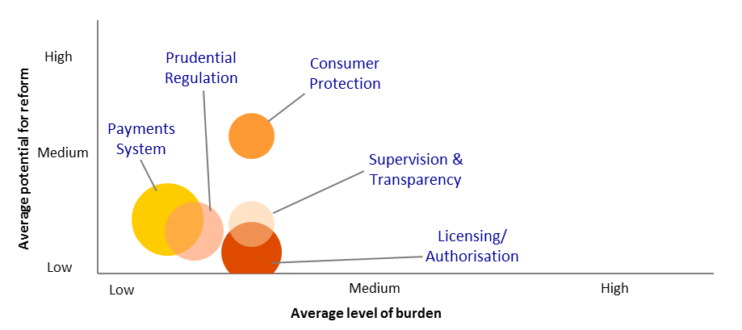

Banking regulation is divided into five main areas relating to prudential regulation, consumer protection, supervision and transparency, licensing and authorisation and the payments system.
Chart 2 shows that consumer protection, supervision and transparency, and licensing and authorisation obligations create the largest average regulatory burdens. Consumer protection obligations have the highest average potential for reform.
No groups of regulatory obligations were found to impose a high burden. Two groups of obligations were found to impose a medium level of total burden with a high potential for reform. The first was the obligation for authorised deposit-taking institutions (ADIs) to be prepared to activate the Financial Claims Scheme (FCS) under the Banking Act 1959. This obligation includes the requirement for ADIs to develop systems that can aggregate all of a customer’s accounts into a single view for the purposes of calculating their FCS entitlements. The second group of obligations found to impose a medium level of total burden with a high potential for reform was the obligation for ADIs to monitor accounts and report and remit unclaimed moneys to the Government.
Within prudential regulation, the requirement for entities to seek approval from the Treasurer in order to hold stakes in ADIs of more than 15 per cent under the Financial Sector (Shareholdings) Act 1998 was assessed as having a high level of potential for reform. All other obligations in this area were assessed as having low reform potential.
The ratings for the groups of banking regulatory obligations are largely a function of the size of the regulated population. Given the small number of entities regulated as ADIs, the total burden of regulation is lower than that imposed by some other groups of financial sector regulation with larger populations. These findings are also affected by the exclusion of some classes of costs — such as the opportunity costs of holding capital — from the definition of ‘regulation’ under the RBM framework.

The Financial Sector — Superannuation
Chart 3: Compliance Burden and Reform Potential of Superannuation Regulation
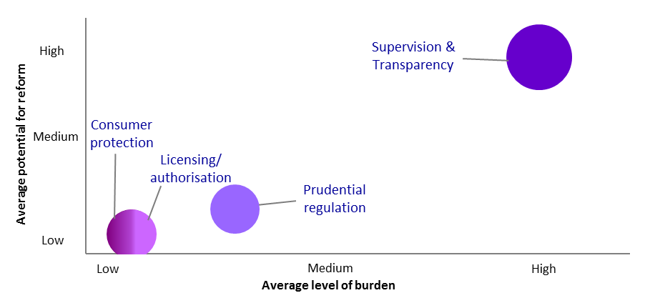

Superannuation regulation has four main areas of regulation: consumer protection, licensing and authorisation, prudential regulation and supervision and transparency.
Chart 3 shows that supervision and transparency obligations create the greatest average regulatory burden, followed by prudential regulation. Supervision and transparency obligations also had the greatest potential for reform. Two groups of obligations were found to impose a high level of total burden and a high potential for reform. These were:
- Public disclosure requirements for registrable superannuation entity (RSE) trustees.
  - Part 7.9 of the Corporations Act 2001 requires trustees to disclose information relating to the issue, sale and purchase of financial products, including the product disclosure statements and periodic statements. The provision also requires RSE licensees to produce information summaries known as ‘product dashboards’ for various products and to disclose the holdings of their investment portfolios.
- Reporting obligations for RSEs.
  - RSEs must provide the Australian Prudential Regulation Authority (APRA) with certain reports relating to their business and other information, such as audits. RSEs must also report data to APRA on standard forms, under the Financial Sector (Collection of Data) Act 2001 — including data collected on behalf of other agencies.
Liquidity adequacy requirements for holders of RSE licensees were assessed as imposing a medium level of burden, with a high potential for reform. The main driver for this burden level is the requirement for RSE licensees to be able to roll over or transfer a fund member’s benefits no later than three days after the member requests it. RSE licensees must also have liquidity management plans for each RSE within their business operations.
Both the consumer protection and licensing and authorisation areas received low ratings for the level of burden they impose and their potential for reform. In both cases, the main drivers of these ratings are the small population of RSEs regulated and the infrequency with which regulated entities generally need to interact with the regimes.

The Financial Sector — Insurance
Chart 4: Compliance Burden and Reform Potential of Insurance Regulation
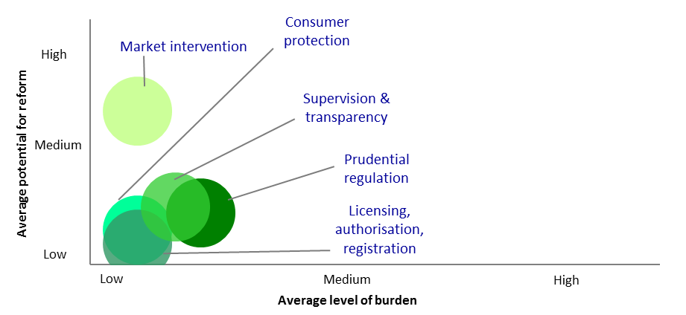

Insurance regulation comprises five main areas of regulation: prudential regulation, supervision and transparency, consumer protection, market intervention and licensing, authorisation and registration.
Chart 4 shows that prudential regulation creates the largest average level of regulatory burden. Supervision and transparency contain the second most burdensome obligations on average. Market intervention was assessed as having the highest average reform potential. This is driven by an assessment of the terrorism insurance requirements for general insurers as having a high level of reform potential.
None of the groups of insurance regulation was found to impose a high level of total burden. One group created a medium level of burden, with a high potential for reform. This consisted of the requirement for entities to seek approval from the Treasurer in order to hold stakes in life insurers and general insurers of more than 15 per cent under the Financial Sector (Shareholdings) Act 1998 and 15 per cent or more under the Insurance Acquisitions and Takeovers Act 1991.
Two other groups of regulation were assessed as imposing a medium average level of burden, but as having low potential for reform. These were:
- requirements for insurers to prepare, audit and disclose data to APRA, and to maintain adequate records of business undertaken; and
- The capital adequacy requirements for insurers, including the obligation for overseas general insurers operating in Australia through a branch rather than a local subsidiary to hold particular levels of assets in Australia.
A significant driver of these ratings is the small regulated population in the insurance sector. As with banking, obligations that have high levels of intensity per regulated entity may nevertheless impose lower levels of total burden.

The Financial Sector — Financial Services
Chart 5: Compliance Burden and Reform Potential of Financial Services Regulation
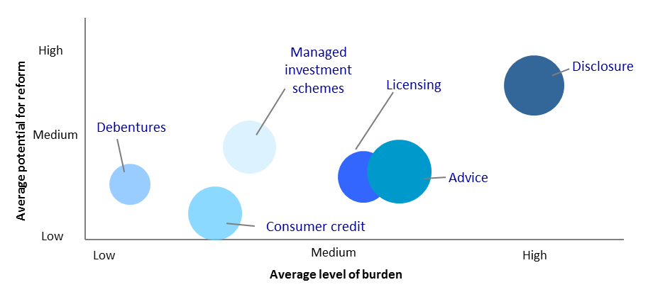

Financial services regulation divides into six main areas covering disclosure, advice, managed investment schemes, licensing, consumer credit and debentures.
Chart 5 shows that disclosure obligations impose the greatest average level of regulatory burden and have the greatest average potential for reform. Obligations relating to the provision of financial advice create the second highest level of burden.
Two groups of obligations, both relating to disclosure, were found to impose a high level of total burden and have a high potential for reform. These groups consist of the requirements for holders of Australian financial services licences (AFSLs) to develop product disclosure statements (PDSs) and Financial Services Guides (FSGs) and provide supplementary PDSs and updated FSGs when issuing financial products and providing financial services.
Four groups of obligations were found to impose a high level of total burden and to have a medium potential for reform. These were:
- the requirement for AFSL holders and their representatives who provide financial product advice to retail clients to ensure that their advice is in the best interests of their clients;
- the requirement for AFSL holders and their representatives to provide Statements of Advice;
- the ongoing licensing requirements for AFSL holders, including obligations to maintain systems and internal controls to ensure compliance with the law, to act honestly and fairly and maintain the ongoing competency of representatives; and
- the requirement for issuers of securities and certain other entities to issue a prospectus, a short-form prospectus or a profile statement.

The Financial Sector — Corporations and Capital Markets
Chart 6: Compliance Burden and Reform Potential of Corporations and
Capital Market Regulation
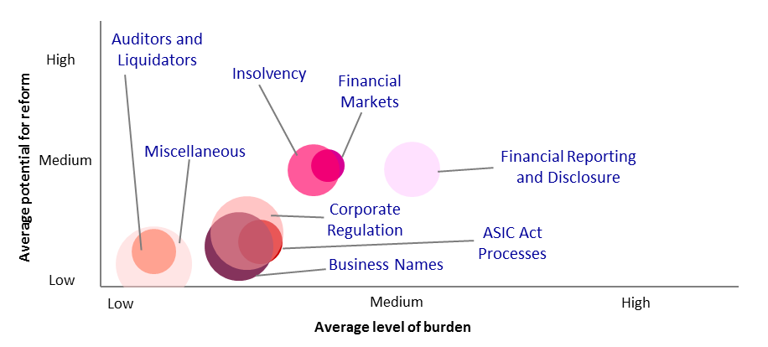

The capital markets category consists of eight main areas of regulation. These cover financial reporting and disclosure, financial markets, insolvency, corporate regulation, business names, auditors and liquidators, processes under the Australian Securities and Investments Commission Act 2001, and miscellaneous obligations.
Chart 6 shows that financial reporting and disclosure, financial market regulation and insolvency impose the greatest average level of regulatory burden. They also have the greatest average potential for reform.
Three groups of obligations were assessed as creating a high average regulatory burden with a medium potential for reform. These were:
- the directors’ and officers’ duties regime;
- obligations for entities producing general purpose financial reports subject to Tier 1 requirements; and
- non-financial reporting obligations for reporting entities.
Several other groups of obligations were found to impose a medium level of burden with a high potential for reform. These covered:
- financial market licensing and compensation regimes;
- requirements regarding corporations’ shareholder meetings;
- remuneration reporting;
- the requirements for voluntary administration, deeds of company administration, creditors’ and members’ voluntary liquidation and court-ordered liquidation; and
- the special purpose financial reporting regime.

The Financial Sector — Foreign Investment
Chart 7: Compliance Burden and Reform Potential of Foreign Investment Regulation
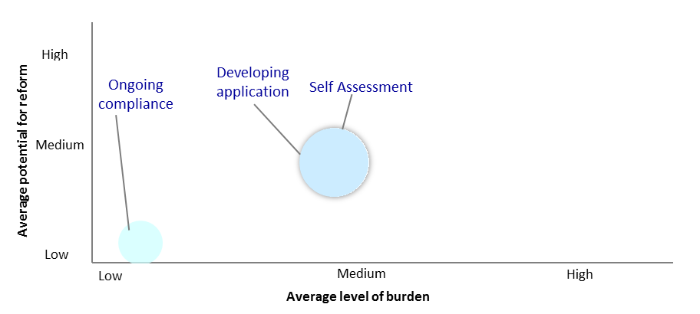

Foreign investment regulation has been divided into three groups of obligations, covering self-assessments of whether approval is required, developing and submitting an application, and complying with any conditions imposed by the Treasurer.
Chart 7 shows that self-assessment and developing an application impose the greatest level of regulatory burden. The main drivers are the large number of applications made each year and the cost of developing them. Both are assessed as having a medium potential for reform. Ongoing compliance activities were found to have a low level of regulatory burden and potential for reform.

Competition and Consumer Regulation
Chart 8: Compliance Burden and Reform Potential of
Competition and Consumer Regulation
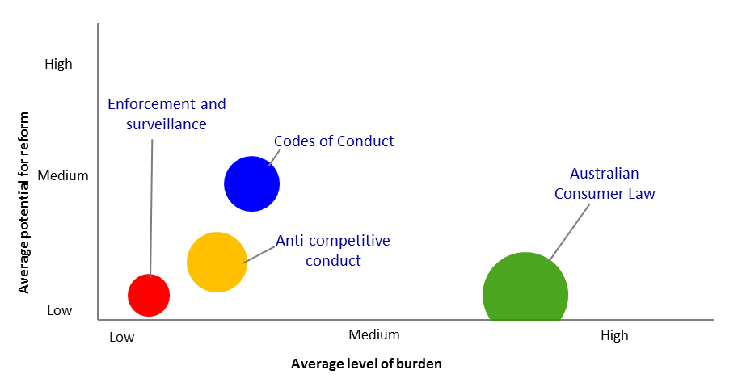

The four main areas in competition and consumer regulation relate to the Australian Consumer Law, anti-competitive conduct, codes of conduct and enforcement and surveillance.
Chart 8 shows that the highest average level of burden imposed arises from complying with the Australian Consumer Law. All groups in this area were rated as either medium or high for the overall level of burden they impose, in part because they apply to more than one million entities. Two groups of obligations received high ratings for their burden level. These cover economy-wide fair trading obligations, which relate to matters such as making misleading and deceptive statements, and requirements regarding the quality and safety of goods and services supplied.
Obligations relating to anti-competitive conduct and codes of conduct were found to have a lower average level of burden, but slightly higher average levels of potential for reform. The codes of conduct category was found to have a medium average potential for reform, due to the high reform potential rating for the franchising code.
The enforcement and surveillance category was found to have a low level of burden and a low potential for reform.

Results of the Quantitative Assessment — Tax Regulation
The qualitative assessment and feedback from consultation revealed that by far the most intensive area of regulation in the Treasury portfolio was the tax system.
As explained above, Treasury focused its costings in proportion to the intensity of regulation in each area, which meant costing almost all the regulatory obligations in the tax system administered by the Australian Taxation Office (ATO). To make this feasible in the timeframe, the ATO used its Standard Cost Model. The basic data set for the model is drawn from a large-scale national survey of most significant tax market segments conducted by Newspoll Market Research on behalf of the ATO in the 2011 financial year.

Overall Assessment — The Tax System — Taxpayers and Taxes
The aggregate compliance cost of tax regulation has been estimated at approximately $40 billion. This is broken down as per the chart below.
Chart 9: Tax Compliance Costs by Entity
Chart 9 shows the overall spending on compliance costs associated with the tax system, by type of entity. The entities are:
- individuals;
- small businesses (defined as those with an annual turnover of up to $2 million);
- medium businesses (with an annual turnover of up to $250 million);
- large businesses (with an annual turnover of over $250 million);
- not-for-profit organisations; and
- self-managed superannuation funds (SMSFs).
As the chart shows, small businesses account for the largest share of compliance costs, at $18.7 billion, followed by medium businesses and individuals, at $7.6 billion and $7.3 billion, respectively. Large businesses, SMSFs and not-for-profits have smaller shares of total compliance costs.
The main driver of the compliance costs for small businesses and individuals is the sheer number of entities involved — around 1.6 million for small businesses and around 12 million for individual taxpayers.
By contrast, large businesses involve a much smaller population, at around only 1,100, but a much higher degree of regulatory intensity. This finding is consistent with the more complex tax arrangements that are relevant to large businesses.
Not-for-profit organisations and self-managed superannuation funds each have relatively small populations (around 600,000 and 500,000 respectively) and a relatively low level of compliance costs per entity.
Chart 10: Tax Compliance Costs by Entity and Activity
Chart 10 separates tax compliance costs into the activities that each entity undertakes. There are a number of standard activities that apply to all or most entities and tax types:
- ‘learning and keeping up to date’ refers to entities’ efforts to understand their tax obligations;
- ‘evaluating and planning’ relates to entities engaging strategically with the tax system. It involves assessing the implications of the regulatory regime for an entity, considering eligibility for elements of the tax system and the costs and benefits of possible actions;
- ‘record-keeping’ covers the creation, collection, storage and retrieval of information and analysis and preparation of data for calculations used in tax operations; and
- ‘completing forms’ consists of preparing for and completing tax forms and schedules.
We have also added one activity for SMSFs covering their annual audit requirements and a category for the cost of fees which are paid to independent professionals, such as external accountants and lawyers. We have been able to allocate these fees to particular entities, but not specific tax types.
Chart 10 shows that the most costly activities for individuals are record-keeping and external fees. The cost of record-keeping is concentrated in income tax and it is very likely that external fees primarily reflect charges by tax agents for the preparation of tax returns.
For small and medium businesses, record-keeping is the largest single cost. External fees are the second-largest cost for each. The gap between the costs of these two activities is quite large for small businesses and much smaller for medium businesses, reflecting the greater need for external advice as businesses become larger and structures more complex.
This analysis is consistent with the breakdown for large businesses, where external fees are the largest compliance cost, ahead of record-keeping. Increased complexity is also reflected in the fact that the third-highest cost is for evaluating and planning, which is the lowest compliance cost for smaller businesses and not-for-profits.
Not-for-profits spend much less proportionately on external fees and on evaluating and planning than any other entity.

Chart 11: Tax Compliance Costs by Tax Type
Chart 11 shows compliance costs by each type of tax. We do not have sufficiently granular data to allocate external costs ($14.0 billion) to types of tax and so have recorded it separately.
This chart shows that the taxes that impose the greatest compliance burden are income tax ($12.4 billion) and GST ($7.6 billion), generally reflecting the large populations subject to them. Following these taxes is a second tier, which includes obligations related to superannuation ($2.6 billion) and Pay-As-You-Go withholding tax ($1.1 billion). Other taxes impose a relatively very small aggregate regulatory burden, driven by comparatively small populations affected.

Results of the Quantitative Assessment – Non-Tax Regulation
The total cost of non-tax regulation has been estimated at approximately $7 billion, consisting of:
- $6.3 billion for corporate and financial sector regulation;
- $600 million for competition and consumer regulation;
- $35 million for tax agent regulation; and
- $200 million for other areas of regulation.

Methodology
To generate the estimate we used the general methodology set out by the Department of the Prime Minister and Cabinet, adjusted slightly for the individual circumstances of Treasury. The assessment involved:
- dividing our non-tax regulation into four main sectors (the financial sector, competition and consumer regulation, tax agent regulation and other regulation);
- taking samples of the regulation from the low-, medium- and high-burden regulation in each sector rated in the qualitative stage;
- calculating the average compliance cost of each group of regulation in the sample for each sector; and
- extrapolating to estimate the total regulatory burden in each sector and the portfolio.
This approach resulted in 191 groups of non-tax regulation. Of these groups:
- 160 relate to the financial sector;
  - Of these, 92 groups relate to regulation administered by ASIC; 52 involve prudential regulation; nine deal with the payments system; four concern financial reporting; and three relate to foreign investment.
- 10 involve competition and consumer regulation;
- 5 relate to regulation of tax agents; and
- 16 cover other aspects of Treasury portfolio regulation.
  - These groups of regulatory obligations cover subjects ranging from the survey programs of the Australian Bureau of Statistics to infrastructure access regimes to aspects of energy regulation.

We initially selected a sample size of around 16 per cent of the total by:
- taking a random sample of the 191 groups;
- reviewing the sample to ensure that it was spread relatively evenly across the groups of regulation;
- weighting the sample towards groups of regulation that were given a ‘high’ rating for their level of compliance burden. (Given the large number of groups of regulation involved and the magnitude of the costs involved in those with ‘high’ ratings, we took the view that costing a higher proportion of the most burdensome regulatory obligations would ultimately yield a more accurate view of the total cost of Treasury regulation); and
- seeking information on costs from relevant regulators and from industry groups.
As the costing exercise progressed, it became apparent that there were a few additional groups of regulatory obligations — primarily those with low and medium ratings for regulatory burden — where good data existed and costings could be undertaken relatively quickly. We supplemented our sample with some of these obligations to create a more representative distribution across the high, medium and low categories and increased the sample size to a total of 35 groups (18 per cent of the total).
It became apparent during the consultation and costing phases that the different non-tax sectors imposed regulatory burdens of different orders of magnitude — particularly for the most cost-intensive areas of regulation. Therefore, we applied the standard methodology in a more granular way by treating each of the four non-tax sectors as involving a different regulated population, with the result that the costings of regulation in one sector are not used to extrapolate the estimates of regulatory costs in other sectors.
As a cross-check, we undertook a separate costing that applied the standard methodology more strictly, by putting all our costings into a single pool when calculating the average cost of high-, medium- and low-burden regulation (rather than separating the costings by area of regulation). This resulted in a much lower estimate of regulatory costs in the portfolio (around $2.2 billion). In our view, this result did not reflect the true cost or structure of regulation in these sectors, and the stakeholders with whom we consulted agreed.

Findings
Chart 12: Total Compliance Costs of Non-Tax Regulation
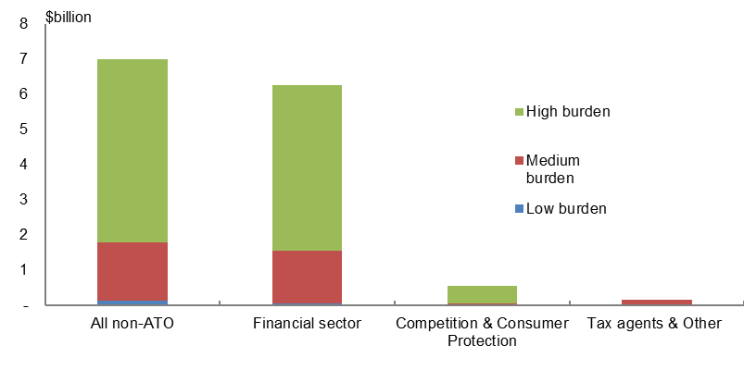
The resulting estimate of the total compliance costs of financial sector regulation, competition and consumer regulation, tax agent regulation and other regulation in the Treasury portfolio is approximately $7 billion. Of this, over $6.8 billion is attributable to financial sector and competition and consumer regulation.
As Chart 12 shows, the vast majority of the compliance cost of non-tax regulation in the Treasury portfolio arises from financial sector regulation ($6.3 billion, or 89 per cent of the total). The next highest source is competition and consumer regulation ($600 million, or
8 per cent of the total). Tax agent regulation and other regulation account for less than
5 per cent of the total.
As this chart also demonstrates, the majority of the compliance costs of the four sectors of regulation relate to the groups of regulatory obligations with ‘high’ ratings for burden level. These account for $5.2 billion (74 per cent of the total). The number of groups of regulatory obligations with a ‘high’ rating is relatively small, at 16 out of 191 (8 per cent). These points indicate that much of the compliance burden in these sectors of regulation arises from a relatively small number of intense regulatory obligations.
These estimates are based on calculating average costs for the low-, medium- and high-burden categories of regulation in each sector and extrapolating them across the regulatory obligations in each sector. The estimates are therefore quite sensitive to changes in the classification of the burden level of groups of regulation — particularly between the medium-burden and high-burden categories — increasing the importance of consultation on the categorisation process and the costings of individual groups of obligations.

Validation and Assurance
The quality assurance process involved both internal and external assessment of the costs. In most cases, the initial costings were undertaken by Treasury regulators, as they had the most direct access to data on the regulated population. Several industry bodies also provided data to assist with the costings. Treasury then reviewed the costings and consulted the relevant MAC.
Given the scope and diversity of the Treasury portfolio, we consulted on the overall results with three MACs:
- the Board of Taxation, for tax matters;
- the Financial Sector Advisory Council (FSAC), for corporate and financial regulation; and
- the Financial Reporting Council (FRC), for technical financial reporting issues.
We also presented our findings on the small business aspects of several areas of regulation to the Small Business Minister’s Advisory Council.
When consulting on the methodology and preliminary findings with each of these bodies, we sought feedback on:
- the aggregation of regulatory obligations into groups;
- the rating of groups in terms of their burden level and reform potential;
- whether any regulatory obligations had been omitted;
- whether the methodology for sampling and extrapolating regulatory costs was reasonable (within the bounds of the PM&C methodology); and
- whether the results were credible.
We also raised sector-specific issues with each MAC.
The MACs generally agreed with the approaches taken to the stocktake and there are no major outstanding issues.
In the case of corporate and financial sector regulation, FSAC members provided individual comments on the structure of our groups of regulation and on the ratings for specific groups. Advice from the FSAC members was particularly useful — especially where shared by multiple members — in determining which of the two compliance cost methodologies and estimates for financial sector and corporate regulation we considered was more accurate. We ultimately adopted the higher of the two estimates, for the reasons set out above.
The FRC commented on the structure and ratings of our groups of financial reporting regulation, particularly in relation to the different populations to which obligations of different levels of intensity applied. We made changes based on the FRC’s advice.
The Board of Taxation commented on several aspects of the estimate of tax system regulation. In particular, the Board agreed with our concern that the estimates of Fringe Benefits Tax (FBT) generated by the model were too low and that a portion of the costs related to FBT was likely to be captured in the external costs paid to accounting professionals and solicitors, where we do not have a breakdown by tax type.
The Board also asked for further detail on several issues, but did not suggest changes to the final cost estimate.

Conclusion
This stocktake estimates the total compliance cost of regulation in the Treasury portfolio at approximately $47 billion. Of this, $40 billion is attributable to the tax system and the rest primarily to corporate and financial sector regulation.
Throughout this process, Treasury consulted with MACs to ensure consistency with the views of industry. MACs generally supported the methodology and results.
Treasury’s overall compliance cost estimate is relatively large compared to other portfolios, driven by the wide span of Treasury’s regulatory responsibility and the large populations affected. However, this total burden should be considered within the broader context of the costs and benefits associated with regulation. Compliance cost reductions need to focus on reducing excessive and unnecessary regulation, rather than just the overall magnitude of regulatory burden, to ensure that broader regulatory outcomes can be pursued in an efficient manner. Nevertheless, the stocktake provides importance guidance on where to search for opportunities to reduce red tape, to allow the portfolio to continue its significant contribution to the Government’s deregulation agenda.

Appendix 1: List of regulations identified as imposing a high burden
Group of obligations | List of relevant legislation, legislative instruments and quasi-regulation | Notes
Superannuation — supervision — preparation, auditing and reporting of information to APRA — registrable superannuation entity licensees and auditors | Superannuation Industry (Supervision) Act 1993 (SIS Act)  Superannuation Industry (Supervision) Regulations 1993  Financial Sector (Collection of Data) Act 2001  APRA reporting standards | The SIS Act requires registrable superannuation entities to provide APRA with certain reports and returns relating to superannuation entities (accounts, statements and audits). APRA also collects data through reporting standards issued under the Financial Sector (Collection of Data) Act 2001, including on behalf of other agencies.
Superannuation — transparency — public disclosure of information in periodic statements, product disclosure statements, product dashboards and portfolio holdings disclosure — registrable superannuation entity licensees | Corporations Act 2001  Corporations Regulations 2001  APRA reporting standards  ASIC FAQs and guidance notes  ASIC Class Orders | Part 7.9 of the Corporations Act 2001 imposes obligations on trustees of registrable superannuation entities to disclose information relating to the issue, sale and purchase of financial products. This includes producing product disclosure and periodic statements, product dashboards and portfolio holdings disclosure.
Directors’ appointments and duties — directors’ and officers’ duties | Corporations Act 2001 Part 2D  Corporations Regulations 2001 | Directors and other officers of a company have various duties to act appropriately in governing the company’s affairs.
Financial reporting — Tier 1 General Purpose Financial Reporting — full reporting requirements | Corporations Act 2001 (Parts 2M.3, 2M.6, 9.3) Corporations Regulations 2001 (incl. Reg 9.4A.02)  ASIC Regulatory Guide 28 (relief from dual lodgement) ASX Listing Rules (Periodic Disclosure)  ASIC Class Orders  ASIC Regulatory Guides  ASIC Form 991/992  Australian Accounting Standards  Australian Auditing Standards | All entities must maintain written financial records, with these to be available for inspection.  Entities subject to full Corporations Act 2001 reporting requirements must prepare audited financial reports according to the relevant accounting and auditing standards.  Listed public companies must keep financial records and use these to prepare financial and directors’ reports semi-annually These reports are then lodged with ASIC, provided to members and laid before the AGM. ASIC has the power to relieve certain companies of financial reporting obligations.

Group of obligations | List of relevant legislation, legislative instruments and quasi-regulation | Notes
Compliance with loss integrity rules | Income Tax Assessment Act 1997  Income Tax Assessment Act 1936  Taxation Administration Act 1953  Income Tax Regulations 1936  Income Tax Assessment Regulations 1997  Taxation Administration Regulations 1976  ATO rulings, determinations and general guidance. | Taxpayers need to keep a record of their unused prior year losses, and apply the continuity of ownership test or same business test when utilising the loss in a later year.
Capital allowances — understanding your obligations — large corporates | Income Tax Assessment Act 1997  ATO rulings, especially TR2014/4, and general guidance | The capital allowance provisions enable taxpayers to claim deductions for the costs of assets used in business. Broadly, taxpayers must estimate the effective life of assets and use this to calculate a deduction each year, based on the length of time they owned the asset. The Commissioner provides tables which can be used by taxpayers as a guide. Other provisions set out other concessions or opportunities to depreciate expenses.
Capital allowances — understanding your obligations — SMEs | Income Tax Assessment Act 1997  ATO rulings, especially TR2014/4, interpretative decisions, practice statements and general guidance | The capital allowance provisions enable taxpayers to claim deductions for the costs of assets used in business. Broadly, taxpayers must estimate the effective life of assets and use this to calculate a deduction each year, based on the length of time they owned the asset. The Commissioner provides tables which can be used by taxpayers as a guide. Other provisions set out other concessions or opportunities to depreciate expenses.
Taxation of corporate dividends — pass through of franking credits (Imputation) — SMEs | Income Tax (Franking Deficit) Amendment Act 1993  Income Tax (Franking Deficit) Amendment Act 1995  New Business Tax System (Franking Deficit Tax) Act 2002  New Business Tax System (Franking Deficit Tax) Amendment Act 2002  New Business Tax System (Imputation) Act 2002. | Corporate taxpayers need to maintain a franking account, the balances in the account, and ensure the correct amount is credited or debited in the franking account. All taxpayers need to comply with a number of integrity rules that were designed to prevent dividend streaming and franking credit trading.

Group of obligations | List of relevant legislation, legislative instruments and quasi-regulation | Notes
Taxation of Individuals — Record keeping obligations | Income Tax Assessment Act 1997  Income Tax Assessment Regulations 1997  Income Tax Assessment Act 1936  Income Tax Regulations 1936  Taxation Administration Act 1953  Taxation Administration Regulations 1976  ATO rulings, determinations and general guidance. | Individuals are required to keep records throughout the year so that the information they provide upon assessment is accurate, and their eligibility for certain offsets and deductions can be assessed (and proven, if required).
General economy-wide fair trading obligations | Chapter 2 of the Australian Consumer Law | Entities must not make misleading or deceptive statements, behave unconscionably or seek to include unfair terms in standard form consumer contracts.
Superannuation — non-prudential regulation specifically targeting self-managed superannuation funds (SMSF) — fund trustees and members are the same | Superannuation Industry (Supervision) Act 1993 Superannuation Industry (Supervision) Regulations 1994 | Entities must comply with a range of standards relating to their structure. They must undergo an annual audit and pay an annual levy.
Taxation of individuals — understanding your obligations | Income Tax Assessment Act 1997; Income Tax Assessment Regulations 1997; Income Tax Assessment Act 1936; Income Tax Regulations 1936; Taxation Administration Act 1953; Taxation Administration Regulations 1976; ATO rulings, determinations and general guidance. | Individuals must spend time understanding their obligations in the personal income tax system. This can typically involve researching online, communicating with the ATO and/or speaking to a professional.
Pay As You Go Withholding — small employers | Income Tax Assessment Act 1997; Taxation Administration Act 1953; Taxation Administration Regulations 1976; ATO rulings, determinations and general guidance. | Employers are required to calculate and withhold income tax (and Medicare levy, HELP contributions, and so on) throughout the year on behalf of their employees and then remit the withheld amount to the ATO. The ATO provide withholding tables to assist employers with this task.
Superannuation — non-prudential superannuation regulation — funds and individuals — contribution rules | Part 7 of the Superannuation Industry (Supervision) Regulations 1994; Part 5 of the Retirement Savings Accounts Regulations 1997. | Compliance with rules and record-keeping.

Group of obligations | List of relevant legislation, legislative instruments and quasi-regulation | Notes
Goods and Services Tax — classification of GST transactions | A New Tax System (Goods And Services Tax) Act 1999  A New Tax System (Goods And Services Tax) Regulations 1999 | Sorting transactions into type (eg GST-free, input-taxed, non-taxable importations etc) to account for multitude of GST classifications. Understanding all relevant classifications.
Superannuation — non-prudential superannuation regulation — funds, service providers and individuals — other regulation including Tax File Numbers | Superannuation Industry (Supervision) Act 1993; Superannuation Industry (Supervision) Regulations 1994; Retirement Savings Accounts Act 1997; Retirement Savings Accounts Regulations 1997. | Compliance with standards, reporting and record-keeping.
Income Tax Returns — lodging — Individuals using a tax agent | Income Tax Assessment Act 1997, Income Tax Assessment Act 1936, Taxation Administration Act 1953, Income Tax Regulations 1936, Income Tax Assessment Regulations 1997, Taxation Administration Regulations 1976, ATO rulings, determinations and general guidance. | Individual taxpayers who earn income above the tax-free threshold and use a tax agent are required to provide documentation and personal information to their tax agent.
Superannuation — Non-prudential superannuation regulation — funds — pension rules | Part 1A of the Superannuation Industry (Supervision) Regulations 1994. | For account-based income streams, entities must make minimum annual payments.
Superannuation — Non-prudential superannuation regulation — funds — preservation and early release arrangements | Part 6 of the Superannuation Industry (Supervision) Regulations 1994; Part 4 of the Retirement Savings Accounts Regulations 1997. | Compliance with standards and record-keeping. Includes dealing with applications for early release.
Superannuation — non-prudential superannuation regulation — funds — unclaimed money and lost accounts. | Superannuation (Unclaimed Money and Lost Members) Act 1999; Superannuation (Unclaimed Money and Lost Members) Regulations 1999; Superannuation Industry (Supervision) Regulations 1994; Retirement Savings Accounts Regulations 1997. | Compliance with rules, reporting, payment and record-keeping.
Pay As You Go Withholding — medium employers | Income Tax Assessment Act 1997; Taxation Administration Act 1953; Taxation Administration Regulations 1976; ATO rulings, determinations and general guidance. | Employers are required to calculate and withhold income tax (and Medicare levy, HELP contributions, and so on) throughout the year on behalf of their employees and remit the withheld amount to the ATO. The ATO provide withholding tables to assist employers with this task.
Group of obligations | List of relevant legislation, legislative instruments and quasi-regulation | Notes
Fringe Benefits Tax — employers — record keeping and payment | Fringe Benefits Tax Assessment Act 1986; Fringe Benefits Tax Act 1986; Fringe Benefits (Application to the Commonwealth) Act 1986; Fringe Benefits Tax (Application to the Commonwealth) Regulations 1989; Fringe Benefits Tax Regulations 1992; ATO rulings, determinations and general guidance. | There is a general requirement that tax payers must keep records that are adequate to enable their fringe benefits tax liability to be assessed.
Capital gains tax — understanding your obligations — Individuals | Income Tax Assessment Act 1997; Taxation Administration Act 1953; ATO rulings, determinations and general guidance. | Individuals who own a capital asset and sell it for a gain have reporting and record keeping obligations.
Superannuation — taxation of income (contributions & earnings) — small withholder superannuation funds ($25,000 or less withheld a year) | Income Tax Assessment Act 1997; Taxation Administration Act 1953; Taxation Administration Regulations 1976; ATO rulings, determinations and general guidance. | Compliance with rules (e.g. contribution caps). Reporting, record-keeping and payment/withholding of tax. Generally annual lodgement and payment of tax via fund income tax return. In practice funds withhold as transactions occur which could be multiple times per day. Obligations completed through the Business Activity Statement.
Superannuation — Superannuation Guarantee (SG) arrangements — large and medium size employers  (>99 employees) | Superannuation Guarantee (Administration) Act 1992; Superannuation Guarantee (Administration) Regulations 1993. | Record-keeping, payment of SG, payment of SG charge where super not paid on time, employers must choose default fund.
Superannuation — Non-prudential superannuation regulation — individuals — preservation and early release arrangements | Part 6 of the Superannuation Industry (Supervision) Regulations 1994; Part 4 of the Retirement Savings Accounts Regulations 1997. | Compliance with standards and record-keeping. Includes applications for early release.
Superannuation — Taxation of benefits — Small withholder superannuation funds ($25,000 or less withheld a year) | Income Tax Assessment Act 1997; Taxation Administration Act 1953; Taxation Administration Regulations 1976; ATO rulings, determinations and general guidance. | Compliance with rules. Reporting, record-keeping and payment/withholding of tax. Generally annual lodgement and payment of tax via fund income tax return. In practice funds withhold as transactions occur which could be multiple times per day. Obligations completed through the Business Activity Statement.

Group of obligations | List of relevant legislation, legislative instruments and quasi-regulation | Notes
Financial services — Licensing — General ongoing requirements — All Australian Financial Services Licences (AFSLs) | Corporations Act 2001 Part 7.6 (especially Div 3, 4), Corporations Regulations 2001 Part 7.6, ASIC guidance | Licensees to maintain systems and internal controls to ensure: compliance with the law, act honestly and fairly, ongoing competency of representatives; register new authorised reps with ASIC, pay annual fee, send notification of breaches to ASIC.
Financial services — Advice — Conduct and remuneration — AFSLs and representatives providing financial product advice to retail clients | Corporations Act 2001 Part 7.7A, Corporations Regulations 2001 Part 7.7A, ASIC guidance | Requirements to maintain systems and internal controls to ensure advice is provided in the best interests of the clients and that conflicted remuneration is not paid or received.
Goods and Services Tax — filling out BAS — small/medium | A New Tax System (Goods and Services Tax) Act 1999  A New Tax System (Goods and Services Tax) Regulations 1999 | Complete BAS every quarter. Complete adjustments.
Financial services — Advice — Personal Advice — AFSLs and representatives providing personal financial product advice to retail clients | Corporations Act 2001 Part 7.7 Div 3, Corporations Regulations 2001 Part 7.7 Div 3, ASIC guidance | Develop and provide a Statement of Advice.
Financial Reporting — Other corporate reporting | Corporations Act 2001 Part 2M.3; Corporations Regulations 2001 | Reporting entities are required to prepare non-financial reports, such as the directors’ report, as part of the annual report.
Financial services — Licensing — Reporting and auditing — Full AFSLs |  | Licensees must engage with accountants and auditors to prepare audited statements, lodge audited statements and accompanying lodgement form (7 pages, or electronically) to ASIC once a year.
Financial Services — Disclosure — Prospectus requirements — Issuers of securities and certain other entities | Corporations Act 2001 Ch 6D, especially Pt 6D.2; Corporations Regulations 2001 Ch 6D, ASIC guidance | Develop and issue a prospectus, short-form prospectus or profile statement.
Financial Services — Disclosure — Financial Services Guide — AFSLs and representatives providing financial services | Corporations Act 2001 Part 7.7 Div 2, Corporations Regulations 2001 Part 7.7 Div 2, 2AA, 2A, ASIC guidance | Develop and provide a Financial Services Guide and provide an updated Financial Services Guide.
Group of obligations | List of relevant legislation, legislative instruments and quasi-regulation | Notes
Financial Services — Disclosure — Product Disclosure Statement — AFSLs, representatives and others issuing financial products | Corporations Act 2001 Part 7.9, Corporations Regulations 2001 Part 7.9, ASIC guidance | Develop and provide a Product Disclosure Statement and provide supplementary PDSs.
Goods and Services Tax — invoice tax requirements | A New Tax System (Goods and Services Tax) Act 1999  A New Tax System (Goods and Services Tax) Regulations 1999 | Comply with invoice tax requirements when giving tax invoices.
Taxation of trusts — understanding obligations | Division 6 of the Income Tax Assessment Act 1936 | There are specific rules which relate to the taxation of trusts. In determining the income of the trust estate, trustees need to have regard to the trust deed, the tax law and general law principles.
Taxation of trusts — determining entitlements | Division 6 of the Income Tax Assessment Act 1936 | There are specific rules which relate to the taxation of trusts. In determining the entitlements of beneficiaries of the trust estate, trustees need to have regard to the trust deed, the tax law and general law principles.
Goods and Services Tax — general record-keeping | A New Tax System (Goods and Services Tax) Act 1999  A New Tax System (Goods and Services Tax) Regulations 1999 | Keep records of all transactions for a period of five years.
Taxation of small business — planning and advice | Income Tax Assessment Act 1997, Income Tax Assessment Act 1936, Taxation Administration Act 1953, Income Tax Regulations 1936, Income Tax Assessment Regulations 1997, Taxation Administration Regulations 1976, ATO rulings, determinations and general guidance. | Many small businesses seek tax planning and advice when establishing the business, changing business structure or winding up a business.
Taxation of small business — claiming the small business tax concessions | Income Tax Assessment Act 1997, ATO rulings, determinations and general guidance material | Entities opt into the small business tax concessions through their tax return. Initial complexity stems from identifying whether the concessions are of benefit to the small business. Some of the rules seem complicated but in most circumstances they are relatively simple. ATO provides guidance material for users.
Taxation of small business — Deductions | Income Tax Assessment Act 1997, Income Tax Assessment Act 1936, ATO rulings, determinations and general guidance material | Small businesses that are eligible to claim deductions need to assess eligibility, keep records and report deductions upon assessment.
Group of obligations | List of relevant legislation, legislative instruments and quasi-regulation | Notes
Taxation of small business — Basic income tax liability | Income Tax Assessment Act 1997, Income Tax Assessment Act 1936, Taxation Administration Act 1953, Income Tax Regulations 1936, Income Tax Assessment Regulations 1997, Taxation Administration Regulations 1976, ATO rulings, determinations and general guidance | Small business taxpayers who earn income above the tax-free threshold have reporting and record keeping obligations and are required to lodge an annual tax return and pay income tax. The business structure chosen will depend on the method of complying with this requirement. Small businesses will generally lodge their Business Activity Statement quarterly.
Excise — Taxation of fuels — Fuel Tax Credits | Fuel Tax Act 2006 and Tax Administration Act 1953 | Fuel tax (excise or customs duty) is applied to all fuel whether domestically produced or imported. Fuel tax credits (FTCs) provide credits to offset the fuel tax on fuel used off road and by emergency services and is claimed through the BAS.
Goods and Services Tax — turnover calculation | A New Tax System (Goods and Services Tax) Act 1999  A New Tax System (Goods and Services Tax) Regulations 1999 | Monthly calculation of GST turnover to determine tax period and whether over/under registration threshold.
Goods and Services Tax — filling out BAS — large | A New Tax System (Goods and Services Tax) Act 1999  A New Tax System (Goods and Services Tax) Regulations 1999  Tax Administration Act 1953 | Complete a Business Activity Statement every month. Complete adjustments.
Australian Charities and Not-for-profits Commission — governance standards | Australian Charities and Not-for-Profits Commission Act 2013, Australian Charities and Not-for-profits Commission Regulations | Charities must ensure the suitability of responsible persons; ensure responsible persons understand and carry out their duties. Charities must be accountable to their members
Primary producer concessions — Claiming a range of tax concessions for eligible primary producers. | Income Tax Assessment Act 1997, ATO rulings and general guidance material | Record-keeping and claiming on annual tax returns. Primary producers are able to access a range of specific tax concessions, including deductions and offsets for eligible expenditure and depreciation, through their annual tax return.
Income Tax Returns — Lodging — Individuals | Part IV, s 161 of the Income Tax Assessment Act 1936 | Lodge individual income tax return.
PAYG Instalments — Payment — All entities | Part 2-10 of the Taxation Administration Act 1953 | Entities in the PAYG instalment system need to remit instalments to the ATO on their business or investment income.
Group of obligations | List of relevant legislation, legislative instruments and quasi-regulation | Notes
Income Tax Returns — Lodging — Sole Traders | Part IV, s 161 of the Income Tax Assessment Act 1936 | Lodge individual income tax return.
Division 7A — understanding obligations | Division 7A of the Income Tax Assessment Act 1936 | Division 7A of Part III of the Income Tax Assessment Act 1936 is an integrity measure aimed at preventing shareholders of private companies (or their associates) from inappropriately accessing the profits of those companies.
Income Tax Returns — Lodging — Companies | Part IV, s 161 of the Income Tax Assessment Act 1936 | Companies lodge a company tax return to report income and tax liability.
Income Tax Returns — Lodging — Trusts and beneficiaries | Part III and Part IV, s 161 of the Income Tax Assessment Act 1936 (Division 6) | The trust lodges a trust tax return to report its net income or loss. As a trust beneficiary, an individual tax return is to be lodged to report income received from the trust, and any other assessable income.
Division 7A — record keeping and other obligations | Division 7A of Income Tax Assessment Act 1936 | Division 7A of Part III of the Income Tax Assessment Act 1936 is an integrity measure aimed at preventing private companies from making tax-free distributions of profits to shareholders (or their associates).
Pay As You Go (PAYG) Withholding — Payment summaries — All entities (total hours per year) | Part IV, s 161 of the Income Tax Assessment Act 1936 | Businesses are to provide payees with a payment summary specifying how much was paid to them in the financial year and how much was withheld from those payments.
Double Tax Relief for Australian Residents — Foreign Income Tax Offset (FITO) — Individuals | Division 770 of the Income Tax Assessment Act 1997 | Taxpayers will be entitled to a non-refundable tax offset for foreign income tax paid on an amount included in their assessable income.
Australian Business Number (ABN) — Quote ABN — All entities | Section 29.7 A New Tax System (Goods and Services Tax) Act 1999 (tax invoices); Section 388-50(1) Taxation Administration Act 1953 (Approved form provisions can require you to provide ABN); Part 2, Division 5 of A New Tax System (Australian Business Number) Act 1999 (Australian Business Register); various other pieces of Commonwealth legislation may require ABNs to be in contracts, etc. | Quote ABN to the ATO, the ABR, on invoices, contracts etc.

Group of obligations | List of relevant legislation, legislative instruments and quasi-regulation | Notes
Pay As You Go (PAYG) Withholding — Lodgement and payment — All entities | Taxation Administration Act 1953 | Businesses must report and pay the amounts withheld to the ATO. Businesses report the amount withheld using the Business Activity Statement.
Pay As You Go (PAYG) Withholding — When a worker leaves or retires — All entities | Taxation Administration Act 1953 | When an employee ceases employment, a business must: make any final PAYG withholding payments on the employee’s behalf; complete an employment termination payment form if required; send a payment summary to the employee by 14 July, or earlier if requested; retain the employee’s TFN declaration until the end of the next financial year; include the details of any final payments made to the employee in your PAYG payment summary statement; keep the necessary PAYG withholding records.  When a contractor ceases their contract, a business must withhold from any final payments at the appropriate rate and keep the necessary PAYG withholding records.  For contractors under a voluntary agreement, a business must:  - forward a PAYG payment summary — business and personal services income to them by 14 July, or earlier if requested;  - include the details of any final payments made to them in the PAYG payment summary statement.  For contractors who have not quoted their ABN, a business is to:  - provide them with a PAYG payment summary — withholding where ABN not quoted with their payment, or as soon as practicable afterwards  - include the details of any final payments made to them in your PAYG withholding where ABN not quoted.

Group of obligations | List of relevant legislation, legislative instruments and quasi-regulation | Notes
Income Tax Returns — Lodging — Partnerships | Part IV of the Income Tax Assessment Act 1936 | Partnerships lodge a partnership tax return to report net income or loss. Each individual partner lodges an individual tax return to report their share of any partnership net income or loss, and any other assessable income.
Income Tax Returns — Lodging — Superannuation Funds | Part IV of the Income Tax Assessment Act 1936 | APRA and self-managed super funds are required to lodge income tax returns for the fund.
Income Tax Returns — Objection to an amended assessment — Individuals | Part IV of the Income Tax Assessment Act 1936; and Part IVC of the Taxation Administration Act 1953 | Businesses and individuals can object an amendment to an assessment either through the ATO’s Business Portal or by lodging an objection form to the ATO.
Tax agent services regulation — maintain awareness of Tax Practitioners Board information products | Tax Agent Services Act 2009  Tax Agent Services Regulation 2009  TPB(PG) 01-2013: Board approved course in basic accountancy principles  TPB(PG) 02-2013: Board approved course in commercial law  TPB(PG) 03-2013: Board approved course in Australian taxation law  TPB(I) 04-2011: BAS agent educational requirements  TPB(EP) 03-2010: Professional indemnity insurance  TPB(EP) 04-2010: continuing professional education | Tax agents must maintain awareness of certain information products published by the Tax Practitioners Board in order to meet Board requirements.
Australian Bureau of Statistics — select business surveys | Business Survey — Average Weekly Earnings  Business Survey — Building Activity  Business Survey — Business Indicators Survey  Business Survey — Economic Activity Survey  Business Survey — Engineering Construction  Business Survey — International Investment (Survey of)  Business Survey — Retail Business Survey  Business Survey — Wage Price Index | Businesses must complete the relevant questionnaires.

Group of obligations | List of relevant legislation, legislative instruments and quasi-regulation | Notes
Competition and consumer regulation — Requirements regarding the quality or safety of goods and services | Part 3-2 Division 1 and Parts 3-3, 3-4 and 3-5 of the Australian Consumer Law (consumer guarantees, product safety, information standards).  Rule 90-92 of the Competition and Consumer Regulations 2010.  Product safety regulations and information standards made under the Australian Consumer Law. | Businesses must meet certain obligations regarding the goods and services they supply — for example, goods and services must be of an acceptable quality for the price. In addition, the regulations may prescribe that certain goods and services supplied in Australia must meet certain safety standards or meet certain information disclosure or labelling requirements.

These sub-totals do not add to $47 billion due to rounding.
These sub-totals do not add to $7 billion due to rounding.
The terms of the most recent FSAC members expired on 30 June 2014, before Treasury could consult with FSAC on the cost estimates. We therefore consulted with the former FSAC members individually.

