

Australian Government Payments to Small Business
Performance Report
The 14th Survey | 1 July 2011 – 30 June 2012

Table of Contents
Survey of Australian Government Agencies 1
Updated Procurement Payment Policy for Small Business 2
Compliance with the 30 Day Payment Element of the Policy 2
Survey History 4
Compliance with the Interest on Late Payments Policy 5

Survey of Australian Government Agencies
This report contains the results of the fourteenth survey of Australian Government Payments to Small Business (the survey) for the period 1 July 2011 to 30 June 2012. The survey monitors compliance with the Procurement 30 Day Payment Policy for Small Business. The policy contains the following elements:

- Payment of invoices within 30 Days
The survey captures data to enable two different measures of payment performance to be calculated for each agency. They are the proportion of invoices paid by number (volume) and the proportion of invoices paid by value. Payments made by credit cards were requested to be included where relevant. Agencies are required to meet or exceed a performance benchmark of 90 per cent of correctly rendered invoices from small businesses being paid within 30 days of receipt.
Where financial systems could not separately identify small business invoices, agencies were requested to include invoices of up to $5 million (inclusive of GST) as a proxy.

- Late payment interest penalty
In December 2008, the Australian Government commenced the policy that an agency must pay simple interest for contract procurements that they fail to pay on-time upon receipt of a correctly rendered invoice with a value of up to $1 million from a small business.

The full policy details are contained in Department of Finance and Deregulation, Finance Circular No. 2008/10.

Updated Procurement Payment Policy for Small Business
The Procurement 30 Day Payment Policy for Small Business was updated on 1 September 2012. In addition to the requirements listed previously, agencies are now required to automatically pay penalty interest to small businesses for payments exceeding 60 days on contracts valued up to $1 million (GST inclusive).

As this updated policy came into effect after the reporting period of this survey, it has not impacted on the performance data collected for this report. Full details of the updated policy are contained in Department of Finance and Deregulation Finance Circular 2012/02.

Compliance with the 30 Day Payment Element of the Policy
The main findings from the 1 July 2011 – 30 June 2012 survey are:

- 40 agencies participated, covering around 904,000 invoices worth a total of approximately $3 billion (see Table 1).
- By number, 96.8 per cent of invoices were paid within 30 days and in terms of value 94.2 per cent of invoices were paid on time (see Table 2).
- Only one department, the Department of Parliamentary Services, failed to meet the 90 per cent benchmark for the on-time payment of invoices from small business.
- Performance, in terms of the total number of invoices received and paid on time, has dropped slightly since the previous survey from 97.7 per cent (2010-11) to 96.8 per cent (2011-12).
- It should be noted that agency performance by value has improved, increasing from 89.2 per cent in 2010-11 to 94.2 per cent in 2011-12.

Table 1: Whole-of-Government performance - combined data on the timeliness of payment of small business invoices, by number and by value (2011-12)
 | Number of invoices (‘000) | Value of invoices ($M)
Paid within 30 days | 875.6 | 2,902.0
Paid within 31-44 days (up to 2 weeks late) | 15.4 | 91.0
Paid within 45-60 days (up to 30 days late) | 6.0 | 43.9
Not paid after 60 days (over 30 days late) | 7.2 | 43.1
Total paid late | 28.5 | 177.9
Total invoices | 904.1 | 3,079.9

Table 2: Whole-of-Government performance – timeliness of small business invoices by percentage share (2011-12)
 | By number | By value
Paid within 30 days | 96.8% | 94.2%
Paid late | 3.2% | 5.8%
Paid over two weeks late* | 1.4% | 2.8%
*The category ‘paid over two weeks late’ is a component of the ‘paid late’ category.

Survey History
The Australian Government has conducted this survey since 2002. Since that time there has been significant improvement in the proportion of invoices paid within 30 days and the number of agencies meeting the 90 per cent benchmark.

Starting from close to 80 per cent in 2002, the Australian Government is now paying almost 97 per cent of invoices on-time (see Chart 1). This is a slight drop from the 2010-11 results, and can be attributed to improved data collection mechanisms which are providing more accurate identification of small business payments. The number of agencies meeting, and in many cases exceeding, the benchmark has significantly improved from a low of 30 per cent of agencies in 2002. This represents an achievement for the Government, particularly as the number of agencies surveyed has grown from 17 in 2002 to 40 in 2012 (see Tables 3 and 5).

Chart 1: History – Whole-of-Government Payment Performance
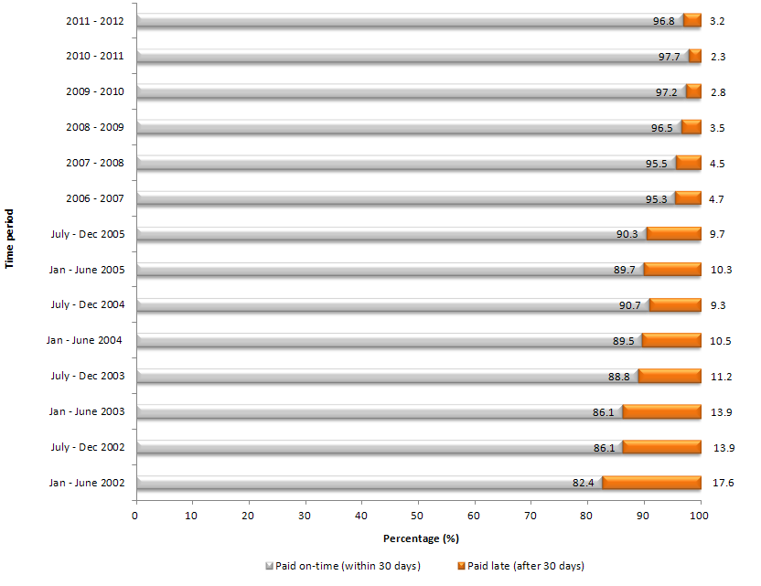
Table 3: History – Number of Agencies Meeting Benchmark
Survey Period | No. of agencies reaching the 90 per cent benchmark
Jul to Jun 2011-12 | 39/40
Jul to Jun 2010-11 | 40/40
Jul to Jun 2009-10 | 39/41
Jul to Jun 2008-09 | 37/40
Jul to Jun 2007-08 | 32/38
Jul to Jun 2006-07 | 34/39
Jul to Dec 2005 | 27/31
Jan to June 2005 | 26/31
Jul to Dec 2004 | 25/30
Jan to June 2004 | 23/31
Jul to Dec 2003 | 22/29
Jan to Jun 2003 | 17/29
July to Dec 2002 | 15/27
Jan to June 2002 | 5/17

Compliance with the Interest on Late Payments Policy
This survey is the third to collect full financial year data on the Government's on-time payment guarantee. This year’s data was similar to the previous reporting period with 50 invoices for late payment interest received with a total value of $21,687.38 (see Table 4). Interest paid on late payments remains a very small amount. However, the revised Procurement On-Time Payment Policy for Small Business came into effect on 1 September 2012, and requires agencies to automatically pay penalty interest to small businesses on payments exceeding 60 days. As a result, the amount of interest paid to small business is likely to change over 2012-2013.
Table 4: History – Australian Government interest on late payments
 | Invoices received for interest on late payments | Amount of interest paid ($)
2011 – 2012 | 50 | 21,687.38
2010 – 2011 | 60 | 3,863.15
2009 – 2010 | 33 | 4,821.80
2008 – 2009 | 1 | 30.27

A breakdown of payment performance by agency for the 2011-2012 reporting period has been provided (see Table 5).

Table 5: Agency performance – percentage of invoices paid within 30 days
Agency | Percentage of invoices paid on time
Attorney-General's Department | 95.39%
AusAID | 91.75%
Australian Bureau of Statistics | 98.17%
Australian Communications and Media Authority | 99.81%
Australian Customs and Border Protection Service | 95.87%
Australian Electoral Commission | 99.53%
Australian Federal Police | 96.53%
Australian Office of Financial Management | 100.00%
Australian Research Council | 94.43%
Australian Securities and Investments Commission | 92.10%
Australian Taxation Office | 97.36%
Australian Trade Commission (Austrade) | 94.58%
Bureau of Meteorology | 94.10%
Defence Material Organisation | 94.35%
Department of Agriculture, Fisheries and Forestry | 90.93%
Department of Broadband, Communications and the Digital Economy | 92.88%
Department of Climate Change and Energy Efficiency | 98.81%
Department of Defence | 98.09%
Department of Education, Employment and Workplace Relations | 94.37%
Department of Families, Housing, Community Services and Indigenous Affairs | 96.39%
Department of Finance and Deregulation | 99.33%
Department of Foreign Affairs and Trade | 93.97%
Department of Health and Ageing | 95.20%
Department of Human Services | 95.53%
Department of Immigration and Citizenship | 95.07%
Department of Industry, Innovation, Science, Research and Tertiary Education | 99.66%
Department of Infrastructure and Transport | 99.55%
Department of Parliamentary Services | 86.04%
Department of Prime Minister and Cabinet | 98.67%
Department of Regional Australia, Local Government, Arts and Sport | 96.79%
Department of Resources, Energy and Tourism | 95.77%
Department of Sustainability, Environment, Water, Populations and Communities | 95.56%
Department of the Treasury | 95.20%
Department of Veteran's Affairs | 94.28%
Family Court of Australia | 98.76%
Future Fund Management Agency | 94.93%
National Archives of Australia | 98.55%
National Blood Authority | 93.43%
National Capital Authority | 92.63%
National Health and Medical Research Council | 93.30%

On 1 September 2012, the policy name was changed to the Procurement On-Time Payment Policy for Small Business
No survey was conducted in the period Jan to Jun 2006 in order to transition into financial year reporting.
Introduction of 90% benchmark.
Includes the participation of Material Agencies for the first time.
Over the period 1 January 2002 to 31 December 2005 eight bi-annual surveys were conducted to monitor compliance with the Procurement 30 Day Payment Policy for Small Business.
This first survey was limited to Departments and did not include Material Agencies.
Reports only about six months worth of data since the policy started on the 1 December 2008.

