Foreign investment into Australia
Foreign Investment and Trade Policy Division
Treasury Working Paper
2016-01
Date created: January 2016
Date modified: January 2016
© Commonwealth of Australia 2016
ISBN 978-1-925220-30-8
This publication is available for your use under a Creative Commons BY Attribution 3.0 Australia licence, with the exception of the Commonwealth Coat of Arms, the Treasury logo, photographs, images, signatures and where otherwise stated. The full licence terms are available from http://creativecommons.org/licenses/by/3.0/au/legalcode.
Use of Treasury material under a Creative Commons BY Attribution 3.0 Australia licence requires you to attribute the work (but not in any way that suggests that the Treasury endorses you or your use of the work).
Treasury material used 'as supplied'
Provided you have not modified or transformed Treasury material in any way including, for example, by changing the Treasury text; calculating percentage changes; graphing or charting data; or deriving new statistics from published Treasury statistics — then Treasury prefers the following attribution:
Source: The Australian Government the Treasury
Derivative material
If you have modified or transformed Treasury material, or derived new material from those of the Treasury in any way, then Treasury prefers the following attribution:
Based on The Australian Government the Treasury data
Use of the Coat of Arms
The terms under which the Coat of Arms can be used are set out on the It’s an Honour website (see www.itsanhonour.gov.au)
Other uses
Enquiries regarding this licence and any other use of this document are welcome at:
Manager
Media Unit
The Treasury
Langton Crescent
Parkes ACT 2600
Email: medialiaison@treasury.gov.au

Foreign Investment into Australia
Foreign Investment and Trade Policy Division
2016-01
January 2016

Abstract
Despite the essential contribution of foreign investment to Australia’s economic growth and prosperity, the benefits of foreign investment are not well understood. This paper aims to provide further insights into foreign investment in Australia by examining the trends, the sources and the positive effects of foreign investment into Australia. The available data on foreign investment in Australia suggests a fairly consistent trend over time despite increases in the number of foreign investment applications received by the Foreign Investment Review Board.
JEL Classification Numbers: F21, O56
Keywords: Foreign direct investment, Australia
Foreign Investment and Trade Policy Division
Markets Group
The Treasury
Langton Crescent
Parkes ACT 2600

Introduction
Foreign investment is integral to the Australian economy but the benefits of foreign investment are often poorly understood. While foreign investment into Australia has attracted a great deal of attention, there has been relatively little work undertaken on the nature and distribution of foreign investment into Australia.
This paper aims to provide further insights into foreign investment in Australia by examining the trends, the sources and the contribution of foreign investment to Australia. The data on foreign investment in Australia is incomplete but available data suggests a fairly consistent trend over time despite increases in the number of foreign investment applications received by the Foreign Investment Review Board (FIRB).
The remainder of the paper is organised as follows. Section 2 describes the trends in foreign investment into Australia. Section 3 analyses the sources of foreign investment. Section 4 discusses the foreign investment data collected by the FIRB. Section 5 considers the benefits of foreign investment to Australia. Section 6 concludes.

trends in foreign investment
There is no single authoritative source of foreign investment data. Apart from the data collected by the FIRB, the Australian Bureau of Statistics (ABS) is the primary source of data on foreign investment into Australia. The ABS international investment statistics provide data, captured on a quarterly basis, on investment activity into and out of Australia.
According to the data from the ABS, foreign investment as a share of total Australian assets has remained reasonably steady in the last decade (Chart 1). There is no clear evidence that Australia has become more dependent on foreign capital since the mid-1990s.
Chart 1: Foreign held equity as a proportion of total national assets
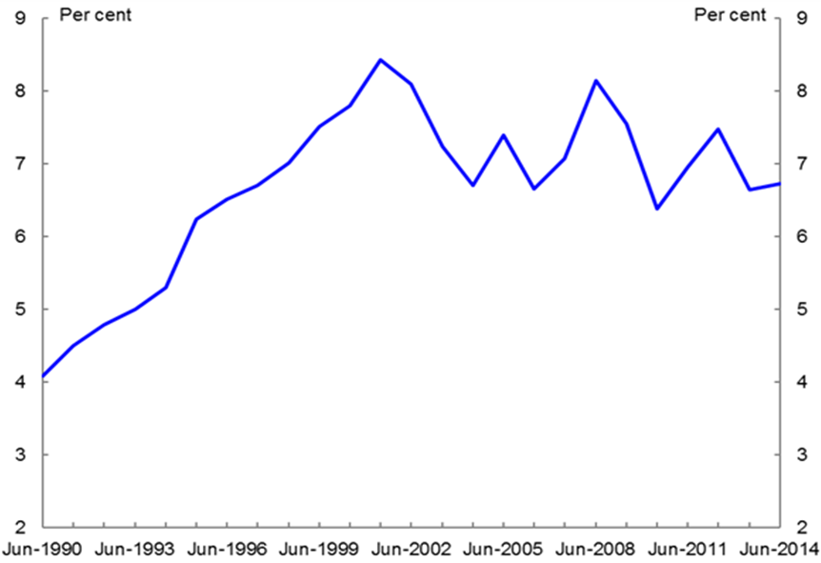
Source: ABS.

Foreign investment in Australia is largely undertaken in the form of portfolio investment. Over half of Australia’s total stock of foreign investment is portfolio investment, with only around one-quarter being foreign direct investment (FDI) (Chart 2).
Chart 2: Level (stock) of foreign investment in Australia
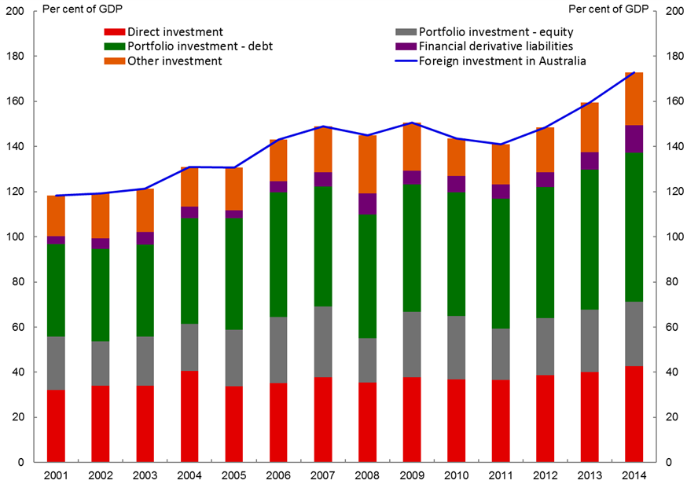
Source: ABS.

The ABS also publishes foreign investment data by industry (Chart 3). Between 2010 and 2014, there was a significant inflow of FDI into Australia in mining and quarrying, and real estate. In 2014,
the FDI stocks in mining and quarrying, and real estate were $264.7 billion and $47.7 billion, respectively.

Chart 3: FDI (stock) in Australia by industry
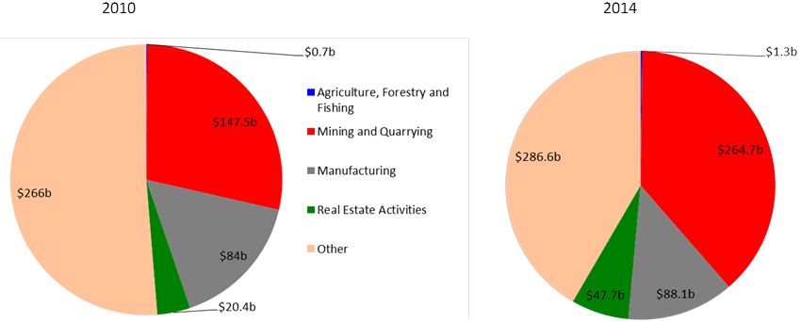
Source: ABS.

Agriculture is an important sector with the potential for significant future growth in foreign investment flows, but our understanding of foreign investment in this sector has been limited. The ABS Agricultural Land and Water Ownership Survey (ALWOS) was established to provide a clearer picture of foreign agricultural land ownership. In 2010 and 2013 an ALWOS collection was undertaken to address a known data gap for national-level information on foreign ownership of agricultural land.
Chart 4 and Chart 5 show that agricultural assets in Australia are still largely locally owned. In 2013, local ownership of agricultural businesses across all the states and territories exceeded 96 per cent. For agricultural land, just under 90 per cent of Australia’s farmland is fully Australian owned.
Chart 4: Ownership of Australian agribusinesses in 2013 |  | Chart 5: Ownership of Australian agricultural land in 2013
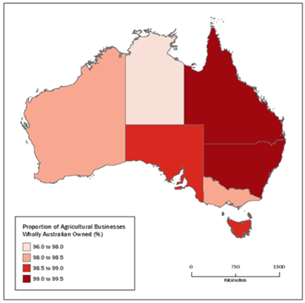 |  | 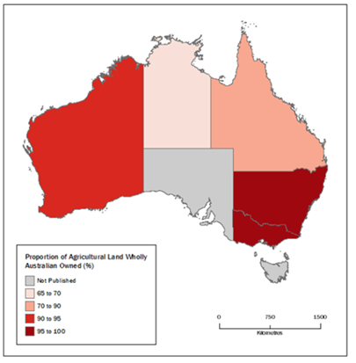
Source: ABS.

The Government has also established the Foreign Ownership Land Register to further improve our understanding of foreign ownership of Australian land. From 1 July 2015, the Australian Taxation Office (ATO) began collecting information such as the location and size of property and size of interest acquired on new foreign investment in agricultural land. This data will be made available on an aggregated basis to the public from 2016. From 1 July 2016, the register will be expanded to include residential real estate. Lower screening thresholds for agricultural land and agribusiness will also mean that more of agricultural investment is seen by the FIRB.
In contrast to the level of foreign ownership in agriculture, the overall foreign ownership of Australian companies is significantly higher (Chart 6). Foreign ownership of financial corporations in Australia is more than 50 per cent.
Chart 6: Foreign ownership of Australian companies
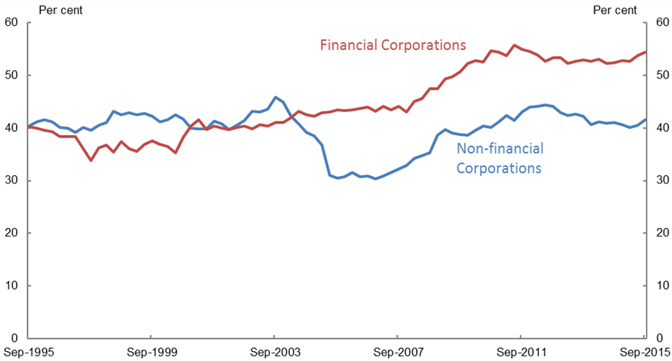
Source: ABS.
Note: Financial corporations do not include the central bank and central borrowing authorities.

Sources of foreign investment
ABS data by country indicates that the United States remains the largest source of FDI into Australia, followed by the United Kingdom and Japan. China remains a relatively minor source, at 4.4 per cent of the total, but is growing rapidly from a low base (Chart 7).
Chart 7: Total stock of foreign direct investment by country
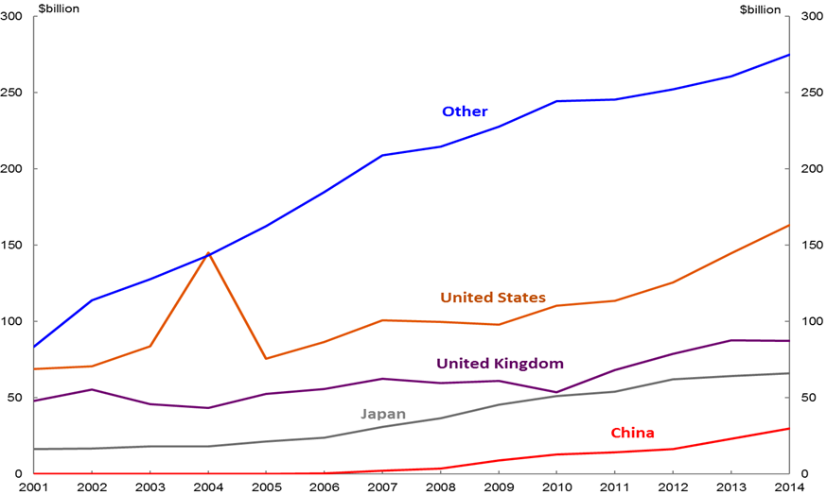
Source: ABS.
While this ABS data is the best available indicator of foreign investment into Australia by country, there is a key limitation. The data is currently only collected on a first investing country (FIC) basis. As a result, the data is unable to correctly attribute foreign investment that occurs via ‘third party’ countries such as tax havens. Because a significant proportion of foreign investment may be flowing via such intermediary countries the existing data is incomplete and includes a large ‘other’ category.
By international standards, Australia’s total level of FDI is not particularly high. The International Monetary Fund’s data show that Australia’s FDI inflow was well behind the United Kingdom and New Zealand and lower than 40 per cent of its GDP (Chart 8). Canada, another country relying on exports and foreign investment, has a similar level of FDI inflow as Australia. Japan and the United States are traditionally FDI outflow countries and recorded a lower level of FDI inflow than other developed countries.
Chart 8: Stock of total inward FDI (as a percentage of GDP)
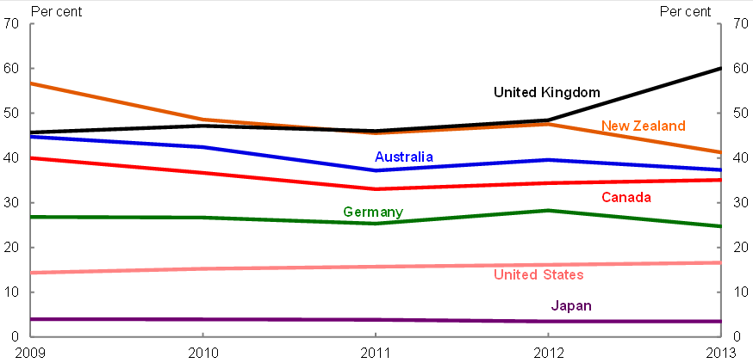
Source: IMF.

Given the relative importance of the resources sector to the Australian economy, Treasury tracks new investment of major mining and energy projects in Australia, including their ownership status. The information collected complements the data from the ABS to provide a more detailed picture of the investment trends and the role of foreign investment in the resources sector. Australia has 26 major projects worth $2 billion or above that are either currently underway or in the design and engineering stages.
Many of these mining projects are joint ventures involving both Australian and foreign investors. Less than 10 per cent of these projects are solely owned by Australian incorporated companies while over 90 per cent have some level of foreign ownership.
Assuming that the share of ownership that companies have in these projects is proportional to their share of the cost of the project, the United Kingdom and United States have the highest level of investment in Australia’s major projects with the United Kingdom responsible for 27 per cent of major project investment costs and the United States responsible for 26 per cent. China has a share of around 3 per cent (Chart 9).

Chart 9: Ownership share of major projects (investment costs)
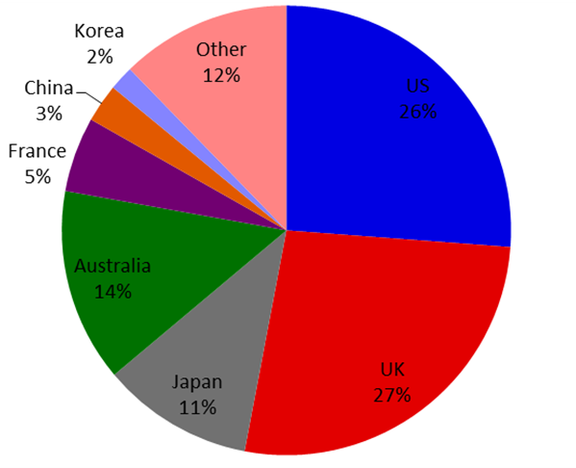
Source: Treasury.

Firb data
The FIRB collects data on foreign investment proposals that are subject to Australia’s foreign investment framework. There are significant demands on the FIRB data as it is generally viewed as the best leading indicator of foreign investment flows into Australia. FIRB data is published in annual reports providing a breakdown of proposed investment by country and sector, including reasonably detailed information on residential real estate.
The FIRB data shows that there has been a substantial influx in the number of foreign investment applications received over the past several years. The applications considered by the FIRB have significantly increased from 5,821 in 2008-09 to 25,005 in 2013-14.
The overwhelming majority of foreign investment applications decided by the FIRB is in the real estate sector, which has accounted for over 90 per cent of the applications decided in the past decade. The value of real estate applications decided has risen from $25.8 billion in 2003-04 to $74.6 billion in 2013-14 (Chart 10).

Chart 10: Applications decided (value of proposed investment)
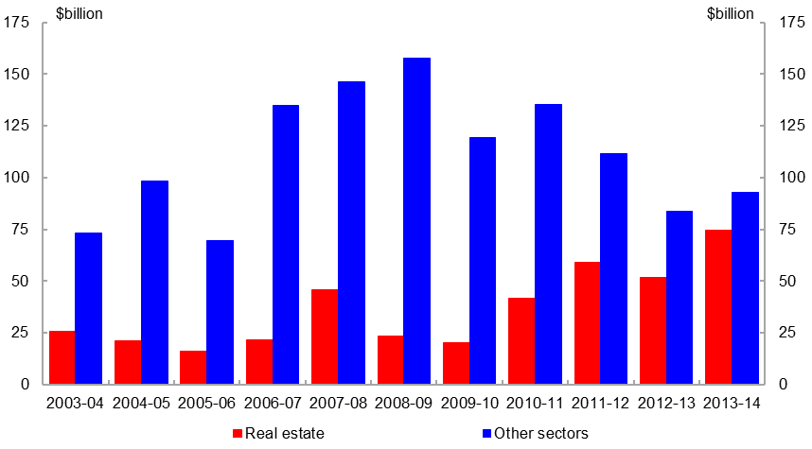
Source: FIRB.
Note: The 2008-09 and 2009-10 real estate figures were impacted by changes to the screening arrangements for residential real estate, as announced in December 2008 and April 2010.

Chart 11 shows the sectoral distribution of approved proposed investment in 2013-14. Real estate remained the largest industry sector by value of approvals at 44.6 per cent of the total.

Chart 11: Sectoral distribution of approved proposed investment in 2013-14
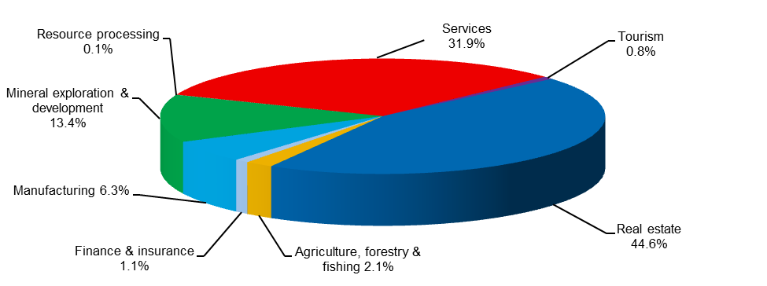
Source: FIRB.
Note: Total may not add due to rounding. Corporate reorganisations are excluded.

During 2013-14, the value of total approved investment by selected country indicates that China, for the first time, became the largest source of proposed foreign investment in Australia overtaking the United States. The data suggests this is mainly driven by a large increase in residential real estate approvals. The other major sources of proposed investment were Canada, Malaysia and Singapore (Chart 12).

Chart 12: Approvals by country of investor in 2013-14
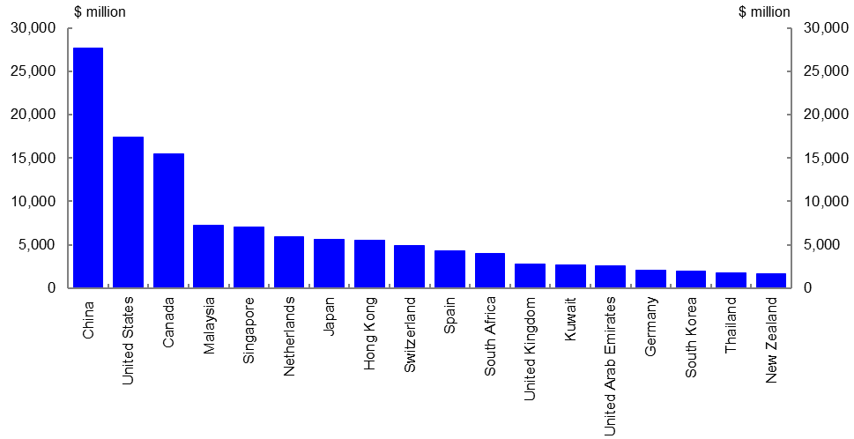
Source: FIRB.
Note: China excludes Special Administrative Regions and Taiwan.

It is not possible to compare the ABS data with the FIRB data. The ABS provides statistics on Australia’s international investment position using balance of payment data so it does not trace the investment back to the original source. The FIRB statistics do not measure total foreign investment made in any year, nor do they measure changes in net foreign ownership levels in Australia.
The data collected by the FIRB is based on approvals for proposed rather than actual direct investments above certain notification thresholds that differ by country and type of investor. The FIRB dataset counts a number of approvals for investment intentions that do not result in actual investments. Closely related to this is the issue of double counting due to approvals for multiple potential acquirers of the same target asset. Chart 13 provides a summary of the coverage of the current FIRB data.
Chart 13: An overview of the current FIRB data
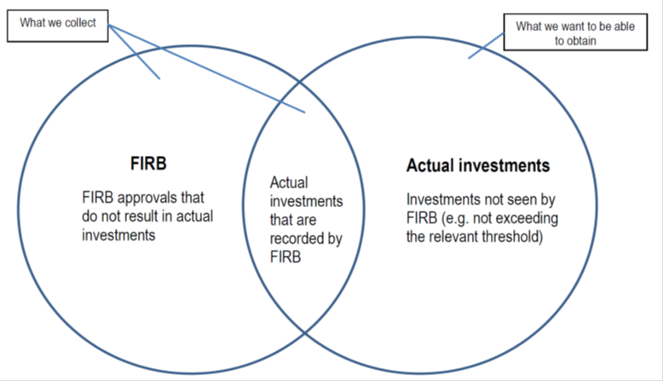
Source: FIRB.
There are a number of other limitations to the FIRB data. With the liberalisation of investment associated with free trade agreements, and the prospect of multilateral agreements covering investment, like the Trans-Pacific Partnership, more countries are subject to a higher screening threshold and comparability between countries becomes more difficult. In respect of business cases, because the FIRB tends to only assess the larger investments, the year on year volumes can be volatile and the trends difficult to interpret.

Benefits of foreign investment
Foreign investment is integral to the Australian economy. As a resource rich country with a relatively high demand for capital and a small population, Australia has historically relied on foreign capital to finance the shortfall between national investment and national saving. Australia’s national investment and saving gap has been on average about 4 per cent of GDP over the last few decades (Chart 14).
Chart 14: Australia’s national investment and saving gap
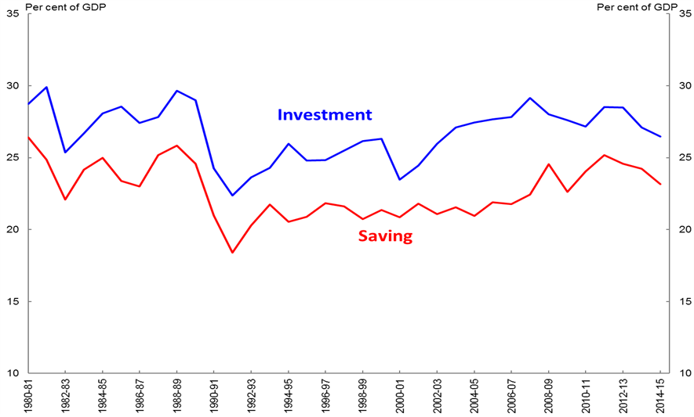
Source: ABS.

FDI is an important component (along with portfolio equity investment and debt finance from third parties) in helping to finance the shortfall between national investment and national saving. By supplementing Australia’s national saving, foreign investment allows Australia to enjoy higher living standards now (by financing current consumption), and into the future (by providing finance for investment which in turn will lead to higher growth in national income and hence living standards) than would otherwise be sustainable.
FDI is generally regarded as amongst the most stable forms of capital inflow because it usually involves a substantial commitment from the investor, whereas debt finance and portfolio investment can be recalled relatively quickly. In addition, the return to direct investment is generally dependent on profitability unlike debt finance where the capital and interest must generally be repaid regardless of performance and may also be subject to various convenants that trigger default or immediate repayment in various scenarios such as a drop in asset values or revenue.
Importantly, FDI not only assists domestic firms receiving the capital injection, it has significant spill over benefits to the broader economy. It provides additional capital for economic growth, creates new employment opportunities and supports existing jobs, as well as bringing potential technology and innovation transfers. FDI can also help deliver improved competitiveness and productivity performance over time, including by: providing much needed infrastructure; allowing access to global supply chains and markets; and enhancing Australia’s skill base — through greater knowledge transfer from foreign enterprises to domestic firms by exposure to more innovative work practices.
There is only limited quantitative data available that can be used to measure the actual contribution that foreign investment makes to the economy. A paper produced by Treasury in 2012 estimated that a reduction in capital inflow and investment equal to one per cent of GDP would reduce Australia’s gross national income by about half a per cent each year over a ten-year period. In other words, other things being equal, restrictions on capital inflow would reduce the wellbeing of Australians.
Another study that provides an indication of the significance of foreign investment is the paper prepared by Access Economics for the Business Council of Australia in February 2010. The paper modelled the economic effects of changes in foreign investment flows on the Australian economy. According to the paper, an increase of 10 per cent in foreign investment increases real GDP by 1.2 per cent or $16.5 billion in real terms at year 2020, 0.3 per cent in employment and 1.1 per cent in real wages.

Conclusion
Available data suggests that foreign investment remains a steady influence on the Australian economy which provides important on-going benefits to the economy. However, as the number and scope of applications to the FIRB continues to grow there is a need to ensure a comprehensive understanding of the changing nature of foreign investment into Australia. The National Foreign Ownership Land Register will provide a clearer picture of the current state of foreign investment in Australia. The Australian Treasury will continue to work with partners in business, academia and the international community to further build on our understanding of foreign investment trends.

References
Access Economics (2010) Foreign Investment in Australia, (Report prepared for the Business Council of Australia).
Australian Bureau of Statistics (2011) Balance of Payments and International Investment Position, Australia: Concepts, Sources and Methods, ABS. Cat. No. 5331.0.
Gali, J and Taplin, B, (2012) The macroeconomic effects of lower capital inflow, Economic Roundup Issue 3, 2012, Australian Treasury.
Appendix a: data sources
Australian Bureau of Statistics (2015) Australian System of National Accounts – 2014-15. ABS Cat. 5204.0. Australian Bureau of Statistics: Canberra.
Australian Bureau of Statistics (2015) Australian National Accounts: Finance and Wealth - September Quarter 2015. ABS Cat. No. 5232.0. Australian Bureau of Statistics: Canberra.
Australian Bureau of Statistics (2014) International Investment Position, Australia: Supplementary Statistics. ABS Cat. No. 5352.0. Australian Bureau of Statistics: Canberra.
Australian Bureau of Statistics (2013) Agricultural Land and Water Ownership Survey – June 2013. ABS Cat. No. 7127.0. Australian Bureau of Statistics: Canberra.
International Monetary Fund (2015) Coordinated Direct Investment Survey. International Monetary Fund: Washington, D.C.
International Monetary Fund (2015) World Economic Outlook Database – October 2015. International Monetary Fund: Washington, D.C.
The Foreign Investment Review Board statistics (2015). The Foreign Investment Review Board: Canberra.
The Australian Treasury statistics (2015). The Australian Treasury: Canberra.
Australian Bureau of Statistics (2015) Balance of Payments and International Investment Position – September Quarter 2015. ABS Cat. No. 5302.0. Australian Bureau of Statistics: Canberra’.

Adam McKissack and Jessica Xu, Foreign Investment and Trade Policy Division, Markets Group, The Treasury, Langton Crescent, Parkes ACT 2600, Australia. Correspondence: Adam McKissack, adam.mckissack@treasury.gov.au. We thank Renae Liang, Shibani Iyer, Stewart Nixon, Philip Hu, Derrick Calder, Paul Fischer and Owen Freestone for their significant contribution to the paper. The paper also benefits from comments and suggestions by John Lonsdale, Rob Donelly, Rupert Jolley, David Earl and Jeremy Curtis.
The views expressed in this paper are those of the authors and do not necessarily reflect those of The Australian Treasury or the Australian Government.
Under ABS definitions, portfolio investment involves participation of less than 10 per cent of interest assumed to have no influence in the operation of the enterprise. Direct investment involves financial transactions and positions where shareholding or voting power is greater than 10 per cent. Other investment is a residual category that captures transactions not classified as direct investment, portfolio investment, financial derivatives, employee stock options or reserve assets of the compiling economy.
The ABS derives data on real estate investment via businesses surveys. However, where foreign investors own real estate directly without investing through an Australian corporate structure, there is no Australian resident to survey. The value of this investment is modelled based on investment intentions collected from FIRB, media reports and industry-specific periodicals.
Foreign investment proposals that were approved, rejected, withdrawn or exempted. Figures include corporate reorganisation approvals. The 2008-09 and 2009-10 figures were impacted by changes to the screening arrangements for residential real estate, as announced in December 2008 and April 2010.
Foreign investment proposals that were either approved or rejected.
Gali, J. and Taplin, B, 2012, The macroeconomic effects of lower capital inflow, Economic Roundup Issue 3, 2012.
Access Economics, 2010, Foreign Investment in Australia (report prepared for the Business Council of Australia).
The modelling takes into account greater investor risk aversion and an increase in the global cost of capital following the Global Financial Crisis. A reference case for the period 2009-2020 is used to represent a ‘business as usual’ economic growth path.
The impacts at year 2020 are relative to the reference case.

