

submission to the Senate Economics References Committee Inquiry into matters relating to credit card interest rates
11 August 2015
© Commonwealth of Australia 2015
This publication is available for your use under a Creative Commons Attribution 3.0 Australia licence, with the exception of the Commonwealth Coat of Arms, the Treasury logo, photographs, images, signatures and where otherwise stated. The full licence terms are available from http://creativecommons.org/licenses/by/3.0/au/legalcode.

Use of Treasury material under a Creative Commons Attribution 3.0 Australia licence requires you to attribute the work (but not in any way that suggests that the Treasury endorses you or your use of the work).
Treasury material used 'as supplied'
Provided you have not modified or transformed Treasury material in any way including, for example, by changing the Treasury text; calculating percentage changes; graphing or charting data; or deriving new statistics from published Treasury statistics – then Treasury prefers the following attribution:
Source: The Australian Government the Treasury
Derivative material
If you have modified or transformed Treasury material, or derived new material from those of the Treasury in any way, then Treasury prefers the following attribution:
Based on The Australian Government the Treasury data
Use of the Coat of Arms
The terms under which the Coat of Arms can be used are set out on the It’s an Honour website (see www.itsanhonour.gov.au).
Other uses
Enquiries regarding this licence and any other use of this document are welcome at:
Manager
Media Unit
The Treasury
Langton Crescent
Parkes ACT 2600
Email: medialiaison@treasury.gov.au

Key Findings
- Headline interest rates on credit cards and unsecured loans have been unresponsive to falling bank funding costs in recent years. This has occurred alongside a fall in the proportion of cardholders paying interest on card balances. Those cardholders that do pay interest have been left facing high rates.
- Low-income credit card users are more likely to pay interest and tend to have higher amounts of credit card debt relative to their income. Survey evidence shows that low income households using credit cards are also more likely to be subject to fees for failing to make minimum payments.
- The credit card market is characterised by a wide diversity of product offerings, with competition most intense surrounding discounted balance transfer offers and rewards programs. Barriers to market entry are relatively low — with non-bank providers now able to issue cards — and legislative reforms have increased consumer protections.
- Nevertheless, the major banks — as in the mortgage lending market — account for around 80 per cent of the credit card market. A measure of the effective ‘spread’ earned by credit card issuers (and on unsecured personal loans) increased sharply during the global financial crisis. While this is reflective of a general repricing of credit risk across advanced economies, spreads have remained high in the post crisis period and have increased a little more over recent years. A slight increase in non-performing credit card loans in recent years appears unlikely to account for this increasing spread.

Options for consideration
- Implement Financial System Inquiry (Murray Inquiry) recommendations to support credit reporting and access to personal data, support innovation in the payments system and enhance regulator focus on competition. By supporting competition in the sector more broadly, implementation of these recommendations should have a positive impact upon competition in the credit card market.
- Examine the operation of the responsible lending obligations in the National Credit Code, particularly with reference to the assessments required of the consumer’s capacity to make repayments and of their requirements and objectives. Ensuring credit card providers assess serviceability based on repayments required to pay off debt within a reasonable period could reduce the incidence of credit card distress.
- Consider regular publication of estimates of bank funding costs and increase the pressure on banks to announce changes in interest rates charged on credit cards following changes in the cash rate. Providing more transparency on card providers’ cost of funds could provide an additional level of scrutiny over the pricing of credit relative to funding costs.

Who Pays Credit Card Interest?
Data from the household, income and labour dynamics survey in Australia (HILDA), the household expenditure survey and the survey of housing and income shows households in the lowest income quintile have more credit card debt relative to their incomes and pay more in credit card interest relative to their incomes than higher income households, though overall differences in interest payments between quintiles are small (Figure 1). These surveys also show households in the bottom two quintiles by net worth also pay the most in credit card interest relative to their income (Figure 2).
Figure 1: Credit card interest payments by income quintile
Source: ABS Catalogue Numbers 6523.0 and 6530.0
Figure 2: Credit card interest payments by net worth quintile
Source: ABS Catalogue Numbers 6523.0 and 6530.0
- An October 2010 survey showed that 62 per cent of low income households have a credit card compared with 84 and 90 per cent of middle and high income households.
  - 47 per cent of low income households report not paying off their monthly balance in full versus 42 and 33 per cent for middle and high income households.
  - 11 per cent of low income households report that they could not make their minimum monthly payment versus 10 and 7 per cent for middle and high income households.
- Although this survey evidence may suffer from biases in underreporting, particularly where it relates to self-reporting of perceived behavioural flaws, it gives some indication that not paying down monthly balances in full and, at the margin, missing minimum monthly payments may be a greater problem for low income households.
- These households would be more likely to be paying the high interest rates charged on credit cards and be more likely to be subject to high additional fees and charges. In particular, they will be more affected by the practice of backdating interest charges when cardholders fail to pay off their full balance at the end of each billing cycle.
  - Moreover, this evidence indicates that if banks fail to pass on reductions in their funding costs to the interest rates charged on credit card debt, this could disproportionately affect low income credit card users.

Credit card interest rates have been unresponsive to movements in the cash rate
Despite a 2.75 percentage point decline in the cash rate since late 2011, credit card interest rates have remained high. The rates on ‘standard’ cards are currently around 20 per cent, while the rates on ‘low-rate’ cards are around 13 per cent (Figure 3). This has prompted concern that there is a lack of competition in the Australian credit card market.
Figure 3: Credit card interest rates and the cash rate target
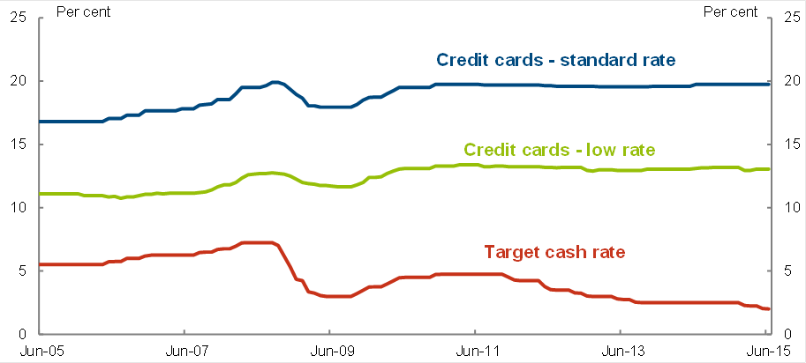
Source: Reserve Bank of Australia

competition in the Australian credit card market
The credit card market appears no less competitive than other Australian lending markets. Recent changes to credit card access regimes and amendments to banking regulation, which came into effect in 2015, should have a positive impact on the level of competition.
- A survey of credit card comparison websites suggest that there are currently around 100 credit card brands in Australia offering over 250 products, though the number of unique issuing institutions is considerably smaller.
  - There is a high degree of concentration among issuers, with the four major banks accounting for around 80 per cent of total card balances outstanding. This reflects the concentration of the Australian banking system more generally rather than being a unique feature of the credit card market (Figure 4).
Figure 4: Credit card issuer market shares (by balances outstanding)
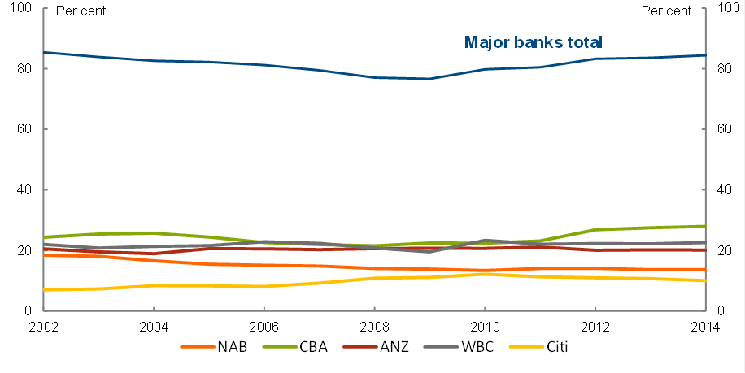Source: Australian Prudential Regulation Authority
- There are minimal barriers to consumers obtaining a new credit card or switching to a different provider, apart from credit assessments and upfront fees (see Appendix A).
- Comparison websites provide a degree of pricing transparency, although the heterogeneity in product offerings can make comparisons difficult.
- Moreover, credit cards are multifaceted products and, given consumers’ relative inattention to headline interest rates (discussed further below), competition is most intense surrounding other aspects of the value proposition. These include: balance transfer offers; fee structures; interest-free periods on purchases; rewards programs; and other benefits such as insurance and concierge services.
  - For example, 70 of the 95 credit cards the Reserve Bank of Australia (RBA) regularly monitors currently offer discounted balance transfers (see Appendix B).

- The interest rates on low-rate credit cards are similar to those on unsecured personal loans and the spread between these personal loan interest rates and the target cash rate has similarly widened in recent years, suggesting whatever is driving the inflexibility in interest rates may not be unique to the credit card market (Figure 5).
- More broadly, the Murray Inquiry considered competition in the financial system to be ‘generally adequate’, but noted that the high concentration and increasing vertical integration in the system could limit the benefits of competition in the future. Over the last five years, the large Australian banks have achieved returns on equity well in excess of most of their international peers (Figure 6). In part this reflects the concentration of the Australian banking sector as well as its large exposure to housing loans, where capital requirements are relatively low.
Figure 5: Interest rates on personal loans, low-rate credit cards vs the cash rate target
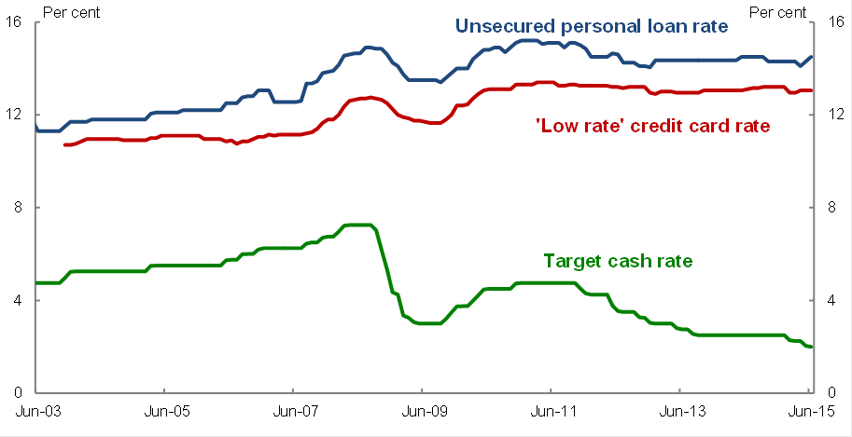
Source: Reserve Bank of Australia
Figure 6: Large banks’ return on equity
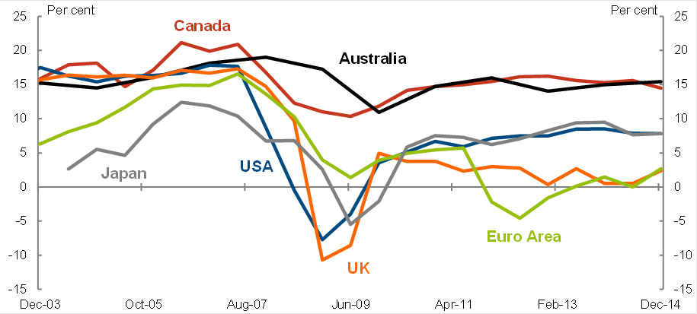
Source: Banks’ Annual and Interim Reports; Bloomberg; Reserve Bank of Australia; SNL Finance

Not all credit card users pay interest — how the basic credit card pricing model works
Because of the prevalence of interest-free periods and users who pay no interest (‘transactors’), credit card issuers have chosen to make most of their return from the subset of users who carry positive balances from month to month (‘revolvers’).
- According to a 2013 RBA survey, only around 30 per cent of credit card users reported that they pay interest on their credit card balances (the ‘revolvers’). However, the share of outstanding balances that actually attract interest is higher, at around two-thirds.
  - Most card users who become ‘revolvers’ likely believed at the time they applied for a credit card that they would be in the group of ‘transactors’. Numerous studies examine the behavioural biases that lead card users to become revolvers. Two commonly cited causes are overconfidence in one’s ability to resist purchasing too many goods and services on credit and a tendency to underestimate the potential for future events to disrupt one’s repayment abilities.
- The prevalence of interest-free periods also affects consumer behaviour: a 2013 Choice survey found that nearly 50 per cent of credit card users were unsure of the interest that they would be charged and the academic literature has documented that many credit card users do not pay attention to the interest rate because they expect not to pay any interest.
- High and inflexible interest rates could be seen as financial institutions taking advantage of this user inattention to credit card interest rates. Card providers may also be reluctant to compete on their relative interest rate offerings since this would draw attention to the fact that their interest rates are high in an absolute sense.

The ‘effective’ interest rate received by banks has moved in line with funding costs
Headline interest rates on credit cards have been largely unchanged in recent years, despite the decline in the Reserve Bank’s target for the cash rate, suggesting issuers have not been passing on funding cost reductions to credit card borrowers. But the target for the cash rate is not the same as a bank’s actual funding cost and, given credit card interest is only paid by a fraction of cardholders at any point in time, headline interest rates are not a particularly good measure for evaluating relative competitiveness across loan products.
For this purpose, it is useful to examine measures of the ‘effective’ interest received by an issuer for all credit extended to cardholders, relative to card providers’ actual funding costs.
- Bank funding costs can be calculated by taking a weighted average of the interest rates paid on banks’ sources of funds. Funding costs have risen relative to the target cash rate since the financial crisis as banks switched to a greater proportion of (more expensive) deposit funding.
- An estimate of the ‘effective’ interest rate on all credit card balances can be calculated by multiplying the headline interest rate by the proportion of credit card balances accruing interest. Figure 7 illustrates that the proportion of credit card balances accruing interest (or, the proportion of ‘revolvers’) has fallen quite significantly since early 2011.
Figure 7 — The declining relative value of credit card balances accruing interest
Source: Reserve Bank of Australia, Treasury

  - This decline likely reflects a range of factors. The experience of the financial crisis, and the impact of reforms enacted under the National Consumer Credit Protection Amendment (Home Loans and Credit Cards) Act 2011 [see pp11-12] may have had some positive impact on card holder behaviour. Increasing use of scheme debit cards, and the growing availability of discounted balance transfer offers, may also have been important.
- The ‘effective’ interest rate on all credit card balances and Treasury’s measure of bank funding costs are displayed in Figure 8 along with the spread between them.
  - Interestingly, there appears to have been a structural increase in the spread between effective interest received and bank funding costs around the financial crisis. This likely reflects a general re-pricing of ex-ante credit risk at this time for which there is some evidence in other lending products and in foreign markets (see, for example, the similar increase in spread for personal loans in Figure 9).
    - This may be attributable to a general under-appreciation of credit risk prior to the crisis, particularly on unsecured lending, but may also reflect a failure to properly price default correlations across asset classes and their propensity to increase following a shock to the financial system.
Figure 8: The spread between credit card ‘effective’ interest and bank funding costs
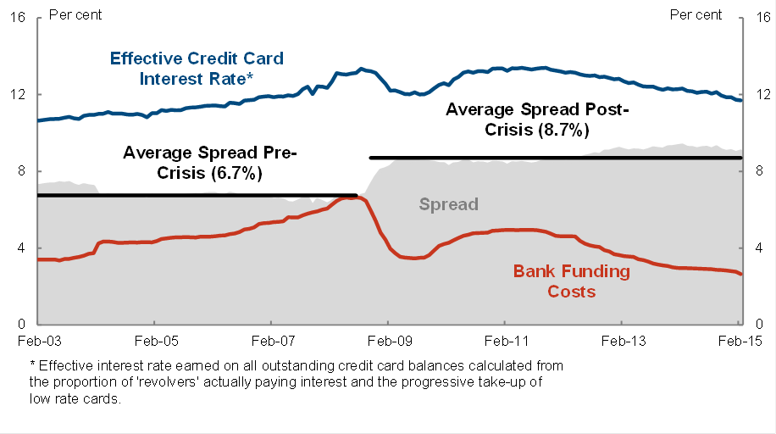
Source: Reserve Bank of Australia, Treasury
- While the financial crisis may have led to a permanent shift in ex-ante credit risk pricing, the spreads earned by credit card providers (and providers of personal unsecured loans) have increased a little further over recent years (Figures 8 and 9).
  - There has been a slight increase in non-performing credit card loans in recent years (Figure 10), but the size of this increase is unlikely to account for much of the change in spread and runs counter to other data showing a decline in personal insolvency rates since late 2009 on a per capita basis.
  - The recent increase in spreads in unsecured lending markets could reflect limitations in competition in the sector more broadly. As noted above, the Murray Inquiry found competition in the financial system to be ‘generally adequate’, but made some recommendations aimed at enhancing competitive dynamics (discussed further below).
Figure 9: The spread between personal loan interest and bank funding costs
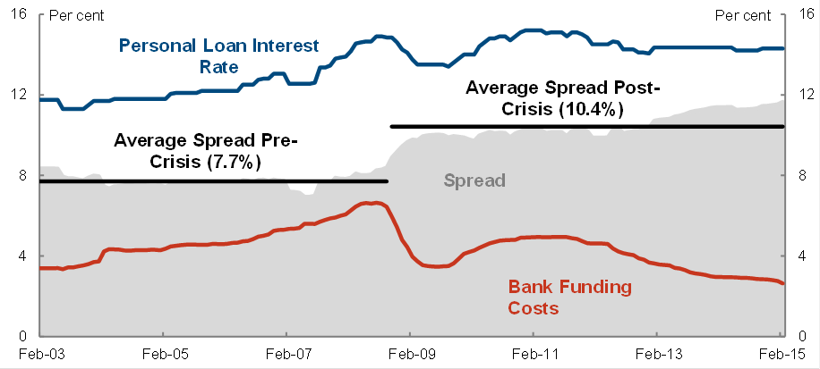
Source: Reserve Bank of Australia, Treasury

Figure 10: Banks’ non-performing household loans rates
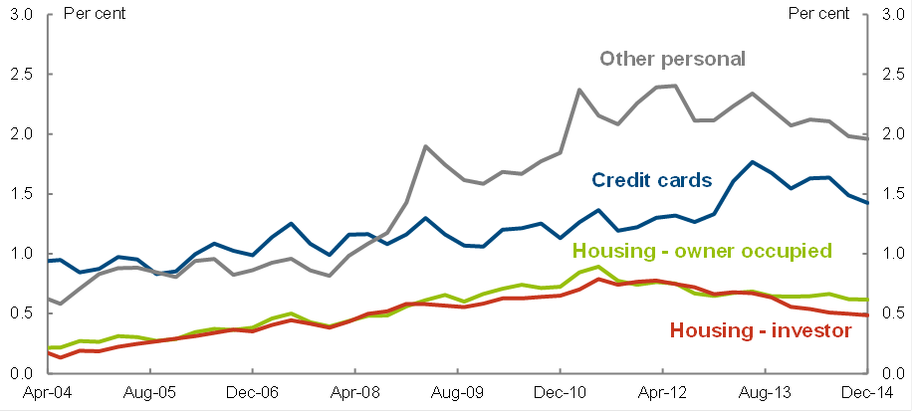
Source: APRA; Reserve Bank of Australia

Credit card interest rates have evolved similarly in other countries
The available data show that credit card interest rates have evolved in broadly the same fashion across most advanced economy markets. In particular, they have been fairly stable in recent years despite a global easing in monetary policy.
- Average credit card interest rates in the United States (US) are a little lower than in other countries, even after taking into account differences in monetary policy. This may reflect the maturity of the US credit card market and the prevalence of individual risk-based pricing: the interest rate available to a credit card user in the US depends strongly on their credit score.
- However, the available data on average US credit card interest rates does not detail distinctions in the total value proposition, such as whether many people are using the equivalent of low-rate cards that have few rewards, which makes it difficult to draw firm conclusions.
- Comparisons with other countries reveal that effective rates are similarly more responsive than headline rates and that the spreads to bank funding costs are broadly stable although all exhibited a structural shift upward around the financial crisis.
  - Figure 11 shows the spread between the effective credit card interest rate and a measure of bank funding costs in the United Kingdom and New Zealand compared with Australia (note that the specific methods of calculating bank funding costs differ according to the data available from the respective central banks in these countries and so the results should be treated with caution).
  - The increase in average spreads pre- and post-financial crisis across the three countries are quite similar. The Australian effective credit card interest rate spread to bank funding cost has generally sat between what was observed in New Zealand and the United Kingdom over the last decade.

Figure 11: ‘Effective’ spread comparison across countries
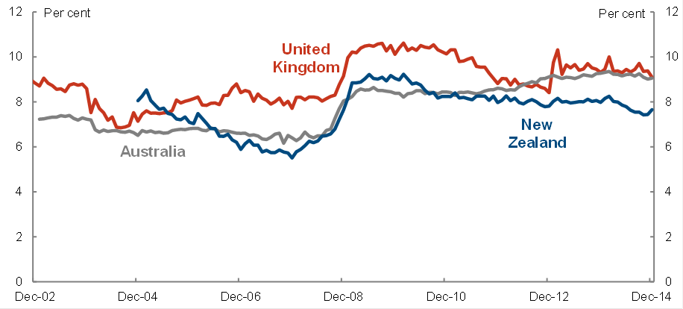
Source: Bank of England, Reserve Bank of New Zealand, Reserve Bank of Australia, Treasury

Recent reforms
The preceding analysis does not suggest that credit card interest rates in Australia are out of line with those in other countries on an effective basis and relative to bank funding costs.
- Nevertheless, the prevailing level of credit card interest rates relative to official interest rates is a source of considerable consumer frustration — and in some cases, significant hardship — both in Australia and in other countries.
- Regulatory reform of credit card markets has typically focussed on enhancing disclosure requirements (and, indirectly, seeking to overcome consumer behavioural biases) and clamping down on irresponsible and predatory lending practices.
  - Australia introduced a significant package of reforms in this area in 2009 and 2011 and, more recently, reforms aimed at significantly reducing barriers to new market entrants.
  - Internationally, the US has recently introduced reforms that place explicit limits on card issuers’ ability to increase interest rates.

Australian regulatory reforms
Recent reforms to consumer credit regulations had their origins under the previous Coalition Government which, in December 2006, tasked the Productivity Commission with reviewing Australia’s consumer policy framework.
- Following the delivery of the report in April 2008, and in response to concerns raised in a report prepared for COAG’s Ministerial Council on Consumer Affairs (August 2008) over the number of consumers burdened by unmanageable credit card debts, COAG Ministers agreed (October 2008) on a two-phase action plan for reform.
  - The first phase of the reforms transferred responsibility for consumer credit regulation to the Commonwealth under a single national credit code — the National Consumer Credit Protection (NCCP) Act 2009.
  - The second phase of the reforms — the National Consumer Credit Protection Amendment (Home Loan and Credit Cards) Act 2011 — introduced a range of new protections for credit card (and home loan) consumers.

National Consumer Credit Protection Act 2009 (the ‘National Credit Code’)
Major reforms contained in the NCCP Act included:
- The transfer of consumer credit regulation from the States to the Commonwealth;
- The creation of a Uniform Consumer Credit Code, including responsible lending requirements;
- Increased powers for the Australian Securities and Investments Commission (ASIC) for the licensing of credit lenders; and
- Stricter civil and criminal penalties for lenders who breach the Code.

Key provisions of the National Consumer Credit Protection Act 2009
- Credit contract documents must explicitly detail whether the fees or interest charges imposed on an account are subject to change, and the means by which the debtor is to be informed of the new fees or charges.
- Credit card providers must provide cardholders with a regular statement of account (at a frequency of no longer than 40 days). The statement must detail any changes in fees or interest charges since the last statement period.
- A credit provider must, not later than the day on which a change in the annual percentage rate or rates payable under a credit contract takes effect, give to the debtor written notice setting out:
  - The new rate or rates or, if a rate is determined by referring to a reference rate, the new reference rate.
- A credit provider must, not later than 20 days before a change in the manner in which interest is calculated or applied under a credit contract (including a change in or abolition of any interest free period under the contract) takes effect, give to the debtor written notice setting out particulars of the change.

National Consumer Credit Protection Amendment (Home Loan and Credit Cards) Act 2011
The 2011 amendment to the Act put in place a range of new protections for credit card consumers. The amendments included:
- the banning of unsolicited higher credit limit offers;
- a requirement on card issuers to notify cardholders in the event they exceed their credit limit, and restricting the ability of card issuers to impose fees or increase interest rates in that event; and
- requiring card issuers to allocate cardholders’ repayments to higher interest debits first (previously, it was common practice in the industry that repayments were used to pay off balances attracting the lowest charges first, such as outstanding balance transfer amounts).
Regulations made under this amendment also require card issuers to provide a personalised ‘minimum repayment warning’ on the front page of credit card statements. This warning informs the consumer that making only the minimum repayment will result in paying more interest and taking longer to pay off the balance. The warning must also state the number of years it will take to pay off the closing balance if only the minimum repayment is made (along with the total interest that would be incurred), as well as the repayment required to pay off the balance in 2 years.

Banking Amendment (Credit Card) Regulation 2014
Recent regulatory reforms have been enacted that aim to reduce barriers to entry for non-bank credit card providers.
- On 1 January 2015, new rules and regulations commenced to open up access to the MasterCard and Visa credit card systems to entities that are not authorised deposit-taking institutions.
  - The Banking Amendment (Credit Card) Regulation Act 2014 removed the determination that credit card issuing or acquiring was banking business (and, thus, subject to Australian Prudential Regulation Authority supervision).
  - The RBA also varied its Access Regimes for the MasterCard and Visa credit card systems, giving those system providers more flexibility to set eligibility criteria for potential card issuers.
- It is too soon to tell whether these reforms have had a material impact on competitive pressures in the market, although anecdotal reports suggest the reforms may be starting to have the desired effect.
  - Banking Day reported on 25 February 2015 that MasterCard had been approached by five organisations so far this year, both local and international, inquiring about membership of the scheme. Visa also said that it had received applications and expressions of interest from ‘merchants and processors’.

Foreign regulatory reforms

United States
The Wall Street Reform and Consumer Protection Act 2010 established a new Consumer Financial Protection Bureau. The Bureau oversees the Credit Card Accountability, Responsibility and Disclosure Act 2009, which took effect in 2010.
- The Act placed a range of prohibitions on credit card providers, including:
  - banning interest rate increases being applied to outstanding balances (except: on the expiration of an introductory rate period; if the rate is pegged to another rate that is not controlled by the provider, such as the prime rate; or, if the borrower is more than 60 days delinquent);
  - requiring issuers give advance notice (at least 45 days) of any interest rate increases applying to new purchases. Cardholders are able to cancel their account within this period and pay off any outstanding balances on existing terms;
  - banning any increases in interest rates, fees or other charges within the first year of an account being opened (except in those cases listed above); and
  - setting minimum terms for promotional rates (must be 6 months or longer).
- Judgements on the impact of these changes on credit card pricing vary. Partly, this reflects the difficulty of attributing causality during a period in which the market was readjusting business models in the wake of the financial crisis, and partly because of uncertainty around the timing and degree to which companies adjusted offer terms in advance of the changes taking effect.
  - An examination of the terms on around 500 credit card offers from late 2008 to late 2011 by the credit card comparator CardRatings.com found the following impacts that, it argued, may have been attributable to the CARD Act:
    - Annual percentage rates on new credit card offers rose by an average of 2.1 percentage points from the end of 2008 through to late-2011, a period in which the Fed Funds rate was unchanged and mortgage rates fell.
    - While the lowest rate tier of credit card offers, for consumers with excellent credit, rose by only 1.6 percentage points from late 2008 to late 2011, the highest rate tier, for consumers with poor credit, rose by an average of 3.4 percentage points over the same period.
    - They found that the average percentage rate charged on balance transfers rose to 3.3 per cent from 2.1 per cent.
  - In contrast, marketing research firm Mintel found that while card providers did tend to pre-empt the introduction of the CARD Act by raising interest rates, competitive pressures saw those rate increases begin to be reversed from the second quarter of 2010.
    - Moreover, they didn’t find evidence to justify initial concerns that the CARD Act would see a significant increase in the number of cards with annual fees and that low introductory (‘teaser’) rates would disappear.
  - In one of the few published empirical papers on the topic, Agarwal et al (2014) find, contrary to their priors, that the CARD Act did not have material ‘unintended’ consequences.
    - They found no evidence of anticipatory increases in card interest rates prior to the introduction of the Act, and no evidence of a sharp or gradual increase in interest rates subsequent to its entry into effect.
    - They also found no evidence of any offsetting increases in interest rates being applied to new accounts.

United Kingdom
Following the UK Government’s Review of the Regulation of Credit and Store Cards, the UK Cards Association amended its Lending Code in 2010 and committed to initiatives developed jointly with the Department for Business, Innovation and Skills. These included:
- requiring the highest cost debt to be paid off first (allocation of payments);
- requiring card issuers to contact customers who repeatedly only make the minimum repayment to make clear that this is the most expensive way of paying off credit card debt;
- for new customers, setting a floor on the minimum repayment, so it at least covers interest, fees and 1 per cent of the principal; and
- introducing a 60-day notice period when the interest rate on existing debt is changed, and requiring customers to be notified twice before any increase occurs.
In 2011, credit card providers also began sending out annual statements to card holders. These statements contain information on card use over the previous year, including the total amount of fees and interest incurred.
Around the same time, the UK Government established the ‘midata’ initiative — a collaboration between Government, consumer groups and businesses to give consumers more access to personal data collected by companies. As of 2015, holders of current accounts can download portable data on their account usage and enter it into a comparison website that provides a personalised list of accounts that they would be better off switching into. The program may be expanded into credit card markets over time.
The UK’s Financial Conduct Authority, which was granted authority to regulate consumer credit markets in April 2014, released terms of reference for a study of the credit card market in November 2014. They are currently consulting on a draft update of their consumer credit regime.

New Zealand
New Zealand recently revamped their consumer credit laws with the Credit Contracts and Consumer Finance Amendment Act 2014. The amendments focussed on enhanced disclosure requirements, additional prohibitions on irresponsible and predatory lending practices and changes to repossession rules.

support for credit card users in financial distress
In addition to recent regulatory reforms in Australia, the Government facilitates a number of avenues of assistance to credit card users to pay down their credit card debts.

Legislation and regulation
- Hardship variations: the National Credit Code allows a debtor to request a change to the terms of their credit contract on the grounds of financial hardship. After an application for such a variation is made, the credit provider must give the creditor a written response within 21 days.
  - If the customer is not happy with their credit provider’s response to the hardship variation application, they can lodge a dispute for free with their credit provider’s external dispute resolution (EDR) scheme. All financial services licensees must be a member of an ASIC-approved EDR scheme.

Services
- Commonwealth Financial Counselling: free services (including a national helpline) delivered through community organisations and local government agencies.
  - The Australian Government funds a number of organisations to provide support (e.g. legal expertise) to financial counselling service providers.
- Money Management Services provide free and confidential practical support to help people build longer-term capability to better manage their money and increase financial resilience. They are delivered by money management workers, who provide one-on-one financial education and information tailored to each individual. The Australian Government provides funding to organisations that deliver this service.
- The Financial Information Service is provided by the Department of Human Services and is a free, confidential service that provides education and information on financial issues — e.g. help on understanding financial affairs, informing consumers of available options, using credit cards in a sensible way and explaining the advantages of reducing debt.

Information
- ASIC provides advice and information on paying off credit card debt on their MoneySmart website. This includes practical ‘next steps’ on managing debt while in financial stress and strategies for consolidating debt across multiple credit cards.

Financial system inquiry recommendations
The Murray Inquiry did not make recommendations in relation to competition in the credit card market. It did, however, make a number of recommendations aimed at enhancing competitive dynamics in the financial system more broadly. Several of these have the potential to improve competition and consumer outcomes in the credit card market.

Narrowing of mortgage risk weights (Recommendation 2)
The Inquiry noted that Australia’s capital framework for banks and other authorised deposit-taking institutions (ADIs) includes two approaches that result in different requirements for different ADIs. Accredited ADIs — currently the major banks and Macquarie — can use their own internal models to determine the risk weights assigned to various credit exposures. In contrast, all other ADIs must use the standardised approach where APRA prescribes a common set of risk weights.
The gap between the standardised and average internal risk weights means the larger banks can use a much smaller portion of equity to fund their mortgage lending. The Murray Inquiry noted that this difference translates to a funding cost advantage for IRB banks.
The Inquiry recommended that this difference in mortgage risk weights should be narrowed by raising the average internal risk weight for the larger banks. To address this recommendation, APRA announced on 20 July 2015 an increase in the amount of capital required for residential mortgage exposures by IRB banks. Levelling the playing field on capital requirements should allow smaller ADIs to compete more effectively with larger ADIs across all parts of their business.

Comprehensive credit reporting (Recommendation 20)
Comprehensive credit reporting (CCR) was introduced in March 2014 to enable market participants to share consumers’ repayment histories. CCR expands on the previous credit reporting regime, where market participants could only share negative credit events, such as a default. The shift from a negative to a positive credit reporting system has the potential to promote competition by enabling credit providers to more accurately assess the creditworthiness of potential borrowers. A more balanced view of credit history may also allow more credit card users to switch card providers in order to receive a better deal.
However, CCR is voluntary and the Inquiry found that, to date, none of the major banks has participated. The Inquiry recommended the Government endorse ongoing industry efforts to expand credit data sharing under the new voluntary reporting regime. If, over time, participation is found to be inadequate, it further recommended the Government consider legislating mandatory participation. Mandatory participation may lower barriers to entry for new credit providers and enhance competition in the credit card market.

Strengthening regulators’ focus on competition (Recommendation 30)
The Inquiry noted that there is currently no process for regularly assessing the state of competition in the financial system, nor a requirement for regulators to demonstrate that they have given consideration to the trade-offs between competition and their other objectives, creating the risk that competition issues may be ignored.
The Inquiry recommended reviewing the state of competition in the financial system, as well as improving the way in which regulators report how they balance competition against their core objectives and to include explicit consideration of competition in ASIC’s mandate. The review would examine and report on whether there are barriers which are inappropriately limiting competition or imposing barriers to foreign or domestic market entrants.

Innovation and efficiency of the payments system (Recommendations 16 and 17)
The Inquiry also made recommendations to encourage the development and use of alternative payment methods, which could also increase competitive pressures in the credit card market. The Inquiry suggested that payments system regulation could better accommodate new entrants and be more competitively neutral if the graduation of the regulation was enhanced. This in turn would encourage innovation and competition in the payments system as a whole, including putting more pressure on credit card providers to provide consumers with a more competitive product offering.
The Inquiry also suggested that surcharging regulation could be improved by ensuring customers using lower-cost payment methods, such as a debit cards, cannot be over-surcharged. This should improve the relative attractiveness of using debit cards rather than credit cards as a means of payment. In turn, this could force credit card providers to offer more attractive terms in order to retain customers.

Data access and use (Recommendation 19)
The Inquiry suggested that the Productivity Commission should commence an investigation of the costs and benefits of increasing access to and improving the use of data, including individuals’ access to public and private sector data about themselves. While the Australian Privacy Principles already give individuals the right to access personal information about themselves, the Inquiry found that a number of impediments are still preventing this data from being accessed and used effectively. Better access to this data could inform consumer decision making — for example by allowing consumers to understand their use of credit cards over a longer timeframe — and allow card providers to offer potential customers with more suitable products.

What Else Could Be Done?
Following recent media attention, further regulation of the credit card market has been suggested, particularly by consumer groups. Other options for reform can be drawn from overseas practices, as well as past Australian reviews into responsible lending in the credit card market. These options include:
- regularly publishing estimates of banks’ funding costs, and effective interest rates earned on outstanding credit card balances;
- expanding the ‘key fact sheet’ requirement under the NCCP Act by including the average annual cost (including interest and fees) of the credit card in a single dollar figure;
- introducing annual credit card statements with information on how the consumer has used their card over the last 12 months, including fees and interest charges incurred over the period, to help shape future repayment behaviour and encourage switching to more suitable products;
- facilitating switching of credit cards by requiring the portability of credit card account numbers or introducing a ‘tick and flick’ option to transfer automated payments (as already exists for direct debits and credits on bank accounts);
- clarifying and strengthening the responsible lending obligations placed on card providers to understand the consumer’s requirements and objectives;
- requiring serviceability assessments to be based on repayments required to pay off debt within a reasonable period, rather than on minimum repayments;
- introducing a floor on minimum repayment percentages for new credit cards and limits;
- introducing a minimum advance notice period for increasing interest rates;
- restricting interest rate increases on existing balances;
- restricting the backdating of interest on purchases to only that portion of the balance that was not paid off within the interest-free period; and
- introducing a floor on the length of balance transfer offers, in order to ensure consumers have enough time to take advantage of these offers to pay down existing debt.
Consideration of these options should have regard for potential unintended consequences. To the extent card issuers have market power, any reduction in interest paid by cardholders or increase in the regulatory burden may be recouped via offsetting increases in headline interest rates, fees, reductions in interest-free periods and balance transfers offers, and less generous rewards programs. Reforms which seek to tighten serviceability standards and reduce credit limits may cause some consumers to substitute towards other forms of lending with even higher fees and charges, such as payday loans, or reduce access to credit altogether.
Of the options raised above, some merit further consideration. In particular:
- while consumers appear, as a general rule, to be relatively insensitive to the headline interest rates on credit cards, providing more transparency on card providers’ actual cost of funds would provide an additional level of pricing scrutiny;
- clarifying and strengthening the obligations placed on card providers to understand the consumer’s requirements and objectives may reduce the likelihood of consumers receiving credit cards and credit limits that are inappropriate to their financial requirements; and,
- requiring credit card providers to conduct serviceability assessments based on repayments required to pay off debt within a reasonable period (given the consumer’s requirements and objectives) could reduce the incidence of credit card distress.

Appendix A — Annual card fees
- Annual fees on credit cards vary from zero to over $400.
  - Cards with larger rewards programs tend to have higher fees.
- There appears to be some relationship between interest rates and annual fees:
  - Low rate cards tend to have lower fees, along with minimal rewards.
  - Zero interest balance transfer offers are less common among low fee cards. This suggests that credit card issuers partly recoup the cost of balance transfer offers through annual fees.
- Advertised annual fees increased in the early 2000s, around the time the RBA imposed interchange fee regulation. More recently, annual fees have been broadly stable for most types of cards. But:
  - these data do not reflect the aggregate fees actually paid by users — for example, fees paid could have risen if there was a shift towards cards with higher fees. On the flipside, consumers may have the advertised fee waived for a number of reasons; and
  - the average reward on ‘standard’ credit cards has gradually fallen from around 0.75 per cent of spending to around 0.50 per cent over the past decade.

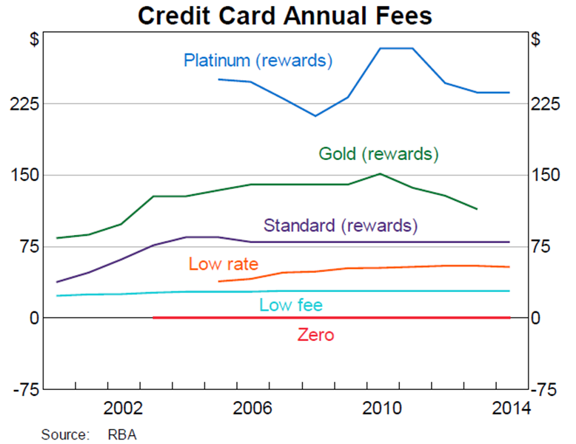

Appendix B — Current Balance Transfer Offers




The Australian Bureau of Statistics notes the need for caution when interpreting income data, particularly for the lowest income quintile, due to underreporting concerns and the potential for reporting temporary rather than typical income levels.
Citibank 2010, ‘Evidence versus emotion: How do we really make financial decisions?’, available at: http://www.financialliteracy.gov.au/media/267572/citibank_evidence-versus-emotion.pdf
Issuers also make money from the interchange fees charged to merchants’ banks and annual fees paid by cardholders. Given both interchange and annual fees are higher for premium cards to compensate for the higher costs of their more generous rewards, the analysis that follows concentrates on interest rate income received by issuing institutions, though it is difficult to disentangle which forms of fee and interest income compensate for the package of rewards and the credit extended.
See, for example: Ali, P., McRae, C. and Ramsay, I. 2012, Consumer credit reform and behavioural economics: Regulating Australia’s credit card industry, available at: http://papers.ssrn.com/sol3/papers.cfm?abstract_id=2052615.
The Reserve Bank’s Survey of Consumers’ Use of Payment Methods indicated that around 24 per cent of ‘revolvers’ accruing interest had low-rate cards in 2013. As such, the appropriate headline rate applied is a mix of the interest rates on the standard and low-rate cards. For simplicity, in Figure 9 it is conservatively assumed that the use of low-rate cards by ‘revolvers’ monotonically increased from zero to 24 per cent over the period in which interest rate data for low-rate cards is available from the Reserve Bank (November 2003 to the present).
Another difference is that US credit card interest rates are often tied to a benchmark, such as the prime rate — that is, their interest rates are at a fixed spread above the rate commercial banks charge their most creditworthy borrowers.
The reforms were telegraphed long before they took effect. The signing into law of the Act in May 2009 was preceded by a long series of events that made the changes almost certain long before May 2009. A paper by the Federal Reserve Bank of Boston argued that by 2008 — and possibly as early as 2007 — issuing banks were aware that the rules governing disclosure and rate increases were about to change (Jambulapati, V. and Stavins, J. 2013, ‘The credit CARD Act of 2009: What did banks do?’, Federal Reserve Bank of Boston Public Policy Discussion Papers, No.13-7).
See www.mintel.com/press-centre/social-and-lifestyle/card-act-fears-dispelled-as-competition- increases-reports-mintel-comperemedia.
Agarwal, S. et al. 2014, Regulating consumer financial products: Evidence from credit cards, August, available at: http://papers.ssrn.com/sol3/papers.cfm?abstract_id=2330942.
See, for example: New South Wales Office of Fair Trading, 2008, Responsible lending practices in relation to consumer credit cards, Consultation Regulatory Impact Statement, available at: www.fairtrading.nsw.gov.au/pdfs/About_us/Resolving_issues/Responsible_lending_RIS_2008.pdf.
Example 3.5 of the Explanatory Memoranda to the National Consumer Credit Protection Act 2009 places a very limited requirement on card providers to make reasonable inquiries to determine whether the particular product they offer is meets their requirements and objectives.
Credit card comparison website Mozo suggests the average minimum repayment is currently around 2.3 per cent of the outstanding balance. See: www.news.com.au/finance/money/choose-the-right-credit-card-or-you-could-be-paying-interest-for-more-than-100-years/story-fnagkbpv-1227378257930.

