Natural Disaster Insurance Review

Inquiry into flood insurance and related matters
June 2011

Executive Summary

Executive summary

Purpose and nature of the Review
Following the series of storms, floods and cyclones that affected many parts of Queensland and some parts of Victoria in late 2010 and early 2011, the Assistant Treasurer, the Hon Bill Shorten MP, announced on 4 March 2011 the Natural Disaster Insurance Review.
It was not these extreme weather events themselves that stimulated the Review, for the insurance industry has demonstrated, in these events and others such as the Victorian bushfires in February 2009 and the hailstorms in Melbourne and Perth in March 2010, that it has the financial capacity and other resources needed to respond effectively to such events.
It was the absence of flood insurance for many policyholders, particularly in Brisbane and Ipswich, that was the primary stimulus to the Review.
The fact that all home insurance policies cover storm damage but many do not cover flood, allied with the insurance industry’s distinction between the two, which is seen as arcane and confusing by many, has led to a community backlash against insurers and considerable distress, financial loss and disillusionment for many insured homeowners.
The theme of the Review, arising from the flood problem and the full terms of reference of the Review (see Appendix 1), is the availability and affordability of insurance offered by the private insurance market, with particular reference to flood and other natural disasters. This acknowledges that the insurance industry cannot solve the flood insurance problem on its own.
There is a good explanation as to why insurers have difficulty in offering flood cover. It is illustrated by the following figure.
Figure 1: What is the flood insurance problem?
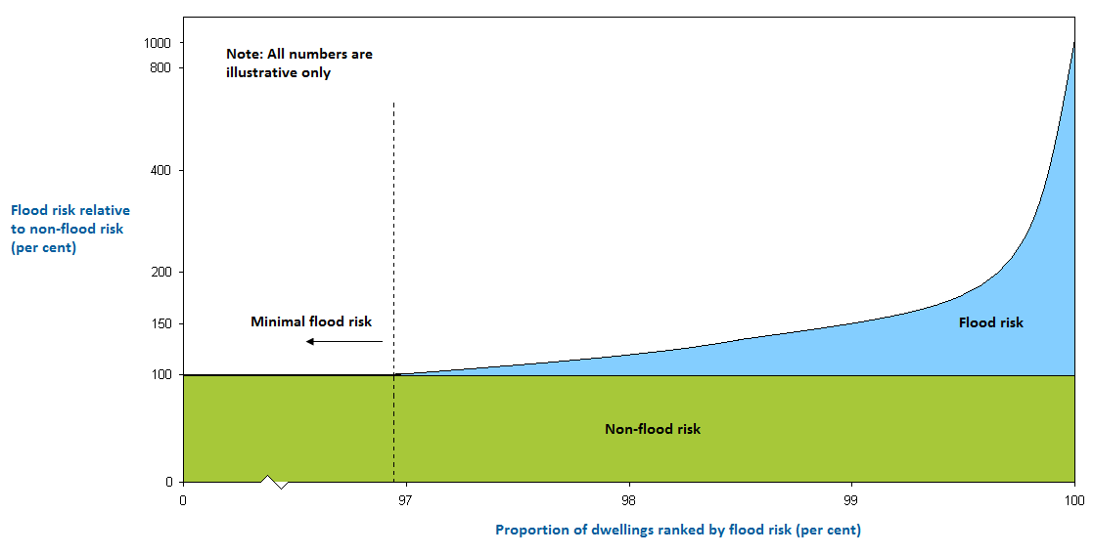
There are probably only about 50,000 homes subject to high flood risk, less than one per cent of Australia’s estimated 6.2 million homes, but if their insurance included flood cover, their premiums would reflect the high risk indicated by the curve on the right of Figure 1. There are probably a further three to six per cent of properties subject to modest flood risk.
In undertaking the Review, the Panel has considered possible new arrangements for flood insurance for homes. It also explores whether any such arrangements ought to be extended to home contents, strata title and other residential properties, and small business.
The Panel has also looked at whether there are any insurance issues related to other natural disasters. They are bushfire, cyclone and earthquake (usually covered as standard in insurance policies) and also actions of the sea and landslide.
Other matters considered by the Review Panel, in the context of availability and affordability, include non-insurance and under-insurance, consumer understanding and dispute resolution, flood risk measurement and mitigation, and some aspects of government funding of natural disaster relief and recovery. The Issues Paper examines all of these matters, explains them in various levels of detail, and poses a set of questions about each of them.

Flood insurance for homes — a way forward
The Review Panel has identified two alternative models of flood insurance for the future: that flood cover be provided automatically as part of home insurance, just as it provides cover automatically for bushfire and storm; or that flood cover be provided automatically but that homeowners be able to ’opt out’ and have home insurance that includes cover for other causes of damage but not flood. The other main possibility is to retain the status quo whereby insurers remain free to offer full, partial or nil flood cover for home insurance and homeowners are free to decide whether or not to include flood cover in their home insurance policies.
Under the first model, Automatic Flood Cover, all disputes about whether water damage is caused by flood or storm would be eliminated. Flood cover would then be in place at the same level as bushfire and storm cover for every insured home. Some homeowners, however, would face significant increases in insurance premiums under such a model unless these homeowners were given some form of assistance to enable them to continue to insure their homes. Such an arrangement would benefit the homeowners themselves, but the broader community would also benefit from extending flood cover to more homes.
Under the second model, Automatic Flood Cover with Opt Out, the take-up of flood insurance would undoubtedly be greater than under the status quo but would still remain limited. Disputes over whether water damage arose from flood or storm could also still occur for policyholders who opt out of flood cover.
Both models require three steps to give some form of assistance to owners of homes exposed to high flood risk so that their premiums become affordable:
- identifying the homes with high flood risk;
- providing discounts to some or all of these home owners; and
- funding these discounts.
Each of these steps requires careful and extensive consideration.
Distinguishing the homes with high flood risk from those with modest flood risk introduces the idea of a high-risk threshold. Two suggestions are put forward:
- an engineering threshold: the threshold is determined by flood mapping and related techniques, using for example a 1 in 100 annual return interval and perhaps also taking account of the design and construction of each house.
This approach relies on engineering techniques and the threshold is set independently of the insurance industry.
- a price threshold: the threshold is specified as an insurance premium relative to a non-flood insurance premium, for example 140 per cent or 150 per cent of the non-flood premium, and if no insurer is willing to offer a lower premium, the home owner would be eligible for a discounted premium.
This kind of threshold could be referred to as an insurance market solution to the threshold question.
The essential argument for introducing discounts is firstly the desirability and importance of solving the flood insurance availability and affordability problem, and secondly the benefit that can accrue to the broader community from a wide take-up of flood insurance. Insurance helps both individuals and communities recover from disasters, it encourages mitigation by the homeowner which also benefits the community, and it reduces the impost on charitable donors or taxpayers.
Under both systems, there is of course a need to maintain the integrity of the total system for the high-risk homes, that is, those where the flood risk is beyond the threshold. The key stakeholders (homeowners, insurers, councils and governments) all need to have a vested interest in order to avoid moral hazard and to maintain incentives for good risk management, including flood mitigation. The full details of the threshold mechanism and the associated premium discount and funding arrangements would need to meet the test of system integrity.
To devise a full insurance system for high flood-risk homes requires not only a high-risk threshold mechanism but also:
- a central vehicle of some kind, referred to in the Paper as the Flood Insurance Pool. It is shown schematically below. The Pool itself could be a form of mutual with insurers as participants, or it could operate as a reinsurer.
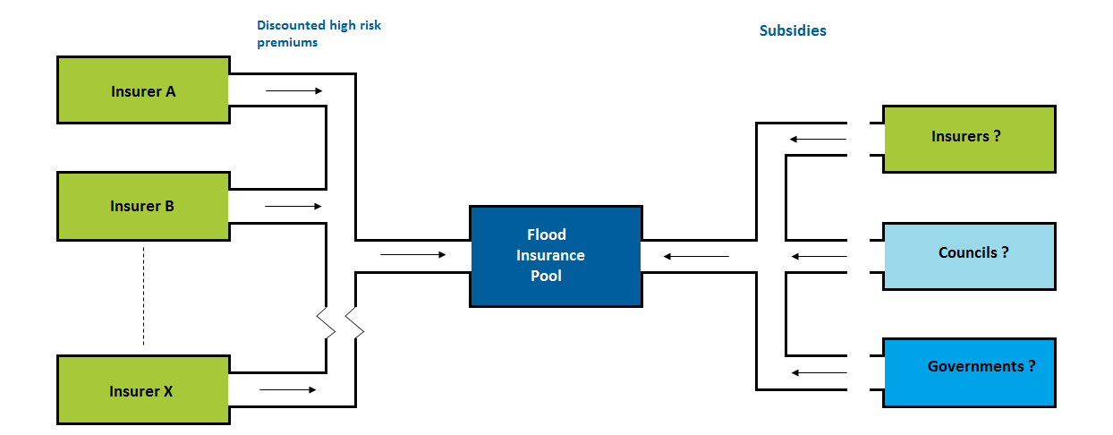
- a pricing regime: for example the price could be set at say 150 per cent of the non-flood premium (as a flat rate for all homes beyond the threshold) or, on a more risk-oriented basis, 150 per cent plus say 10 per cent or 20 per cent of the cost of flood cover beyond 150 per cent.
The discount is then the difference between the full risk-based price and the discounted price charged to the homeowner.
Note that the full risk-based price is assessed by the Flood Insurance Pool.
- eligibility criteria: which homes with high flood risk are eligible for premium discounts? It can be argued, for example, that future new homes with high flood risk should not be eligible for discounts.
- an insurance underwriting regime: for example under an engineering threshold, insurers would be obliged to accept homes beyond the high-risk threshold at the specified discounted price; under a price threshold, if no insurer were willing to offer a premium below the threshold price (of say 150 per cent), insurers would be obliged to accept homes at the specified discounted price.
- a mechanism for funding the discounts: there are several ways to deal with the discounted premiums. For example, the flood portion only of the risk could be transferred to the Pool or the whole risk could be transferred, with a suitable premium also transferred to the Pool. It is suggested that, for transfer of flood risk only, the whole flood premium plus 25 per cent of the non-flood premium would go to the Pool or, for transfer of the whole risk, 90 per cent of the whole premium would go to the Pool. The insurer shortfall implicit in the percentages, the 25 per cent and the 10 per cent respectively, are intended as incentives on insurers to accept as many homeowners as possible to their own account rather than cede them to the Flood Insurance Pool.
Another possible approach is for the whole risk to be retained by the insurer, with the insurer receiving a contribution or subsidy from the Pool to meet the cost of the discount.
- a source of funding for the discounts: the discounts have to be funded and therefore need to be subsidised by someone. The main possible sources of subsidies are governments, councils and insurers. In these cases, the subsidies would ultimately be met by, respectively, taxpayers, ratepayers or policyholders.
In considering an insurance system for high flood-risk homes, the reader’s attention is drawn to the existence of ‘residual market’ schemes known as Fair Access to Insurance Requirements (FAIR) Plans in many states in the United States. These plans, which cater for various kinds of hard to place and high risk homes, have a generic similarity to the type of insurance system for homes with high flood risk that is described in this Issues Paper. These plans are a rich source of ideas and experiences around pricing, funding, governance and risk mitigation. The Review Panel will be examining these systems further, including their successes and failures, as part of the next stage of this Review.

Other issues
Structuring an insurance system for homes with high flood risk is the key focus of the Review. As is evident from the above, it is an undertaking that involves important and in some respects difficult conceptual, technical and practical matters. Their resolution will take extensive analysis, investigation and debate following release of the Issues Paper.
However, there is a range of related issues that also need to be worked through in order to enhance the role that insurance can play in mitigating the costs of natural disasters. The Issues Paper poses a series of questions around each of them.
These questions are recorded in the addendum to this Executive Summary, for convenience both in understanding the scope of the issues being considered by the Review Panel and in framing submissions in response to this Paper.

Submissions
The Review Panel encourages all interested parties to examine the questions posed. Submissions are invited accordingly in response to this Issues Paper

The Natural Disaster Insurance Review Panel
Mr John Trowbridge (Chairman)
Mr John Berrill
Mr Jim Minto

