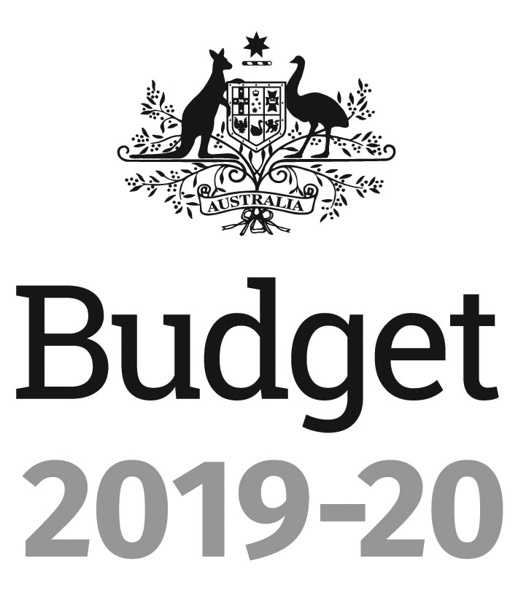
Portfolio Budget Statements 2019-20
Budget Related Paper No. 1.16
TREASURY Portfolio
Budget Initiatives and Explanations of
Appropriations Specified by Outcomes
and Programs by Entity
© Commonwealth of Australia 2019
ISSN 0728 7194 (print); 1326 4133 (online)
This publication is available for your use under a Creative Commons BY Attribution 3.0 Australia licence, with the exception of the Commonwealth Coat of Arms, the Treasury logo, photographs, images, signatures and where otherwise stated. The full licence terms are available from http://creativecommons.org/licenses/by/3.0/
au/legalcode.

Use of Treasury material under a Creative Commons BY Attribution 3.0 Australia licence requires you to attribute the work (but not in any way that suggests that the Treasury endorses you or your use of the work).
Treasury material used 'as supplied'
Provided you have not modified or transformed Treasury material in any way including, for example, by changing the Treasury text; calculating percentage changes; graphing or charting data; or deriving new statistics from published Treasury statistics – then Treasury prefers the following attribution:
Source: The Australian Government Department of the Treasury
Derivative material
If you have modified or transformed Treasury material, or derived new material from those of the Treasury in any way, then Treasury prefers the following attribution:
Based on The Australian Government Department of the Treasury data
Use of the Coat of Arms
The terms under which the Coat of Arms can be used are set out on the Department of the Prime Minister and Cabinet website (see www.pmc.gov.au/government/
commonwealth-coat-arms).
Other uses
Enquiries regarding this licence and any other use of this document are welcome at:
Manager
Media Unit
The Treasury
Langton Crescent
Parkes ACT 2600
Email: medialiaison@treasury.gov.au

Treasurer
parliament House
canberra 2600
President of the Senate
Australian Senate
Parliament House
CANBERRA ACT 2600

Speaker
House of Representatives
Parliament House
CANBERRA ACT 2600

Dear Mr President
Dear Mr Speaker
I hereby submit Portfolio Budget Statements in support of the 2019-20 Budget for the Treasury portfolio.
These statements have been developed, and are submitted to the Parliament, as a statement on the outcomes for the portfolio.
I present these statements to provide accountability to the Parliament and, through it, the public.
Yours sincerely

The Hon Josh Frydenberg MP
Abbreviations and conventions
The following notation may be used:
NEC/nec not elsewhere classified
- nil
.. not zero, but rounded to zero
na not applicable (unless otherwise specified)
nfp not for publication
$m $ million
$b $ billion
Figures in tables and in the text may be rounded. Figures in text are generally rounded to one decimal place, whereas figures in tables are generally rounded to the nearest thousand. Discrepancies in tables between totals and sums of components are due to rounding.
Enquiries
Should you have any enquiries regarding this publication please contact Mr Robert Twomey, Chief Financial Officer, Department of the Treasury on 02 6263 2111.
Links to Portfolio Budget Statements (including Portfolio Additional Estimates Statements and Portfolio Supplementary Additional Statements) can be located on the Australian Government Budget website at: www.budget.gov.au.

User Guide
To The
Portfolio Budget Statements

User guide
The purpose of the 2019-20 Portfolio Budget Statements (PB Statements) is to inform Senators and Members of Parliament of the proposed allocation of resources to government outcomes by entities within the portfolio. Entities receive resources from the annual appropriations acts, special appropriations (including standing appropriations and special accounts), and revenue from other sources.
A key role of the PB Statements is to facilitate the understanding of proposed annual appropriations in Appropriation Bills (No. 1 and No. 2) 2019-20 (or Appropriation (Parliamentary Departments) Bill (No. 1) 2019-20 for the parliamentary departments). In this sense, the PB Statements are Budget related papers and are declared by the Appropriation Acts to be ‘relevant documents’ to the interpretation of the Acts according to section 15AB of the Acts Interpretation Act 1901.
The PB Statements provide information, explanation and justification to enable Parliament to understand the purpose of each outcome proposed in the Bills.
As required under section 12 of the Charter of Budget Honesty Act 1998, only entities within the general government sector are included as part of the Commonwealth general government sector fiscal estimates and produce PB Statements where they receive funding (either directly or via portfolio departments) through the annual appropriation acts.
The Enhanced Commonwealth Performance Framework
The following diagram outlines the key components of the enhanced Commonwealth performance framework. The diagram identifies the content of each of the publications and the relationship between them. Links to the publications for each entity within the portfolio can be found in the introduction to Section 2: Outcomes and planned performance.

Enhanced Commonwealth Performance Framework
Key components of relevant publications

Portfolio Budget Statements (April)
Portfolio based

Corporate Plan (August)
Entity based

Supports Annual Appropriations. Informs Senators and Members of Parliament of the proposed allocation of other resources to government outcomes and programs.
Provides links to relevant programs undertaken by other Commonwealth entities.
Provides high level performance
information for current, ongoing programs, particularly a forecast of performance for the current year.
Provides detailed prospective
performance information for proposed new budget measures that require a new program or significantly change an existing program.
Primary planning document of a
Commonwealth entity.
Sets out the purposes of the entity, the activities it will undertake to achieve its purposes and the results it expects to achieve over a minimum four year period.
Describes the environment in which the entity operates, the capability it requires to undertake activities and a discussion
of risk.
Explains how the entity’s performance will be measured and assessed.
Annual Performance Statement (October following year)
Entity based

Included in the Commonwealth entity’s Annual Report. Focuses on recent
performance.
Reports on the actual performance results for the year against the forecasts made in the corporate plan and Portfolio Budget Statements, and provides other performance information relevant to the entity.
Provides an analysis of the factors that contributed to the entity’s
performance results.

Contents
Portfolio overview 1
Entity resources and planned performance 7
Department of the Treasury 9
Australian Bureau of Statistics 57
Australian Competition and Consumer Commission 75
Australian Office of Financial Management 101
Australian Prudential Regulation Authority 121
Australian Securities and Investments Commission 143
Australian Taxation Office 171
Commonwealth Grants Commission 225
Inspector-General of Taxation 241
National Competition Council 255
Office of the Auditing and Assurance Standards Board 271
Office of the Australian Accounting Standards Board 289
Productivity Commission 307
Royal Australian Mint 323
Glossary 343

