Regulating digital asset platforms
  - The Albanese Government is working to regulate digital and crypto asset platforms in Australia. These platforms hold billions of dollars of assets for Australians while providing services such as trading and staking. While innovation in this sector is critical to enabling growth and competition in Australia’s financial sector, failures and vulnerabilities of these platforms have increased the need to regulate to protect consumers.

Terms
Digital tokens are digital units or records that can be used to represent or refer to anything. Digital tokens include cryptocurrency tokens (like bitcoin) and non-fungible tokens (like for art and in game items).
Digital assets are digital tokens and the entitlement they grant to their holder.
Digital asset platforms are platforms that hold people’s digital assets for them. These are also known as crypto exchanges or brokers. They often provide other services that rely on this feature of holding client assets (such as trading).

Need for regulation
Interest in digital and crypto assets has grown rapidly. According to Swyftx, around 1 in 4 Australians own some crypto. The most common way for Australians to access these tokens is through digital asset platforms. These platforms hold billions of dollars of assets for Australians − exposing them to significant risk.
Collapses of digital asset platorms, both locally and globally, have seen Australians lose their assets or be forced to wait their turn amongst long lines of creditors. These reforms seek to reduce the risk of these collapses happening, by lifting the standard of their operations and increasing their oversight.
Further regulation will achieve three goals:
- Introducing a framework for industry innovation and growth
- Providing certainty and clarity for industry
- Protecting consumers and their assets

Leveraging Australia’s financial services laws
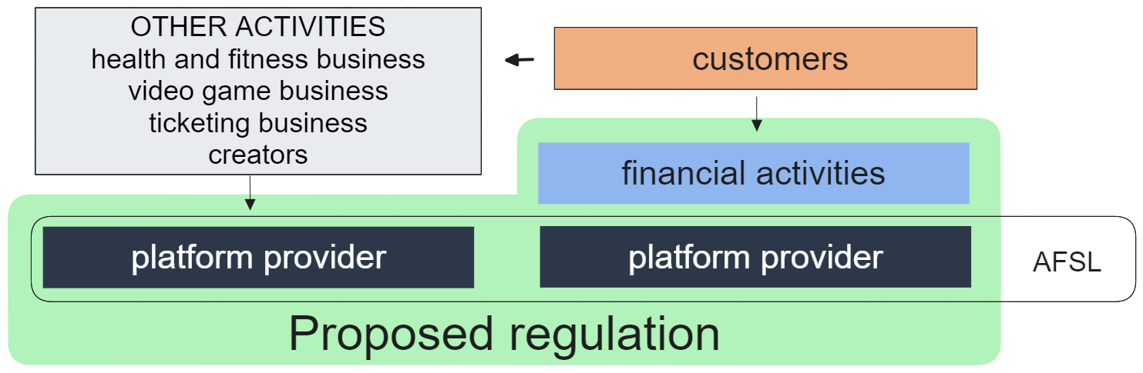

Digital asset platforms will be licensed, with standard obligations
Our regulation proposal will seek to leverage existing Australian financial services laws. It would require digital asset platforms that hold over a certain threshold of Australians assets ($1,500 for an individual; $5 million in aggregate) to obtain an Australian Financial Services Licence. The Australian financial service laws are a time tested and well understood framework to mitigate risks involving businesses holding or utilising client assets.
Digital asset platforms would need to meet all general licence obligations, consistent with other licence holders.
The general obligations are drawn from the Australian financial services law, and include:
- providing the financial service efficiently, honestly, and fairly
- managing conflicts of interest
- having a dispute resolution system
- meeting solvency and cash reserve requirements
- keeping and submiting financial records
- producing product disclosure statements
- monitoring for and disrupting market misconduct.

Specific obligations will also apply
All digital asset platforms will also need to meet specific obligations that take into account the nature of the platforms, of tokens, and their risks. The specific obligations, unique to the digital assets industry, will include:
- standard form platform contracts
- minimum standards for holding tokens
- standards for custody software
- standards when transacting in tokens.
These obligations are inspired by frameworks used to regulate digital asset platforms in jurisdictions like the EU, UK, Canada, and Singapore. They take into account the nature of the platforms as well as the crypto networks and tokens they provided services in relation to.

Certain digital asset activities will have additional obligations
The proposal would also apply additional obligations to four specific activities involving non-financial products offered by digital asset platforms.
- Trading – the exchange of digital asset platform entitlements between account holders.
- Staking – the participation in validating transactions on a public network.
- Tokenisation – the creation and exchange of entitlements backed by tangible and intangible assets.
- Fundraising – the sale of entitlements to fund the development of products and services.
Obligations are targeted to address some of the risks that arise from digital asset platform business models and the nature of the tokens they provide access to.

Regulations that are fit-for-purpose
The government is proposing a fit-for-purpose regulatory regime.
The proposed regulatory approach focusses on the digital asset service providers who hold people’s digital assets, rather than the token itself. This minimises the exploitation of regulatory loopholes, and is designed to accommodate a future where an increasing number and variety of products are tokenised.
Regulations are proposed to be technologically neutral, keeping open the opportunities for technological innovation to happen in the future.
Where digital assets are currently regulated as a financial product, these regulations will remain.

How does this help?
Extending these types of obligations to digital asset platforms will decrease the risk of crypto exchange collapses, protecting the assets of Australians who use these platforms.
It will increase scrutiny on exchanges to ensure their customers are well informed, and reduce the risks of consumers being impacted by scams involving crypto.
The reforms address growing financialisation of services regarding tokens, by lifting the quality of service of providers through additional obligations. This approach will mitigate the risks and harms that have arisen because of the financialisation of digital assets.

Next steps
Consultation closes on 1 December 2023.
Further consultation on exposure draft legislation in 2024.
Twelve month transitional period following legislation being made law.

