

Merger Reform

Consultation paper – Appendices

November 2023

Appendix A: Australia’s merger control regime 4

Mergers test 4

Mergers assessment processes 5

ACCC informal merger review 5

ACCC merger authorisation 6

Federal Court 6

Key facts and figures 7

Outcomes 7

**Figure 1:** Number of informal merger reviews since 2015-16 where competition concerns were raised by the ACCC 7

Processes 8

**Figure 2:** Number of ACCC merger reviews since 2009-10 8

**Figure 3:** Average length of ACCC public informal reviews 9

Appendix B: Serial or creeping acquisitions – previous reform proposals 10

Appendix C: Mergers clearance processes – previous proposals 12

Appendix D: Overview of overseas merger control regimes 14

# Appendix A: Australia’s merger control regime

## Mergers test

Section 50 of the *Competition and Consumer Act 2010* (Cth) (CCA) prohibits the acquisition of shares or assets where it ‘would have the effect, or be likely have the effect, of substantially lessening competition in any market’. In assessing whether a proposed acquisition would be likely to substantially lessen competition, it is necessary to:

compare the likely future state of competition in the relevant market with and without the merger; and

without limiting the matters that may be taken into account, consider the ‘merger factors’ in section 50(3):

* + the actual and potential level of import competition in the market;
  + the height of barriers to entry to the market;
  + the level of concentration in the market;
  + the degree of countervailing power in the market;
  + the likelihood that the acquisition would result in the acquirer being able to significantly and sustainably increase prices or profit margins;
  + the extent to which substitutes are available in the market or are likely to be available in the market;
  + the dynamic characteristics of the market, including growth, innovation and product differentiation;
  + the likelihood that the acquisition would result in the removal from the market of a vigorous and effective competitor; and
  + the nature and extent of vertical integration in the market.

‘Likely’ means a ‘real commercial likelihood’ in the context of section 50.[1] Further, a ‘substantial’ lessening of competition does not need to be ‘large or weighty… but one that is ‘real or of substance… and thereby meaningful and relevant to the competitive process’.[2]

## Mergers assessment processes

Three voluntary processes exist by which proposed mergers may be subject to competition assessment:

informal merger review;

merger authorisation; and

Federal Court proceedings.

### ACCC informal merger review

Merger parties may request an informal view from the Australian Competition and Consumer Commission (ACCC). There is no legislative basis for this review.

An ACCC informal view provided to merger parties has no legal effect. Rather, it provides an assurance that the ACCC does not intend to take court action to stop a proposed merger from proceeding (based on the information available at the time of the decision).

The ACCC considers mergers either through a pre-assessment or public review process.

* A **pre-assessment** is an expedited review of low risk and non-contentious mergers. 83 per cent of ACCC merger reviews have been pre-assessed since introduction of this process in 2009-10. In the past 5 years, 93 per cent of ACCC merger reviews were pre-assessed, with the majority of these assessed within 2 weeks (excluding time taken for merger parties to provide additional information to the ACCC).
* A **public review** involves market inquiries and submissions from affected parties such as competitors and customers. The ACCC will issue a Statement of Issues and extend the review if it considers competition concerns have arisen. Timelines depend on the complexity; however indicative timeframes are approximately 6-12 weeks for mergers that do not require further consideration, with an additional 6-12 weeks where a Statement of Issues is released.

Parties may also request a confidential assessment that leads to a preliminary view being provided prior to a merger becoming public.

As an unlegislated process, there are no formal obligations on mergers parties to provide information to the ACCC when seeking informal merger review. However, merger parties are encouraged to provide sufficient documentation to enable the ACCC to assess the competition impacts of the proposed merger and to avoid delays.

If the ACCC concludes that a proposed merger would be likely to breach section 50, it may accept a court-enforceable undertaking under section 87B of the CCA to remedy competition concerns. If this is not offered by the merger parties and the parties do not voluntarily abandon the transaction, the ACCC must then commence action in the Federal Court of Australia (Federal Court) to prevent the merger proceeding.

If a merger about which the ACCC has competition concerns completes, the ACCC may seek divestiture[3] (within 3 years of the merger completing) and/or pecuniary penalties[4] (within 6 years of the merger completing).[5]

### ACCC merger authorisation

Alternatively, merger parties may apply to the ACCC for merger authorisation. Authorisation provides formal legal immunity from court action under section 50.[6]

Merger parties who seek authorisation are required to provide an undertaking to the ACCC that they will not complete the merger until their application has been determined.[7]

Upon receipt of a valid application, the ACCC will conduct market inquiries and seek public submissions and further information as necessary. If the ACCC does not issue a determination within the 90 calendar day statutory timeframe (unless extended), the ACCC is taken to have refused authorisation.[8]

The ACCC must not grant authorisation unless it is satisfied that either the proposed acquisition would not be likely to substantially lessen competition or the likely public benefit from the proposed acquisition outweighs the likely public detriment.[9]

The ACCC may grant authorisation unconditionally or subject to conditions (such as divestiture of specific assets).

ACCC decisions are subject to limited merits review by the Australian Competition Tribunal (the Tribunal), on application by an interested party. Decisions of the Tribunal are subject to judicial review by the Full Court of the Federal Court.

Between 2007 and 2017, merger parties could apply directly to the Australian Competition Tribunal for merger authorisation. Following recommendations by the Harper Competition Policy Review, the ACCC was reinstated as the primary decision-maker for merger authorisations from November 2017.

### Federal Court

Merger parties may seek a declaration from the Federal Court, at its discretion, that the merger will not contravene section 50 of the CCA. In such proceedings, the onus of proof is on the merger party to prove that the merger would not be likely to substantially lessen competition on the balance of probabilities.[10]

In practice, merger parties almost always first seek the ACCC’s informal view or merger authorisation given the comparative complexity, cost and time associated with seeking a declaration.

## Key facts and figures

### Outcomes

From 2015-16 to 2022-23, out of 2,710 informal merger reviews:

the ACCC opposed 9 mergers;[11]

the ACCC did not oppose 27 mergers subject to an enforceable undertaking to remedy competition concerns; and

a further 27 mergers were withdrawn after the ACCC raised competition concerns (as shown in Figure 1).[12]

**Figure 1:** Number of informal merger reviews since 2015-16 where competition concerns were raised by the ACCC

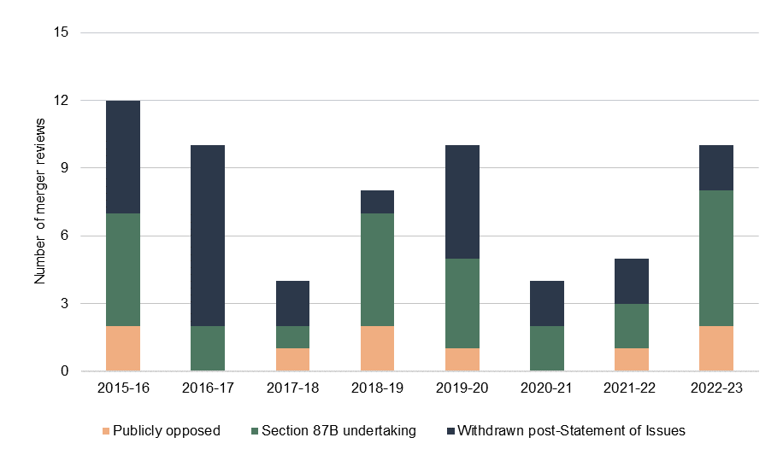

Note: Financial year. Source: ACCC.

The ACCC has considered 7 applications for merger authorisation since it was reinstated as the decision-maker at first instance in November 2017. Out of these, the ACCC:

granted 1 authorisation unconditionally;

granted 4 authorisations subject to section 87B undertakings; and

denied 2 applications for authorisation.

### Processes

Figure 2 shows that, since 2009-10, when the pre-assessment process was introduced:

the ACCC has reviewed an average of 333 mergers each year;

the number of mergers that were pre-assessed by the ACCC since 2009-10 has increased, with a spike in 2020-2022 corresponding with an increase in merger activity during the COVID-19 pandemic;

the number of informal public reviews declined by around 80 per cent between 2009-10 and 2015‑16 and then broadly stabilised (albeit declining slightly during the pandemic); and

few merger authorisation applications have been lodged with the ACCC.[13]

**Figure 2:** Number of ACCC merger reviews since 2009-10

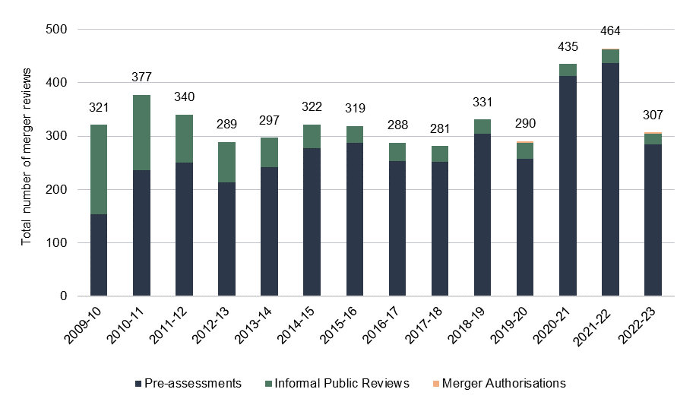

Note: Financial year. Source: ACCC.

For merger authorisations:

The ACCC has taken 171 days on average to complete its assessment, with the shortest time period being 88 days[14] and the longest 260 days.[15]

In all but one application for merger authorisation, the ACCC’s review required one or more extensions to the 90 calendar day statutory timeframe.

The Tribunal has reviewed one ACCC merger authorisation decision,[16] which took 181 days to complete.

As shown in Figure 3, the time taken for the ACCC to complete confidential reviews and pre‑assessments has not changed significantly since 2006 (on average, taking 11 days in 2006 and 14 days in 2023).

Mean average timeframes for informal public reviews have increased since 2006. In particular, timeframes for complex informal public reviews (where a Statement of Issues was issued by the ACCC or where a section 87B undertaking was offered) have increased significantly since 2019.

**Figure 3:** Average length of ACCC public informal reviews

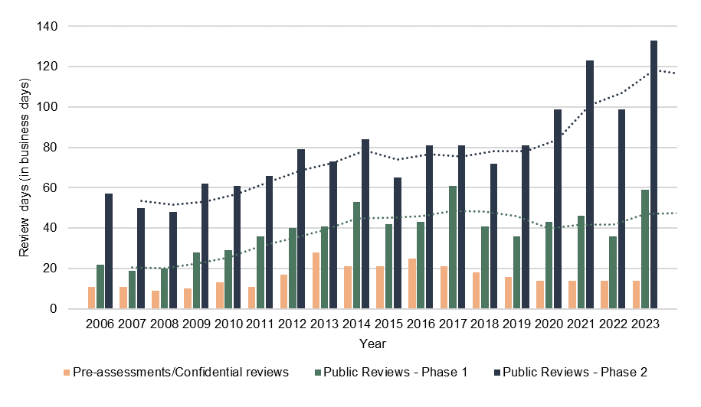

Note: Calendar year. The duration is in business days, excluding any timeline suspensions while the ACCC awaits information from the merger parties. Timeline suspensions were not recorded for pre-assessments prior to 2018. For the purposes of this figure, merger assessments include matters that are withdrawn or where no decision is reached. Source: ACCC.

# Appendix B: Serial or creeping acquisitions – previous reform proposals

Serial or creeping acquisitions generally refers to a series of acquisitions of smaller competitors over time which do not individually raise competition concerns, but which when taken together may have a significant impact on competition. It can also refer to acquisitions involving firms slowly increasing their stake in an individual firm.

The 2003 Dawson review considered proposals to address creeping acquisitions, including market share caps; requiring merger parties in highly concentrated markets to notify the ACCC; and adding a merger factor to section 50(3) on creeping acquisitions. However, it concluded that section 50 was adequate to enable the ACCC to consider creeping acquisitions, and that ‘while a genuine competitive environment exists, the preservation of the number of competitors in a market is more a matter for industry policy than competition policy.’[17]

In 2007, a private members’ bill unsuccessfully proposed amending the CCA to deem an acquisition to substantially lessen competition if acquisitions within a 6-year period together were likely to have that effect.[18]

In July 2008, an ACCC report into grocery prices supported legislatively addressing creeping acquisitions, noting that this was a potential concern in the retail supermarkets sector.[19]

Treasury released discussion papers in 2008 and 2009 on possible legislative amendments to address creeping acquisitions. The 2008 paper suggested two possible approaches:

to prohibit a corporation from making an acquisition if, when combined with acquisitions made by the corporation within a specified period, the acquisition would be likely to substantially lessen competition in a market; or

to add a new prohibition to section 50 whereby a corporation must not make an acquisition if it already has a substantial degree of power in a market, and the acquisition would result in any lessening (as opposed to substantial lessening) of competition in the market.

The 2009 paper invited comment on two further options to implement a creeping acquisitions law:

to prohibit mergers and acquisitions that enhance a corporation's existing substantial market power where a direct or indirect acquisition of shares or assets 'would have the effect, or be likely to have the effect, of enhancing that corporation's substantial power in that market'; or

to give the Minister the power to unilaterally 'declare' a corporation where s/he has concerns about potential and/or actual competitive harm from creeping acquisitions.

In 2009, a second private members’ bill unsuccessfully proposed to amend section 50 to replace ‘substantially’ with ‘materially’ and prohibit acquisitions by corporations with a ‘substantial share of a market’ from acquiring shares or assets that would have ‘the effect of lessening competition in a market.’[20]

In 2011, the CCA was amended to apply section 50 to ‘any market’ rather than a ‘substantial market’ or ‘a market’. The changes to section 50 were intended to make it clear that it can apply to a local market and allow consideration of multiple markets.[21]

In 2015, the Harper Competition Policy Review acknowledged concerns about creeping acquisitions and noted that ‘[a]s a matter of concept, competition law should assess the overall effect of business conduct and not be narrowly focused on individual transactions’.[22] The Final Report discussed an aggregation model but ultimately concluded that the case for change was not strong enough as there was no evidence of harmful creeping acquisitions.[23]

# Appendix C: Mergers clearance processes – previous proposals

A voluntary formal merger clearance process existed in Australia between 1974 and 1977. The process was removed when the mergers test changed from ‘substantial lessening of competition’ to ‘dominance’. By the early 1990s, the current informal review process had emerged.[24]

In 1992, the Senate Standing Committee on Legal and Constitutional Affairs, in its report *Mergers, Monopolies and Acquisitions*, recommended that mandatory notification be introduced for ‘substantial’ mergers.[25]

In late 1994, Treasury released a consultation paper on pre-merger notification but ultimately did not proceed with the reforms.

The 2003 Dawson Competition Policy Review did not recommend replacing the informal process with compulsory, formal notification as it considered that it ‘would greatly increase the regulatory burden both on corporations proposing to merge and on the ACCC’.[26] The Dawson Review instead recommended that:

the ACCC provide greater transparency in its decision-making in the informal process; and

that a voluntary, formal clearance process be created operating in parallel to the informal process.[27]

A voluntary, formal clearance process was subsequently introduced in 2007 and operated until 2017 when recommendations from the 2015 Harper Review were implemented.[28]

The Harper Review recommended combining the formal clearance process with merger authorisation into a single formal approval process, with consideration of applications by the ACCC in the first instance.[29]

In relation to the informal process, the Harper Review noted that:

The vast majority of submissions support the informal clearance process because of its flexibility and relatively low cost. The fact that the process leads to the ACCC forming a view, rather than a decision of a court, means that it is not necessary for parties to provide legally admissible evidence. This reduces the complexity and expense associated with the process.[30]

It also observed that:

There do not appear to be any examples of merger regimes overseas that offer a high level of transparency without also imposing stricter information requirements and longer timelines than the Australian system.[31]

The Harper Review concluded that:

the informal process works quickly and efficiently for a majority of mergers. Issues of transparency and timeliness arise with the informal process when dealing with more complex and contentious matters. Addressing those issues by changing the informal process could weaken it. Nevertheless, there should be further consultation between the ACCC and business representatives with the objective of delivering more timely decisions in the informal review process.[32]

# Appendix D: Overview of overseas merger control regimes

| Jurisdiction | Mergers test | Decision-maker | Notification | Statutory timeframes[33] | Ability to review non-notified mergers | Remedies and penalties |
| --- | --- | --- | --- | --- | --- | --- |
| United States | May substantially lessen competition, or tend to create a monopoly | Department of Justice (DOJ)/ Federal Trade Commission (FTC) must take court action to stop a merger[34] | Mandatory above thresholds based on transaction value and turnover | Phase 1: 30 days  Phase 2: 30 days | DOJ or FTC may investigate mergers below notification threshold | Penalties apply for not notifying  Parties may offer structural and behavioural remedies with DOJ/FTC  DOJ/FTC may seek court orders for injunction or divestiture |
| Canada | Likely to prevent or substantially lessen competition | Competition Bureau Canada (CBC) must seek orders from Canadian Competition Tribunal | Mandatory above thresholds based on transaction value and turnover | Phase 1: 30 days  Phase 2: 30 days | CCB may investigate mergers below notification threshold | Tribunal may order injunction or divestiture  Structural and behavioural remedies may be negotiated |
| United Kingdom | Substantial lessening of competition | Administrative decision by the Competition and Markets Authority (CMA)  Judicial review by Competition Appeals Tribunal | Voluntary | Phase 1: 40 working days  Phase 2: 24 weeks[35] | CMA may investigate mergers that meet its jurisdictional thresholds  CMA may impose Interim Measures to halt or unwind integration | CMA may accept structural and behavioural remedies  CMA may impose fines and/or divestiture orders |
| New Zealand | Merger clearance:[36] New Zealand Commerce Commission (NZCC) must be satisfied that the merger is not likely to substantially lessen competition  Merger authorisation: NZCC must be satisfied merger is not likely to substantially lessen competition or the public benefits outweigh the public detriments  Commerce Act section 47 investigation: Likely to substantially lessen competition | Clearance/authorisation: Administrative decision by NZCC  Reviewable by New Zealand High Court on merits  For section 47 investigations: NZCC must take action in High Court to stop or unwind a merger | Voluntary | Clearance: 40 working days  Authorisation: 60 working days | NZCC may review all mergers that affect a market in New Zealand | NZCC may accept a structural remedy  High Court may order pecuniary penalties, divestiture, injunction and/or damages |
| European Union | Significantly impede effective competition, in particular as a result of the creation or strengthening of a dominant position | Administrative decision by European Commission  Reviewable by EU General Court on grounds of lack of competence, infringement of an essential procedural requirement, infringement of the Treaty or of any rule of law, or misuse of powers. | Mandatory, with notification thresholds based on turnover | Phase 1: 25 working days  Phase 2: 90 working days[37] | EU Member States may refer mergers to the EC under EUMR Article 22[38] | EC may impose fines up to 10% of aggregate turnover of the merger parties for failure to notify or proceeding before end of statutory review period  EC may accept structural and behavioural remedies |
| Germany | Significantly impede effective competition, in particular a concentration which is expected to create or strengthen a dominant position | Administrative decision by Bundeskartellamt  Reviewable by Düsseldorf Higher Regional Court on point of law | Mandatory, with notification thresholds based on turnover | Phase 1: 1 month  Phase 2: 5 months | Bundeskartellamt may order notification of future mergers under specific circumstances | Fines may be imposed by the Bundeskartellamt and the merger may be made void for failure to notify or completion before clearance is obtained |
| France | Likely to have an adverse effect on competition in particular through the creation or strengthening of a dominant position or reinforcing buying power that places suppliers in a situation of economic dependence | Administrative decision by Autorité de la Concurrence  Reviewable by Conseil d’État | Mandatory, with notification thresholds based on turnover | Phase 1: 25 working days  Phase 2: 65 working days | n/a | Penalties apply for not notifying if above the thresholds |

1. *Australian Competition and Consumer Commission v Pacific National Pty Limited* [2020] FCAFC 77, [246].
2. *Australian Competition and Consumer Commission v Pacific National Pty Limited* [2020] FCAFC 77, [104].
3. *Competition and Consumer Act 2010* (Cth) s 81.
4. *Competition and Consumer Act 2010* (Cth) s 76.
5. *Competition and Consumer Act 2010* (Cth) s 77(2).
6. *Competition and Consumer Act 2010* (Cth) s 88.
7. *Competition and Consumer Act 2010* (Cth) s 89(1A) provides that the ACCC may approve an authorisation application form requiring an application for merger authorisation to contain an undertaking under section 87B that the applicant will not make the acquisition while the ACCC is considering the authorisation application.
8. *Competition and Consumer Act 2010* (Cth) s 90(10B).
9. *Competition and Consumer Act 2010* (Cth) s 90(7).
10. *Australian Gas Light Company v Australian Competition & Consumer Commission (No 3)* [2003] FCA 1525, [355].
11. This figure excludes merger authorisation applications to the Tribunal however includes Toll/Sea Swift (2015) as there was an informal review decision. It excludes Tabcorp/Tatts (2017) as the ACCC did not reach a decision in its informal review. The ACCC commenced reporting on matters withdrawn post-Statement of Issues in 2015-16.
12. Prior to 2015-16, the ACCC did not formally report on the number of mergers withdrawn post-Statement of Issues.
13. Figure 1 does not include applications for merger authorisation that were made direct to the Tribunal before November 2017.
14. AP Eagers Limited proposed acquisition of Automotive Holdings Group Limited (2019).
15. Linfox Armaguard Pty Ltd and Prosegur Australia Holdings Pty Ltd (2023).
16. Telstra Corporation Limited and TPG Telecom Limited proposed spectrum sharing (2022).
17. Dawson, [*Review of the Competition Provisions of the Trade Practices Act*](https://webarchive.nla.gov.au/awa/20030417022726/http:/tpareview.treasury.gov.au/content/report.asp), ‘Dawson Report’, 2003, p 67, accessed 2 November 2023
18. Trade Practices (Creeping Acquisitions) Amendment Bill 2007.
19. ACCC, [*Report of the ACCC inquiry into the competitiveness of retail prices for standard groceries*](https://www.accc.gov.au/about-us/publications/report-of-the-accc-inquiry-into-the-competitiveness-of-retail-prices-for-standard-groceries), 2008, p.xxi.
20. Trade Practices Amendment (Material Lessening of Competition—Richmond Amendment) Bill 2009.
21. *Competition and Consumer Legislation Amendment Act (Cth)* 2011.
22. I Harper, P Anderson, S McCluskey, M O’Bryan AC, [*Competition Policy Review – Final Report*](https://treasury.gov.au/publication/p2015-cpr-final-report)*,* ‘Harper Review’, 2015, p 320, accessed 29 October 2023.
23. I Harper, P Anderson, S McCluskey, M O’Bryan AC, [*Competition Policy Review – Final Report*](https://treasury.gov.au/publication/p2015-cpr-final-report)*,* ‘Harper Review’, 2015, pp 321-323, accessed 29 October 2023.
24. Australian Parliament Senate Standing Committee on Legal and Constitutional Affairs, [*Mergers, Monopolies & Acquisitions – Adequacy of Existing Legislative Controls*](https://catalogue.nla.gov.au/catalog/602438), ‘Cooney Committee Report’, December 1991, para 4.2-4.3, accessed 2 November 2023.
25. Australian Parliament Senate Standing Committee on Legal and Constitutional Affairs, Mergers, Monopolies & Acquisitions – Adequacy of Existing Legislative Controls, ‘Cooney Committee Report’, December 1991, para 4.40, accessed 2 November 2023. At the time, the Attorney-General’s Department had suggested a mandatory notification and suspension arrangement.
26. D Dawson, [*Review of the Competition Provisions of the Trade Practices Act*](https://webarchive.nla.gov.au/awa/20030417022726/http:/tpareview.treasury.gov.au/content/report.asp), ‘Dawson Report’, 2003, p 61, accessed 2 November 2023.
27. D Dawson, [*Review of the Competition Provisions of the Trade Practices Act*](https://webarchive.nla.gov.au/awa/20030417022726/http:/tpareview.treasury.gov.au/content/report.asp), ‘Dawson Report’, 2003, pp 60-64, accessed 2 November 2023.
28. *Trade Practices Legislation Amendment (No 1) Act 2006* (Cth) Schedule 1; *Competition and Consumer Amendment (Competition Policy Review) Act 2017* (Cth) Schedule 9.
29. I Harper, P Anderson, S McCluskey, M O’Bryan AC, [*Competition Policy Review – Final Report*](https://treasury.gov.au/publication/p2015-cpr-final-report)*,* ‘Harper Review’, 2015, p 332, accessed 29 October 2023.
30. I Harper, P Anderson, S McCluskey, M O’Bryan AC, [*Competition Policy Review – Final Report*](https://treasury.gov.au/publication/p2015-cpr-final-report)*,* ‘Harper Review’, 2015, p 325, accessed 29 October 2023.
31. I Harper, P Anderson, S McCluskey, M O’Bryan AC, [*Competition Policy Review – Final Report*](https://treasury.gov.au/publication/p2015-cpr-final-report)*,* ‘Harper Review’, 2015, pp 325-6, accessed 29 October 2023.
32. I Harper, P Anderson, S McCluskey, M O’Bryan AC, [*Competition Policy Review – Final Report*](https://treasury.gov.au/publication/p2015-cpr-final-report)*,* ‘Harper Review’, 2015, p 332, accessed 29 October 2023.
33. In practice, total merger review timelines may exceed the above statutory timeframes for various reasons. This can be due to time spent engaging with competition authorities prior to formal notification, stopping the clock when an information request is issued, timing agreements with the merger parties and/or competition agencies continuing to investigate a merger after the expiry of the statutory period.
34. The FTC can challenge a non-consummated merger by filing an administrative complaint before an Administrative Law Judge. However, as this does not itself block the parties from closing the merger, the FTC will simultaneously seek an injunction in a US district court. In practice, the application for an injunction results in a substantive hearing of the issues. If the FTC prevails, the merger parties will be required to defend the administrative complaint or abandon the merger.
35. Extendable by up to 8 weeks.
36. The vast majority of merger parties use this process.
37. Extendable by 15 working days if parties offer remedies after 55 working days from start of Phase 2.
38. Note however that the EC is a supra-national body and that mergers may be reviewed by national competition agencies within the European Union.